Pentecost #9-1

Acts 2:1-11

And when the day of Pentecost arrived, they were all together in one place.

And suddenly a sound came from heaven like a strong rushing wind, and it filled the whole house where they were sitting.

And there appeared to them tongues as if of fire, which spreading out, came to rest upon each one of them.

And they were all filled with holy spirit, and began to speak in other tongues, as the Spirit was giving them utterance.

Now there were Jews staying in Jerusalem, deeply religious men from every nation under heaven.

And when this sound occurred, the multitude came together, and were bewildered, because each one was hearing them speaking in his own language.

And they were all amazed, and marveled, saying, “Look! Are not all these who are speaking Galileans?

And how is it that we are hearing them speaking, each of us, in our own language in which we were born?”

Parthians and Medes and Elamites, and those who live in Mesopotamia, in Judea and Cappadocia, in Pontus and the province of Asia,

in Phrygia and Pamphylia, in Egypt and the parts of Libya near Cyrene, and visitors from Rome (both Jews and proselytes),

Cretans and Arabians, we hear them speaking in our tongues the mighty works of God.

Even though we have spent many chapters discussing the Pentecost experience, we are still only minutes into the event! Because Pentecost was a one-day feast that all male Jews were to attend, “there were Jews staying in Jerusalem … from every nation under heaven.” These out of towners lived in these foreign lands mentioned and spoke their native languages except for Jewish religious activities. Imagine their shock as these common Galilean men began speaking their home languages! Think of the setting. Everyone was sitting in the posture of prayer at the temple. It was generally quiet except for the occasional sacrifice and priestly incantations in the inner temple area. First comes the sound of a mighty wind. Then it’s combined with tongues of fire which “light” on each of the twelve. Then they start speaking out loud in languages that they couldn't know. Let’s say Peter spoke in Latin. There’s no way a Galilean fisherman can speak Latin! And yet, there he is doing it with perfect pronunciation like he’s a Roman orator! Peter has no idea what he’s saying, but the visitors from Rome “heard them speaking in our tongues the mighty works of God.” Mind-boggling!

Each of the apostles spoke in a language that was foreign to them, but recognizable to a portion of the out of towners. These languages were the dominant sounds in the temple. It was so extraordinary that “the multitude came together”. The out of towners surrounded the apostles and the locals drifted closer to see what these Galileans were doing to cause such excitement. Can you see thousands of people surrounding the seated apostles as they spoke in many foreign languages praising God, and questioned to themselves “What is going on?”

Here’s a couple of points. Firstly, the Bible lists 15 places the out of towners came from.

1. Parthia
2. Media
3. Elam
4. Mesopotamia
5. Judea [locals]
6. Cappadocia
7. Pontus
8. Asia
9. Phrygia
10. Pamphylia
11. Egypt
12. Libya near Cyrene
13. Rome (both Jews and proselytes),
14. Crete
15. Arabia

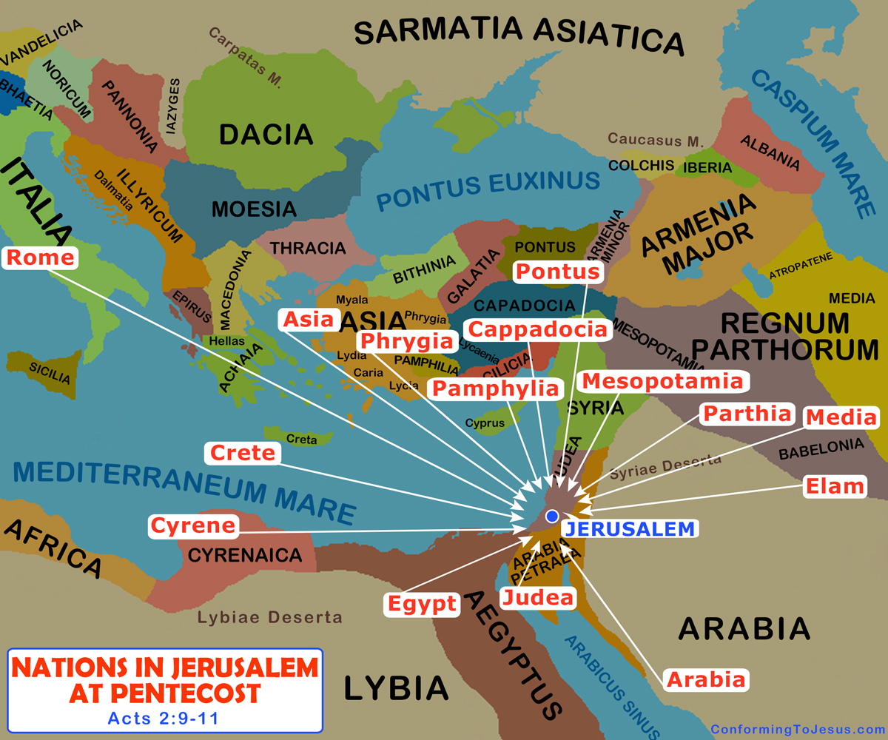

“So what? you might ask. Well, there were 15 different foreign language centers represented and 12 apostles. That means that an apostle or apostles were speaking in more than one foreign language to speak to the 15 different areas! Do you mean that a person can speak in more than one tongue? Yes indeed. That’s one reason why it’s called speaking in other tongues (other languages - plural). Most Christians who are filled with the spirit speak in one other language. Some can speak in multiple languages. Yes. How does that work? I don’t know. How can a person who is never exposed to a language speak it fluently, anyways?

A while back I posed that question to a man after a Bible fellowship. He was attending to see what his son was getting into. I asked what he did for work. He told me he did research on brain capacity and functions at a nearby university and taught there too. “Great!” I exclaimed. That night I made sure that there was a lot of speaking in tongues with interpretation at the fellowship. After the fellowship, I (the old psychology major) cornered the professor (respectfully of course) and asked how we can speak in languages we don’t know. We discussed the physiological possibilities. He said none made sense. We discussed the neurological possibilities. He said those also held no water. I asked about all the psychological theories I had heard of and he just shrugged. “Your explanation of the spirit inspiring the content makes as much, if not more sense than anything else I know,” he explained. So, if the professor, someone who studied brains daily for years in a lab with a big budget, couldn’t figure it out, yours truly is understandably at a loss too.

The out of towners at Pentecost had the same reaction as we do – “Wow! There’s something in them beyond the natural, energizing their ability to surpass the laws of education and reason. There’s something in them that’s supernatural. God Almighty is doing this!”

Hey, do you speak in tongues? If not, why not? Are you scared? I was at first then as I read the Bible, the fear began to vanish, and I wanted what the apostles had. What Jesus had promised. What made Peter and the apostles bold and free. What I saw other Christians have – quiet confidence. So, I got with folks who spoke in tongues and they led me into it. It has been one of the greatest blessings in my life. And not only my life, but God’s life too.

Benefits of Tongues to God

John 4:23,24

But the hour is coming, and now is here, when the true worshippers will worship the Father in spirit and truth, for the Father is seeking such people to be his worshippers.

God is spirit, and those who worship him must worship in spirit and truth.”

Ever try buying a gift for someone who has everything? It’s tough because they “have everything”. What about God? Talk about someone who “has everything”! Yet there’s one major thing he doesn’t have – your heart and mine. How many times can you think of the Bible saying God “seeks” something? Not many. Here’s one place Jesus says that God seeks people to worship Him in spirit and truth. Is that by singing or dancing? Lifting up holy hands or giving money? Going on missions or entering seminary? No. It’s by speaking in tongues because although the speaker doesn’t recognize what they are saying, they are “speaking in our tongues the mighty works of God.”

Acts 10:46a

For they heard them speaking in tongues and exalting God.

When Gentiles first got saved and spoke in tongues, the listeners reported that they “exalted God”.

1 Cor 14:2

For whoever speaks in a tongue does not speak to people, but to God, for no one understands, but by the spirit he speaks sacred secrets.

When we speak in tongues, God and the spirit speak sacred secrets together. Can we instantly understand the information? No, but I have found that sometimes later the spirit within can give me some insight. Nonetheless, God loves the conversation. It’s quality time for Him!

1 Cor. 14:15 - 17

What, then, is to be done? I will pray with the spirit, and I will pray with the understanding also. I will sing with the spirit, and I will sing with the understanding also.

Otherwise, if you praise with the spirit, how will anyone who is unlearned say “Amen!” at your giving of thanks, seeing he does not know what you are saying?

For indeed you are giving thanks very well,

When we speak in tongues, we praise God in the spirit and give thanks very well. This is what God seeks and deserves.

Romans 8: 14,15

For as many as are led by the spirit of God, these are sons of God.

For you did not receive a spirit of slavery to fall back into fear, but you received a spirit of adoption, in connection with which we cry out, “Abba” (Father, or Daddy).

When we speak in tongues we are crying out “Daddy, Daddy!” Do you see why God seeks to be worshipped by the spirit? With our imperfect minds, we love God but fall short in praise and recognition of His eternal works and magnificence. God’s gift helps us do what we and He want – praise God. This is what the out of towners heard on Pentecost – perfect praise from ordinary men, not priests, Levites, or other religious elites. Perfect praise from children to their Father.

Acts 2:12,13

And they were all amazed, and were perplexed, saying one to another, “What does this mean?”

But others mocking said, “They are filled with sweet new wine.”

These out of towners were sharp enough to realize that Galilean men praising God in languages that they couldn’t know was a sign by God of something significant – but what? Some ‘Negative Nancys’ accused the apostles of being drunk. As if alcohol can induce instant Rosetta Stone or Babbel foreign language learning results!

Acts 2:14-23

But Peter, standing up with the eleven, lifted up his voice and spoke to them, saying, “Fellow Jews, and all you who are residing in Jerusalem, let this be known to you, and pay close attention to my words.

For these are not drunk, as you suppose, seeing it is but the third hour of the day.

But this is that which has been spoken through the prophet Joel:

And it will be in the last days, says God, I will pour out a portion of my spirit upon all flesh, and your sons and your daughters will prophesy, and your young men will see visions, and your old men will dream dreams.

And even on my male servants and on my female servants I will pour out my spirit in those days, and they will prophesy.

And I will show wonders in the heavens above, and signs on the earth beneath: blood, and fire, and a cloud of smoke.

The sun will be turned into darkness, and the moon into blood, before the great and glorious Day of the Lord comes.

And it will be that whoever calls on the name of the Lord will be saved.

You men of Israel, hear these words: Jesus of Nazareth, a man pointed out to you by God by mighty works and wonders and signs, which God did through him in the midst of you, just as you yourselves know,

this man, delivered up by the decreed plan and foreknowledge of God, you, by lawless hands, crucified and killed.

Benefits to the Speaker

Peter and the other apostles were recently “behind closed doors for fear of the Jews”. They were mentioned on the front page of the Jerusalem Journal in the story of Judas’ suicide. They were being painted as “insurrectionists”, rebels against the establishment. They had good reason to be concerned about the threats. The same religious leaders governing the temple that day had just engineered Jesus’ execution 50 days before. The threats were not a bluff. Now Peter and the eleven are boldly accusing the multitude of Jesus' murder! Receiving the holy spirit transformed them and gave them cause to be bold and stand up for Christ. How? Here are some ways the spirit empowered them.

Acts 2:4

And they were all filled with holy spirit, and began to speak in other tongues, as the Spirit was giving them utterance.

Speaking in tongues is direct proof that God is alive, real, and working directly in your life - right now! Many people think of God as “the Creator” who created “way back when”. They think of Him as the original mover but silent now. Speaking in tongues is proof that God is working NOW. When we speak in tongues, it’s not as if we are saying “boop, boop, boop - Blah, blah, blah - cluck, oink, moo!” We are not making nonsense noise or animal sounds. We are making sounds of a language. What language?

1 Cor. 13:1

If I speak with the tongues of men and of angels but do not have love, I have become a sounding bronze, or a clanging cymbal.

When someone speaks in tongues, they are speaking in the languages of men or angels. The language of men includes all those since the ancient days. If it’s a current language, then someone or some group in the world could understand it. I had a friend who once told me that after a Christian fellowship a person who came to the fellowship for the first time came up to him and began speaking in an unknown language to him. He stopped the person who was speaking the foreign language, explaining that he didn’t understand what he was saying. The person speaking in a foreign language switched to English and blurted out, “Of course you understand Armenian! You were just speaking it!” It took the tongues speaker a few seconds to understand what was happening, but when he did, he was overjoyed. “I speak Armenian!” he announced to everyone as he bounced around.

It wasn’t long before he asked the question that everyone who speaks in a tongue and interprets wants to ask, “What did I say?” The native Armenian speaker looked at him askew and replied, “What do you mean? You said what you said in Armenian and then said the same thing in English!” The Armenian speaker was convinced that the tongues speaker was lying. “How can you speak Armenian so beautifully and say you don’t know it?” he demanded. How, indeed! “The Spirit was giving them utterance.” There is no other explanation. It’s proof in the senses-world of the internal reality of the holy spirit working in us. Proof that God not only “was”, but also “is” within us at work as we trust Him.

The world grinds us down today just like the apostles. Speaking in tongues helped them overcome.

1 Cor. 14:4

Whoever speaks in a tongue builds himself up,

The world system tears us down. Speaking in tongues builds us up. It infuses strength into us.

Jude 20

But you, beloved, building yourselves up on your most holy faith, praying in the holy spirit,

There’s nothing like knowing that God is at work in you - HERE and NOW. He is not the God of the past, or someday, but of NOW. He’s not the God in the temple, or at Jerusalem, or high above the stratosphere, but the God who is right HERE where we are. He is helping us HERE and NOW speak in a language of men or angels we don’t know.

Romans 8:15-16

For you did not receive a spirit of slavery to fall back into fear, but you received a spirit of adoption, in connection with which we cry out, “Abba” (Father).

The Spirit himself bears witness together with our spirit, that we are children of God,

When we speak in tongues and spiritually cry out “Daddy!”, it is the Spirit bearing witness with our spirit “that we are children of God”. So many people want proof of God’s existence and the truth of Christianity. The proof is right in front of us. We can speak in a language we don’t know! At will! Anytime we want! This is a witness, a first-person testimony to the truth of something. In a courtroom, witnesses are the highest form of proof. We carry the witness with us everywhere we go.

Proof of what? “That we are children of God”. Not some intellectual concept of association with God. Not some eastern mystical “all of the same substance with God” mumbo jumbo. Speaking in tongues is a witness that we are born again of God’s spirit - incorruptible seed. We are literally God’s children. How do we know? Because there’s something in us, bigger than us, stronger than us. It’s something that can help us speak in a foreign language, that we can also interpret, prophesy, get revelation, etc. etc. This is not conceptual. It is actual. It happens here and now when we speak in tongues. Does this build us up? Boy Howdy! We feel like we can take on the world because “greater is he who is in you than he who is in the world.” We are children of the living God!

Romans 8:17

and if children, then heirs, on the one hand, heirs of God, and on the other hand, co-heirs with Christ, since indeed we share in his sufferings, we will also share in his glory.

This verse could be meditated upon almost daily because of the abundance of truth and blessings it holds. “Heirs of God” “Joint hears with Christ” “Share in Christ’s glory”. It’s almost too good to be true… but it is absolutely true. Speaking in tongues helps solidify these truths in our hearts and practical lives. It builds our confidence as we experience the spirit’s witness.

Benefits to Others

Besides speaking in tongues benefiting God and the speaker, it can also benefit others, as it did on Pentecost.

1 Cor. 14:22

So then, tongues are for a sign, not to those who believe, but to the unbelieving,

When the out of towners saw and heard the apostles speak in tongues, there was no doubt in their minds that the supernatural was at work. They knew God was behind it, but what did it mean? Peter answered that question in his preaching.

1 Cor, 14:5

Now I want all of you to speak in tongues, but even more that you would prophesy, for greater is the one who prophesies than the one who speaks in tongues, unless he interpret, so that the church is built up.

When we speak in tongues out loud around other saints, God wants us to interpret it so that others can be built up. If we speak in tongues without interpretation, most probably the others present have no idea what is being said. The speaker is built up spiritually, but his understanding is unfruitful, as is the listener’s “unless he interprets so that the church (the others present) is built up (in their minds)”. The interpretation of tongues is bringing forth a message what was said in tongues that edifies, exhorts, and comforts the hearers. Because God controls the content of tongues, he can adjust it from praise to exhortation depending on the situation. Tongues with interpretation is a “two-fer”. It reminds us of God’s power and presence and comforts the hearers regarding God involvement in their current situation.

Acts 10:44-47

While Peter was still speaking these words, the holy spirit rushed onto all those who were listening to the word.

And the believers from the circumcision were amazed, all those who came with Peter, because on the Gentiles also the gift of the holy spirit was poured out.

For they heard them speaking in tongues and exalting God. Then answered Peter,

“Surely no one is able to refuse water and insist that these should not be baptized, these who have received the holy spirit just as we have?”

Speaking in tongues is proof to the speaker and the hearer of the truth that the speaker has been born again. Peter and the Jewish saints from Jerusalem had no love for Gentiles in Caesarea or anywhere else. As we shall see, God had to give Peter all kinds of guidance to get him to go visit them. Although respectful, when Peter preached, he never expected the reaction to his gospel message that he saw. They spoke in tongues! Dirty, uncircumcised, tattooed, Romans! It was unbelievable to Peter and the other Jews’ thinking. To them, it was almost like dogs talking!

What was the unquestionable proof that the Gentiles were born again? Was it baptism? Was it lifting holy hands or any kind of emotional outpouring? No, it was speaking in tongues. It is not “counterfeit-able”. I’ve seen people speaking strangely by an unholy spirit and it is as different from genuine speaking in tongues as day and night. Genuine tongues are characterized by the fruit of the spirit.

Gal. 5:22,23a

But the fruit of the spirit is love, joy, peace, patience, kindness, goodness, faithfulness,

meekness, self-control;

People speaking by unholy spirit are characterized by one word – weird. The only things in common are the words “people” and “talking”. Everything else is a contrast in good and evil, free will and oppression, light and darkness. Cornelius and the Gentiles spoke in tongues. There was no doubt to Peter and the Jews. The hardcore circumcision sect had to finally admit:

Acts 11:18b

“Then God has granted the repentance to everlasting life to the Gentiles also.”

Speaking in tongues helps our prayer life for ourselves and others.

Eph. 6:18

Be praying at all times in the spirit with all kinds of prayers and petitions. And to that end, be watchful with all perseverance and petitions for all the holy ones.

When we petition God for ourselves and others, God encourages us to pray in the spirit also. We picture God blessing us and others while the spirit within reaches out to God on our behalf.

So, do you speak in tongues? God wants you to.

1 Cor. 14:5a

Now I want all of you to speak in tongues.

If you haven’t spoken in tongues yet, please get with someone who does speak in tongues so that they can help you get in on the blessing. Don’t take “no” for an answer or give in to fear. Bless God, yourself, and others by speaking in tongues today! God won’t give you a stone! He’s a faithful, loving Father.

Reasons for, and Benefits of Speaking in Tongues

Toward God

1. To worship God via the spirit – John 4:24.
2. To speak the mighty works of God – Acts 2:11.
3. To exalt God – Acts 10:46.
4. To share sacred secrets – 1 Cor. 14:2.
5. Giving thanks well – 1 Cor. 14:17.
6. Crying out, “Daddy! Daddy!” – Romans 8:15.

Toward Yourself

1. Proof God is at work in us now – Acts 2:4.
2. Speak in languages of men and angels - 1 Cor. 13:1.
3. Edifies us – 1 Cor. 14:5.
4. Builds us up – Jude 20.
5. The spirit bears witness with our spirit – Romans 8:16.
6. Proof that we are children of God, heirs of God, joint heirs with Christ and will share his glory – Rom. 8:17.
7. Praying in the spirit. 1 Cor. 14:15

Toward Others

1. Sign to unbelievers – 1 Cor. 14:22.
2. Interpretation of prayer or praise to God for the hearers – 1 Cor. 14:5.
3. A witness to others of the new birth – Acts 10:44.
4. Praying in the spirit for yourself and others – Eph. 6:18.