17 - More on Healing and Miracles

Let me point out one more important thing when Jesus healed the demonized boy who exhibited ‘special effects” with the blame shifting father.

Mark 9:25,26

And when Jesus saw that a crowd was quickly gathering around him, he subdued the unclean spirit, saying to it, “You mute and deaf spirit, I command you, come out of him and never enter into him again.”

And after crying out and throwing him into a violent convulsion, he came out. And the boy appeared as if he were dead, so that most of them said, “He is dead.”

Even as the spirit left, the special effects kept coming. “Crying out”, “violent convulsions” and a “death-like” demeanor followed the command to leave. Some spectators said, “Nice job, Jesus - you killed him!” Wait, I thought that Jesus commanded the evil spirit to go. Why did the spirit do more special effects? Because these spirits have free will. They have to obey when commanded by Jesus (or by us in his name) but they don’t have to like it. Ever throw a dog or wild animal out of your yard that doesn’t belong there? Sometimes they growl at you on the way out. So what? The point is, they go! This spirit was on his way out of his longtime home and wanted to vandalize it on the way out. Like bad renters, they’re not concerned about getting their “deposit back”! This is a fight. They hate the kid, the father, the disciples, Jesus, you and me. They are evil. This is who they are and what they do. They’ve had thousands of years to perfect their “special effects” to fool humans. Thankfully, Jesus was demonstrating what humans with holy spirit could also do!

Mark 9:27-29

But Jesus, taking him by the hand, lifted him up and he stood up.

And when he had come into the house, his disciples asked him privately, “Why were we not able to cast it out?”

And he said to them, “This kind of spirit cannot come out by anything except prayer.”

There are some older Bible versions that say, “prayer and fasting”, but modern research has shown that the words “and fasting” were added to the text. That’s why most modern versions omit them. The saying, “This kind of spirit cannot come out by anything except prayer” is not talking about ‘praying the spirit away’. Jesus never did that. He commanded the spirit out. He didn’t ask God to get rid of it, he just commanded and evicted the spirit. Jesus mentioned prayer to reinforce the need of those of us who want to minister effectively to be deep into prayer. We must be clear and solid in our relationship with God. We must be comfortable with shutting out the world and focusing on God. “This kind of spirit” was an expert distractor. It knew how to get human’s minds off God and rocked into doubt by circumstances. Jesus knew how to pray and stay his mind on God, ignoring distractions. The disciples who were unable to discover the short circuit in the child’s deliverance (the dad’s doubt) were distracted by the religious leaders’ pressure, the crowd’s frenzy and the spirit’s dramatic “special effects”. In the Christian life, the basics – prayer, fellowship, giving, Bible reading, etc. – are both our life’s practical foundation and the key to our advanced performance of our abilities in Christ.

For many situations we must be able to “lock in” with God. Jesus taught this earlier.

Matt. 6:5,6

“And when you pray, do not be like the hypocrites, because they like to pray while standing in the synagogues and on the corners of the streets in order to be seen by people. Truly I say to you, they have received their reward.

But when you pray, go into your inner room, and after closing your door, pray to your Father who is in secret, and your Father who sees what is done in secret will repay you.

Open, or public prayer is great. It’s useful to lead group prayer or set a tone. What God wants is private prayer – just each of us and Him. Avoid distractions and focus on our relationship – talking, listening, obeying, repenting, rejoicing, etc. Just like ‘quality time’ with my wife – lose the phone and turn off the TV. With God, it’s lose the ego and turn off all the distractions – schedules, responsibilities, commitments, etc. It’s this bonding time that is the foundation of our spiritual life. The more we have the deeper ability to focus on God, the better it is to focus on spiritual matters in the battle of life when the ‘bullets are flying’. The manifestation of trust takes us from revelation to realization… if we keep focus.

The Working of Miracles

The manifestation of working of miracles is defined in the Gift of Holy Spirit book as “You exercising your God given ability to do miracles by the power of God, according to what God or the Lord Jesus Christ has revealed to you by a message of knowledge or a message of wisdom.” Here’s some more insight from the book: “The manifestation of gifts of healings and working of miracles are often interwoven. There are certainly miracles that are not healings, such as when Moses parted the sea so that the Israelites could escape Egypt. Also, there are healings that are not miracles, when, by the healing power of God, the healing is not instantaneous. However, there are many miracles of healing in the Bible, such as the instantaneous healing of Bartimaeus, who was blind (Mark 10:46-52). Also, casting out a demon can be a miracle (Mark 9:39).” Let’s look at Jesus and Peter.

Matt. 14:23-29a

And after he [Jesus] had sent the crowd away, he went up by himself onto the mountain to pray, and when evening had come, he was there alone.

But the boat was already a long way from the land and was being beaten by the waves because the wind was against them.

And in the fourth watch of the night he came to them, walking on the lake.

And when the disciples saw him walking on the lake, they were terrified, saying, “It’s a ghost!” And they cried out in fear.

But immediately Jesus spoke to them, saying, “Take courage! It is I. Do not be afraid!”

And Peter answered him and said, “Lord, if it is you, command me to come to you on the water.”

And he [Jesus] said, “Come.”

Here’s the revelation (technically, it was a message of wisdom), “Come”. Now, what must Peter do? He must get out of the boat and ‘walk out’ on that revelation. To do that he’ll need help from God with the manifestation of trust. Peter uses his mind to respond to Jesus’ revelation to “come”. Then God adds energizing to Peter’s trust, and he does the miraculously impossible – he walks on water.

Matt. 14:29

And he said, “Come.” And Peter climbed out of the boat and walked on the water and came toward Jesus.

What manifestations of the spirit do we see in operation here? Message of wisdom, trust and miracles. But what happens if Peter loses focus on the revelation and begins to doubt and becomes afraid?

Matt. 14:30

But when he saw the strong wind he was afraid, and beginning to sink, he cried out, saying, “Lord, save me.”

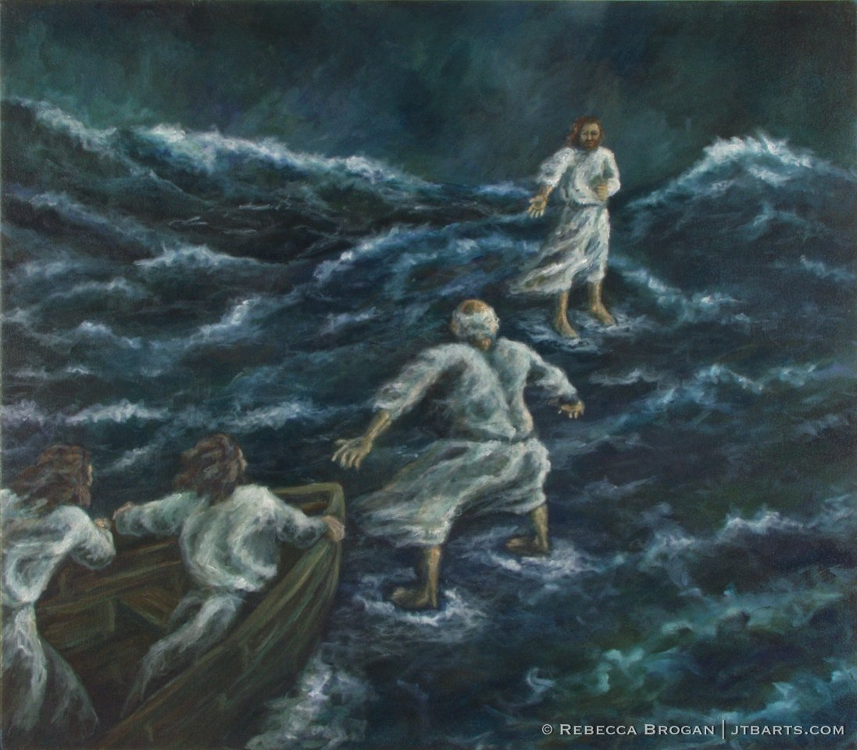

Peter was no wussy. Look at the picture above and tell me if you would be shaken by the conditions. I’d hate to be in a storm aboard a boat much less on the water itself. With these waves, walking on water meant walking uphill and downhill on the waves! At first, when he was looking at and walking toward Jesus – trust and miracles locked in. But soon he was walking up and down on the steep waves, he lost sight of Jesus, while the gusting wind tore at his exposed skin. His mind strayed to his past experiences on that same lake (he fished the Sea of Galilee all his life). He began to doubt the revelation and outcome in comparison to his experiences. Then the manifestation of trust evaporated, causing the miracle to vanish. Glub, glub! Did Jesus get angry and hit him with a flounder? No.

Matt. 14:31-32

And immediately Jesus stretched out his hand and took hold of him, and said to him, “O you of little trust, why did you doubt?”

And when they got up into the boat, the wind ceased.

Jesus stayed his mind on God despite the circumstances. Peter started out that way too but doubted midway through his water walk, short circuiting God’s power. Jesus grabbed and helped him as he was going down. He pointed out the short circuit – doubt and not enough trust in Peter’s heart. Keep in mind that walking on water is not some “Believing equals receiving” mind exercise. No amount of mental power overcomes gravity. Only superior physical or spiritual power can. There was no buoyancy, mechanical, or aerodynamic power in evidence so it had to be spiritual power sustaining Peter’s water walk. That comes from revelation, trust and miracles, not from the human mind or “the universe”. When Peter doubted, that ended the trust and that turned off the miracle power.

Let me point out something interesting in the text, “when they [Jesus and Peter] got up into the boat”. In the Greek, the word “got up” is plural and in the active voice. That means “they” (plural) actively and intentionally, got up to the boat and got in. “They” did. It doesn’t say, “Jesus dragged Peter through the water to the boat and Jesus pulled him into the boat.” It says, “they got up into the boat”. Perhaps Peter started out great, got distracted, then got saved by Jesus and was further instructed on the manifestations, reset the journey, and then “they got up into the boat”. We don’t know for sure what happened, but Jesus was not in the business of teaching failure. He taught victory. He didn’t teach perfection, but he did teach persistence.

Prov. 24:16

For a righteous person will fall seven times, and he stands back up, but the wicked stumble in times of distress.

This is how we learn to physically walk and talk. We try, we fail, we do it again a little better next time. This is also how we learn to spiritually walk and talk. We persist. Jesus will grab us like he did with Peter, before we join Luca Brasi and “sleep with the fishes”! He loves us!

Like gifts of healings, the key to miracles is getting revelation and believing it all the way to the end. With Peter walking on water, the time he had to trust was seconds at first, then seconds again when he was rescued and reset. Sometime the duration is seconds, minutes, hours, days or decades. We usually don’t decide what miracles we want to see, unless, like Peter we request a certain miracle and God says, “OK”. We can request all we want, but it all begins when God or Jesus say, “Come”. Revelation is the beginning. Trust is the middle. Miracles and healing are the end.

Another point to keep in mind. Humans don’t overcome physical laws unless we use superior physical power or spiritual power. Engineers use superior physical power to overcome gravity in bridges, airplanes, and rocket propulsion. Miracles are not secret techniques to manipulate perceptions of physical reality. The Israelites really went through the sea on the way to the promised land. King Hezekiah really built a tunnel under Jerusalem in 700 BC. I walked through it. Jesus really was raised from the dead. I know because I speak in a language I never learned. Magicians and illusionists are skilled at presenting the perception of physical laws being superseded, but they hide the rabbit before it comes out of the hat. Miracles are not just perceptions that physical laws are being overruled, because physical laws are actually being overruled. Miracles make sense – only if you know the revelation. They are mind blowing whether you know the revelation or not, but for the unbelievers, they are just a noticeable novelty. For believers or for those spiritually hungry, they are signs that God is real and involved in life. Some call miracles “God’s advertising”. They are like God throwing a rock in a calm pond. Miracles cause ripples - sometimes spiritual waves. Jesus’ resurrection continues to rock the world!

REASON, IMAGINATION AND REVELATION by Kevin Porter of Lightbearers Ministry

Jesus said to him, "If you can believe, all things are possible to him who believes." Mark 9:23 NKJV

As a child I played, and one day I was a pirate, one day a king, one day I was Willie Mays jacking home runs out of Candlestick Park. As my imagination sparked the spirit of adventure, I was more than a conqueror, and nothing was impossible. As we renew our minds our natural faculties begin to demonstrate their unique redemptive purposes that enable us to be a more complete son or daughter of God, with more wholeness in every category of our lives. We want to look at imagination, reason and memory to see how they work with faith, love and revelation.

And do not be conformed to this world, but be transformed by the renewing of your mind, that you may prove what is that good and acceptable and perfect will of God. Rom 12:2 NKJV

I sat in the doorway of our first school in Ndele, Central African Republic, and I watched as young girls with tears in their eyes carried five-gallon jerricans on their heads filled with water from the village well. I thought about the water that flows so easily from my tap at home. I said, “Lord, how long until these people live the way I live?” He said, “How long does it take for My Spirit to move, to accomplish anything? I’m waiting for them!” Just a few days ago I was in a conference where the preacher was calling our prophecies and speaking RHEMA words, and people were getting healed. I think people were astonished, but I wasn’t. I was thankful, but I wasn’t astonished. I’ve been teaching this truth for thirty years and practicing it for longer. God is waiting for us to believe!

But Jesus looked at them and said to them, "With men this is impossible, but with God all things are possible." Matt 19:26 NKJV

The human brain is such a marvel, such a wonder, that it silently testifies to the greatness of a Creator like almost nothing else in all creation. Weighing less than two kilos, it has computing power greater than all the super computers in existence. It is alive, growing, changing and adapting all of the time. If its physically damaged the brain can rewire itself around the damaged areas to begin to function again. Imagination develops neural pathways that allow the physical brain to process revelation. As a man thinks in his heart, so is he.

One of the great reasons we don’t get revelation in certain areas of our lives is because we have never allowed imagination to prepare the way for revelation. If you think something is impossible, you’ll never receive revelation about it. If you can imagine yourself doing something, like that preacher giving RHEMA words and healing people, or turning on a tap and having water come out of it, then God can give you revelation about that and your mind and heart can receive it. If you want a new car, go sit in one and imagine yourself driving and owning it. If you want to get married, imagine your wedding day. If you want to bear children, buy baby clothes, put them in bags and sleep with your ‘babies.’ If you want to be a king, a president, a pirate, or jack home runs, imagine yourself there. Revelation faith runs down the neural pathways that imagination plows and builds!

Reason is a good servant. In northern Kentucky there is a structure that is a full-scale adaptation of the biblical record of Noah’s Ark. It’s really cool! The designers of it did a good job engineering a boat that met all the biblical specifics and handled the problems that would be involved if eight people and all the animals were on it for months at a time. How would you supply ventilation, using three-thousand-year-old technology to keep everyone alive in an enclosed space? What about food? Human and animal waste? They worked it all out. Personally, I think the animals went into hibernation in the dark space and needed neither food, nor water and had very little waste. Hibernation is amazing! There is a bird in the Arctic that freezes solid every year and comes back to life in the spring thaw. Believe it or not!

But the Helper, the Holy Spirit, whom the Father will send in My name, He will teach you all things, and bring to your remembrance all things that I said to you. John 14:26 NKJV

Revelation can pull all the disparate pieces of your reason together and we call it inspiration. This is the truth behind all the great breakthroughs of mankind. You may say, But these guys were unbelievers! HELLO! Who makes you and I so superior? Does God work with unbelievers? (don’t even answer that!) The problem comes when we don’t glorify God who in grace and mercy works with every man. Reason, intellect, ‘smarts’ if you will, anointed with the oil of revelation can produce what we call the genius anointing, solving any problem and bringing Heaven to earth (Mt.6:10). Hallelujah!

…because what may be known of God is manifest in them, ***for God has shown it to them***. 20 For since the creation of the world His invisible attributes are clearly seen, being understood by the things that are made, even His eternal power and Godhead, so that they are without excuse, 21 ***because, although they knew God, they did not glorify Him as God, nor were thankful,*** Rom 1:19-21 NKJV

I’m told that our brains record everything, every sensation, even from when we were in the womb of our mothers, but the challenge comes in the recall of those thoughts. The brain acts like a physical muscle in that the more exercise it properly receives the more it can function well, and in the case of memory, recall more easily. Holy Spirit works with our memories to bring up the right word at the right time to release faith and do the works of God. Right works come from right words, and HS can bring up those right words from scripture and even from what you or others have spoken. One time, a dear friend died. When I heard about it, HS immediately brought up a conversation he and I had had thirty years previously where we promised to take care of the other’s families if something happened to us. I had no thought about it in thirty years, but there it was. I took care the brother’s spouse until she passed as well!

Therefore You delivered them into the hand of their enemies, who oppressed them; and in the time of their trouble, when they cried to You, You heard from heaven; And according to Your abundant mercies You gave them deliverers who saved them from the hand of their enemies. Neh 9:27 NKJV

How do you redeem bad memories? The mercy of God has been on us every day since before we were born. The evidence that we are still alive testifies to the fact of His daily mercy. Just yesterday I avoided a car accident through no fault of my own that would have destroyed my car with me in it. Mercy! The key to redeeming bad memories – and I know people have gone through awful things – is to ask the Lord to reveal what He was doing during those bad incidents. Yes, you got hurt, but you didn’t die. Yes perhaps someone else died, but God was being merciful to the greatest possible extent that people allowed Him. Ask Him to show you what He was doing. Be quiet, close your eyes, watch and listen, and realize the mercy of God in your time of greatest need. Bad memories will lose their sting and get healed as you rejoice in His mercy…

Now Jesus loved Martha and her sister and Lazarus. John 11:5-6 NKJV

Love empowers your imagination, reason and memory. This is why we are called to lives of constant service to God and others regardless of our age. Service gives us purpose and draws focus to our love. People get old only when they stop dreaming. Our youth is renewed like the eagles in imagination, love, joy and faith. Do happy mental exercises when you drive down the road! When you see old, broken-down buildings, imagine them to be rebuilt, beautiful, clean and prosperous. Look at the tired, sad unbelieving crowds and imagine potential saints full of life, joy and victory. Imagine people that hate you becoming people that respect, love and value you. Love sees the end even before the first step in the journey…

Let the word of Christ dwell in you richly… Col 3:16 NKJV

Our redeemed natural faculties are given to us to help us walk by the Spirit. We must use them faithfully and fervently for His glory and the blessing of everyone. There is so much joy as we walk with the Lord with our minds and hearts renewed to His truth, and invested in faith, love and revelation! Love you!

The nine dots challenge. Connect the nine dots with only four lines with the pen never leaving the page.



The answer:



This exercise reveals our mental bias to “stay within the dots – the normal”. The point is, we must think “outside the nine dots” to solve the problem. To have miracles – experiences outside the normal – we must be able to think outside ‘normal’ to get ‘extra normal’ revelation which leads to ‘extra normal’ results, in other words, miracles.

We must be mentally flexible, imaginative, ‘crazy’, intuitive, have a ‘wild mind’, etc., to get “walk on water” revelation, so that we can trust it and actually walk on water.