Pentecost #4-1

Acts 2:1-4 REV (Revised English Version – used throughout unless otherwise noted)

And when the day of Pentecost arrived, they were all together in one place.

And suddenly a sound came from heaven like a strong rushing wind, and it filled the whole house where they were sitting.

And there appeared to them tongues as if of fire, which spreading out, came to rest upon each one of them.

And they were all filled with holy spirit, and began to speak in other tongues, as the Spirit was giving them utterance.

Only four verses describe one of the greatest events in history. Since the garden, God had planned for “the seed of the woman” to crush Satan’s head after Satan had crushed his heel. This “heel attack” occurred outside Jerusalem on Calvary about two months before, when Jesus was beaten, tortured, and killed at the same time as the Passover lamb was. Three days later he was raised by God from the dead and appeared to his disciples for 40 days before he ascended out of this world. Then God was able to bestow the first fruits of what Christ achieved 10 days later on the annual Jewish feast, Pentecost. Let’s discuss who, what, where, when, why, and how of that day.

Where

The traditional teaching of Pentecost is that 120 disciples were in the upper room and spoke in tongues that multitudes from across the world could understand. Then Peter preached and about 3000 souls were saved, giving birth to the Christian church. This summation is part right and part wrong. Let’s clarify each aspect beginning with where Pentecost occurred. The traditional idea of 120 people in an upper room germinated from Acts 1 after the ascension.

Acts 1:12-14

Then they returned to Jerusalem from the mount called Olivet, which is near Jerusalem (a Sabbath day’s journey away).

And when they had entered Jerusalem, they went up into the room upstairs, where they were staying; that is, Peter and John and James and Andrew, Philip and Thomas, Bartholomew and Matthew, James the son of Alphaeus, and Simon the Zealot, and Judas the son of James.

These all with one accord continued steadfastly in prayer, with the women, and Mary the mother of Jesus, and with his brothers.

It says that the 11 apostles were staying in a room upstairs (or upper room) in Jerusalem. Then verse 14 mentions that they were steadfastly praying with the faithful women including Mary and Jesus’ brothers. Notice it doesn’t say where the women and family were praying. Then it expands the focus.

Acts 1:15

And in those days Peter stood up in the midst of the brothers and said (and there was a multitude of names, about 120 people together at that one place),

During the days between the ascension and Pentecost, Peter addresses the tragedy of Judas and the steps forward for the ministry. It notes that there were “about 120 people at that one place” without specifically naming the place. We have some indication from the context where that place was.

Acts 1:4

And being assembled together with them, he commanded them not to depart from Jerusalem but to wait for the promise of the Father, which, he said, “you heard about from me,

The place must be in Jerusalem, where the apostles carried out Jesus’ command. They were all from Galilee and some had family businesses still there, so to stay in Jerusalem was an effort on their part. They would need a hotel room - as we would call it. The room upstairs (or upper room) fits that need. But were they just sitting in the room all day and night? Luke’s gospel sheds light on the answer.

Luke 24:50-53

And he led them out until they were opposite Bethany, and he lifted up his hands and blessed them.

And it came to pass, while he blessed them, he was separated from them and was carried up into heaven.

And they, after paying homage to him, returned to Jerusalem with great joy,

and were continually in the temple, blessing God.

Perhaps they slept and brushed their teeth at the “upper room”, but the apostles spent much of their time “continually in the temple, blessing God.” This explains how the apostles could have been praying with the believing women. It certainly was not in the upper room where the apostles (all men so far) were staying. It was not proper for men and women in Jewish culture to reside together unless they were married or family. But could they pray together in the temple? Sure. That location makes the most sense in other aspects too.

Can about 120 people fit into an “upper room”? Perhaps to consider that some would think of an upper room in a current hotel, but conditions were far different in first-century Jerusalem. Here are some pictures of old Jerusalem’s streets so we can start to get a feel for “the upper room”.

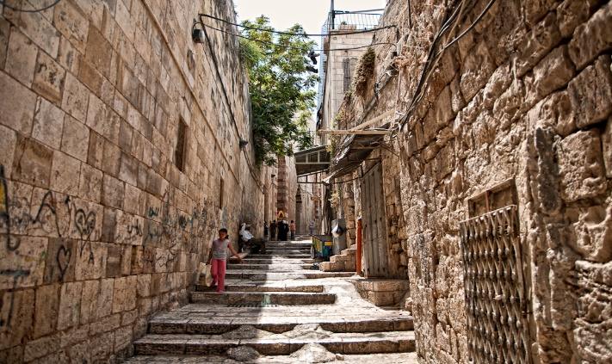 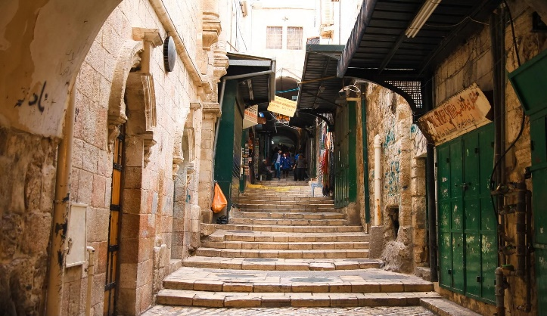

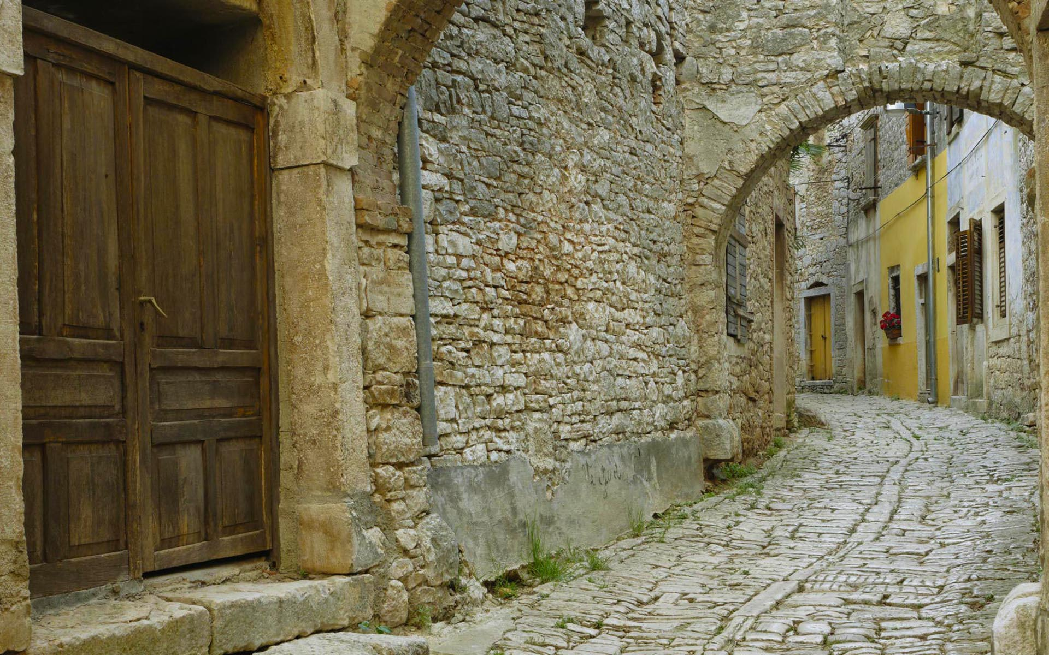

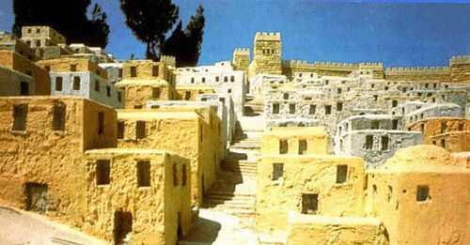

Here is a model showing how archeologists think ancient Jerusalem looked near the temple. Do you think 11 men could sleep overnight there? Sure, when you consider that there were no “one king-size bed” or “two double-bed” options. Put your first-century glasses on. There were no beds, like today. They slept on bedrolls – a sort of primitive sleeping bag – on the floor. Assuming 11 apostles at first, then 12 after Matthias’ selection, you can figure a minimum 12ft x 18ft room for the sleeping 12. This corresponds to a large upper room in the photo above. 

Now, could 30 people fit in it? Maybe standing straight up, shoulder to shoulder. How about 4 times that – 120 disciples? No chance, short pants! The 120 disciples could not have been in the upper room for Pentecost (or any other time). Then, where were they? There are some clues in the record that guide us to a logical conclusion.

Acts 1:5-7

Now there were Jews staying in Jerusalem, deeply religious men from every nation under heaven.

And when this sound occurred, the multitude came together, and were bewildered, because each one was hearing them speaking in his own language.

And they were all amazed, and marveled, saying, “Look! Are not all these who are speaking Galileans?

The location where Pentecost occurred must have been conducive for the out-of-town visitors to hear them speaking in tongues and recognize that the speakers were all Galileans. Certainly, the upper room is not a candidate for either condition, but the temple fits both perfectly. Could the Temple fit the 120 disciples? Easily. Would the sound of the rushing wind and speaking in tongues carry to others nearby? Yes. And could others see by their clothing their area of origin? Yes. The apostles were not behind closed doors for fear of the Jews but in the open temple area, during the hours of prayer.

Acts 1:41

Then those who received his word were baptized, and in that day there were added to their number about 3,000 souls.

How could about 3000 souls be added to the church that day if Peter preached in the upper room? How about even if he preached in a courtyard outside the house (see picture above)? No, the only place that makes sense logistically is the temple.

Could the word “house” in Acts 2 be used figuratively as “the House of the Lord” or “God’s house” as other places in scripture? It seems more likely that that is the case than the apostles were in an upstairs large motel room and crowds heard then speak in tongues and about 3000 people were somehow saved.

Where would God introduce the great gift of the Spirit that Christ made available through his death and resurrection? In a residential house? In a hotel meeting room? Or in “His house”?

1 Kings 9:3

Yahweh said to him, “I have heard your prayer and your supplication that you have made before me. I have made this house holy that you have built, to put my name there forever; and my eyes and my heart will be there perpetually.

It is interesting to note that the mercy seat – the focus of the entire temple – inside the Holy of Holies, which was inside of the Holy Place, which was in the heart of the Temple itself - had a special function.

Ex. 25:21,22a

You are to put the mercy seat on top of the ark, and in the ark you will put the testimony that I will give you.

There I will meet with you…

In the Old Testament, God could have chosen to focus his presence and communicate on a mountain top in Nepal, but He didn’t. He could have chosen to inhabit an awesome cedar in Lebanon, but He didn’t. He could have chosen to animate a magnificent waterfall, but he didn’t. He chose to inhabit the Holy of Holies in the tent, and later the temple of His chosen people, Israel. He called it “My house”. And where logically would God choose “there will I meet you” at the dawn of a new age of Grace, but “His house”, the temple in Jerusalem? Pentecost makes sense when you look at it from a God-centered perspective. He’s finally getting family beside Jesus! The redemptive plan of Gen. 3:15 is finally bearing fruit.

When

Under the law there were three times a year that all males needed to present themselves before the Lord in Jerusalem.

Ex. 23:14-17

You are to observe a feast to me three times a year.

You are to observe the Feast of Unleavened Bread. Seven days you are to eat unleavened bread, as I commanded you, at the time appointed in the month Abib (for in it you came out from Egypt). And no one is to appear before me empty-handed.

And the Feast of Harvest, the firstfruits of your labor, of what you sow in the field. And the Feast of Harvest at the end of the year, when you gather in your labors out of the field.

Three times in the year all your males are to appear before the Lord Yahweh.

The feast of Unleavened bread, or Passover, was a weeklong remembrance in the spring. The last festival called Sukkot (Tabernacles, Tents, or Booths) was also a weeklong festival in the fall. The middle festival was called Shavuot (Weeks, Pentecost or First fruits). It was a one-day festival at the beginning of summer, fifty days after Passover. The law mandated all males to “appear before the Lord Yahweh”. Where do you think that happened? At the temple of course. This explains…

Acts 1:5

Now there were Jews staying in Jerusalem, deeply religious men from every nation under heaven.

All Jews needed to be there for the one-day feast of Pentecost. Where do you think they were? The temple. Where do you think the apostles and disciples were? Everyone was at the temple.

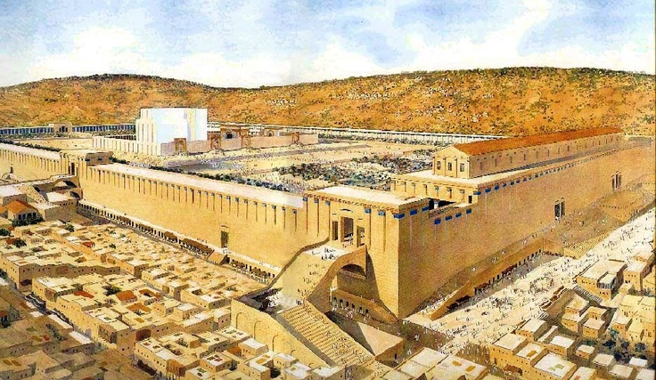

What God was about to do was not going to be done in a dark corner. It would be done with all Israel invited and present where God said He would meet His people. On the Feast of Fruit fruits, God made it available to be born of His spirit and become a new creation in Christ. Pentecost was right where and when it should have been – in front of all His chosen people with all invited. What a day!