Stick or Carrot?

1 Cor. 4:1

People should regard us in this manner: as of ministers of Christ, and stewards of the sacred secrets of God.

In ancient times rulers and wealthy families had stewards to oversee their operations. This is what Eliezer did for Abraham in Gen. 15:2 and Joseph did for Pharoah in Gen 45:8. They were the “under ruler” for the owner or ruler, much like a general manager or a ranch foreman. They did most of the work and took most of the blame, while the owner got most of the credit and profit! Some of you have had that job and can concur. The steward was not just an ordinary employee, but the chief employee, empowered by the owner to make consequential decisions on their behalf. The ancient steward was usually a slave (like Joseph) or a freed man who was fiercely loyal to his master and was trusted to buy and sell, hire and fire in the owner’s interest. They served at the pleasure of the owner and could be replaced if their stewardship was found lacking, as is described in Luke 16.

Once again Paul paints a familiar picture of worldly stewards describing his and Apollos’, spiritual positions. They were like officers of Christ and stewards of God’s sacred secrets. That means they were endued with authority to act in the boss’s (Christ’s) behalf. Paul, Apollos and Peter weren’t the big authority, Christ was. And their job was to be fiercely loyal to him and make decisions as he would have. The key factor in a steward or officer is not ability, enthusiasm, or persuasion, but fidelity to the boss’s desires. Paul’s job was to teach, encourage, and enforce the “sacred secrets of God”. This is how Christ wanted his people to think and live. Paul’s job was to bring Jesus’ vision to life.

1 Cor. 4:2,3

Moreover, it is required of stewards that they be found faithful.

But with me, it is a very small thing that I should be judged by you, or by man’s day of judgment. In fact, I do not even judge myself.

1 Cor. 2:13 spoke of judgment for rewards in “the Day”, referring to “the Lord’s Day” of judgment, when Christ does the judging. Today is not that day, obviously. It’s the “Day of Man’s Judgement”. Watch the news. Perhaps it should be called “the day of bad judgement”! That’s what you call an election of someone with dementia to the US presidency – bad judgement! Oh well. The Bible calls the day we live in “the day (or, the time) of man’s judgment”, and it sure is. Living today is as crazy as Costco on the Saturday before Christmas! Global warming, forced vaccinations, closing schools for a year or two, governments running huge deficits in non-emergent times, forcing children into surgical mutilation… I could go on, but you need no reminders – you’re living in it too!

This is the time of “man’s judgement”, when human’s make the rules. Perhaps you’ve heard people say that “truth is relative”. Well, it is today. Get enough people to think that killing babies in the womb is OK with laws protecting infanticide and evil is relative. It may be evil and wrong, but it becomes legal when government condoned. Soon this kind of insanity will cease forever when the time of man’s judgment ends. Until then, we must function within the shifting sands of madness. One day we are declared a hero, the next day we’re a menace. Jesus was judged by people that way and so was Paul. When Paul first preached the gospel to the Corinthians and manifested the spirit, they probably thought he had the status of a divine angel. Later he was dragged before the civil authority as a menace. After he left and Apollos preached, some of them said, “Paul Who?” Ah yes! How quickly those listening to WIIFM (What’s In It For Me) can switch to their next favorite station, WHYD-FM (What Have You Done For Me Lately?) Paul went from hero to zero in many eyes. Paul didn’t pay much attention to that opinion. If fact he didn’t even care about his own opinion. Why?

1 Cor. 4:4,5

For I am not aware of anything against myself—but I am not declared righteous by that. The one who judges me is the Lord.

So then, do not pass judgments before the proper time, until the Lord comes, who will both bring to light the hidden things of darkness, and reveal the motives of people’s hearts, and then each one will have his praise from God.

When you’re a steward, the only opinion that matters is the boss’s. If your underlings don’t like you, it doesn’t matter… as long as the boss does! What he thinks and wants carried out is always the primary concern.

Now look at the transition from “the day of man’s judgement” to “the day of the lord’s judgement”. When he comes, he will shine the light and “reveal the hidden things of darkness and reveal the motives of people’s heats”. What may seem like an evil majority opinion now will be overturned by a godly minority opinion of one, Christ Jesus. On the day of the Lord there be no place for dark things or evil motives to hide. They will be burned away (by “fire”, remember?) and extinguished. What’s left? Only the good and the corresponding praise from God for it.

There are some doctrines that teach that when a Christian dies, they are not ready for heaven yet because they must pay for their sins first. This intermediate stage between earthly life and heaven is called “purgatory”, perhaps from the word “purge” in that we should “purge” ourselves from sin before we can enter perfection. Firstly, purgatory, the word or the concept, is not in the Bible. There is no mention of Christ dropping some or all of us off at an intermediate location around Jupitar where we pay for our sins before we can go on the second part of our heavenly journey. This doctrine probably comes from Uranus. Did that offend you? OK, then Satan’s. Sorry. The Bible tells a different story.

“Until the Lord comes… and then each one will have his praise from God.” If the bad we did is “burned up” in the Lord’s judgement as we learned in the pervious chapter (not in purgatory) then what is left? Only the good we have done. What happens then? “Each one will have his praise from God.” How many of us will have praise from God? “Each one”. This idea that God wants to grill us over the stupid and evil things we thought or did in this life is wrong and should itself be purged. The Bible teaches no such thing. Did Christ take away the sins of the world or not? If some sins were taken away and we have to pay for the ones that were not, then purgatory makes some sense. Then perhaps we will stand before the Lord while he berates us for our failures. But if…

1 John 2:2

And he is the atoning sacrifice for our sins, and not for ours only, but also for the whole world.

If his life and sacrifice was more valuable than the debt our sins incurred, then the words of John the Baptist ring so true…

John 1:29

On the next day he saw Jesus coming to him, and said, “Look! The Lamb of God who takes away the sin of the world!

All gone! Sins taken away! How many are left from which we must atone? NONE! Jesus’ value to God far surpassed our debt and paid in full for not only our sins but for that of the world. Anyone and everyone can be saved. What amazing grace!

The idea of purgatory is a slap in Christ’s face. It means he wasn’t enough and didn’t do enough through his sacrifice. That idea will be burned up for sure! What’s left? God will praise each of us for our right motives and deeds in this life. So, how much praise does each person get? Remember this…?

1 Cor. 3:8b

each will receive his own reward according to his own labor.

Some will get a little praise for their little good works and some will need help to back up the semi-trucks and load up all the praise reflected by their good works. The point is – there will be no “depression session” at the Lord’s Day for us, only praise. How much praise and rewards each person gets depends on them. How much do you want?

1 Cor. 4:6,7

Now these things, brothers and sisters, I have figuratively applied to myself and Apollos for your sakes, so that you learn from us not to go beyond the things that are written, so that none of you get puffed up in favor of one person over against another.

For who makes you to differ? And what do you have that you did not receive as a gift? But if you received it, why do you boast as if you had not received it?

What a question… “What do you have that you did not receive as a gift?” In America we have the myth of “a Self-made Man”. Is that real or possible? How can it be when we are …

Living on a planet in a universe we didn’t create…

Surrounded by heavenly objects light years away that we didn’t arrange…

Breathing air we never produced…

Living in a body that was a gift from God (and our parents)…

Speaking a language we never invented and was taught by others…

Drinking water we never sourced… Eating food we never planted, grew, or harvested …

Wearing clothes we never designed or made…

Living in a house we never built…

Driving a car made of materials we never mined, machined or manufactured …

Listening to music we never composed, recorded, or performed…

Watching programs we didn’t create, produce or perform… on a TV that we didn’t build…

Using electricity we didn’t generate…

Molded by our family, neighborhood, and environment…

Spending much time in an existing profession we joined…

Thinking thoughts and speaking ideas informed by the schools and media…

Led by our government… Propelled into the future by societal and cultural expectations…

We are anything but self-made! The next question: “If you received it, why do you boast as if you had not?” The answer is: “Because we are stupid and acting like stupid heads!”

1 Cor. 4:8

Already you are filled! Already you have become rich! Without us you have become kings! And indeed, I wish that you really did reign, so that we also could reign with you.

This is sarcasm. He gives voice to their sinful motives and desires, bringing them out into the open and exposing them to the ridicule they deserve. In other words, “Do you want to be full of importance, be rich and be like kings? (Yes, you do. But, are you? No, you’re not.) I wish you were reigning (like we will when Christ returns) because that would mean that we (Paul and Apollos) would reign with you, too.”

1 Cor. 4:9-13

For I think God has put us, the apostles, on display last of all in the procession, as men doomed to death, for we are made a theatrical spectacle to the world, both to angels and people.

We are fools for Christ’s sake, but you are wise in Christ; we are weak, but you are strong; you have glory, but we have dishonor.

Even to this present hour we are both hungry and thirsty, and are naked, and are roughly treated, and have no home,

and we labor, working with our own hands. When we are insulted, we bless; when we are persecuted, we endure;

when we are defamed, we entreat. We are made as the filth of the world, the offscourings of all things, even until now.

Everybody wants to be an apostle - until they see the cost. Remember Paul’s calling?

Acts 9:15,16

But the Lord said to him [Ananias], “Go, for this man is a chosen vessel to me, to carry my name before the Gentiles, and kings, and the sons of Israel,

for I will show him how much he must suffer for the sake of my name.”

Not “if” he will suffer, or “that he will suffer”, but “how much he must suffer” for me. Yeow!

For the Corinthians saints, their biggest challenge was stopping their carnal thinking and adopting their new identity as new creations. Paul’s challenge was side-stepping evil from every direction - from the Jewish world, the political world, and any other place Satan could attack the spread of the gospel. Here’s some insight from the REV commentary:

“Paul is drawing this analogy from the Roman Triumph, which was a parade that followed certain military victories that was followed by gladiator fights or by the losers being killed by wild animals in the arena. In the Triumph parade, the men who lost the war and who were taken prisoner were paraded through the streets of Rome, and then at some time after the parade were usually condemned to death in the arena. What is ironic in this verse is that Paul portrays himself as one of the losers: last in the parade, a spectacle to the jeering crowds who lined the streets and filled the seats of the arena, and “doomed to death.” Of course, this is ironic. Paul did not think of himself as a loser but as “more than a conqueror” in Christ (Rom. 8:37). But the ironic point he was making in 1 Cor. 4:7-14 by portraying himself as one of the losers was designed to warn [or shame] the Corinthians (v. 14). At that time, the believers in Corinth were not treating Paul as their teacher and leader in spite of the fact that he himself had started the church in Corinth.”

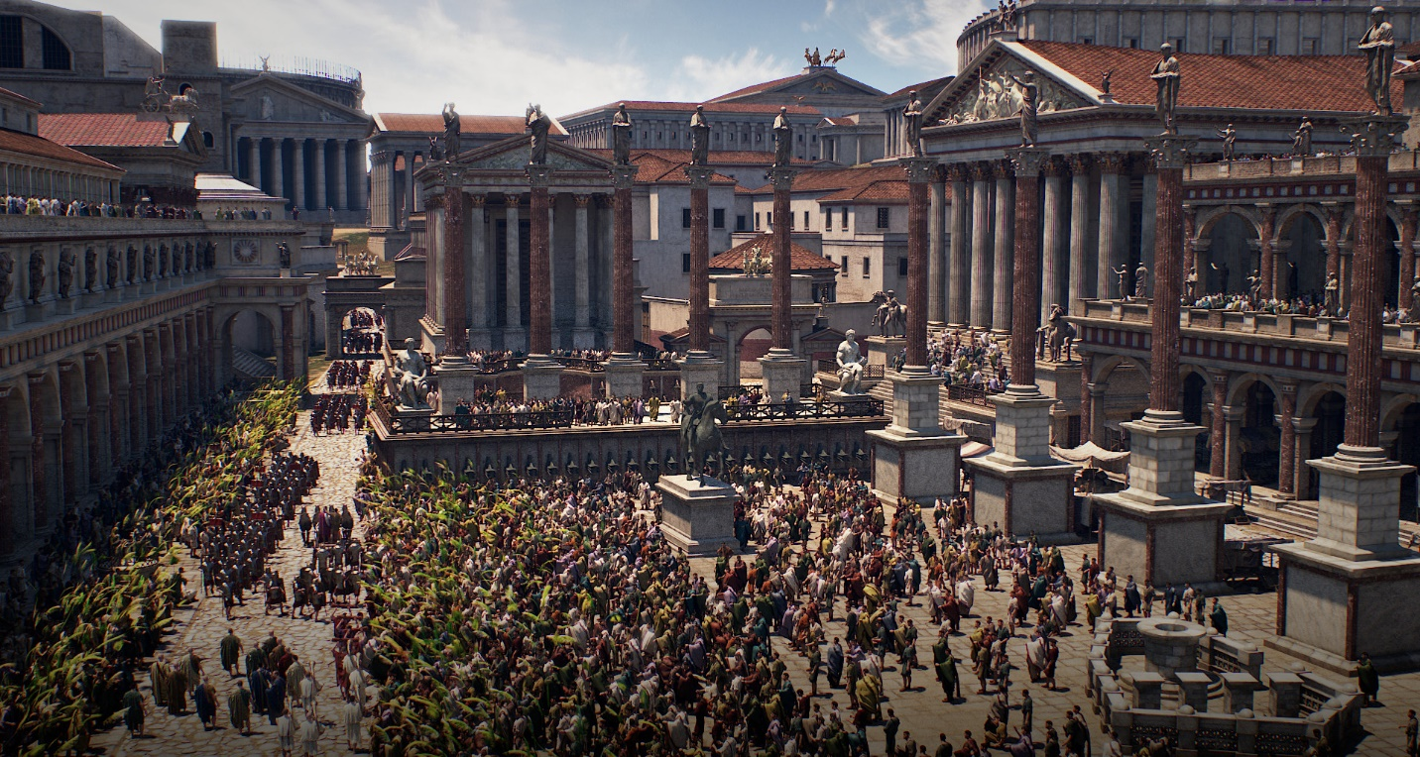

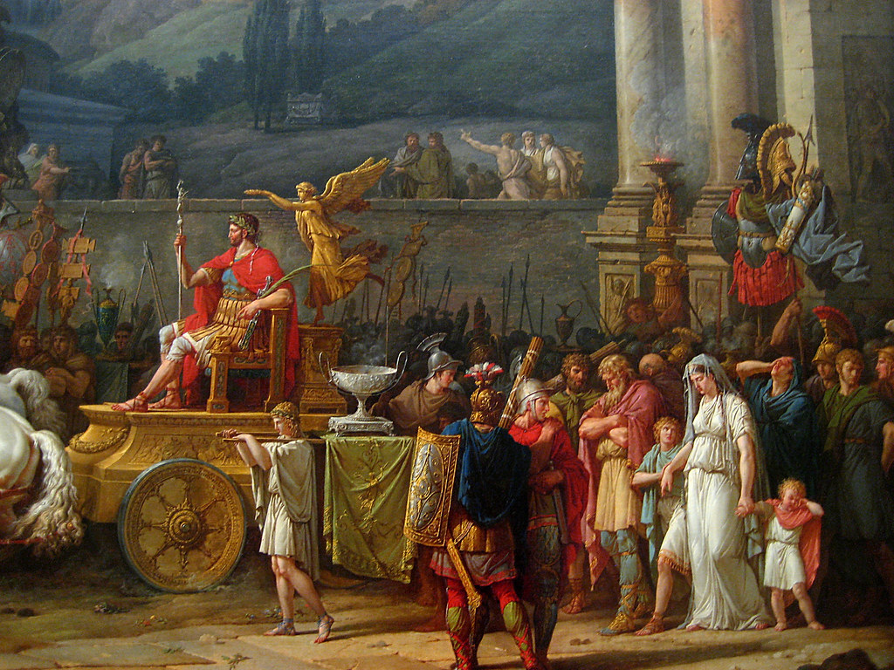

Paul refers to himself figuratively as “last of all in the procession”, in other words, as one of the captured prisoners of war, destined for death. Was he? No, but it felt that way because it seemed everything was against his ministry. Even those whom he ‘fathered in Christ’ were tricked into speaking against him. He was trying to help the Corinthians remember who he was, someone who stood for the gospel whether in the front (victorious) or back (seemingly defeated) part of the figurative Roman procession.

Think about this: Where did Paul sleep while he taught in Corinth? On someone’s couch. How did he eat? He worked with Aquilla making tents, then worked the scriptures, and then worked at teaching. As we’ll see the only money he received was from tent sales. He even went before the local governor, risking his life and liberty for the sake of the gospel. And the Corinthian saints were dismissing Paul? That attitude was completely 100% wrong because of his 100% commitment to Jesus, the gospel and them. He had “crawled over broken glass and climbed through barbed wire” for them. Christ wanted them to respect him and especially his message.

1 Cor. 4:14

I do not write these things to shame you, but to admonish you as my beloved children.

The Corinthian saints needed “a check up from the neck up”. This message was confrontational and will become even more so, as we will see. Paul didn’t intend for his message to shame them, but to confront them to change their thinking. Nonetheless, sometimes shame results, and could be necessary, like scars, to remind us of past bad decisions that could still arise.

1 Cor. 4:15

For though you have 10,000 guides in Christ, yet you do not have many fathers, for in Christ Jesus I fathered you through the good news.

There is a special place in the heart of a saint for the one who “fathered you through the good news”. Paul was reminding them of their shared legacy and bond, implying, “You wouldn’t even be a believer if I hadn’t given you something to believe! Open your hearts to me and my message, like children would to their father!”

1 Cor. 4:16

Therefore, I urge you, be imitators of me.

From the Greek word for “imitators” we get the English word “mimic”. When our son, Beau, was young people would comment that as we walked together, it was the exact same walk – full size and miniature. He “mimicked” my style of walking. I’m glad he didn’t mimic his mother or sisters! This is what Paul was encouraging the Corinthians to do, “walk” – figuratively speaking – imitating him. In other words, have the same commitment to Christ – the same humility and willingness to sacrifice for the gospel – the same lack of desire for personal glory. This is not physically mimicking, like say, if Paul had a particular distinctive mannerism like raising his eyebrows when he preached, that they should all do. It was a spiritual imitation of heart, attitude, and habit.

1 Cor. 4:17

For this reason I sent Timothy to you, who is my beloved and faithful child in the Lord. He will remind you of my ways in Christ, just as I teach them everywhere in

every church.

Paul was sending Timothy to serve the Corinthians because he had the same qualities as Paul, which the Corinthians needed to imitate. For immature Christians, a physical example to see, hear, and imitate is important because their spiritual senses are still secondary to their physical ones. Exposure to one example of Christianity is good, but a second and even more is better. The observers can see the common traits that characterize Christianity and imitate them. This was Paul’s aim.

1 Cor. 4:18

Now some are puffed up, as if I were not coming to you.

“Puffed up” pictures a creature puffing out their chest, full of pride. Some in the Corinthian church were imitating a strutting rooster, not Paul’s humility. Why were they doing that? There’s an old saying, “While the cat’s away, the mice will play.” Some in the church were letting their flesh express itself in sinful ways, reverting back to their pre-Christian, Corinthian-crazy days. And because Paul was away, the proud sinners were not afraid of receiving any consequences for their ungodliness. Certainly their ungodly neighbors wouldn’t correct them because sinning was normal (and perhaps expected) in Corinth. So, some slid back to their old ways and without Paul present, they sinned fearlessly.

1 Cor. 4:19,20

But I will come to you shortly, if the Lord wills, and I will know, not the word of those who are puffed up, but the power.

For the Kingdom of God is not in word, but in power.

Oh-oh! The cat’s coming back! So, the mice better run for the hills! Let me ask you, what gives Paul the right to portray himself as “the cat” and the sinners as “the mice”? You know who… Jesus Christ, the boss! Paul took his appointment as a steward seriously. What about the guy in the fellowship who had over 100 slaves and had business in many cities and sat on the town council? What about the guy who was “old money”, had an estate with a driveway a mile long, and was in the upper class of the upper class? Was Paul still “a cat” and the rich guy “a mouse”? The answer is, only if he’s sinning and “mousing” around!

Was Paul upper class? No, he was a Jew and they were recently evicted from Rome. He had no fancy home, slaves, or impressive wealth. He did sleep on nice couches from time to time and made some really great tents! What made him able to correct the Corinthians? The big “Cat”, the Lion of Judah - Jesus Christ”! Who made Jesus the boss? The one who raised him from the dead. The Creator of heaven and Earth – Almighty God. So ultimately Paul was empowered by God to be his steward and Paul intended to be faithful and manage the operation in whatever was needed to see God’s will done.

God empowered Paul to keep order in the church – to keep distractions at a minimum and the focus on Christ at a maximum. Paul intended to present “fruit” to the owner of the vineyard when it’s harvest time. Anything that hindered that would be weeded out. God supplied the power – the manifestations of the spirit – revelation, miracles, etc. to do the job. Anyone can talk. But when supernatural power is introduced, the divine backing is revealed. And those who fight that man, realize that they are ultimately resisting God and Jesus. That’s a sobering decision – for the present and the future.

1 Cor. 4:21

What do you want? Should I come to you with a rod, or in love and a spirit of meekness?

The “rod” is figurative. This is how the ancients disciplined their children before there were personal injury lawyers and CPS! Just kidding. This is more of the physical/spiritual growth analogy. Paul is asking the Corinthians, “Do you want me to visit you confrontationally or in humble love? When I visit, I will confront the return to fleshly Corinthian sinning if it’s still happening. The Christian church has no place for it. If you weed it out now, you’ll get loving humble Paul. If not, you’ll get spiritually powerful and intense Paul. It’s up to you. Spiritually grow up and police the church. (Especially those of you who consider yourself elders and/or leaders) If you won’t, I will. Do you want the stick or the carrot?”