29 – Suffering and Spirituality

1 Cor. 12:26
And if one member suffers, all the members suffer with it, or if one member is honored, all the members rejoice with it.

In the church, the joy and the suffering of our brothers and sisters is also ours. We all intuitively know and feel this. Our shared experience comes from allowing ourselves to be loving and open to others. Insulating ourselves from pain indicates that we’re selfish and not trusting that God can comfort, support, and ultimately carry us all the way to victory.

Now, this is not talking about “stupid” suffering – like the kind a person has when they repeatedly put their hand on a stove. The cause of that suffering is their own unwise or sinful behavior. That’s a simple fix. To stop the suffering, stop the behaviour. In other words, stop the addiction, the immorality, the criminality, or whatever the “stupidity” may be that causes the suffering. If the individual involved in the stupid behavior stops, the suffering stops. If they don’t want to stop the stupid behavior, the rest of us are under no obligation to share that suffering. Hopefully their suffering will be a wake up call to them to change their behavior. Christ paid the penalty for those sins and all others so that we won’t have to. Carrying the suffering of someone who’s unrepentantant behaviour consistanly brings pain to them and those around them, is not wise. That’s not the suffering spoken about in verse 26. This is the suffering that comes with living in this broken, sinful world. This kind of suffering is inescapable and trying to insulate ourselves from it is an escapist fantasy, one that is regrettfully promoted by some errent “Christian” doctrines.

If I’m Suffering, It Must be My Fault

Some teach that if you’re suffering, it must be caused by you doing something sinful. They teach that God is only involved in victory, never in defeat or suffering. Is this true? To answer, look at one of the greatest miracles of all time, Jesus raising Lazarus from the dead.

John 11:43,44
And when he had said these things, he cried out with a loud voice, “Lazarus, come out!”
He who was dead came out, bound hand and foot with grave clothes, and his face was wrapped with a handkerchief. Jesus said to them, “Loose him and let him go.”

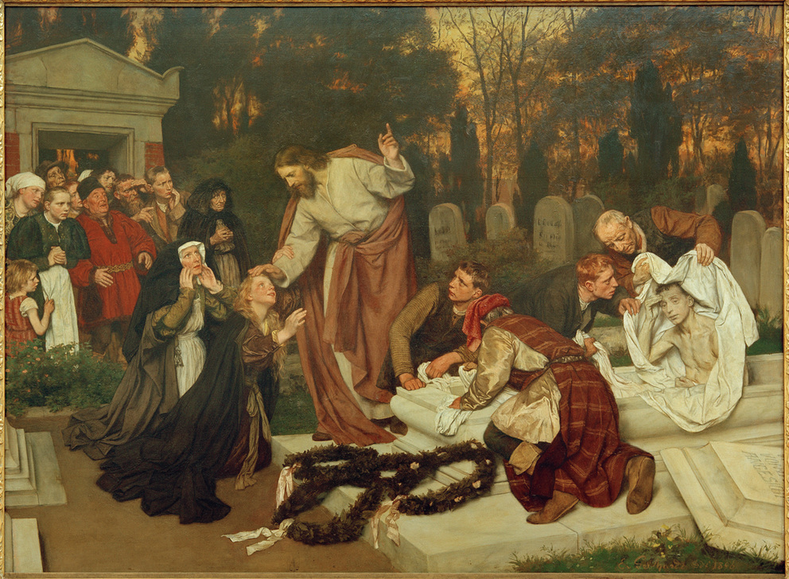
The Raising of Lazarus by Eduard von Gebhardt, 1896

What a miracle! A crowd came for a funeral, but got the surprise of a lifetime – the deceased was released with a new lease… on life! This was absolutely the talk of the area anywhere the story went – and you know it went everywhere!

Ok, having said that, have you ever met Lazarus? No? Why not? You’d probably venture, “Because he’s dead, I guess.” You are correct! Death is ultimately inescapable.

1 Cor. 15:22
For just as in Adam all die, so also in Christ all will be made alive.

I really don’t like the first part of this verse. I want it to say that Christians escape death - they avoid the consequences of what Adam’s sin unleashed on humanity. But that’s not what it says. “All die.” How awful … but true. So even though Jesus helped Lazarus cheat death once, it ultimately caught up with him again and he joined the rest of humanity who were never raised from the dead as he was, dying again. Think about this …

Ps. 34:19
Many evils happen to a righteous person, but Yahweh delivers him out of them all.

I wish this verse said, “Many evils happen to an unrighteous person”, but that’s not what it says. I’ve thought that evils happen to those who walk unrighteously, but God says the righteous people get it too. “Evil happens” is not necessarily related to someone’s behaviour, but to their being alive in this “present evil world”, as Gal.1:4 says.

Romans 5:12 teaches us that sin and death were “baked into the human cake” after Adam. That means that the suffering accompanying sin and death are also “baked in” to the human condition. It is an undesired, yet inescapable part of this life between Adam’s sin and Christ’s return. So why raise Lazarus from the dead if he is ultimately going to land there anyway? The answer is in the second part of Ps. 34:19, “Yahweh delivers him out of them all.” Yahweh will deliver us from all the many evils that happen to us… sooner or later. Later deliverance happens at Christ’s return. We get a new body dominated by God’s spirit replacing a broken body with limited soul life. A new mind. A new start. Total deliverance – for – ever! Halalujah! But Yahweh can also deliver us from some of the many evils in this life now, and that’s where the manifestations of the spirit come in. Yes, the healing is temporary. Yes, the rasing from the dead is temporary, but is anyone complaining? Don’t think so! We’ll take it! Anytime, anywhere! Yay, manifestations of the spirit!

Perspectives on Suffering

We want to keep our perspective on suffering realistic. If we can avoid suffering, we should do it by changing whatever we can without breaking God’s word. Escaping suffering is good, despite some misguided souls who think that misery is “the stairway to heaven”. That’s not in scripture. Even Jesus wanted out of the suffering for our redemption, but heroicly endured it for us anyway. He suffered for our sins so that we don’t have to - so don’t suffer - if you can avoid it.

What about when we experience the inevitable suffering of this world surronding us? We should do our best to get God’s deliverance in the here and now. How? The manifestations of the spirit! First, we ask God for help. He loves us and wants us helped and blessed. Many times the help will come in the form of the body of Christ. Get with a healer, a miracle worker or a prophet. What if they’re not in your denomination? Are you kidding? Do you want to be delivered or follow man-made divisions? Part of the problem for deliverance with some of us is that we want deliverance on our terms, not God’s. Naaman the leper in 2 Kings 5 was like that. He wanted deliverance from leprosy but balked at the prophet’s guidance to wash in the Jordan river 7 times. He made great excuses – even logical ones – but got no results because of disobedience. Then an underling (someone who was like a ‘weaker’ or ‘less honorable’ member of the body) spoke an insight that caused him to change his mind and obey the guidance and deliverace followed. Naaman first wanted deliverance on his terms, not God’s. When he changed his mind – wham!

So, you want the right reverand bishop of your church to heal you? Good luck! Does he even believe in healing? Maybe not. What should you do? Look for where there’s smoke because odds are you’ll find healing fire! Ask God to get you together with the right member of the body of Christ. Remember, the Church of Grace is “the called out” and is MUCH bigger than your church. What if he/she doesn’t believe in everything 100% as you do? My perspective is, “So what?” I’m looking for a healer or deliverer, not a theologian! What if they are 1000 miles away? Have a phone? Use it – might as well, we pay for it if we use it or not. What about traveling to where they are? It might cost $1000. Do you want deliverence or a financial plan? Go, go, go where God leads you if you want deliverance. And when He tells you to “dip in the Jordan seven times”, tell your mind to shut up and do it!

Condemnation

Now, what if you are suffering and don’t have the trust in God currently, or are confused, or just in a bad way? I suggest you condemn your self and fill yourself with shame. Really? Thanks, Satan! What awful advice! Yet this is what we are sometimes tricked into doing to ourselves and others by the adversary. Have you ever read this verse from Romans 12:15?

Romans 12:15
Rejoice with those who are rejoicing, cry with those who are crying.

That verse is as clear as mountain creek water, yet many read it as if it should say,

1 Condemnations 12:15 (Fictional and evil)
Rejoice with those who are rejoicing, reprove those who are crying.

I’ve actually experienced Christians harshly reprove themselves or someone else in the midst of suffering! The accusation is, “Stop disgracing Jesus and believe God!” Holy heartbreak! That’s the opposite of Rom. 12:15 and 1 Cor. 12:26. That’s putting additional weight on an already overburdened soul. We should never condemn ourselves or others when we or they are suffering and crying. Most of us come into this word crying and occasionally relive our entrance experience with more tears. Why? Because life is hard. Stuff happens. Suffering sometimes comes along like an unwanted passenger, hitching itself to our life for a time. How long? It depends. Sometimes it behaves like an unwanted visitor, staying longer than we want and departing without notice. Sometimes the visit is just a quick stopover. Sometimes it wants to take up residence in our life and force us out of it. Suffering unchecked can usurp our lives and make us want to quit living to end the pain. It’s during these challending times that the healthy members of the body must link arms and hearts with those suffering to help break the hurtful momentum and turn the tide against this intruder. This is why we “cry with those who are crying”. We add no shame to their situation, but indicate our solidarity with them in their pain. Then we gradually manifest God’s love and mercy at His direction to evict the enemy before it overwhelms our family member. We fight for each other in this spiritual contest.

Sometimes this victory process can be quick and sometimes it takes a while. Perhaps this is why one aspect of the fruit of the spirit is “longsuffering”. This “steel spine” aspect of the tender love of God surfaces next chapter when God declares …

1 Cor. 13:7
[Love] bears all things, believes all things, hopes all things, endures all things.

Shame, criticism, and condemnation has NO place when a brother or sister is suffering through no fault of their own. Yet, I can hear today’s Pharisees saying, “Well, you should have believed God. If you had listened to God, none of these bad things would have happened. Tsk, tsk! Bad believer! Bad!” These folks should go to Satan and ask for their pay because, when saying those things, they’re working for him!

Some folks really think that it’s available to “run through the raindrops” and never have have bad events or sickness touch them. Really?

John 16:33a
I have told you these things so that, in union with me, you have peace. In the world you will have hardships,
You know, it was tough being the Son of God. Sometimes it was so harrowing that Jesus caved in, got weak, and “confessed negatives”. Everybody knows that he really meant to say, “In the world you will have hardships if you don’t believe God or aren’t listening to Him”, but Jesus spoke curses, right? No? You mean Jesus meant to say, “In the world you will have hardships - period”? Yes, that’s right. Evil, suffering, hardship, pain, etc. is inescapable in this life at times. There is no “running through the raindrops”. The only question is how are we going to deal with it? Jesus came so we could overcome it with him.
John 16:33
I have told you these things so that, in union with me, you have peace. In the world you will have hardships, but have courage; I have overcome the world.”

We will be delivered from all the consequences of Adam’s sin sooner or later by Jesus’ victory. A big avenue of “sooner” victories is through the body of Christ, in other words, the ministries and the manifestations of the spirit.

Longsuite Services in the Church

1 Cor. 12:27-28
Now you all are the body of Christ, and individually parts of it.
And God has set some in the church, first apostles, secondly prophets, thirdly teachers, then miracles, then gifts of healings, helps, governments, various kinds of tongues.

God lists some of the individuals ministries (services) in the church. Once again, these are not all the ministries, just a sampling to make a point. Perhaps these were some of the dominant individual ministries of the Corinthian church and if the past sections of this epistle are any indication, those with these ministries were perhaps extolling “their” longsuites. I wouldn’t have been surprised if they gave themselves lauditory nicknames like “Miracle Mike”, or “Helen the Healer” or “Tammy Tongues”. A problem for them at that time is the same as a problem popping up today. It’s all about “me”, not “we”.

The first three ministries listed represent the five leadership services mentioned in Ephesians 4. Apostles initiate churches and doctrine. Prophets confirm and establish. Teachers make doctrine and practice simple to understand and do. This is what the Corinthians were in need of and Paul was providing this by the epistle. (By the way, a person can have multiple ministries, or services in the church as 1 Tim. 2:7 says.) Then God mentions the power manifestations – miracles and healing – God’s public displays to the world. Then those who help – they build, fix, serve, clean up, protect, etc. Then those who can organize and manage – work, finances, goods, people, etc. Then “kinds of tongues”. Although all of us can speak in tongues, some have a longsuite in speaking many language. How does that happen? The speaker has the trust and/or expectation and the Spirit gives the utterance. Remember, God energizes all these ministries and manifestations in the body of Christ.

1 Cor. 12:29-30
Are all apostles? Are all prophets? Are all teachers? Are all workers of miracles?
Do all have gifts of healings? Do all speak in tongues? Do all interpret?

These two verses include seven rhetorical questions which make emphasized statements using questions to persuade the audience. These seven questions are making the point that we all have unique longsuite services in the church, distinctly different from each other, like our bodies do. The first three are gift minstries in the church while the last four are named as manifestations but are really those with the longsuites in those manifestations. For instance, everyone of us can speak in tongues and interpret, but a few members leave you breathless when they do it. The same is true with teaching, which all of us can do but a few of us can make a lasting impact when it’s done. Why? It’s how the Spirit energizes in those individuals when they trust God to do what He’s called them to do.

This section is not a list of simple questions asking, “Can everyone in the church work miracles? Obviously not. Can everybody speak in tongues in the church? Obviously not.” Here is my idea of the logical thrust of the questions:

1 Cor. 12:29-30 (Writer’s logical extrapolation of the Rhetorical Questions)
Are all called with a ministry of an apostle in the church? Obviously not. Are all called with a ministry of a prophet in the church? Obviously not. Are all called with a ministry of a teacher in the church? Obviously not. Are all called with a ministry of a worker of miracles in the church? Obviously not. Are all called with a ministry of gifts of healings in the church? Obviously not. Are all called with a ministry of kinds of tongues in the church? Obviously not. Are all called with a ministry of intrepretation in the church? Obviously not. (The point is we are many members and all members have not the same function, right?)

The point is, stop envying the flashier, more visible spiritual ministries and be the best you God has shown you to be. You are unique and irreplacable and much needed in the body. You are at least as valuable as an anus! Just kidding! Be like Ananias, a certain disciple, whom God invited on a ‘suicide’ mission – to minister to the most viscous Christian hunter at that time, Saul of Tarsus. And because of the obedience of that certain disciple – not an apostle, prophet, or teacher - the church got the greatest Apostle and teacher of that generation, Paul. Position and title mean little. Maximizing who you are with obedience to God means everything. Each of us with Christ within can be earth changers.

1 Cor. 12:31
But earnestly desire the greater gifts. And yet I now show you a more excellent way.

What are the “greater gifts”? It depends. Perhaps a prophet would be benificial to establish them in the foundation Paul had built. Perhaps a teacher was needed to help them understand the centrality of the gospel and Christ. Perhaps a pastor was needed to help the discouraged saints after reading this correction epistle. There is no real heirachy of gifts in the church just as there is no hierarchy of needs for the physical body.
Sometimes our bodies need food or water. Sometimes it needs oxygen or antibodies. Sometimes it needs heat or cold depending on the enviornment. Sometimes it needs shelter from the elements or it needs companionship. Sometimes it needs a tender touch or salt and minerals. Our bodies needs lots of things to keep it going and spiritually so do we – individually and collectively. The “greater gifts” are like the greater needs of the body. Whatever is currently needed is the “greatest need” and the other needs should be on standby because it won’t be long before they will be the “greatest need”. We all become the ”greatest gift” to the church at one time, or many times in our lives. Each of us makes an indelible and substantial contribution to the church in ways that we can not even fathom at the time. Do you think Ananias in Damascus thought we would be talking glowingly about him 2000 years later? Probably not. Each of us is a big deal with God’s spirit within.

Eph 2:10
For we are his handiwork, created in union with Christ Jesus to do good works, which God prepared in advance so that we would walk in them.

We are in the adventure of a lifetime making His-story as we trust God’s calling for our own life and the church as a body. When we see pain and suffering, we have the answer – the spirit of God to heal, comfort and exhort. Each of us can manifest the spirit to encourage the weary, heal the sick, deliver from evil, and raise the dead. Yet, now God will show us a more excellent way than the manifestations and ministries in which to walk spiritually… .

