Jan 6th 2021

We went to DC Sunday Jan. 3rd and stayed at a hotel on 400 New Jersey Ave, a couple of blocks from the Capital. On Monday we went to Monticello, outside Charlottesville VA, about a 2 ½ hour drive away. It was amazing. It transports you back 250 years ago to the times of the American revolution to the home of the man who wrote the Declaration of Independence. He was brilliant and flawed – courageous and in some respects cowardly, as we all are. Yet there would be no America that we enjoy today without his transcendent words and leadership. He was the first ambassador to France, the second governor of Virginia, the second US Secretary of state, the second vice president, the third president and the founder of the University of Virginia. Other than that… .

On the next day, we walked the national mall, seeing the set up for the big meeting at the Ellipse. That’s the large “lawn” behind the White House where I believe the helicopter lands and takes off for the president. It looked like a rock concert set up with stage, backdrop and chairs for a few thousand people. If you look closely, you can see the White House past the stage below.

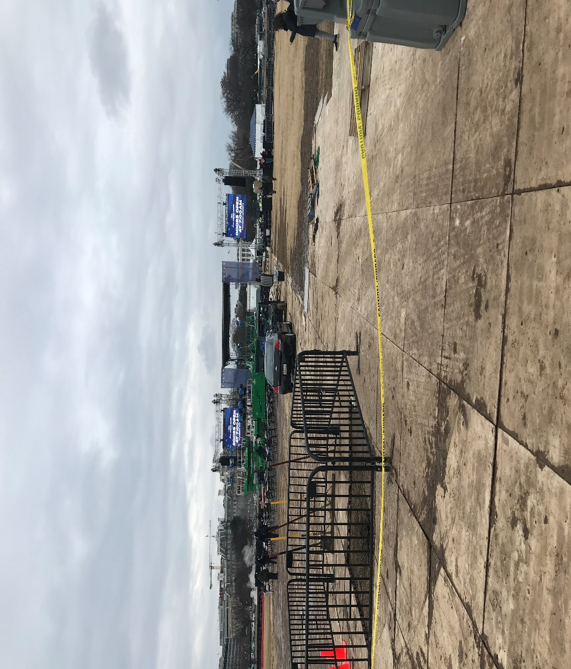

Later we settled in at the Freedom Plaza, where Christians where holding basically a prayer meeting for the 300-500 people attendees. One preacher and speaker after another shared and prayer was solicited. Also public rebuke of Satanic forces were encouraged and enjoined. It was positive and powerful. We left about supper time and wandered back to the hotel seeing a great increase of people arriving from everywhere. It was a gregarious family atmosphere as we felt a political and spiritual kinship with most other attendees.

The next morning was the rally, Jan.6th. We arrived at the Ellipse at 7:15am to a cold and overcast day that was beyond packed. The atmosphere was festive like Mardi Gras or a large concert, except this was larger than I think the organizers expected. Not skilled at estimating crowds, it seemed to me to be many stadiums full of people. That’s how I estimate large crowds, a stadium full – about 50,000 people. It was many of them. We stood near a large TV monitor across the street from the Ellipse literally shoulder to shoulder. The crowd stretched like that all the way to the Washington Monument.

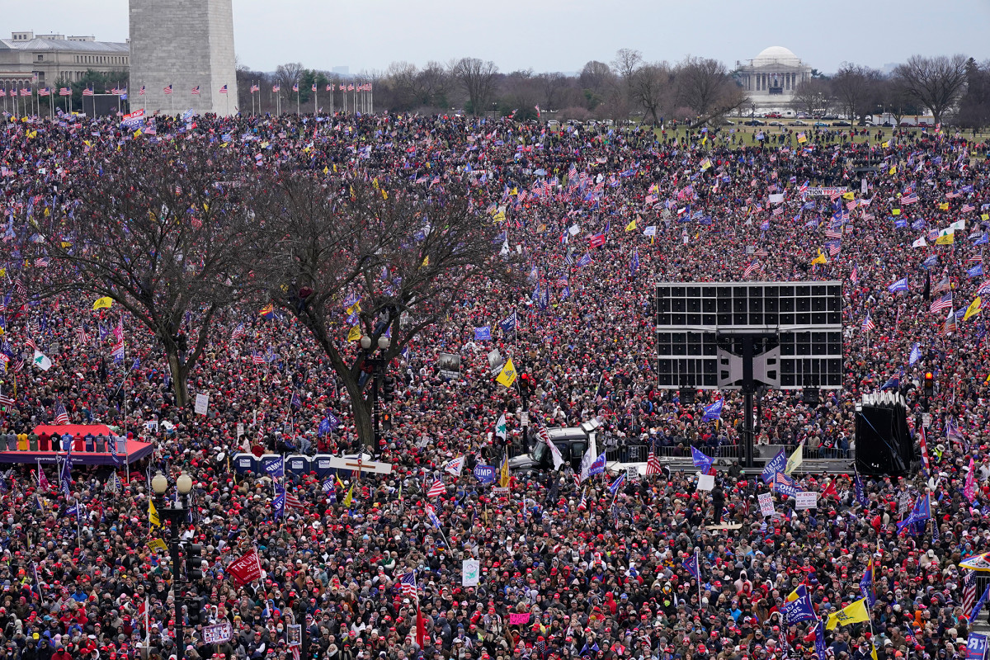

We were by the yellow flag between the tree and the large monitor. Keep in mind this picture is only the street and the grounds around the Washington Monument, not the Ellipse and the area from the stage to the street (which is the bottom of this picture). The rally began with prayer and the pledge of allegiance and the star-spangled banner. We had a variety of speakers, from the lady leader of “Women for America First”, the sponsor of the event, to the president’s sons, to a couple of congressmen and others. Rudy Giuliani shared as a well as a constitutional scholar. Finally, the president shared around noon for an hour, detailing some of the election “irregularities” and ended with encouraging us to all walk the two miles to the US Capital on Pennsylvania and Constitution Avenues and let the Congress know that we’re watching them vote. He, nor anyone else on stage, or that I encountered in the audience (of which there were hundreds) even hinted at violence or breaking the law. A riot was the last thing any honest, rational person would call any aspect of this event.

It took 30 minutes to walk to the Capital. Constitutional Avenue was packed. The mood was jovial and positive. When we got there the crowd surged forward chanting “U-S-A, U-S-A” and “Stop the Steal”.

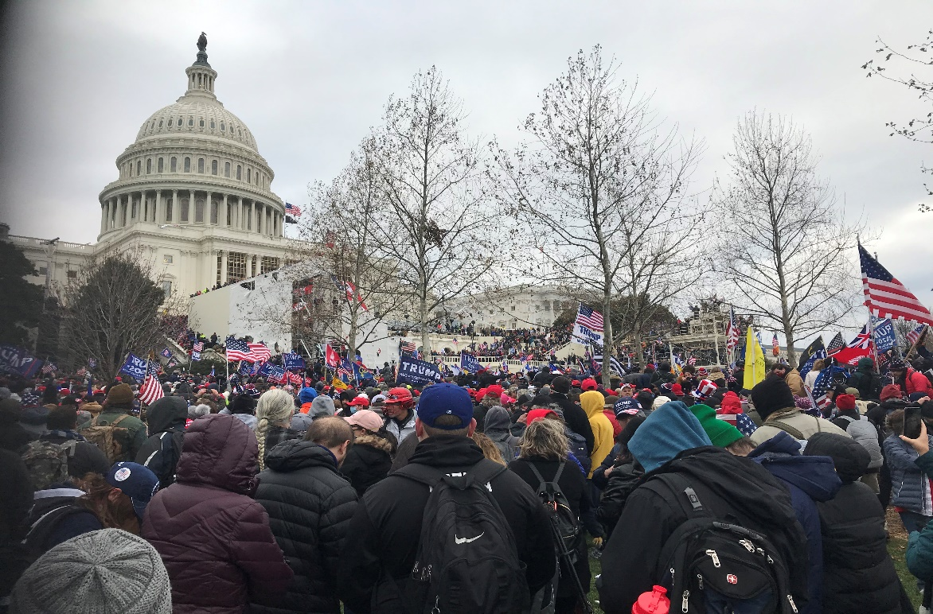

We walked up the steps to the left of center of the Capital till the crowd stopped and people were coming back through the crowd recovering from tear gas. You could see small clouds of tear gas rising ahead and occasional popping. The word came down from ahead that rubber bullets were being fired. A large American flag was passed over our heads toward the front, surging the crowd forward. I got Teresa and I out from beneath it and began our way back down to the surrounding grounds.

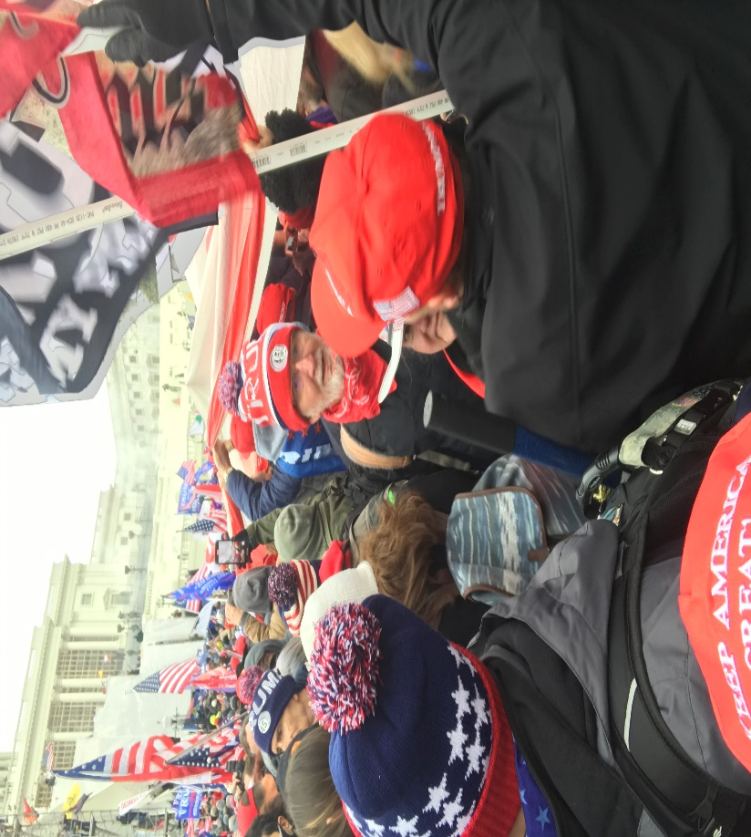

We stood around for awhile talking with others trying to ascertain what was happening close to the Capital. It seemed like people were sitting on the stands set up for the inauguration and on the patios above. The mood was still positive, but an element of uncertainty began to emerge. About then we received an emergency bulletin on our phones that the mayor of DC declared a curfew for 6pm.

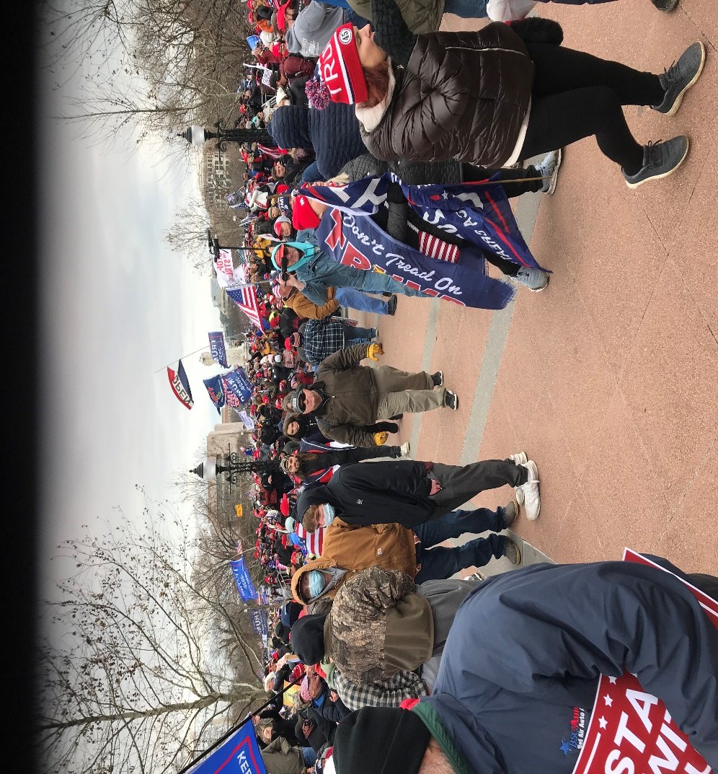

Tired and cold, Teresa and I decided about 4:30 to return to the hotel because we hadn’t eaten or used the bathroom all day. We finally arrived at the hotel and felt the atmosphere had completely changed, as hotel workers and others eyed us suspiciously. We went to our room, turned on the TV to Fox news and found out a reality that still shocks us days later. They described passionately an event we had experienced all day as being 100% out of phase of what we had experienced. It was almost an out of body experience. We were being called “insurrectionists” and “rioters”, when the opposite was the facts. I turned the channel, and everybody mouthed the same line enthusiastically. It was like we had cruelly been thrust into a pretend scenario as a joke, but it was no joke. Everyone around us believed we were involved in Antifa-like riots. How in the world could everybody in the US think the president had instigated “insurrection”, when he had absolutely done nothing of the kind? How could people think that the rally attendees wanted to “take over the US” when this crowd was very strongly democratically oriented. I know, we spoke to many of them. Besides, and this may be uncomfortable for some to hear, but if we wanted to “take over” the US Capital (what ever that means and to whatever dubious end that would be) we could have. This crowd was large enough to take over the entire federal government at all the different locations easily. There was not enough bullets in all the guns combined to deter us all. Not even close. The reason it never happened was because we never thought of it, much less wanted to do it. We were looking to make our voice heard on investigating the voting irregularities and making sure we were democratically voting for the president, not having outside influences add or delete legitimate votes. We were, and are, pro-democracy - not insurrectionists.

It seems to me that the size of the crowd scared some to death and they want to make sure it never happened again. This they are doing by demonizing the rally attendees and the president. I am a supporter of President Trump and have yet not approved of some of his “tweets” and sometimes his tone in some communications, but this idea that he criminally led his followers to insurrection Jan.6th is irresponsible and disconnected from reality. It’s almost as if the entire population around us has lost their minds and are living a different reality – where up is down and left is right and democracy is anarchy. It’s hard to watch TV. It’s so insane – and I use that word correctly. It’s as if a gas has been spread throughout the population and mass hysteria and hallucination is the result.

We personally never experienced people breaking into the capital and idiots doing whatever criminal acts they did inside. But to let a few knuckleheads paint the rest of us as insurgents is as responsible as calling a first century religious uprising as phony because it’s secretary treasurer stole ministry money and betrayed it’s founder. Every organization has it’s Judas’s and defaming a group and it’s tenets is usually willfully done to deflect honest consideration of its merits. This seems to me what’s going on here. Instead of genuinely looking at the election, the country is focused on a bogus charge of insurrection and … “impeachment”? Are you kidding? About a week before inauguration impeaching the outgoing president? For…what exactly?

It seems that Pelosi and her side is so terrified of Trump and the so called “mob” that they want to tarnish him and us historically, and that may just be the beginning. Some of you may not like this, but these verses came to mind, describing how I feel.

Luke 22:52-54a

And Jesus said to the chief priests, and commanders of the temple, and elders, who had come out against him, “Have you come out as against a robber, with swords and staves?

When I was daily with you in the temple, you did not stretch out your hands against me. But this is your hour, and the authority of darkness.”

And they seized him,

“This is your hour and the authority of darkness”. This is way beyond political, psychological, or sociological. This is spiritual. This is the authority of darkness activated against righteousness. The implications of that statement are uncomfortable to say the least, but I defy you to explain the current events in any other context. This is the unleashing of evil plans and the execution of them, the extent of which I have never experienced before. This is madness writ large. This is the world – the political, business, and upper social class – turned into a mob and insurrecting against God. “And they seized him.” Sorry to say it, but get ready to get grabbed like Jesus was. In what way? Our rights, our money, our allegiance, our dignity, our friends, our coworkers, our family, our country… and even reality. We are watching them trying to redefine reality. This comes from the “father of lies”, as Jesus called him.

Teresa and I felt like this…

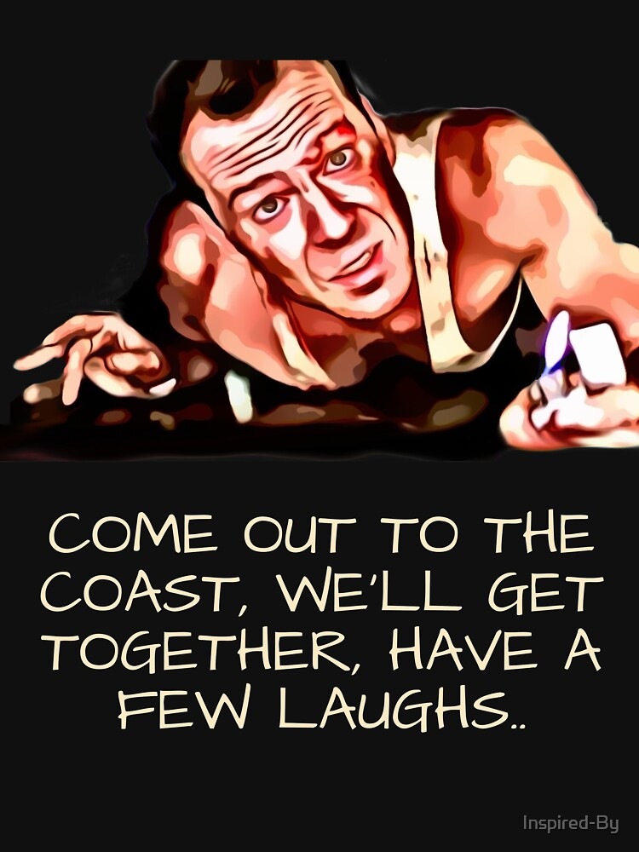

Like John McClain in the movie, Die Hard, we had no idea what we were walking into when we went to DC. Before you know it, we’re hiding and climbing through a vent in the dark, hunted and surrounded by evil. Is that the end of the movie? No, through trial and adversity McClain turns the tables.

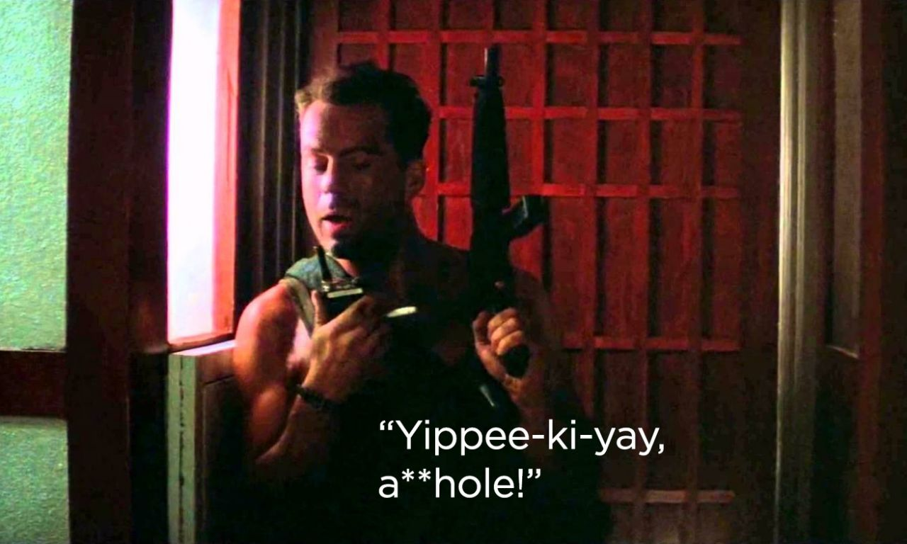

How does the movie end?



How will this chapter of US History end? Don’t know. We’re writing it as we speak. But ultimately the evil people, influences and spirits will descend – like Hans Gruber – into the lake of fire. And we help!

1 Cor. 6:2,3 KJV

Do ye not know that the saints shall judge the world? and if the world shall be judged by you, are ye unworthy to judge the smallest matters?

Know ye not that we shall judge angels? how much more things that pertain to this life?

Romans 16:20 REV

And the God of peace will crush the Adversary under your feet swiftly. The grace of our Lord Jesus be with you.

Now is the time for us to “draw near to God”. He will “guide us with His counsel and afterward receive us to glory”. Through trial and adversity God will guide and lead us to victory ultimately. When and how will that be? Don’t know, but it’s great knowing the final score. Buckle up! This will be quite the odyssey. Yippie Kay Yay!

(The next section briefly explains why we went to DC.)