The Game of the Kings – Israel

Do you know what the national sport of Rome was in the 1st Century A.D.? It was murder. You might think, “How could that be?” I would respond “Do you remember the movie ‘Gladiator’? They weren’t playing checkers!” Ever see this building below?

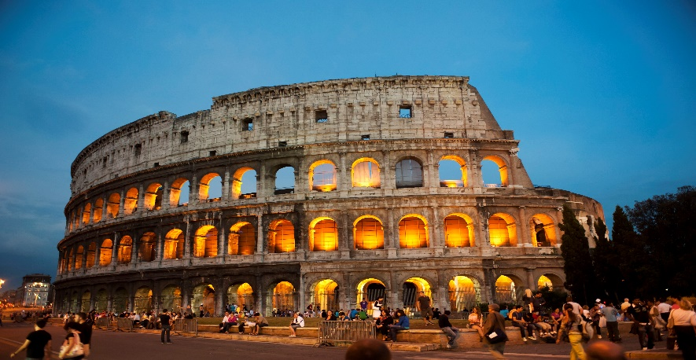

The Roman Colosseum was where the public spectacles were presented as depicted in the movie Gladiator which usually climaxed in the murder of some or all the participants. In Roman amphitheaters plays were presented with actors acting out their parts using masks.

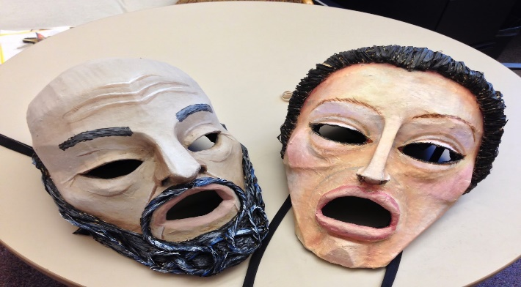

In the case of tragedies, slaves were substituted for the stars in the last act and actually murdered to climax the play. Rome was clearly a sick and barbaric culture which feasted on evil.

Is. 53:4, 7-8 REV

Like one from whom men hide their faces, he is despised and we did not respect him.

We all like sheep have gone astray. Everyone has turned to his own way, but Yahweh has laid on him the iniquity of us all.

He was oppressed, yet he suffered willingly, and he did not open his mouth. As a lamb that is led to the slaughter and as a sheep that before its shearers is mute, so he did not open his mouth.

Due to oppression and unjust judgment he was taken away and who among his generation considered that he was cut off from the land of the living and afflicted because of the disobedience of my people?

Hundreds of years before Jesus was born Isaiah prophesied about the Messiah. He would be: “despised and rejected”, “not respected”, “the bearer of our iniquity”, “silently oppressed and a willing sufferer”, and “taken away, unjustly judged, and cut off from the land of the living”.

When we were in Jerusalem, we visited the subterranean dungeon of what used to be the Antonio Fortress, the place next to the Temple where the Roman soldiers were stationed to keep order in the temple area. This is where Jesus would have been brought to stand before Pontius Pilate, the Romans governor of Judea.

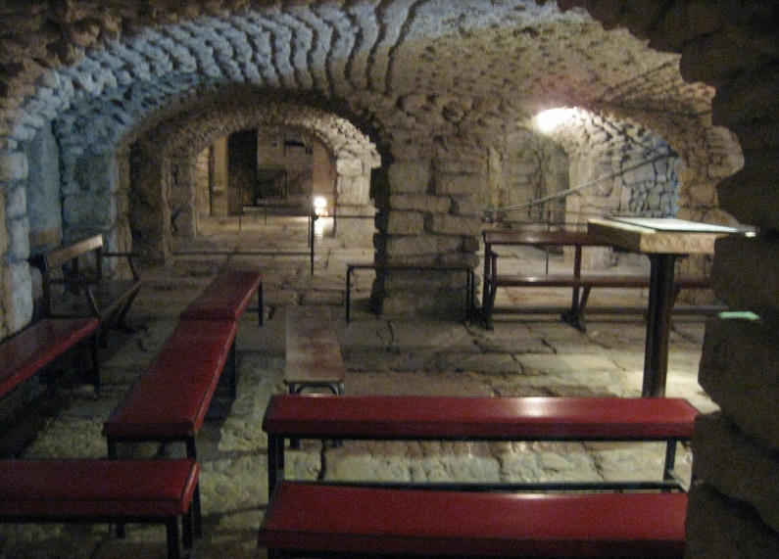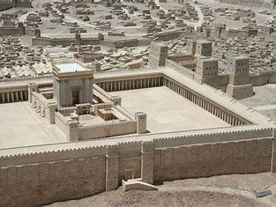

The dungeon under the Antonio fortress. The fortress is to the upper right of the temple area.

In the dungeon is a level slab with etchings on it that depict what we would call a game board.

The “game board” depicted a perversion that Roman soldiers did with prisoners called “The Game of the Kings”. The chart below clarifies and explains what they did.

The soldiers would each have markers on the “game board” and simultaneously move the prisoner around the players as the game progressed and the condemned man advanced through the “game board”. What did they do?

Mark 15: 16-20

And the soldiers led him away inside the palace (that is the governor’s headquarters), and they called together the whole cohort of Roman soldiers.

And they clothed him in a purple robe, and after twisting together a crown of thorns, they put it on him,

and they began to greet him, “Hail, king of the Jews!”

And they kept striking his head with a reed and spitting on him, and kneeling down, they paid homage to him.

And after they had mocked him, they took the purple robe off of him, and put his own clothes on him. And they led him out to crucify him.

Jesus was used as a perverse game prop by Romans soldiers, humiliated and degraded. At some point in the game, he was dressed in the royal purple color. At another point, they crowned him with thorns and mocked him, “Hail, king of the Jews!” Later on they hit him in the head with bamboo-like reeds, spit on him, and contemptuously ‘worshiped’ him. When the game was over, the favorite sport of Rome began – murder. He was to be a public spectacle for the sport of the citizens and (honestly) a crazed audience of evil spirits. Remember what Jesus said when he was betrayed?

Matt. 25:51-53 REV

And Look! One of those who was with Jesus stretched out his hand and drew his sword and struck the servant of the high priest and cut off his ear.

Then Jesus said to him, “Put your sword back into its place, for all those who take the sword will perish by the sword.

Or do you think that I am not able to call on my Father, and even now he will send me more than 12 legions of angels?

12 legions is 76,000 angels! He was never hopeless or helpless – even in the dungeon. He willingly endured the suffering, pain, and degradation for our sakes. He allowed himself to be thought of as a game toy so that you and I could be redeemed and saved from our sins - which he took on himself for our behalf. Words fail to describe such love!

Heb. 12:1-3 REV

Therefore, seeing we are surrounded by so great a cloud of witnesses, let us lay aside every weight, and the sin that so easily entangles us, and let us also run with endurance the race that is set before us,

fixing our eyes on Jesus, the leader and finisher of our trust, who, because of the joy that was set before him, endured the cross, thinking nothing of the shame, and has sat down at the right hand of the throne of God.

Yes, think carefully about him who has endured such opposition from sinners against himself, so that you do not grow weary, becoming exhausted in your souls.

Our redemption, salvation and sonship were free to us, but it certainly was not free for Jesus. He purchased it with everything thing that he was. This is why we push ourselves to glorify God and Jesus. This is also why we deem this world as passing and trifling. Because soon everyone will be before the King and it won’t be a “game”. The scorners will be silent. Every knee will bow – and not in mocking. And all of us will be rewarded for things done for God and Jesus.

1 Cor. 15:58

So then, my beloved brothers and sisters, be steadfast, unmovable, always abounding in the work of the Lord, knowing that your labor in the Lord is not in vain.