23 - Prophecy

1 Cor.12:10

and to another energizings of miracles, to another prophecy, to another discerning of spirits, to a different one various kinds of tongues, and to another the interpretation of tongues.

When some think of prophecy, perhaps they think of a prophet like this:

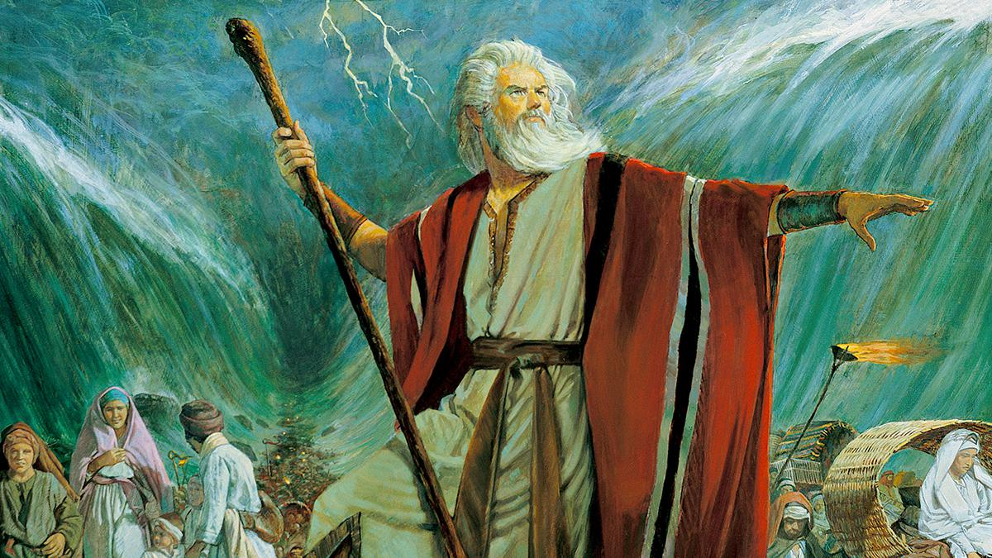 

The only time we see someone similar today is under an overpass, and it taints the idea of prophecy. Perhaps our concept of a prophet and/or prophecy recalls someone doing supernatural feats, pointing out sin, or bringing the wrath of God. These things may have seemed appropriate long ago but feel out of place today. Let’s update our thinking.

The definition of the manifestation of prophecy from the Holy Spirit book is “speaking, writing, or otherwise communicating a message from God to a person or persons.” Another simple definition is “God gives us some words and/or ideas and we communicate them”.

What Prophecy Is and Isn’t

Let’s distinguish terms. “Prophecy” is a noun. “Prophesy” is a verb. “Prophecy” is the message itself. “Prophesy” is what someone does to deliver it. For instance, “Harry prophesied a prophecy at the prophecy practice session. Then it was Suzy’s turn to prophesy.” Think of these words like “Harry spoke a speech.” “PropheSy” is the action, and “propheCy” is that which is produced by the action.

Some folks envision prophecy as only predicting the future. That’s not solely the case, although it can be. The first person called a prophet in the Bible is Abraham in Gen. 20:7. Although he certainly knew a lot about the future because of God’s promises to him, it is not recorded that he foretold anything to anyone. Prophecy is both “forth-telling” (bringing forth a message from God about the past or present) and “foretelling” (bringing forth a message from God predicting the future). As the definition states, prophecy is communicating a message from God. If that message includes the future, then that prophecy is foretelling. If it is not time specific, then it’s forth-telling, just relaying info God wants shared. Is there much foretelling in the Bible? Yes – lots! Is there forth-telling? Yes – all of it! It’s all God’s word – whether it’s regarding the past, present, or future.

Ministry vs. Manifestation

Let’s distinguish between the ministry of a prophet and the manifestation of prophecy. Here’s the quick synopsis – prophets are very adept at the manifestation of prophecy. Here’s an analogy. When I was young, I played baseball. During the summer we played all kinds of baseball in the neighborhood all the time. When I was 16 our softball team won the city championship. Soon after I realized that I lacked the ability to play at higher levels and became more spiritual minded, reluctantly leaving baseball behind.

This summer we will go see the Seattle Mariners play, the local professional baseball team. They play baseball too, but on a whole different level. They hit balls thrown at them at 90 miles an hour that are curving! (Ever stand next to a highway where the vehicles go 70 miles an hour past you? Well try standing next to a baseball going 20 miles an hour faster that seems to be aiming at you then swerves away! And then trying to hit it in an approved location!) It’s almost incomprehensible what they can do. And this is in front of thousands of fans and 10 TV cameras. It is said that they can distinguish the rotation of the ball coming at them at 90 miles an hour! That kind of eye/hand coordination is not something you can teach. It is an ability that you’re born with that can only be further refined.

This is the difference between prophets and prophecy. “Prophecy” is like playing baseball and “prophets” are the pro players. I can prophesy as a prophet can, but they are MUCH better at it like pro baseball players are better at playing baseball. I once heard a prophet call himself self-deprecatingly, “a freak”. Why was that? Because he can get specific info from God about people, situations, and events almost at will. It comes easy and ‘naturally’ to him. Why? Because that’s how God energizes holy spirit in him. Remember this?

1 Cor. 12:5,6

And there are ministries being distributed to people, and yet it is the same Lord.

And there are energizings being distributed to people, but it is the same God who energizes all of them in all people.

A prophet is one of the ministries given to the church that we will discuss soon. Their ability to prophesy is spiritually “born into them” like the pro baseball player’s ability is born into them. My early desire to be a professional baseball player was misplaced because I have different gifts that need to be expressed in ways besides baseball. God energizes the prophetic ministry just as He energizes all the ministries and manifestations in all of us.

Prophecy Guidelines

Let’s talk about some of the differences and similarities of prophets and non-prophets’ prophecy. Usually saints (non-prophets) prophesy non-specific info from God bringing edification by way of encouragement and comfort to the body of saints present.

1 Cor. 14:3

But whoever prophesies speaks to people for building them up, and encouragement, and comfort.

Prophets do the same but also bring the possibility of specific direction and correction. I say “usually” because we must remember Who gives the utterance – the Spirit, God. If He wants to include info in a saint’s prophecy that is specific, it’s His option (and the saint’s obligation to not freak out and communicate it!) I think God sparingly does this because He knows that the saint might balk at sharing specific direction or correction unless they are spiritually equipped (like with a ministry) to do it. A prophetic minister is spiritually enabled to be thick skinned. Check the biblical record. When prophets share specific info to individuals, the reactions are varied. You know, when you kick the beehive of the human heart, the bees can fly and sometime sting the supposed antagonist. Some prophets have died from bad reactions to their prophecies. This is genuine “speaking truth to power”.

When I say that saints (non-minister members of the body of Christ) can prophesy specific information, that surprises some. Here’s some examples. We can see the well-known example of Ananias who ministered to Saul of Tarsus after his conversion.

Acts 9:10,17

Now there was a certain disciple at Damascus, named Ananias, and in a vision the Lord said to him, “Ananias.” And he said, “See, I am here, Lord.”

And Ananias departed and went into the house, and laying his hands on him said, “Brother Saul, the Lord has sent me—Jesus, who appeared to you on the road by which you came—so that you can receive your sight and be filled with holy spirit.”

Ananias was a “certain disciple” and Jesus chose him for a mighty task, part of which was to communicate a message from him to Saul. This event is considered by many as a turning point in the first century Christian church. It was entrusted to a “certain disciple” to prophesy, minister healing and lead into tongues (filled with holy spirit) the great persecutor turned convert. Why? Probably because no one else would do it! And God’s perspective is “Next man up!” Ananias got called to the big leagues and hit a grand slam!

Here's another example of a believer – a non-prophet – prophesying specifics.

Luke 1:39-45

In those days Mary got up and went with haste into the hill country, to a city of Judah,

and went into the house of Zechariah and greeted Elizabeth.

And it came to pass when Elizabeth heard Mary’s greeting, the baby leaped in her womb. And Elizabeth was filled with holy spirit

and cried out with a loud voice and said, “Blessed are you among women, and blessed is the fruit of your womb.

And how is this happening to me, that the mother of my Lord should come to me?

For look, when the voice of your greeting came into my ears, the baby in my womb leaped for joy.

And blessed is she who believed, because there will be a fulfillment of the things that have been spoken to her from the Lord.”

Notice that this event didn’t happen in a worship setting (which some consider the only appropriate place for prophecy) but probably near Elizabeth’s front door. Also notice that this prophecy had no witnesses. It was just Elizabeth and Mary - one person prophesying to another. This is sometimes called “personal prophecy” in some Christian groups and was like what Ananias did with Saul. Have you ever heard of a prophecy to a baby?

Luke 1:67-79

And his father Zechariah was filled with holy spirit and prophesied, saying,

“Blessed be the Lord God of Israel, because he has visited us and brought about redemption for his people,

and he has raised a horn of salvation for us in the house of his servant David,

just as he spoke by the mouth of his holy prophets from ancient times;

salvation from our enemies and from the hand of all who hate us,

to show mercy to our fathers, and to remember his holy covenant,

the oath that he swore to Abraham our father,

to grant to us that we, having been rescued out of the hand of our enemies, can serve him without fear,

in holiness and righteousness in his presence all our days.

And you, child [John the Baptist], will be called a prophet of the Most High, for you will go before the Lord to prepare the way for him,

to give the knowledge of salvation to his people by the forgiveness of their sins

because of the compassionate mercy of our God, by which the Rising Sun from on high will visit us,

to shine on those who sit in darkness and the shadow of death, to guide our feet into the way of peace.”

The Bible never calls John the Baptist’s father, Zachariah, a prophet. Yet here he prophesies to his newborn son his future and who it will be in conjunction with – the Messiah. I’m sure those hearing this prophecy never forgot it. It was electrifying! Why? Because it was energized by God and the message, timing and location were high voltage!

Although these three instances of prophecy were person to person, note that each time it was prompted by God. Ananias, Elizabeth and Zachariah didn’t just have good ideas and decide to share them. God initiated it, they responded by trusting His lead, and God energized the utterance. Notice that each prophecy was mostly edification by way of exhortation and comfort. Each prophecy also contained a little bit of specifics to the ‘prophecy receiver’.

Did you know that angels prophesy?

Luke 2:8-14

And there were shepherds in the same area, living out in the fields and keeping watch over their flock at night.

And an angel of the Lord suddenly stood before them and the glory of the Lord shone around them, and they were frightened with great fear.

And the angel said to them, “Do not be afraid, for listen, I bring you good news that will cause great joy, which will be for all the people.

For to you was born this day in the city of David the Savior, who is the Messiah and Lord.

And this will be the sign for you: you will find a baby wrapped in swaddling clothes and lying in a manger.”

And suddenly there was with the angel a multitude of the heavenly army, praising God and saying,

“Glory in the highest heavens to God, and on earth peace among people with whom he is well pleased.”

This communication came not in a worship setting but in the Bethlehem hills to a group of shepherds one night, perhaps gathered around a campfire. This was a life-changing event for them! Here’s two more prophecies in as much of a ‘worship setting’ as you’ll find outside Corinthians and Acts. These prophecies were directed towards a young family.

Luke 2:25-38

And Look! There was a man in Jerusalem whose name was Simeon, and this man was righteous and deeply religious, waiting for the comforting of Israel, and holy spirit was upon him.

And it had been revealed to him by the holy spirit, that he would not see death before he had seen the Lord’s Messiah.

And he came by the spirit into the Temple, and when the parents brought in the child Jesus to do for him what was customary under the law,

then he took him into his arms and blessed God and said,

“Now Master, you are letting your servant depart in peace, according to your word,

since my eyes have seen your salvation,

which you have prepared before the face of all people,

a light for revelation to the Gentiles, and for glory to your people, Israel.”

And his father and his mother were amazed at the things that were being said about him.

And Simeon blessed them and said to Mary his mother, “Look! This child is appointed to cause the falling and rising of many in Israel, and to be a sign that will be continually opposed,

(yes, and a broadsword will pierce through your own soul), so that the reasoning of many hearts will be revealed.”

Note that Simeon is not said to be a prophet, yet he prophesies general and specific information to Mary and Joseph. I’ll bet Mary thought she could have done without the last part of the prophecy. Nonetheless, it sustained her and especially thirty years later when Jesus suffered and died. She knew God would see her through good times and really bad times. And, of course, He did. You can bet she was part of the 120 disciples after Jesus’ resurrection and was back in the temple on Pentecost morning. Here’s another one.

Luke 2:36-38

And there was a prophetess, Anna, the daughter of Phanuel, of the tribe of Asher (she was advanced in years, having lived with her husband seven years from when she was a virgin,

and then as a widow until the age of 84), who did not depart from the Temple, serving with fasting and prayers night and day.

And in that moment she came up and began to give thanks to God and to speak about him to all those who were waiting for the redemption of Jerusalem.

Surprisingly, the details of Anna’s prophecy are not listed as the details of Simeon’s were. This might surprise some of us that value titles because Anna is called a prophetess while Simeon is called “righteous and deeply religious”. In other words, “a certain disciple”. Does this mean that us regular “untitled” saints can prophesy as good as those called a “prophet” or “prophetess”? Yes. Even I could “get lucky” and hit a base hit if I was in a major league game… if I was thrown the ball and swung the bat. Anna did what she regularly did – prophesy. Simeon hit one out of the park that day! Let’s note God’s emphasis. What’s important is the message, not the title, gender, age or even the species of the messenger. If I’m remembering correctly, God once used a donkey to send a message to a wayward prophet! So, if donkeys can prophesy, so can we! Do you?

Quality Control

Many times prophecy is utilized in a worship/church setting. Prophecy can also occur person to person – alone or in a group setting like Zachariah did after his son’s birth. The message can be non-specific or specific. It’s up to God.

Now some of us see the large scope of prophecy and think, “I don’t know if I could prophesy like Ananias or Zachariah. If I get specific in my prophecy to someone, or if someone gets specific towards me, how will I know if it’s accurate? I don’t want to hurt someone by being wrong. I also don’t want to be misled if someone prophesies wrongly to me.” These are good questions and concerns. The folks in the first century had the same concerns. Here are the ways God handled it.

1 Thess. 5:19-21

Do not quench the spirit.

Do not treat prophecies with contempt,

but test everything and hold on firmly to what is good.

“Quench” has been defined as “to put out or extinguish”. The spirit of God we have is compared to a fire and we are exhorted not “to put it out or extinguish it”. When there is much love and trust in God, it seems that there is a rise in the spiritual temperature and spiritual life abounds. God’s wants to encourage that and not tamp it down. The problem is – we still have the flesh and it sneaks its ugly head into spiritual things. This could result in a ‘tamping down’ of the spirit. How? For one thing, let’s say someone prophesies to another saint and wrongly says something inaccurate. What will the reaction be? I think ‘contempt’ would be a safe assumption. How do we handle that situation? The next verse tells us. “Test everything and hold on firmly to what is good”. In other words, we shouldn’t toss out the baby with the bathwater. And … neither should we drink the bathwater!

Fact 1. People with body, soul, and spirit still make mistakes and sin.

Fact 2. People with body, soul, and spirit can prophesy.

Fact 3. People with body, soul, and spirit are going to mess up prophecy (and other manifestations, too).

If it seems that we have a situation with an inescapable conflict, it’s because we do. It’s called “Imperfect people manifesting perfect holy spirit.” Ouch! Then, we shouldn’t be surprised when a performance is less than perfect. There’s nothing wrong with the spirit. The problem is the flesh. Again, the solution is, “Test everything and hold on firmly to what is good”. Test – what? Everything. What does that mean? It means we test every manifestation from every person, every time in every place. God says ‘everything’.

Why does God lay the responsibility on each of us to “test everything”? For one reason, we will be the one’s harmed if we drink “dirty bathwater”, right? God wants us healthy, but because of free will, it’s up to us to “check the labels” on the products we consume. Just because we are with fellow saints and/or in a church setting, there is no guarantee of perfection. God gives the utterance, but imperfect humans must relay it. And they may (regretfully) add to it, subtract from it or change it.

Now some of us are thinking, “Wow, that’s a lot of work and a high standard. Why should I do that?” The answer is, “First off, because the baby is worth the extra effort of separating it from the bathwater! And secondly, because God says so!” We are hearing from the Creator of the heaven and the earth and/or our Lord and savior. We don’t want to miss that! We don’t want to stop walking because the shoelace is undone. We should stop, re-tie our shoelace, and keep on trucking!

Perhaps after fellowship if someone prophesies incorrectly to me individually or to the group as a whole, I should have a corrective discussion with them alone as Gal. 6:1 says.

Gal. 6:1

Brothers and sisters, if a person gets entrapped in some transgression, you who are spiritual restore such a one in a spirit of meekness, watching out for yourself so that you also will not be tempted.

Note that we should correct someone who gets “entrapped in some transgression”. That indicates they habitually sin or mess up – not a one-time transgression. If someone prophesies incorrectly and it’s the first time we experience it, should we correct them? That’s probably a message of wisdom call. We all have bad days. If it happens again, the weed needs to get pulled before it takes significant root and grows. The spirit flourishes when we kill the flesh. This is as true with the manifestations as it is with our personal lives.

Rom. 8:13

For if you live according to the flesh, you will certainly die, but if by the spirit you put to death the practices of the body, you will live.

We want to maximize the spirit in our lives and in the church by minimizing the flesh’s dominance when it tries to reign. We don’t quench the spirit – we quench the flesh by emphasizing and then walking by the spirit!