Flee Idolatry

As expected, chapter 9 flows from the end of chapter 8, which we will read through with insertions to remind us of the context and thrust of the message.

1 Cor. 8:10-13 REV [my insertions added]

For if someone sees you who have knowledge [that idols aren’t real but just fake identities] reclining to eat in an idol’s temple [in a temple complex restaurant], will not his conscience, if he is weak [like a child is weak, compared to a mature adult], be emboldened to eat things sacrificed to idols?

And so by your knowledge, the one who is weak is ruined—this brother for whose sake Christ died.

And when you sin against the brothers or sisters in this way, and when you wound their conscience when it is weak [immature], you sin against Christ.

Therefore, if food causes my brother to fall away, I will never eat meat, lest I cause my brother or sister to fall away.

I can almost hear an upper class entitled saint who knows that Christ’s achievements gave us unimpeachable righteousness say, “Wait a minute! You’re not going to ever eat idol meat again? What about ‘All things are lawful’? Are you putting yourself back under Mosaic law?” Here’s Paul’s answer to that assumed objection.

1 Cor. 9:1

Am I not free? Am I not an apostle? Have I not seen Jesus our Lord? Are you not my work in the Lord?

If to others I am not an apostle, yet at least I am to you, for the seal of my apostleship is you in the Lord.

There were some preaching a form of Christianity (who will be discussed in second Corinthians) that taught that Paul was not an apostle. He asserts that he was and for proof of that, all they needed to do was look in the mirror. His ministry was how they got saved.

1 Cor. 9:3-5

My defense to those who examine me is this:

Don’t we have the right to eat and to drink?

Don’t we have the right to lead about a wife who is a believer, as do the rest of the apostles, and the brothers of the Lord, and Cephas?

One method of persuasion is to begin asking easy questions to have the listener agree before introducing controversial points where they are challenged to change their mind. Paul starts with this: “Don’t we have the right to eat and to drink?” The assumed answer is, “Sure we do! All things are lawful!” The next question is, “Don’t we have the right to lead about a wife who is a believer, as do the rest of the apostles, and the brothers of the Lord, and Cephas?” The assumed answer is “Sure we do!” (Most of the church leaders were married and had families, as did most adult men at that time.)

1 Cor. 9:6

Or is it only I and Barnabas who have no right to refrain from working for a living?

Oh, oh! We have veered off from the safe questions! This one has some teeth! The point is, “Barnabas and I, genuine serving ministers of the gospel, have a right to be supported by those we serve – you! But are we?” The assumed answer from the Corinthians is - crickets!

1 Cor.9:7-10

What soldier ever serves at his own expense? Who plants a vineyard, and does not eat the fruit of it? Or who shepherds a flock, and does not eat of the milk of the flock?

Do I speak these things from a purely human perspective? Or doesn’t the law also say the same thing?

For it is written in the Law of Moses, Do not muzzle the ox while it treads out the grain. Is it only for the oxen that God is concerned?

Rather, is it not altogether because of us that he says it? Surely for our sake it was written, because whoever plows ought to plow in hope, and whoever threshes should thresh in hope of partaking.

The evidence for his claim of support is taken from ‘wisdom’ as the Corinthians would call it – the examples of soldiers, planters and shepherds. Then he quotes Mosaic law for the benefit of the former Jews for evidence of his right to financial support. The point is:

1 Cor. 9:11,12

If we sowed to you spiritual things, is it too much if we reap your material things?

If others partake of this right over you, shouldn’t we even more so? Nevertheless,

we did not use this right, but we endure all things so that we cause no hindrance to the good news of Christ.

Who are the “others who partake of this right over you”? The government did (and does). Also, the idol temple priests and priestess didn’t work for free. In fact, no one does! Yet Paul and Barnabas were expected to. One characteristic of young people (and young Christians too) was that they think the world revolves around them. They think mom and dad work for them – and to some degree it’s true – but not forever! After a while the youngsters need to start “pulling their weight” or they will grow to become selfish, entitled and ultimately useless. Paul was helping the Corinth saints grow up and focus on Christ and not just themselves and their desires and appetites. One more analogy from the Torah.

1 Cor. 9:13,14

Do you not know that the ones working for the Temple eat of the things of the

Temple, and those who regularly attend to the altar have their portion with the altar?

So also the Lord commanded that those who proclaim the good news should live from the good news.

Here is a repeated exhortation after 5 logical analogies from ‘wisdom’ and scripture. The point is, “You think I’m not committed to ‘All things are lawful’ and Christ? Hey, I’m working for free and paying for the parchment this epistle is written on out of my own pocket! That’s as committed as it gets!”

1 Cor. 9:15,16

But I have used none of these things, and I am not writing these things so that something will be done for me, for it would be better for me rather to die than…. No one will take from me my grounds for boasting!

For if I proclaim the good news, I have nothing to boast about, for an obligation has been placed upon me. Indeed, how terrible it will be for me if I do not proclaim the good news.

God called Paul to a heavy responsibility – the stewardship of the Sacred Secret. As he carried it out, preaching the good news, he felt there was no need for boasting, because he dreaded not doing what God asked him to do! “Unto much is given, much is expected.” After starting his life as a persecuting murderer, he wanted to finish it as a glory to God.

1 Cor. 9:17

For if I do this willingly, I have a reward, but if unwillingly, I still have an administration entrusted to me.

What then is my reward? That when I proclaim the good news, I can offer the good news without charge, so as not to make full use of my right to be supported in proclaiming the good news.

Many are ignorant about this point theologically, but God called Paul to this responsibility…

Eph. 3:9

and so that I could bring to light for everyone what is the administration of the sacred secret, which has been hidden for ages in God who created all things.

Jesus first revealed to Paul the details about the time from Pentecost to the Rapture. He revealed what God did in Christ for, and in the saint. And what the saints are in Christ and when Christ returns - and how to practically live in that light. It’s in the Church Epistles.

Eph. 3:3

regarding which, when you read it, you will be able to understand my insight into the sacred secret of Christ,

What a calling! If he did it with his whole heart, God would reward him. If he didn’t, he still had the revelation and the responsibility but would be miserable. And the world would lose! How did he carry out God’s calling to him and what motived him? He discusses this.

1 Cor. 9:19-23

For though I was free, a slave to no one, I have made myself a slave to everyone so that I win even more.

And to the Jews I became like a Jew, so that I win Jews. To those who are under the law, I became like one under the law (not being myself under the law), so that I win those who are under the law.

To those who are without law, I became like one without law (not being without God’s law, but subject to the law of Christ), so that I win those who are without law.

To the weak, I became weak, so that I win the weak. I have become all things to all people, so that by every possible way I save some.

And I do all things for the good news’ sake, so that I can be a joint-participant of it.

In these verses in the Greek, the word “I” is seen 13 times. 11 times it’s used in the active voice, meaning the subject, Paul, is actively and willingly performing an action on an object. Twice it is used in the middle voice where the subject is actively and willingly performing an action on themself. Paul is not accidentally, not eating meat offered to idols. He was not “being tricked into it” or manipulated by an outside source. That would have been indicated by the absent passive voice. The point is: “I know what I’m doing and it’s purposeful. I’m doing this in fulfillment of God’s call to me and for others’ benefit (freemen, slaves, Jews, Gentiles, legalists, non-legalists, or weak – everybody). And so that I get God’s future reward. (Not to gain your praise or financial support.)”

1 Cor. 9:24

Do you not know that those who run in a race all run, but only one receives the prize? So run in such a way that you attain it!

And everyone who is competing in the games exercises self-control in all things. Now they do it to receive a corruptible crown, but we an incorruptible.

The Olympic games began in ancient Greece centuries before Paul visited. Three other Greek tournaments sprung up in the four-year interval, one of which was the Isthmian games in Corinth. Men would compete in the nude across a range of events, including running, wrestling, boxing and chariot races. Only the winner received a prize - a wreath crown - there were no silver or bronze medals. Perhaps the prize seems disproportionate but consider that poems and statues would also be made to the winner, which lined the competition perimeter. Winning a competition was a big deal, just like today.

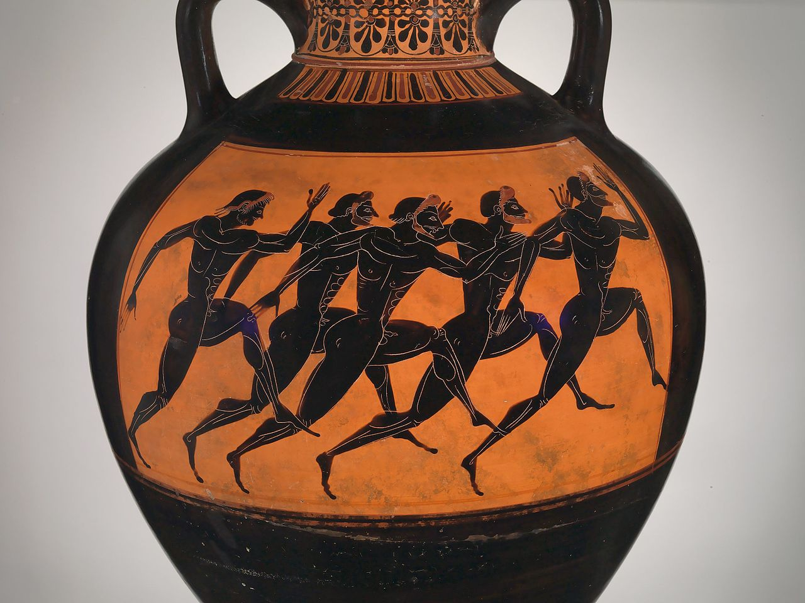

An amphora, or handled vase, picturing a race from the Corinthian games. 520 BC

How does the winning runner in the games “So run in such a way that he attains it.”? They remove any restrictive clothing - in fact, all clothing! They get themselves in great shape to compete. They face forward towards the goal. There are many other techniques racers use to win and Paul urges the Corinthians to not be only spectators, but also spiritual competitors and even beyond that – to strive to win in seeking God’s glory and other’s betterment. This is for eternal rewards, not just wreaths, poems and statues. Although those things were valuable, the winner’s statues grow discolored and disfigured from age and the poems were forgotten. In contrast, God promises eternal glory.

1 Cor. 9:26,27

Therefore, I do not run like one who runs aimlessly, I do not box as one beating the air,

but I treat my body harshly and make it my slave, lest by any means, after that I have preached to others, I myself should be disqualified for the prize.

Paul says he isn’t aimlessly shadow boxing. This describes how a boxer practices their punches without hitting anything. Although this is good offensive preparation, it misses an important aspect of competition – the competitor gets a say on the outcome. The boxer Mike Tyson said, “Everyone has a plan… until they get hit in the face!” Winning in boxing means you know how to “take a punch” too and keep fighting to the point of winning. To prepare for that means “I treat my body harshly and make it my slave”. It means you know how to tell your body to shut up when it says, “I hurt - it’s time to quit and stop this pain!” You prepare to override information from your body telling you to do things contradicting what you need to do to win. A winner learns to ignore pain and bodily desires temporarily until victory. Then, the pain and deprivation are eclipsed by the triumphal rewards.

The Corinthians needed to learn this to be successful Christians. Their bodies told them it needed sex. They didn’t fight that info but obeyed it in whatever way was most convenient. Their bodies and mind told them they needed respect, so they attached themselves to the “best” preacher to bask in some reflected glory. Their bodies said it was hungry and when food was available, they ate it, despite what their witness did to others. They needed money and instead of working hard, they sued their brothers in Christ in hope of a windfall.

They “ran the race” of Christianity “aimlessly”, detouring wherever their bodies dictated.

They needed to start acting like winners and make their bodies – their appetites, urges, and self-esteem – do what was right, not fulfilling to their flesh. God’s approval and their rewards for doing right would make it all worthwhile. Thus ends the carrot. Now, the stick.

1 Cor. 10:1-5

For I do not want you to be ignorant, brothers and sisters, that our fathers were all under the cloud, and all passed through the sea,

and were all baptized into Moses in the cloud and in the sea,

and all ate the same spiritual food,

and all drank the same spiritual drink, for they were drinking from the spiritual rock that followed them, and the rock was Christ.

Nevertheless, with most of them God was not pleased, for their bodies were scattered in the desert.

For the Jews primarily, but to the former Gentiles also, Paul uses a past scriptural lesson to bolster his persuasion. In chapter 9 he exhorted them to strive to “win”. Now he’ll describe what losing looks like. The emancipated Israelites from Egypt started out similarly to the Corinthians. They were “baptized” (into the Red Sea) like the Corinthians and also partook of the spirit. They also drank from (figuratively took inspiration and nourishment from) the Rock, Christ. But most of them ended badly and died. Why?

1 Cor. 10:6-10

Now these things became patterns for us, so that we will not lust after evil things, as they lusted.

Do not be idolaters, as were some of them, as it is written, the People sat down to eat and drink, and rose up to play.

We must not commit sexual immorality, as some of them committed, and 23,000 fell in one day.

We must not tempt the Lord, as some of them tempted, and perished by the serpents.

We must not grumble, as some of them grumbled, and were destroyed by the destroyer.

Was idolatry a problem in the Corinthian church? Regrettably, yes. The scabs of their past idolatrous entanglements were being picked by the ones with “knowledge” and little love. Was there a problem with eating and drinking? Yes. How about sexual immorality? Yes. How about tempting God, lust, and grumbling? Yes, some were even complaining about having their “freedom” limited. What happened to those Israelites who did these things? They assumed room temperature much sooner than they should have. Why? Because God gave them a choice – obedience or disobedience – with the results being – life or death. And, as the old crusader from the Indiana Jones movie said, “They chose poorly.”

1 Cor. 10:11

Now these things happened to them as an example, and they were written for our admonition, upon whom the ends of the ages have come.

Do you think that Paul was trying to scare the Corinthians? Was he saying, “If you don’t stop lusting and grumbling, you’re going to drop dead!” No. He said that Israel’s example should admonish us - confront us - to better behavior “upon whom the ends of the ages have come”. Those ages, the ages of the patriarchs and Law, ended. We have a different age, the day of man’s judgement. People don’t fall over dead (usually) from lust and grumbling immediately or we would see considerable dead air on TV. They will, however, die in the day of the Lord, when judgement is executed for those without Christ. Those of us in Christ will be judged in the future for our good works for rewards. Any expectations from church of grace members for rewards for lust, etc., will drop dead too. (Not the saints, but the expectations will drop dead. The saints still have eternal life!) Israel’s past proves that God despises and will never reward these evil practices. (So, stop it Corinthians!)

1 Cor. 10:12

So then, let the one who thinks he stands watch out, lest he fall.

This verse has been used by preachers to cause fear in the church as opposed to what God’s will truly is. God doesn’t want us fearful about attacks that could trip us up. He wants us to be confident in Him. In context “the one who thinks he stands” is like the Israelite who was confident in his idolatry before Moses returned down Sinai. Or one of the 23,00 Israelite men who died after joining Midian women in idolatrous sex, like was also being done in Corinth. If a person thinks that they will stand in these evil practices, they’d better “watch out” because after summer, comes the fall! - the fall of quality of life and the fall of the hope of rewards.

1 Cor. 10:13

No temptation has taken hold of you that is not common to humankind, but God is faithful, who will not allow you to be tempted more than you are able, but with the temptation will also make the way of escape, so that you will be able to endure it.

You can almost imagine the thinking of the Corinthians listening to the reading of this epistle in church. “It’s hard not stopping at Aphrodite’s on the way home from work. And all my neighbors are eating cheap forbidden meat and drinking from their jugs of Corinthian cabernet with slave girls whenever they want. And I am stuck with my wife and 5 kids and can’t get drunk enough to drown out all the crying and whining! Poor, poor, me!” Wait, is that a chariot horse farting I hear or just an ancient Corinthian grumbling?

Here's the solution – look to God! God will help you with these temptations. Everybody has them. Ask Him and He’ll show you a new way home and give you strength to tell your lust to shut up! And how to make your home a blessing and not a burden you want to escape from. Some of the answers are in the scriptures, some will be straight from God, and some will be from the spiritual family who has conquered these temptations already. In all these things were are more than conquerors – in Christ! The key is – get in – and stay in - Christ.

We have been given access to God. We need to use it and access God. And then limit our flesh’s desires access to our mind and heart. If we want to win at life, we must do this or we will be losers, despite any trappings of earthly “success”.

1 Cor. 10:14

Therefore, my beloved, flee from idolatry.

This was written about 50AD. Idolatry began in earnest at Babel about 2000BC. If evil spirits are behind idolatry (and this section says that), then those demons had been at it for two millennia. Note that God doesn’t say “Fight them!” or “Rebuke them.” He says, “Flee from idolatry.” These demons have been deceiving people for centuries and generations. They are good at it. Don’t play in their sandbox or you’ll get sand in your shorts and spirits in your soul. Want wisdom? Here it is - stop playing with fire. You will get burned.

1 Cor. 10:15-18

I am speaking to you as to sensible people. Judge what I say.

The “cup of blessing” that we bless, is it not a participation in the blood of Christ? The bread that we break, is it not a participation in the body of Christ?

Because there is one loaf of bread, we who are many are one body, for we all partake of the one bread.

Consider Israel according to the flesh: aren’t those who eat the sacrifices participants with the sacrificial altar?

The words “participation” and “participants” come from the Greek word translated elsewhere as “fellowship”. In essence it means to “share fully”. When we partake in the cup of Christ’s blood we fellowship with him. We remember that we share our lives and sin with him, and he shares his righteousness and sacrifice for sins (among other things) with us. The bread is like the wine. He gives us his wholeness while we share our brokenness with him. It’s an exchange – a fellowship. The same was true with the food from the sacrifices from Israel’s tabernacle and temple. Conditional sin covering was exchanged for an animals’ sacrifice on the sinner’s behalf.

1 Cor. 10:19

What am I saying then? That a thing sacrificed to idols is anything, or that an idol is anything?

But I say that the things that the Gentiles sacrifice, they sacrifice to demons, and not to God, and I do not want you to be participants with demons.

The word “participants” is from “fellowship” like the preceding verses. The Gentiles may think they are sacrificing to Aphrodite or Poseidon, but it’s really to demons. And there is fellowship involved – “full sharing” – an exchange! The partaker gives the demon something - worship, deference, honor, attention, etc. – and the demons give the partaker something… and it ain’t good! This is how lives get ruined and, regrettably those ruined rarely see it because it’s spiritual and they’re still carnally oriented. They see cheap or available meat, good wine, and great service at Aphrodite’s Annex Restaurant. They see a great social scene with agreeable “hostesses”, nevertheless they miss the unseen spiritual exchange.

1 Cor. 10:21,22

You are not able to drink the cup of the Lord and the cup of demons. You are not able to partake of the dinner table of the Lord and the dinner table of demons.

We can’t do both. God won’t share his glory with other gods, idols or demons.

Is. 42:8

I am Yahweh. That is my name. I will not give my glory to another, nor my praise to carved images.

Why should He? They are rebellious and contrary to everything He stands for. Fellowshipping with these dirtbags just angers God, as it should because they are stealing His well-deserved attention, thanks and glory.

1 Cor. 10:22

Or are we provoking the Lord to jealousy? We are not stronger than he, are we?

The older Corinthian saints thought they were “stronger” than the “weak” newer saints and could eat idol meat without consequences. But were they stronger than the Lord? No. We should stay away from any place or form of idolatry, except if we eat meat from the market with a bad history that we are ignorant of. Just because we can do something, doesn’t mean we should. We should always consider …

1 Cor. 10:24,31, 11:1

No one should seek his own good, but the good of the other person.

Therefore, whether you eat, or drink, or whatever you do, do everything to the glory of God.

Be imitators of me, just as I also am of Christ.

Thankful love for God and others is the heartbeat of a mature Christian, not knowledge. Let’s imitate that.