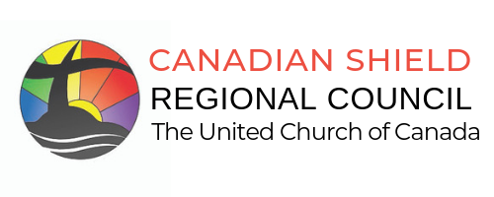
Main Office: 395 Lakeshore Drive, North Bay, ON P1A 2C5
Main Phone: 705-474-3350 | 1-833-236-0281
Website: www.canadianshieldrc.ca

Hon. Sylvia Jones,
Minister of Health, Government of Ontario
sylvia.jones@ontario.ca

Hon. Michael A. Tibollo
Assoc. Minister of Mental Health and Addictions, Government of Ontario
Michael.Tibolloco@pc.ola.org

RE: Funding for Sudbury’s Supervised Consumption Site (Minoogawbi, La Place, The Spot)

November 23, 2023

Dear Minister Jones and Minister Tibollo,

On behalf of The Canadian Shield Regional Council of The United Church of Canada, we share our full support for the work of Réseau ACCESS Network, an organization which supports those who are living with HIV, and other blood borne diseases such as hepatitis, and people who use drugs. Our strong support comes out of the many stories of their work to bring people back into the realm of high functioning adults.

Réseau ACCESS Network and the “Community Drug Strategy” members have done the set-up Sudbury’s Supervised Consumption Site (also known as Minoogawbi, La Place, and ‘The Spot’), to mitigate the enormous fatality rate - since 2018 there has been a 346 per cent increase in opioid overdose deaths in Sudbury compared to 60 per cent in Ontario, 78 opioid-related deaths this year thus far! Our Canadian Shield Regional Council Executive ask you to renew your contract with Réseau ACCESS Network immediately, if you note the statistics, that Supervised Consumptions Sites do prevent overdose deaths.

Out of a sense of neighbourliness and love, we believe that you have a responsibility to care for the vulnerable, including those who will overdose today on our city streets. Addiction treatment does not work for all people with substance use disorder, but we support any effort at medical support, especially our collective role to care for Indigenous neighbours who come from far northern Ontario communities. Réseau ACCESS Network and partners managing other Supervised Consumption Sites across Ontario, offer critical support for such neighbours. We therefore ask that you ensure that there is funding for “The Spot” beyond December 31st 2023.

Sincerely,

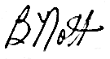

Barbara Nott
Chair, Canadian Shield Regional Council Executive
The United Church of Canada

CC: France Gélinas (Health Critic, Opposition Party) Fgelinas-co@ndp.on.ca
Jamie West (Member for Sudbury) JWest-QP@ndp.on.ca
Peter Hartmans (Executive Minister, Canadian Shield Regional Council) phartmans@united-church.ca

