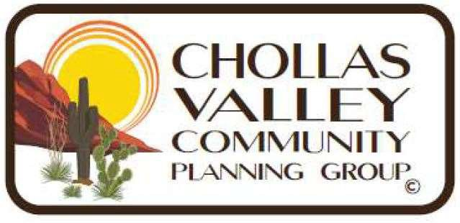

Serving: Alta Vista, Broadway Heights, Chollas View, Emerald Hills, Encanto, Lincoln Park, O’Farrell, and Valencia Park

# Robert Campbell, Acting Chair

# Sheila Mitnick, Acting Vice Chair

Chollas Valley Community Planning Group (CVCPG)

Thursday, 12 June 2025

NOTICE OF MEETING DATE CHANGE

1. The Chollas Valley Community Planning Group’s regularly scheduled meeting on June 16th 2025 is being postponed by one week due to a scheduling conflict with the June 16th San Diego City Council meeting. Given our community’s strong interest in the agenda topic at City Council we believed it was in our community’s best interest and more accommodating to deconflict.
2. The CVCPG will instead meet on June 23rd, 2025 at 6:30 at KIPP Adelante Preparatory Academy, 426 Euclid Avenue, San Diego CA 92114 (Located in Jacob’s Center lot. Closest Entry is of Market Street.)

Meeting agenda will be published in accordance with the Brown Act.

Email: ChollasValleyCPG@gmail.com