**CLUB STANDARD AND TRIUMPH INC.**

AOO49352D A.B.N.75832436055

# 97 Walls Rd Werribee 3030

## amboman@rocketmail.com

**APPLICATION FOR MEMBERSHIP.**

**I.......................................................................................... Tel.........................................................................A/H**

(Full name of Applicant).

**Of........................................................................................... MOB..........................................................................**

(Street Name)

**.............................................................................................................................. Post Code...........…………….**

**(Suburb/Town)**

**Email…………………………………………………………………………….**

**Occupation……………………………………………**

**Would you like to receive your newsletter via Email ?......................**

**Would you allow other members to contact you?..........................**

**.........................................**  (Birthday) **................................ ............................**  (Birthday)**..............................**

(Signature) **(Day & Month only)** (Spouses Name)  **(Day & Month only)**

**REFERRED BY. …………………….………**

**Annual Subscription $35.00**

**Joining Fee $15.00**

**TOTAL $50.00**  **cheques or money order to Club Standard and Triumph INC**

**or direct debit Bendigo bank b.s.b 633_000 a/c 129212296 and include your name.**

**Forwarded**

**CARS OWNED YEAR COMM / VIN BODY TYPE RESTORED UNRESTORED**

**MODEL.................................... ……… ………........................... ..……………………**

**..................................... ……… ………........................... …………………….**

**..................................... …….... ……….. ........................... …………………….**

**Reverse side of the page needs to be completed for acceptance to the club. P.T.O**

(Club use only)

Date Received............................Welcome Letter Sent……….

Membership No.......................... Receipt No......................

**C.S.T. Vehicle Registration Form**

**NAME: TELEPHONE:**

**ADDRESS:**

**VEHICLE DETAILS**

**Make ____________________ Model _____________________ Year _______**

**Saloon _____ Estate _____Ute ______Tourer_______ Panel Van______ Other ______**

**Horse Power _______No. Of Cylinders _______Petrol _______Diesel_________**

**Registered Or Not ________Registration Number _____________**

**Previous Registration Number If Known _____________Chassis No.____________**

**Engine No. ________________________ Commission No. __________________**

**Body No._________ Colour _______ _Trim colour______________**

**Transmission: 3speed_______4Speed_______Auto______Overdrive______**

**Condition: Excellent _______Very Good _______Good _______Poor_______**

**Mileage _______________ Year Purchased____________**

Even if you have a bucket of bolts or is under restoration please include as many details possible

as it all helps the club registrar to compile a realistic fact of when and where your vehicle was built.

Please send with photo of vehicle and application form

### 

If you have more than one vehicle (who hasn’t) regardless of it’s condition

please feel free to photocopy this form.

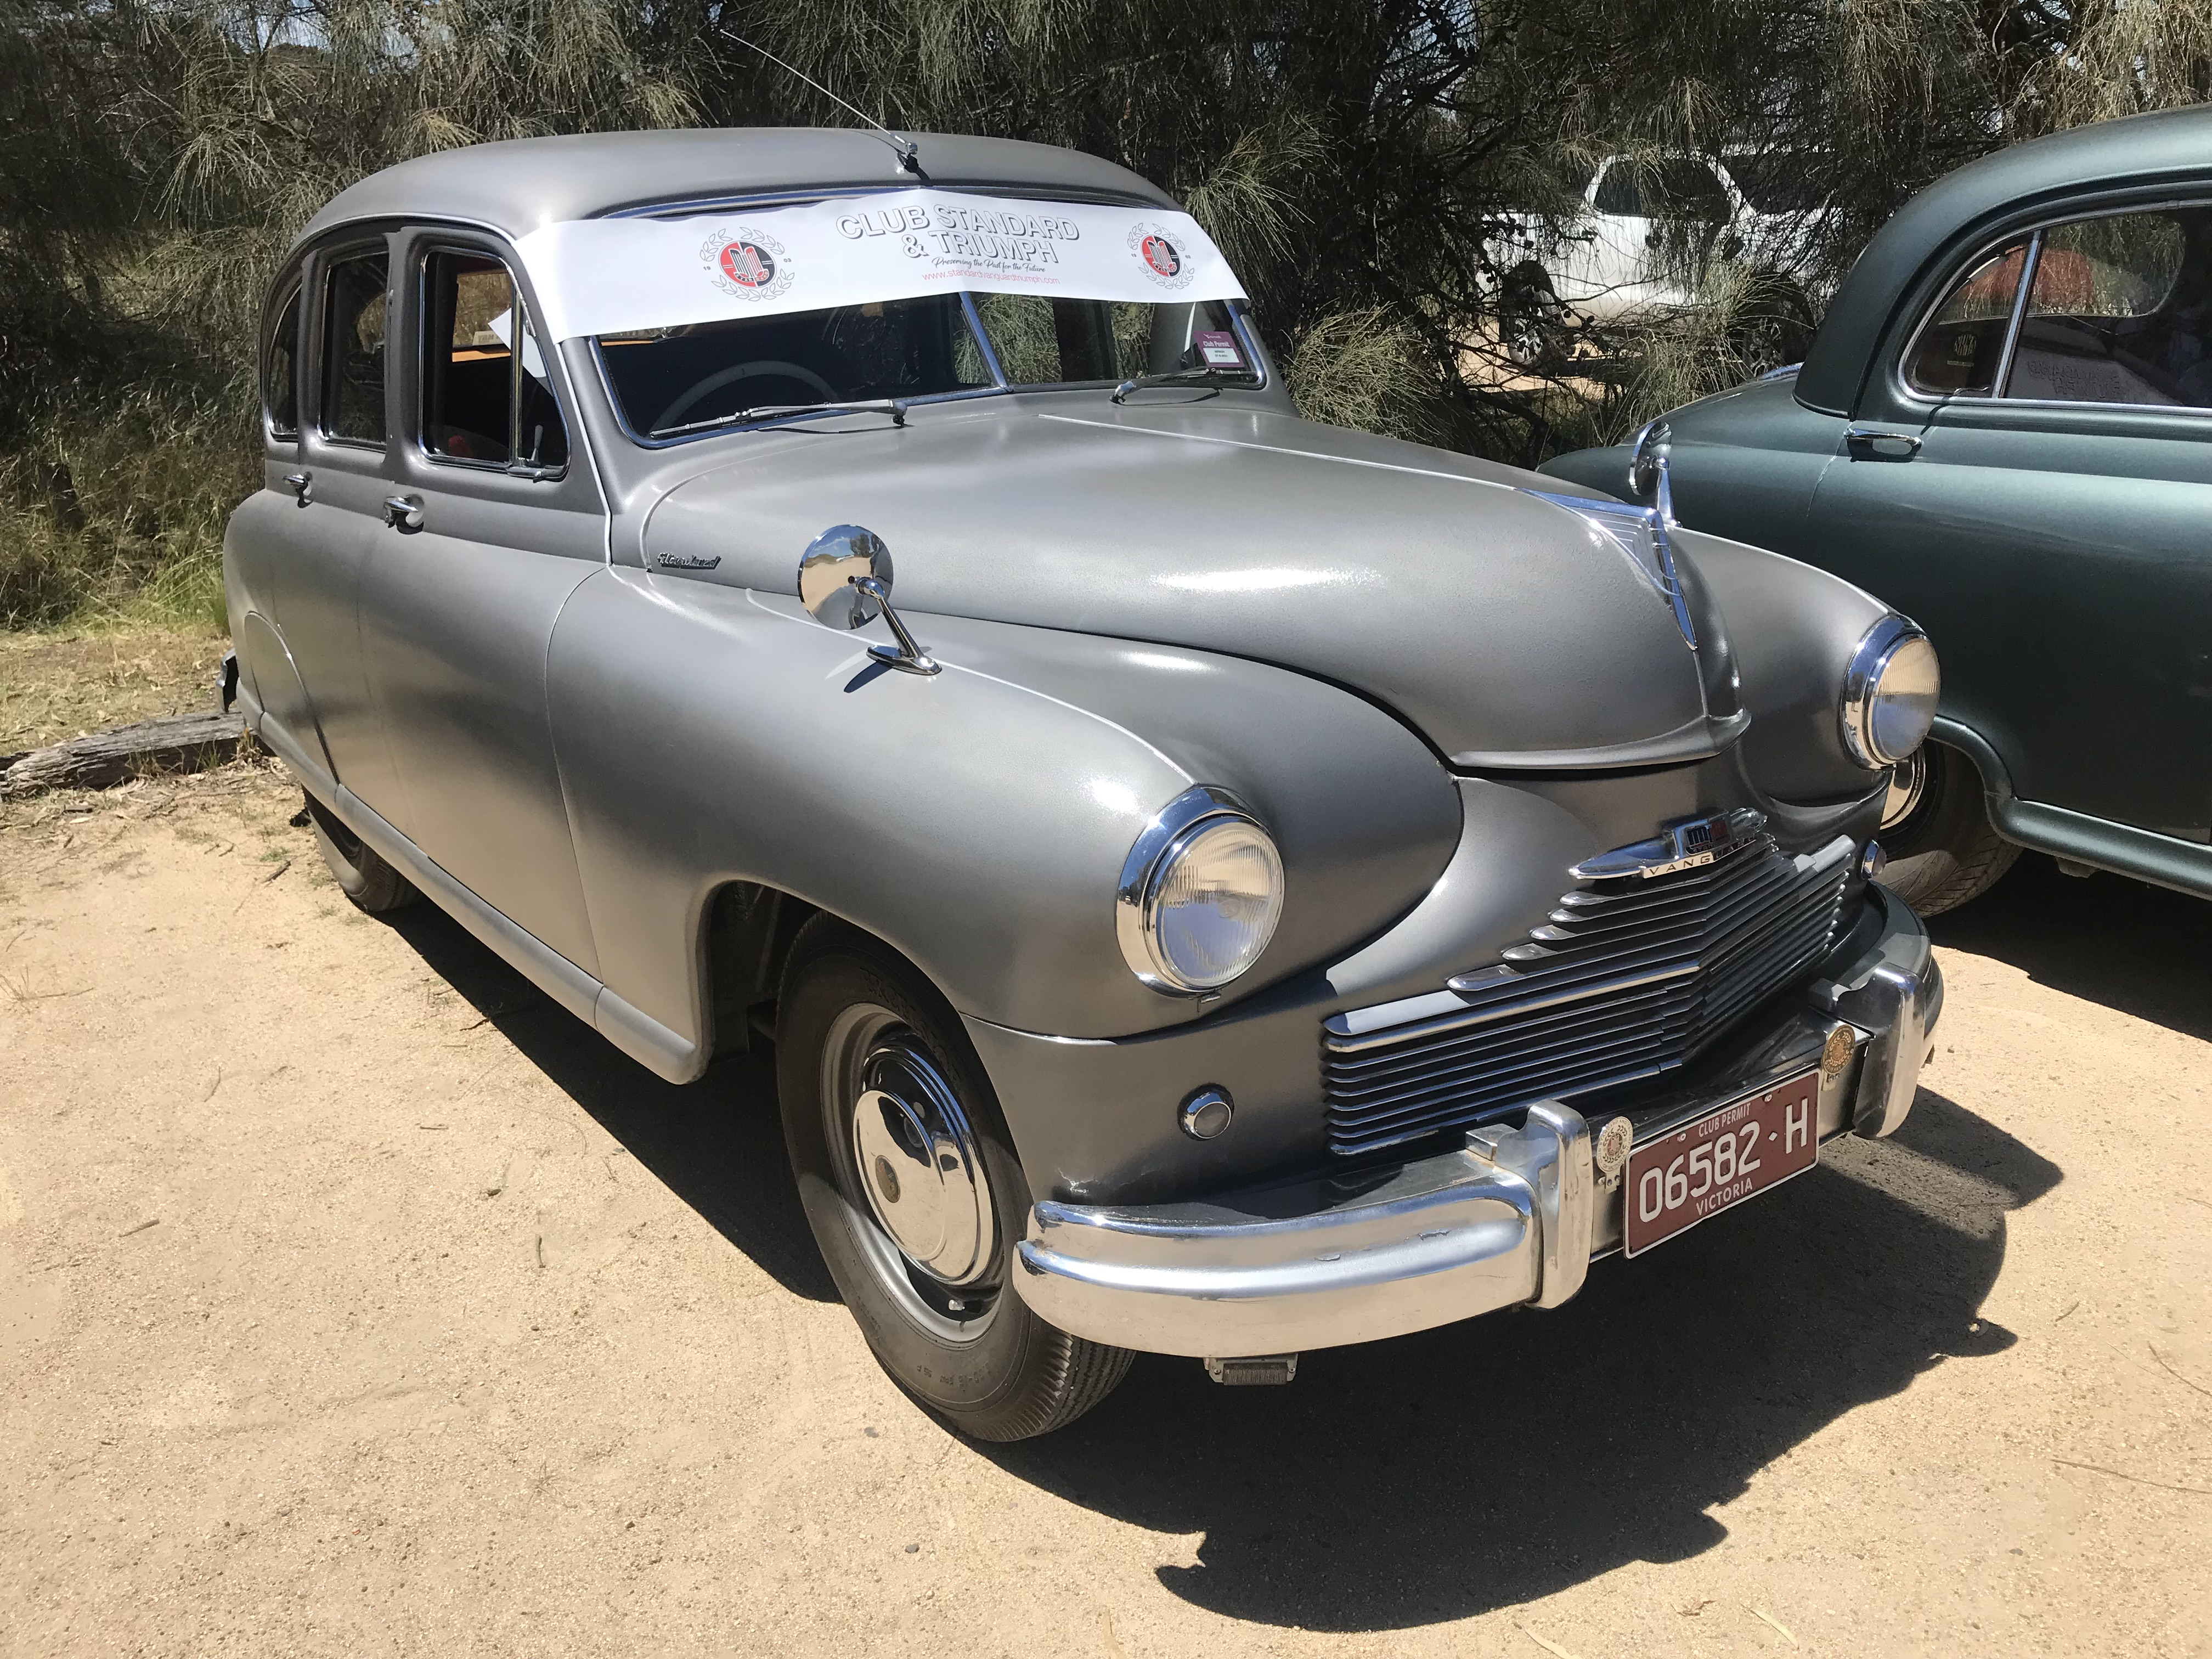

Sample of what we need to appease Vicroads.

Shows front including number plate. 4” x 4” minimum