Pine-Strawberry Fire District
P.O. Box 441  Pine, Arizona 85544 Phone: (928) 476-4272  Fax: (928) 476-4634
Website: www.pinestrawberryfiredistrict.com

RESIDENTIAL EMS LOCK BOX PROGRAM
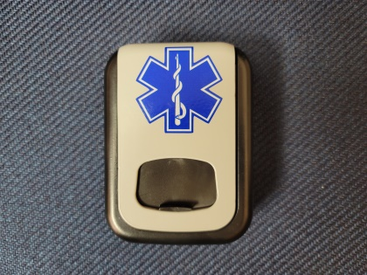

The Pine Strawberry Fire District is pleased to announce the launch of its Residential EMS Lock Box Program. Lock Boxes will be made available to residents of the fire district or any contracted service area, for installation at living places for the purpose of providing a rapid means of access by first responders to the premises in the event of a reported or suspected medical emergency. This program is not available for commercial properties where the Knox Box program should be used.

Participants must submit an application and a liability release prior to installation and participation in the program. Participants who do not own their residence must also show proof of approval of the property owner via signature on the application. Applications are available as fillable or printable PDF’s on our website, psfdaz.com. They may also be picked up at our administrative office, 3741 North Prince Drive; Pine or at either station. Once completed and signed, they can be dropped off at the administrative office, scanned and emailed to psfdfm@gmail.com, or mailed to the attention of the Fire Marshal at PO Box 441; Pine, AZ 85544. Applications will be reviewed by the Fire Marshal to determine eligibility, completeness, and for recording.

Program availability will be dependent upon and subject to available funding and continued fire district appropriations. All EMS Lock Boxes will be assigned a serial number and remain the property of PSFD and must be returned if the participant no longer wishes to participate in the program. Participants will NOT ever be given the combination code to the EMS Lock Box.

Lock Boxes will only be installed within two (2) feet of the main entrance to the structure and clearly visible from the path of approaching first responders. Participants will provide a key or a residential door code to the installer prior to start of installation. The installer will place the key or code in the lock box after installation. Any damage resulting from installation requires a digital photo of the damage and notification of the Fire Marshal or Fire Chief prior to leaving the premises. Emergency Medical information and contact information may be placed on a small piece of paper inside the EMS Lock Box. Information should be limited to that commonly found on medical alert bracelets.

