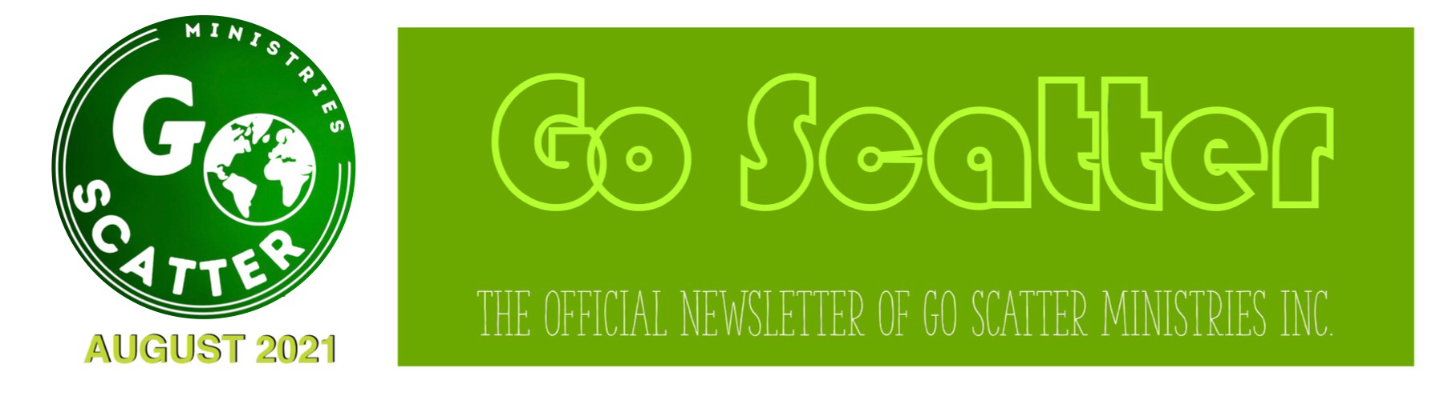
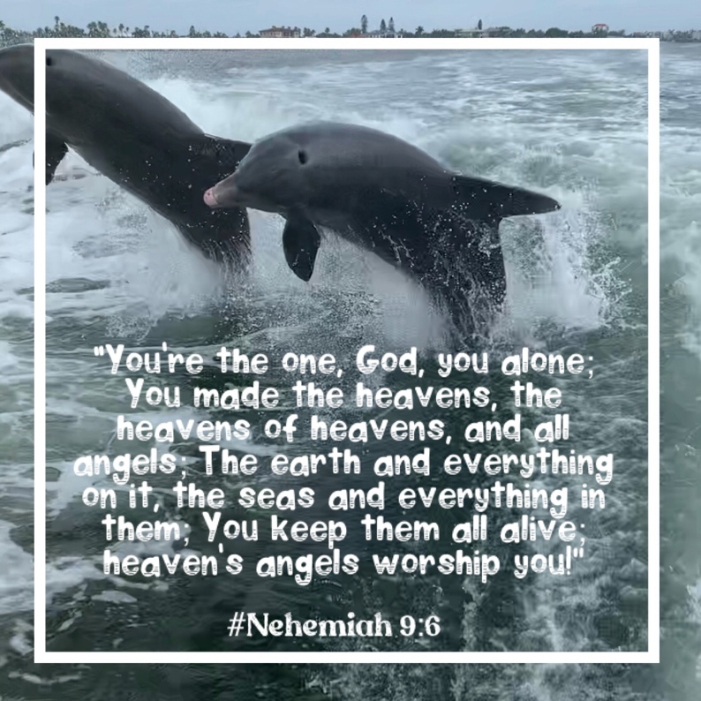
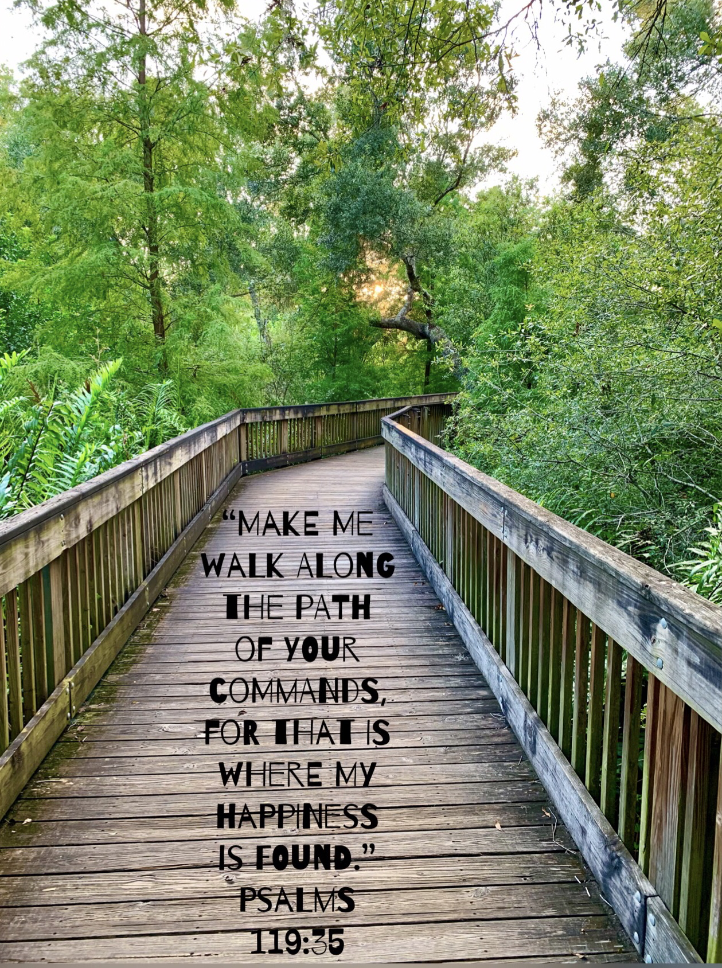
Welcome to the August 2021 Edition of the Go Scatter Newsletter!!! In addition to highlighting some of the events from The summer I will share what is ahead for The Fall.

Blessings!
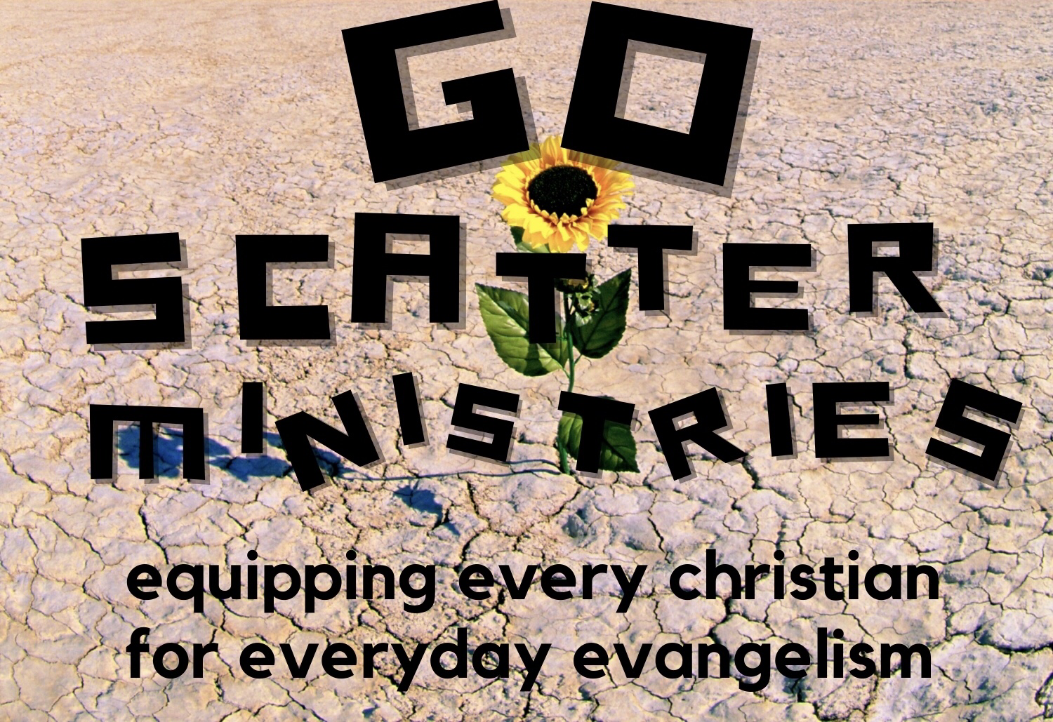
Pastor Randy

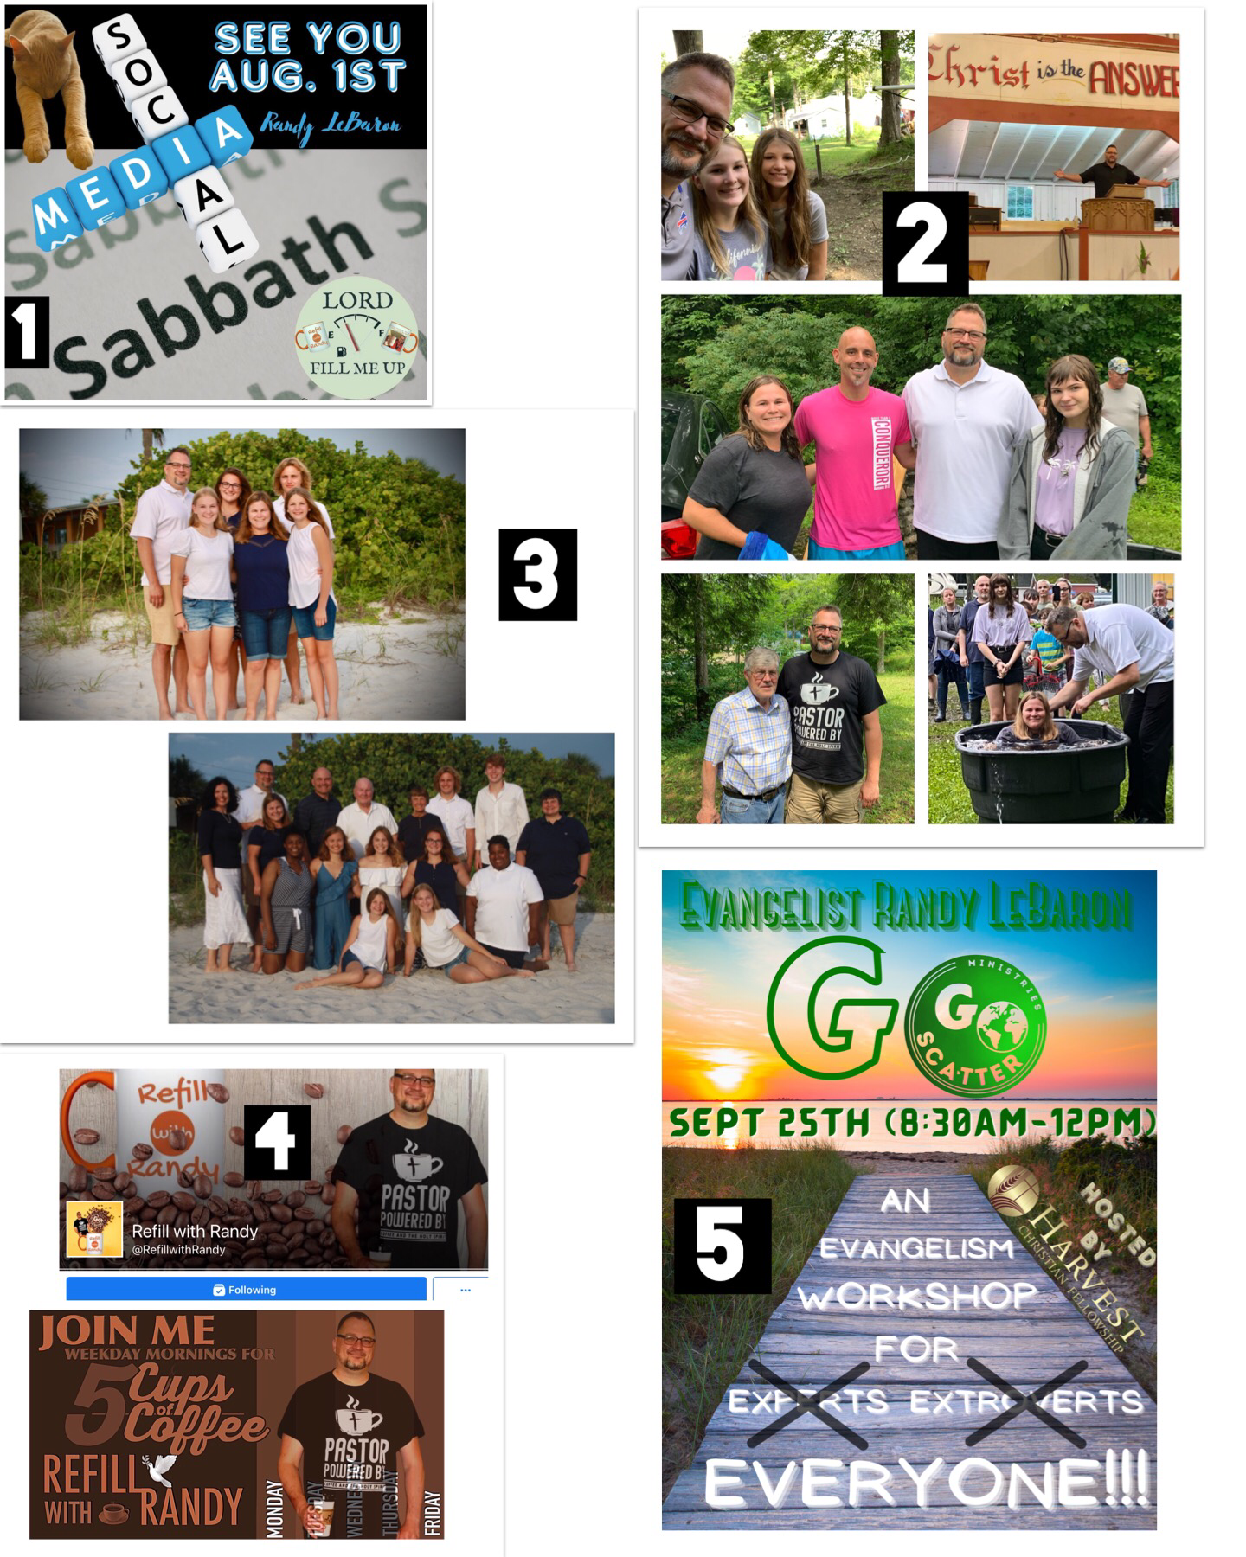
- I started off the summer by taking a much needed Sabbatical from social media in order to disconnect from the world and reconnect more intentionally with God and my family. I believe that taking these sort of breaks are beneficial physically, mentally, emotionally, and spiritually during this digital age that we live in and I would encourage you to do the same from time to time.

- It was the summer of camps! On the first Sunday in June I preached at Lighthouse Community Camp and then for 8 days in July I served as the Evangelist at Cattaraugus Christian Family Camp. My family and I enjoyed experiences immensely and a personal highlight for me was being able to baptize, among others, my wife Sheryl!

- After 2 yrs. of staying close to home due to Covid-19 and travel restrictions my family and I were able to finally get away for a week at Madeira Beach where we were joined by Sheryl’s parents, siblings, and their families.

- Among other changes coming this Fall will be a reboot of “Refill with Randy” featuring both video content as well as a written blog. In order to not miss anything please follow “Refill with Randy” on FB, Instagram, YouTube, and Twitter. You can also sign up to receive blog posts at goscatter.blog or the GSM Newsletter at goscatterministries.org

- I had the privilege of preaching at Harvest Christian Fellowship last month and next month they will be hosting me for a half day Everyday Evangelism Worship.

Looking Ahead…
- In August I will be speaking at Pearce Church in North Chili (8/7-8/8), Medina First Baptist Church (815 & 8/22), and Oakfield-Alabama Baptist Church (8/29). On Labor Day I will be speaking at Community Fellowship Church.
- For the remainder of September through at least the end of November I will be serving as the interim Preaching Pastor at FreeChurch.net which currently meets Sundays @11am at Brighton Presbyterian Church.

Please Pray…
- That I might the make the most of every opportunity God gives me to share the gospel in both word and deed!
- That I might reach a larger online audience through social media, the web site, and the blog.
- That I might impact others for The Kingdom through my volunteer efforts counseling at the Care-Net Pregnancy Center, praying and serving others on the Hands 4 Hope Street Ministry truck, being available to support local law enforcement as an Orleans County Sheriff’s Chaplain, working with other pastors through P.A.C.T.(Pastors Aligned for Community Transformation) and offering pastoral care to those in need of advice and encouragement.
- That I might transition to the next phase of my speaking ministry which would be less pulpit fill and more event, retreat, and conference speaking and training events.
- That I might secure full funding through the end of 2022 through the ongoing gifts of donors, GSM Ministry Partners, and GSM Church Partners. I am hoping to add a number of individual donors at each level as well as at least one more church at each level. Currently between gifts pledged and honorariums received I have reached ½ time and hope to be ¾ time by the start of 2021 with a goal of being full-time and fully funded by the start of 2022.

If you would like to give a one-time gift or consider becoming a GSM Ministry or Church Partner please go to goscatterministries.org or contact me at randylebaron@gmail.com to find out how.

AND FINALLY, PLEASE JOIN ME IN WELCOMING OUR NEWEST BOARD MEMBERS TO THE GSM FAMILY…

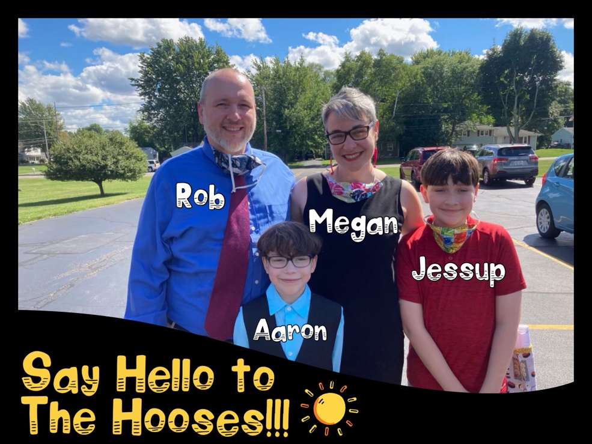
I have known the Hooses for decades having met and becoming friends with Rob during my undergrad at Robert’s Wesleyan College and getting to know Megan first as her camp counselor at Covenant Acres Camp and then as one of her Jr. High Youth Leaders at Pearce Church. Between ministering together previously and having the privilege of officiating at their wedding 20 yrs. ago I am very excited to have them join the GSM Team!

Rev. Megan Hoose and her husband, Robert have ministered together in a number of settings ever since they first met in 1998, while serving as counselors at Covenant Acres Camp. Megan graduated from Northeastern Seminary in 2006 and served as a hospital chaplain from 2005-2010. She was ordained in the Free Methodist Church as an elder in 2009. She has continued to minister in various capacities (camp pastor, family chapel speaker, adult Bible teacher, teen program co-leader) in Christian camping programs such as Covenant Acres youth camps, Lighthouse Christian Getaway Camp, and Cattaraugus Family Camp ever since. Megan served as a regional ambassador with International Childcare Ministries from 2014-2020, traveling and speaking on behalf of sponsor children and promoting church partnership programs. Megan has also taught courses in Humanities at Roberts Wesleyan College since 2015, which, in addition to her two boys, Jessup (13) and Aaron (10), is her primary discipleship field.

Robert Hoose has been actively involved in youth ministry in a voluntary capacity for more than 20 years, beginning with youth camps and continuing throughout college. He served on the Roberts Wesleyan College summer ministry team in 1997, as a counselor at Chamber Camp (Beaver Dams, NY) and Covenant Acres Camp (Pike, NY) for a number of years, and has led the youth program at Cattaraugus Family Camp (Cattaraugus, NY) (some of them co-led with Megan!) for several years. Robert and Megan had the privilege of serving together on a short term trip to Haiti in 2015 where they worked alongside Haitian locals with Eden Reforestation Projects to plant trees. Robert and Megan continue to volunteer in their local church (Pearce Church, North Chili, NY) leading Bible studies and serving in youth and college student programs.

