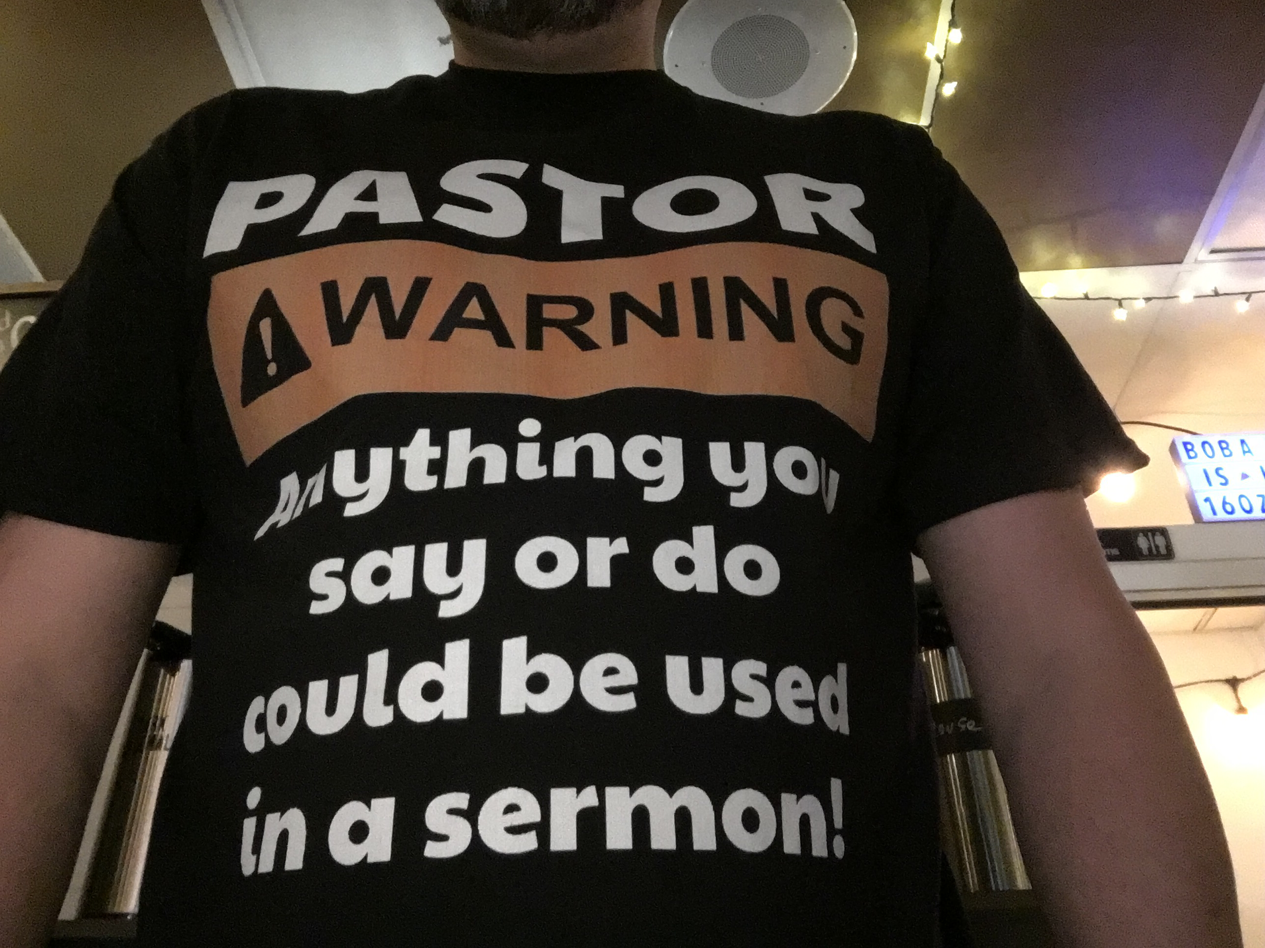
Welcome to this edition of the Go Scatter Newsletter!!! In addition to highlighting some of the events from April & May I will share what is coming up the second half of 2021.

Blessings!
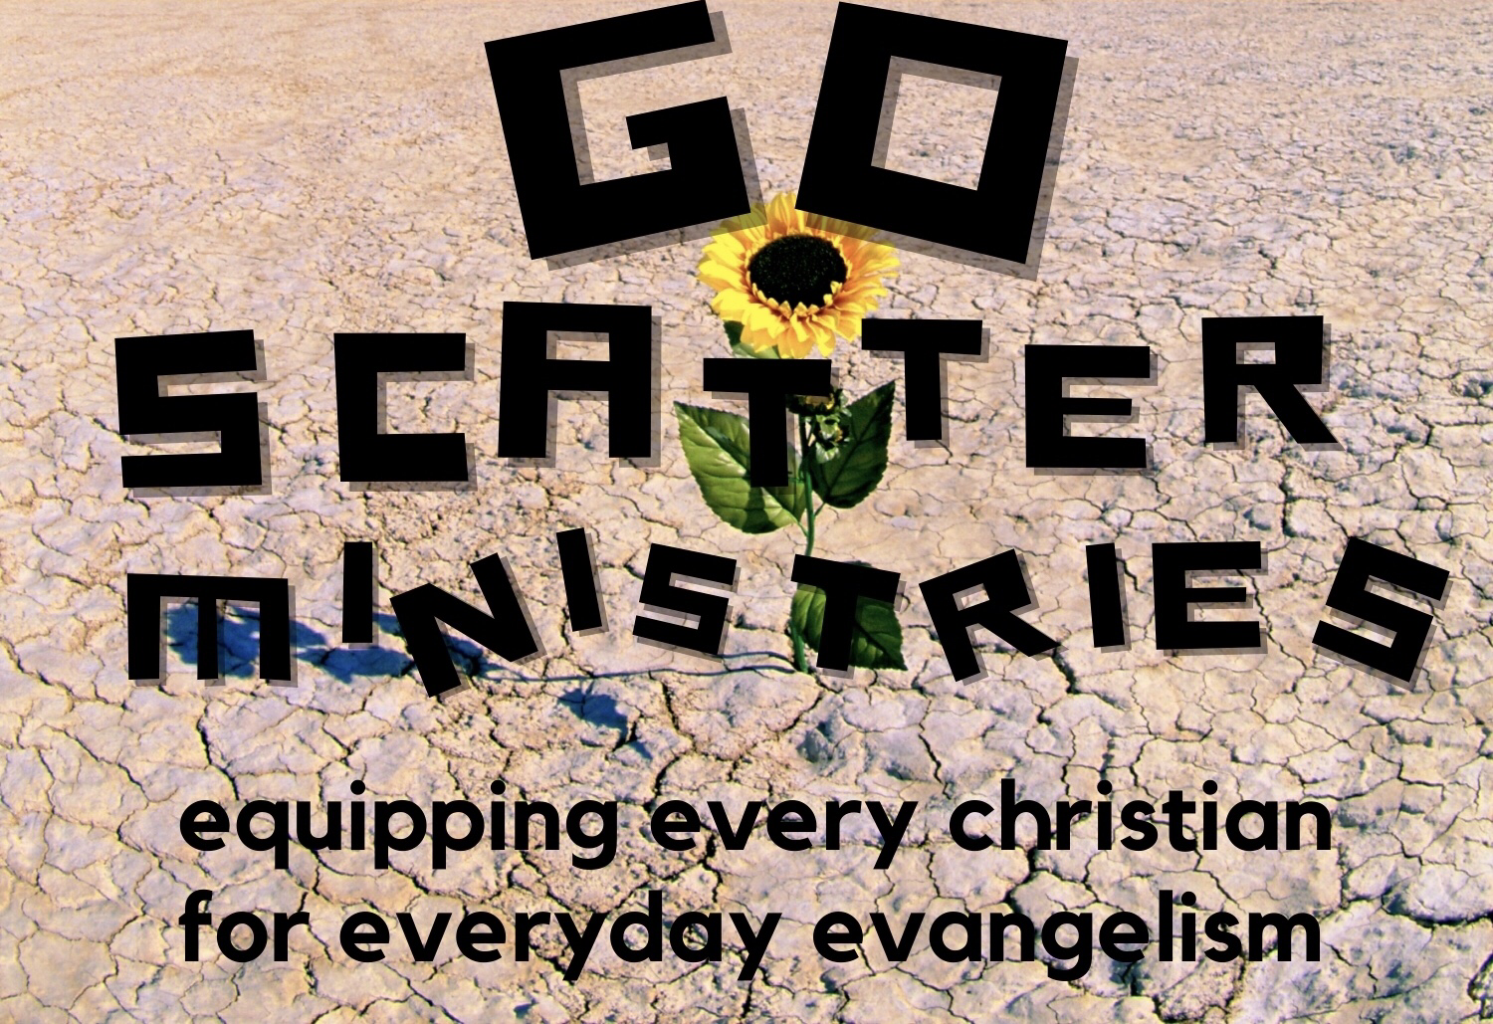
Pastor Randy
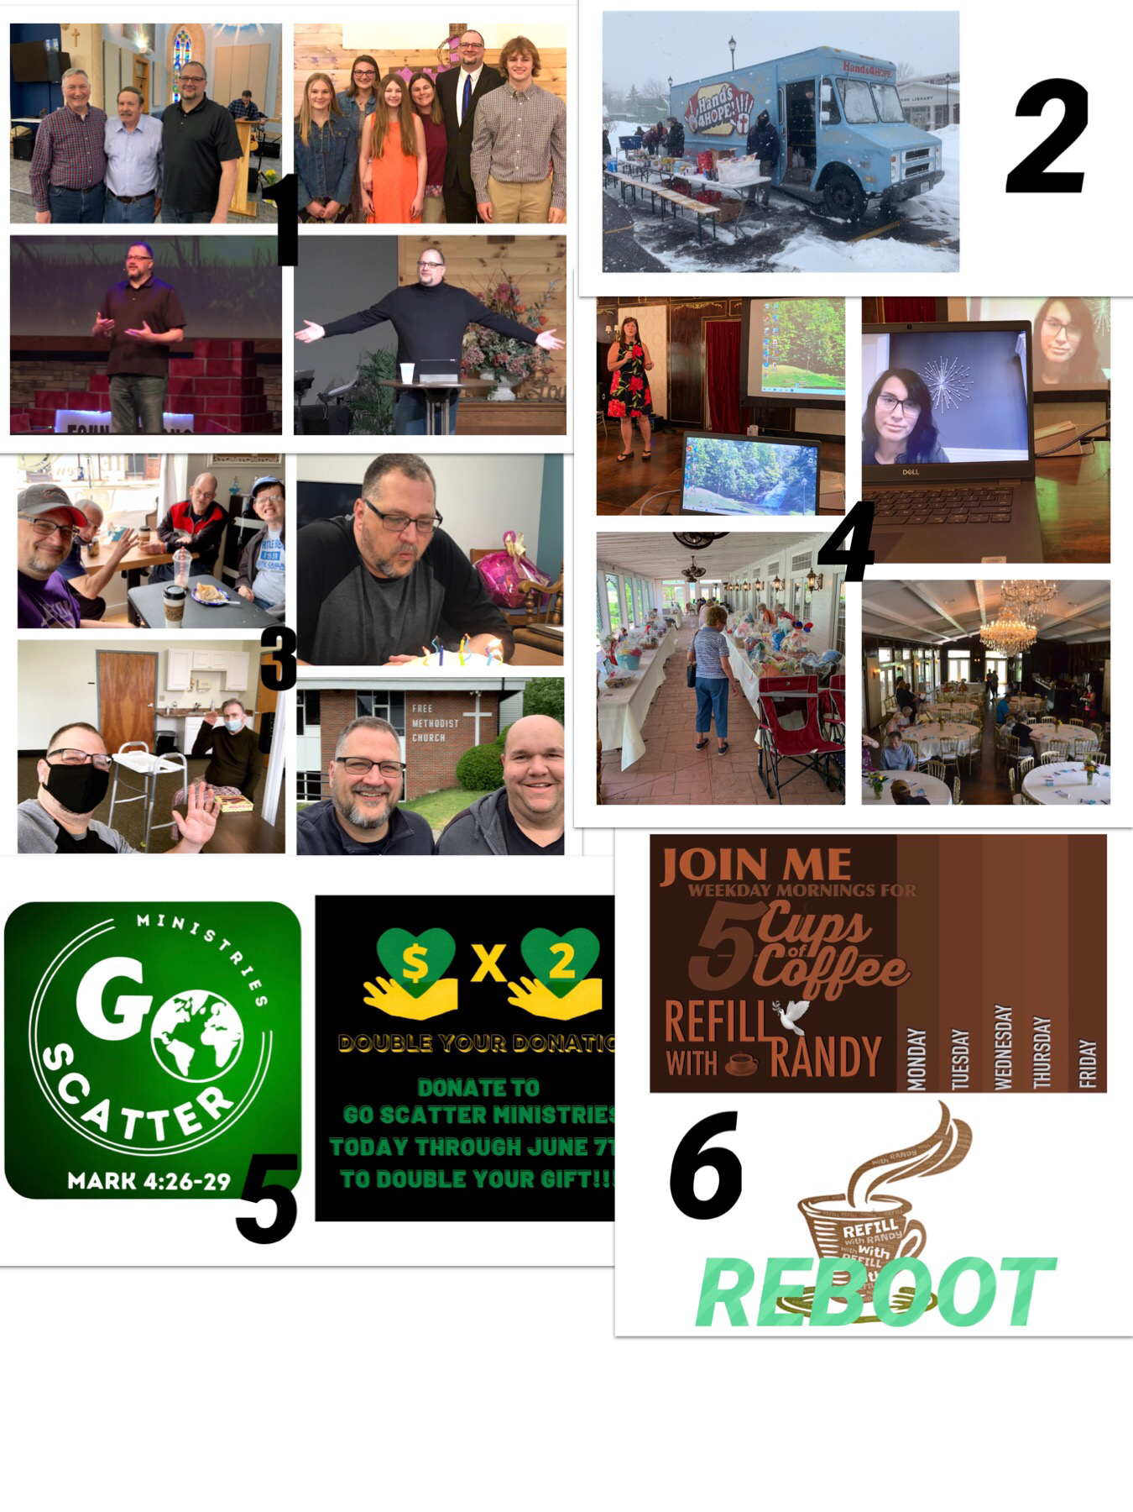

- I started April off by sharing at Grace Ridge Church’s Easter Service. I am not often with my whole family for worship between my travels and the fact that Ashlyn has been away at college but we did all get to spend this special day together. I spoke there again later in the month in addition to preaching at FreeChurch.net and Gowanda FMC. I also taught at a Men’s Conference alongside Pastors Rich Allis & Woody Woodson.

- In April Hands 4 Hope added four more stops a month on Wednesday evenings. On those occasions that I have been able to serve I have had amazing prayer times with the many who come for food and hope. I am thankful for Jack Burris, Kevin Lemcke, and the many other “Hands” who keep this ministry going week in and week out!

- One of the things that I love to do is gather with friends and other Christ followers. (Top Left) ARC Coffee Group, (Top Right) celebrating my birthday at The Care-Net Center of Greater Orleans with a delicious carrot cake made by the Director Wende Swick, (Bottom Left) after more than a year of not being allowed to visit residents at our local nursing home I finally got to go and see my good friend Larry Shea face to face, and (bottom right) my friend Jason Runge and I visited Gerry FMC a week after it was closed. It was a sad event but thankfully we could focus on a lot of good memories from the start of my ministry to Jason & Jessica’s wedding.

- The place that I have probably spent the most time, and subsequently seen the most fruit, is the Care-Net Center of Greater Orleans. First off, I am privileged to be able to serve alongside some of the best staff and volunteers who have a heart for The Lord and for both parents and babies that need to be cared and advocated for. In addition to setting aside Tuesdays to counsel the male clients that come to The Center I also assisted with our large fundraiser for the year, a Garden Gala, by securing donors for the online basket auction, producing videos to be shown on site, and helping run the audio/visual elements during the gala along with fellow IT wizard Kyle Holz. This past month was also marked by having the privilege of helping a young father come to know Jesus and then having his girlfriend ask Lee Anne, the Client Services Manager, to help her make the same commitment the very next week.

- After months of trying to come up with a new logo for GSM, and not being content with any of the designs that I had commissioned through Fiverr, a friend turned me on to Canva.com where I could create it myself. I also have another opportunity for new gifts given through June 7th to be doubled up to $2,500! If you are interested you can participate by either giving online or writing a check. You can find out more about both options at my website GoscatterMinistries.org or by e-mailing me at RandyLeBaron@gmail.com

- COMING THIS FALL!!! A reboot of “Refill with Randy” with all new videos via FaceBook and YouTube along with a new blog that will come out every weekday!

THIS SUMMER…
- I already have 15 speaking opportunities, including serving as the Evangelist at Cattaraugus Christian Camp, so please pray as I spend time preparing the messages so that God would tailor each one as needed.
- My family and I are going away for our first full family vacation since the start of Covid, and possibly our last one for a while as the kids balance college, work, sports, etc., so please pray for safety and making good memories.
- Pray that I might have a much needed time of renewal. Between being busy at camp and then away on vacation I have decided to take a social media sabbatical during the month of July in order to disconnect mentally and reconnect spiritually. My next newsletter will be coming out right after in August so I will catch you up on everything at that time.
HOW CAN I BE PRAYING FOR YOU?

