Trust Mookie With the Moment
Every gathering has a reason behind it. Tell us what you are planning, who you are bringing together, and what you want the experience to feel like. Your answers will help Mookie begin shaping the right food and service for your occasion.

Client Information
Full Name: _______________________________________________
Phone Number: ___________________________________________
Email Address: ____________________________________________
Preferred Contact Method:
☐ Phone ☐ Text ☐ Email

This form begins the consultation process and helps Mookie understand your vision. Completing it does not confirm availability, reserve a date, or create a service agreement. The starting prices shown below are provided for planning purposes; final pricing and booking details will be provided after the event needs are reviewed.
Client Initials: ____________________

Event Information
Event Date: _______________________________________________
Requested Service Time: __________________________________
Estimated event end time or requested service duration: __________________________________
Event Location: ___________________________________________
Estimated Guest Count: ___________________________________
Occasion or Event Type: __________________________________
Event Theme, Colors, or Special Details:
________________________________________________________________
________________________________________________________________

Service & Experience
Which service level best fits your event? Select one.
☐ Prepared Food Only — Starting at $25 per guest | $500 minimum
Food preparation and disposable catering packaging. Customer pickup.
☐ Delivery & Setup — Starting at $40 per guest | $800 minimum
Prepared food, local delivery, and basic buffet setup.
☐ Staffed Catering Experience — Starting at $65 per guest | $1,500 minimum
Prepared food, delivery, buffet setup, service staff, food-service support, and breakdown of Mookie’s service area.
☐ Private Dining Experience — Starting at $95 per guest | $950 minimum
Customized menu planning, on-site preparation, elevated presentation, meal service, and kitchen cleanup.
☐ Not sure — I would like Mookie’s recommendation.

Preferred Dining Format
☐ Drop-off
☐ Buffet
☐ Family-style
☐ Plated dining
☐ Open to Mookie’s recommendation
☐ Other: ______________________________

Venue & Setup Details
Will food service take place indoors, outdoors, or both?
☐ Indoors ☐ Outdoors ☐ Both ☐ Not sure
Will a working kitchen or food-preparation area be available?
☐ Yes ☐ No ☐ Not sure
If a kitchen or preparation area is available, which features can Mookie use?
☐ Oven ☐ Stovetop ☐ Refrigerator ☐ Freezer ☐ Sink/running water ☐ Electrical outlets ☐ Loading or staging access ☐ Not sure
Which items are available at the venue? Select all that apply.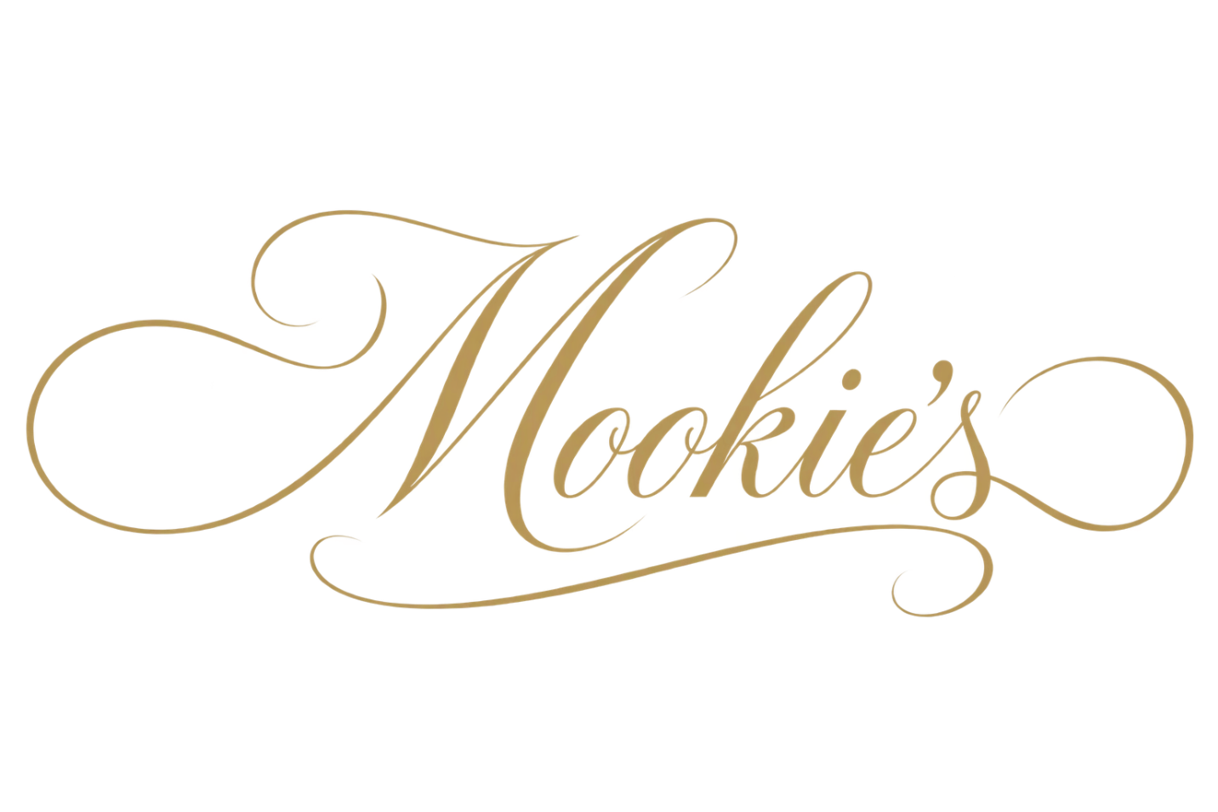
☐ Tables and seating
☐ Linens and place settings
☐ Serving equipment
☐ None
☐ Not sure
Additional service needs:
☐ Event rentals through a third-party provider
☐ Additional service staff
☐ Extended service time
☐ Cleanup beyond Mookie’s food-service area
☐ Not sure — I would like Mookie’s recommendation

Event Rentals
Tables, chairs, linens, place settings, and other event rentals are not included in Mookie’s starting prices. Rental coordination may be arranged through a third-party provider and added to the final proposal.
Final pricing depends on the menu, guest count, location, staffing, equipment, rentals, and requested service elements. The minimums shown above apply to the corresponding starting service levels.

Culinary Preferences
Preferred Cuisine or Cultural Influence:
________________________________________________________________
Foods, dishes, or flavors you would like included:
________________________________________________________________
Foods or ingredients you would prefer to avoid:
________________________________________________________________
Known food allergies or dietary requirements:
________________________________________________________________
If allergies or dietary requirements apply, approximately how many guests require accommodation? ______________________________
Mookie’s takes food allergies and dietary requirements seriously. However, food may be prepared in environments where common allergens are present, so an allergen-free environment and complete protection from cross-contact cannot be guaranteed. Final accommodations must be reviewed and confirmed before booking.

Flavor Direction
What kind of food experience are you looking for?
☐ Bold & Flavorful
Rich seasoning, confident flavors, and memorable combinations.
☐ Comforting & Familiar
Food that feels welcoming, satisfying, and made for gathering.
☐ Light & Refreshing
Bright, balanced flavors with a lighter approach.
☐ Elevated & Indulgent
Richer dishes and a more refined presentation.
☐ Health-Conscious & Balanced
Thoughtfully prepared food that prioritizes balance without sacrificing flavor.
☐ A Mixture of Styles
A balanced combination of familiar, bold, light, or elevated dishes shaped around the occasion.
☐ Trust Mookie
Give Mookie the freedom to create the experience based on your occasion, guests, and preferences.

Menu Direction
How much of the menu have you already decided?
☐ I have a specific menu in mind ☐ I have a few dishes or ideas in mind ☐ I would like Mookie to develop the menu
Would you prefer:
☐ A familiar menu
☐ A customized menu
☐ A combination of familiar and original dishes
☐ I am open to Mookie’s recommendation
Would you like beverages or desserts included in the proposal?
☐ Beverages ☐ Desserts ☐ Both ☐ Neither ☐ Not sure — I would like Mookie’s recommendation
If selected, briefly describe what you have in mind: ________________________________________________
Are there any must-have dishes or family favorites?
________________________________________________________________
________________________________________________________________
Is there anything else Mookie should know before reviewing your event?
________________________________________________________________
________________________________________________________________

What Happens Next
Thank you for sharing the details of your event. Mookie will review your responses and follow up to discuss availability, clarify any remaining details, and begin shaping the right food and service experience for your occasion.
Submit Your Completed Form: Email the completed form to MookiesCatering@MookiesKitchen.com.
Preferred time to follow up: ______________________________
Different occasions call for different experiences. Trust Mookie with the moment.

