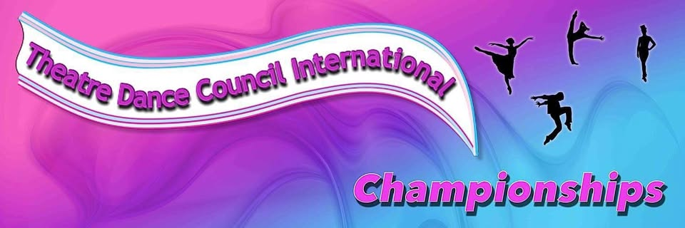
Registered Charity No 289965
2026 ENGLISH CHAMPIONSHIPS
21st – 22nd NOVEMBER 2026 BALLET, TAP, SONG & DANCE
23rd JANUARY 2027 MODERN
Official Entry Form
PLEASE PRINT CLEARLY AND CHECK THE SPELLING OF THE COMPETITIORS NAMES
Name of School ………………………………………………………………………………...
Principal ………………………………… Email …………………………………………….
Contact Address ……………………………………………………………...…………………
Post Code ……………………………. Mobile ……………………………...……………….
Association …………………………. Membership Number …………….………………....
I enclose a cheque(s) to the value of £ ……………… for the entry of …………… number of championships @ £16 per dance (Please note there are NO babies or Juveniles in these Championships)
Please make cheques payable to Theatre Dance Council international.
Closing date 1st October 2026 or when all days are full, whichever is sooner.
Return all entries and cheques to Mr Chris Booth, TDCI General Secretary, 41 Howey Lane, Frodsham, Cheshire WA6 6DD
Conditions of entry: -
- All entries must be submitted by the Dance School Principal
- Private entries from parents or guardians will not be accepted
- The organisers will be obliged to increase or reduce the days depending on the number of entries
Please fill in with the following information: -
FORENAME | SURNAME | EVENT | SECTION | AGE
 |  | BALL/MOD/TAP/S&D | JUN/SEN | ON ACTUAL DAY OF COMPETITION
Official Entry Form
School Name …………………………………………………………………………………………………
FORENAME | SURNAME | EVENT | SECTION | AGE

