In victory for Harvey victims, Army Corps found liable for flooding damage upstream of Addicks, Barker reservoirs
Gabrielle Banks Dec. 17, 2019 Updated: Dec. 18, 2019 9:56 a.m.
Comments
6
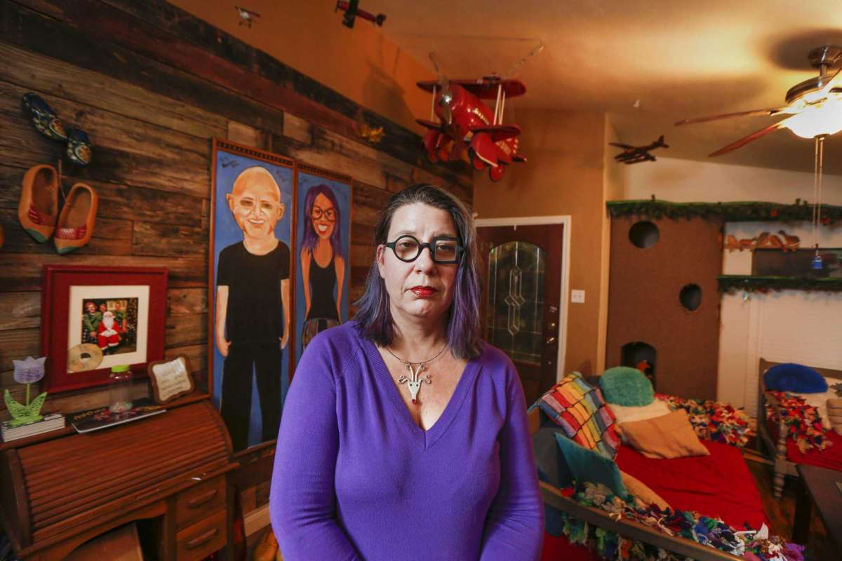
1of6Elizabeth Burnham, a Houston artist who sustained five feet of water damage at her Bear Creek home, is now working on getting her new home decorated with artwork Tuesday, Dec. 17, 2019, in Houston.Photo: Steve Gonzales, Houston Chronicle / Staff photographer
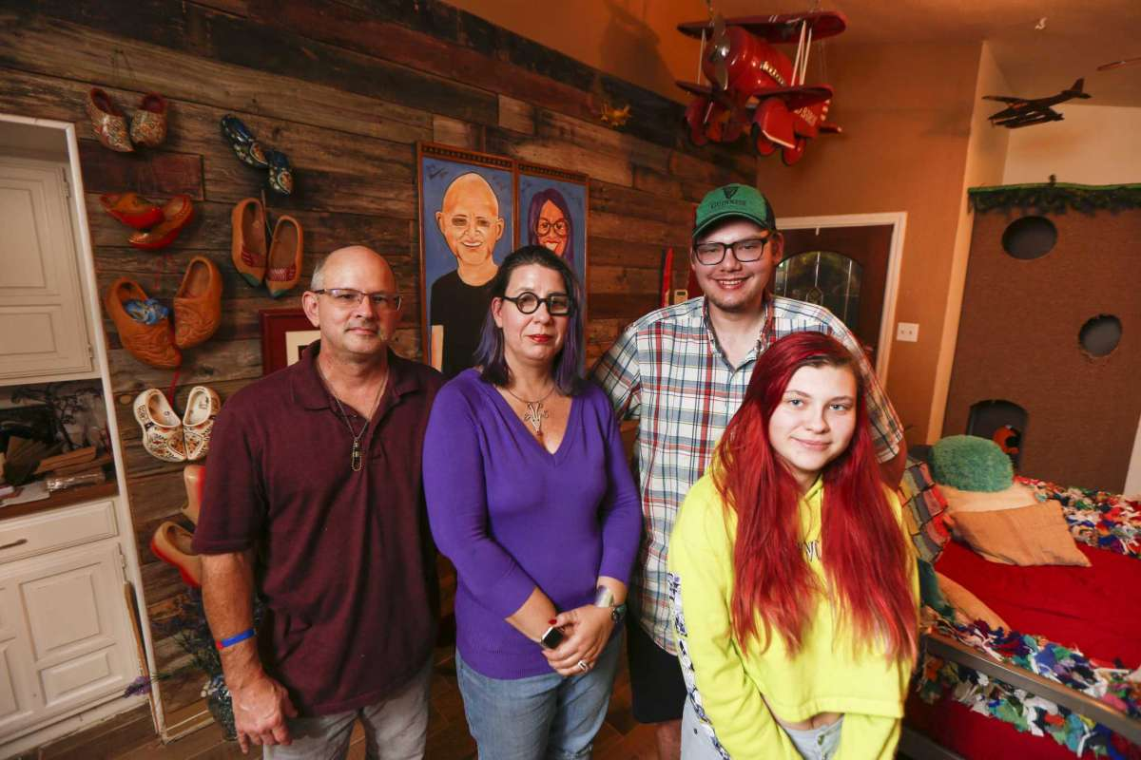
2of6Elizabeth Burnham (second from left), a Houston artist who sustained five feet of water damage at her Bear Creek home, is now working on her new home with her husband, Kenneth Gwynne (left), and her son Trysten and daughter Josena Burnham Tuesday, Dec. 17, 2019, in Houston.Photo: Steve Gonzales, Houston Chronicle / Staff photographer
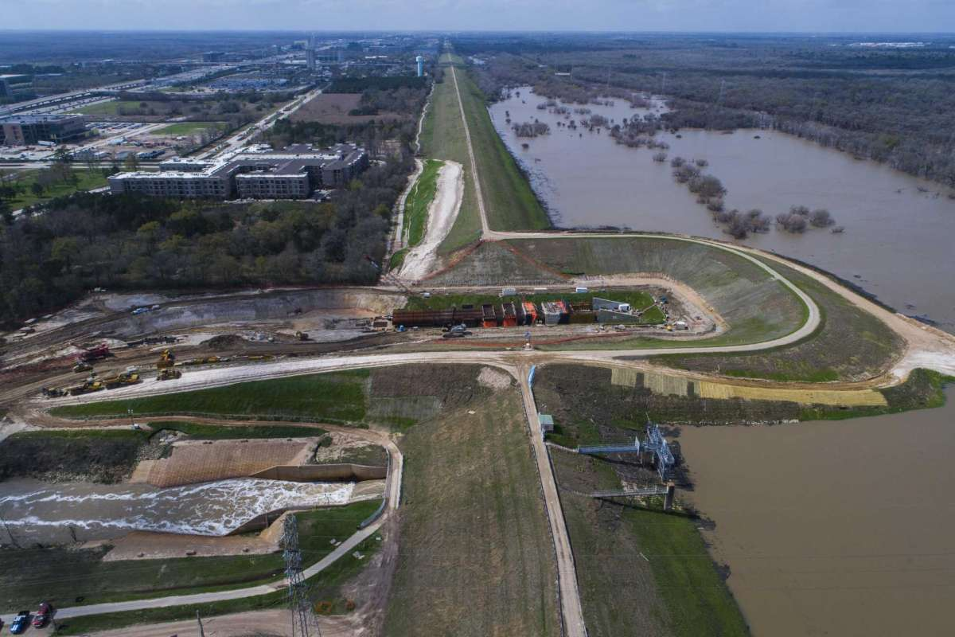
3of6Water flows out of the Addicks Reservoir down the main spillway near N. Eldridge Pkwy., Wednesday, Feb. 28, 2018, in Houston. A coffer dam is in place where the Army Corps of Engineers is building a new spillway. ( Mark Mulligan / Houston Chronicle )Photo: Mark Mulligan, Houston Chronicle / Houston Chronicle

On December 17, U.S. Judge Charles F. Lettow ruled the U.S. Army Corps of Engineers was liable for damage caused by its decision to retain floodwaters upstream of the Addicks and Barker reservoirs during Hurricane Harvey, acknowledging that the flood damage above the two World War II-era dams was a foreseeable result of government’s actions.
Judge Lettow detailed how government officials knowingly and intentionally used private property to store rising floodwaters. He ruled that the victims living near the federally owned reservoirs did not know their property was in a flood pool and that they must be allowed to seek compensation for their losses.
The Corps’ decision to retain floodwaters, designed to avert worse flooding downstream, caused major flooding in 10,000 to 12,000 properties. Attorneys for the residents and businesses that brought suit estimated that the cost of damages could surpass $1 billion.
The judge will assess evidence on damages at a hearing set for Jan. 21, 2020 in Houston. Property owners may file suit for six years from the time of the flooding.
Alma Soto, who lost her house and her home-based graphic design business in the deluge, broke into tears when she learned of the judge’s ruling. Soto called the news a “complete surprise” and “a small Christmas miracle.”
“This has been a long journey, two years-plus for our family,” said Soto, 53, who along with her husband and teenage son was displaced for six months from the Villages at Bear Creek community. “We lost our entire home and everything in it. Just to be able to know that wrong can be made right is very nice.”
On HoustonChronicle.com: Officials patched and prayed while pressure built on Houston dams
The two giant reservoirs, 17 miles west of Houston, were built in the 1940s to prevent catastrophic flooding along Buffalo Bayou in the city of Houston and the Ship Channel. Property owners said the government knew for decades that the reservoirs could not contain the floodwaters in a deluge and did nothing over decades to prevent it.
Justice Department lawyers argued during a 10-day trial last spring that Harvey — which dumped more than 60 inches of rain in some parts — was an unprecedented event that no one could have foreseen. They noted that properties across the region, nowhere near the dams, flooded.
Hundreds of property owners sued under a branch of the law that deals with temporary use of land by government entities. The ruling means that owners of properties that took on water west of the two dams may seek damages from the federal government for the harm caused in the wake of the 2017 storm.
The ruling only applies to properties upstream of the dams. A separate group of property owners that suffered flooding downstream of the reservoirs is awaiting its own court ruling following a December hearing from the Court of Federal Claims.
The court separated the cases in large part because the facts for those above and below the dams were different. “Equipped with the knowledge that storms of the design storm magnitude were probable, the Corps did not stray from its primary objective to prevent downstream flooding (indeed, it probably could not), even when it knew that could well mean impounding water on private property,” Lettow wrote.
Property owners had reasonable “investment-backed” expectations they wouldn’t be inundated, the judge wrote.
Futhermore, he said, the government had known for decades that it was likely that storm water would exceed the capacity of the government-owed storage area in a heavy storm.
“It is true that Tropical Storm Harvey was a record-setting storm,” the judge wrote in a 46-page opinion. “But the evidence markedly shows that pools of this size and the attendant flooding of private property were, at a minimum, objectively foreseeable. Thus, Harvey’s magnitude does not exculpate the government of liability for its actions.”
The judge found the government was responsible for damage based on the severity of the flooding, the length of time the properties were used to store water and the benefit to the government of retaining water.
“Plaintiffs have sufficiently demonstrated that the inundation of floodwaters onto their private property was the ‘direct, natural, or probable result’ of the government’s activity,” he wrote.
Daniel Charest, among the lawyers who argued on behalf of the the flood victims, said, “We are extraordinarily pleased for the upstream flood victims and honored that the court found that the government was liable for the damage they suffered.”
Wyn Hornbuckle, a spokesperson for the Justice Department, declined to comment.
Addicks and Barker — created in the wake of a disaster — have played a vital role in the development of modern-day Houston, safeguarding a growing population, the Texas Medical Center and petrochemical facilities that form the epicenter of the U.S. energy economy. The dams prevent catastrophic loss of life following heavy rainfall.
The dams were created by an act of Congress following the Great Flood of Houston in 1935. Starting in 1942, the Army Corps dug up 8.4 million cubic yards of prairie and sculpted huge embankments to intercept storm runoff from across the Buffalo Bayou watershed. The government spent $5 to $10 an acre to acquire 24,000 acres of woods and wetland north and west of the dams to serve as reservoirs.
As Houston’s population grew, the government began offering easements, causing measurable consequences for the reservoirs, including increased sediment flowing into them, which caused a loss of flood storage capacity and faster runoff, according to the ruling.
Documents presented during the trial showed how public officials, including Army Corps leaders, had evidence of the mounting pressure on Addicks and Barker, compounded by urban sprawl, but they opted to wait and see.
As far back as 1973, the Corps lamented that the possibility of flooding lands in the reservoirs beyond the government-owned land was soon expected to become a public issue.
Since the early 1990s, reports have outlined the problems and identified potential remedies. But decision-makers concluded each time that the situation wasn’t bad enough to justify costly remedies.
A 1996 study highlighted a “unique, once-in-a-lifetime opportunity” to build a tunnel beneath Interstate 10 to carry water out of the reservoirs to a point 12 miles east. The cost was estimated at $325 million to $400 million. But officials chose not to act.
The Army Corps took steps to reinforce the dams and address signs of deterioration, but officials opted not to buy more downstream properties, build relief canals or add a third reservoir to intercept storm runoff before it reached Addicks and Barker.
In 2009, the reservoirs were placed in the highest-risk category of federally operated dams: DSAC I, signifying “very high urgency” for government action.
In 2011, the Harris County Flood Control District examined how massive amounts of water were overflowing from Cypress Creek into the Addicks watershed during major storms. The problem was expected to get worse, all while the population of northwest Harris County was expected to double over 50 years.
Two years before Harvey, the district issued a report on possible remedies, including building new reservoirs upstream of Addicks to collect Cypress Creek’s overflow. Harris County did not move forward on the proposals.
Charest said he encourages people in the upstream area who haven’t submitted a claim to do so.
“The window remains open for people to join the litigation, and I encourage them to do so to bring justice to the flood victims,” he said.
Todd Banker, whose home in Kellywood Park was one of the Bellwether properties involved in the trial, called the ruling “a big first step.”
Banker and his wife have a daughter with special needs whom he said “will never be able to take care of herself.” Prior to Harvey, the couple had 17 years of savings to pay for her care after they die. They lost all that money along with both cars, the use of their house and its contents.
Reyna Gamero, a teacher in Katy ISD, said she was so happy that she cried when she learned about the ruling. Gamero and her sister both lost homes upstream of the reservoirs.
“We both lost everything, we both evacuated and we both sued,” said Gamero, 51, who rebuilt the place and now rents it out.
Elizabeth Burnham, an artist who lost her eclectic home collection in Bear Creek, said she too was overcome with emotion when she learned of the ruling and had to pull over in her car. “I had zero faith in the justice system,” the 49-year-old said, but “I thought ‘we should give it try.’”
“I’m hoping when we go to damages it pays off the debt that this has incurred,” she said, adding, “I know it won’t even come close.”
gabrielle.banks@chron.com

Sign up for the Breaking News newsletter
Get breaking news alerts sent directly to your inbox.

SIGN UP

By subscribing, you agree to our Terms of use and acknowledge that your information will be used as described in our Privacy Policy.

Gabrielle Banks
Follow Gabrielle on:
https://www.facebook.com/gabrielle.banks.56GabMoBanks
Gabrielle Banks covers federal court for the Houston Chronicle. She has been a criminal justice and legal affairs reporter for nearly two decades, including staff work at the Pittsburgh Post-Gazette and The Los Angeles Times, and freelance work for The New York Times, The Mercury News, Newsday and The Miami Herald. She has a graduate degree in journalism from Columbia University. Before her years as a reporter, she worked as a teacher, social worker and organizer.

Past Articles from this Author:
- Why Houston is the armored truck robbery capital of the United States
- Veteran judge resists adding more time for man sentenced to 18 months for backing ISIS
- Would-be ISIS fighter faces re-sentencing before federal judge

