Flooded Houston-area homeowners might have been spared ruin — but only if they read the fine print

Politicians knew it. Bureaucrats knew it. Developers knew it. But homeowners appear to have received little to no notification about the danger their homes faced from government actions in case of a storm.
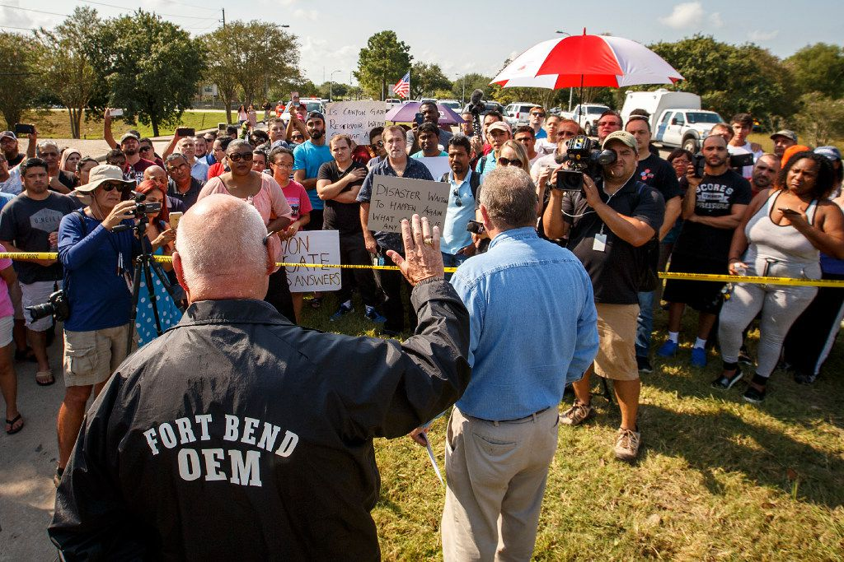
Fort Bend County Judge Robert Hebert raises his hand as he takes questions from Cinco Ranch Canyon Gate subdivision residents who gathered to demonstrate at a police roadblock outside their neighborhood in Katy earlier this month.(Staff Photographer / Smiley N. Pool)
By Naomi Martin
9:18 AM on Sep 20, 2017
HOUSTON — They sat tucked away in a Fort Bend county clerk's file for the past two decades: 25 words on a public document that could have spared thousands of homeowners from losing everything.
If only the homeowners had seen them.
In the finest of fine print, the county warned in 1997: "This subdivision is adjacent to the Barker Reservoir and is subject to extended controlled inundation under the management of the U.S. Army Corps of Engineers."

ADVERTISEMENT

In other words, during a major storm, the corps could choose to flood the subdivision in an effort to protect greater Houston.
Which is exactly what happened during Hurricane Harvey.
Now, as Houston begins a massive recovery effort projected to cost as much as $180 billion, it is increasingly clear that government officials at every level did little to warn residents in some of the hardest-hit areas that they were buying into risk — living in areas designed to flood.
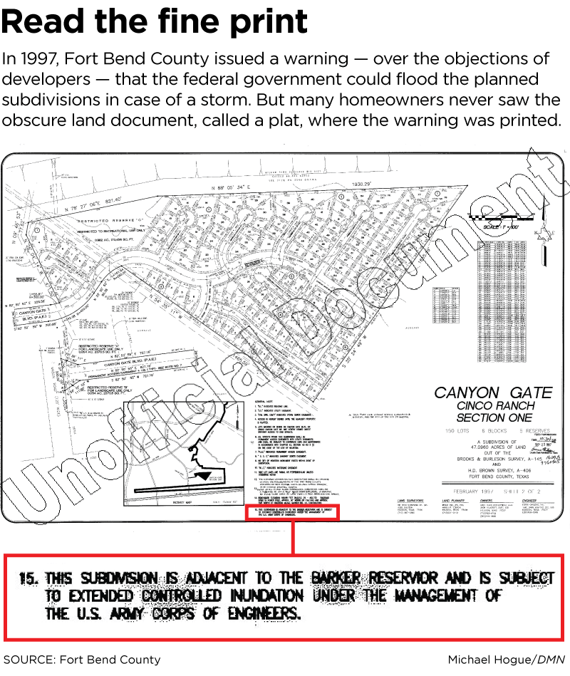
Many of the victims knew little or nothing about the risk they faced. They never purchased flood insurance. They had no clue their homes were built within government reservoirs engineered in the 1940s to fill with billions of gallons of water in case of heavy rains. The undeveloped, government-owned land inside the reservoirs had a 1 percent chance of flooding in a given year. But residents' homes just upstream, in the so-called maximum pool of the reservoirs, had a significant chance of being intentionally flooded in the event of a major storm.
"I feel cheated," said Binay Anand, 46, an engineer who lived with his wife and two kids in a $275,000 home in Canyon Gate, a subdivision in the maximum flood pool. "I was not aware — and none of the residents were aware — that this was flood-prone. If they would have told us, I would not have taken it."
ADVERTISING
inRead invented by Teads
Anand said he and his neighbors only learned since Harvey that Fort Bend County had issued notice about the corps' plan to use their property as a reservoir on the original plat, which is the county's public land record approving the subdivisions.
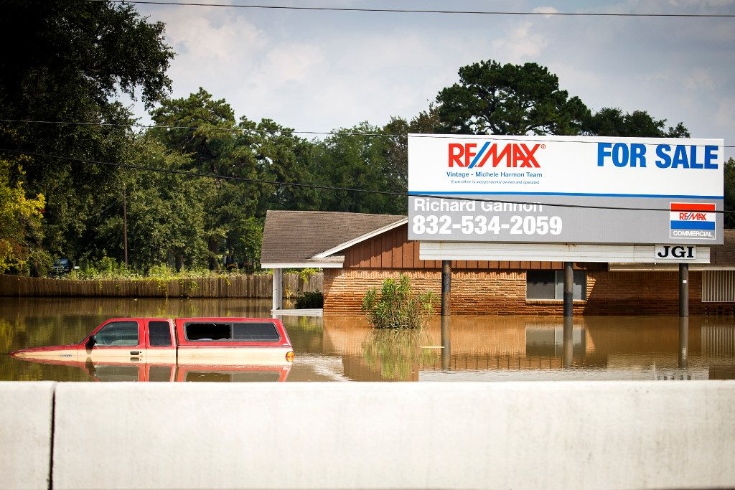Floodwater from Hurricane Harvey remained around a house on the service road of Interstate 10 near Addicks Reservoir in Houston days after the storm. (Smiley N. Pool / Staff Photographer)
Politicians knew it. Bureaucrats knew it. Developers knew it. But homeowners appear to have been offered little to no notification.
Even providing the most basic information in the plat's fine print was a political fight at the time, Fort Bend County officials said.
"It took a yeoman's effort because the developers were saying, 'You can't make us do that,'" said Richard Stolleis, the Fort Bend county engineer. "It was a pretty significant battle — a high-level discussion — before these were put on the subdivision plat."
County officials believed the plat's warning would be passed through the property's title to every prospective owner at closing. However, many residents said they never saw it. They may have overlooked it or missed it in a stack of documents, or their real estate agents and title workers may have not clearly explained the risk. State law doesn't require disclosure of such notes, experts said.
Meanwhile, Harris County residents who live within the reservoirs didn't even get that minimal official notice.
Now, as residents demand answers after having lost their homes and all their possessions, government leaders are pointing fingers at each other, saying they failed the people of Houston.
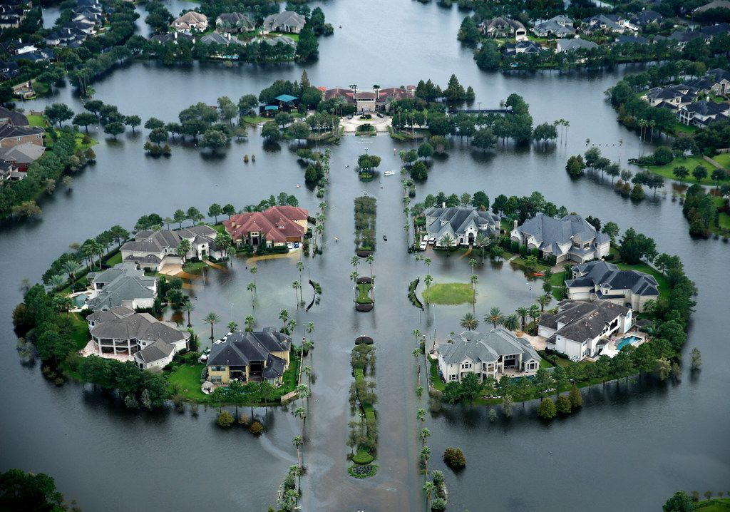
1/5Floodwaters rose into the Lakes on Eldridge North neighborhood near the Addicks Reservoir in West Houston shortly after the storm hit.(Tom Fox / Staff Photographer)
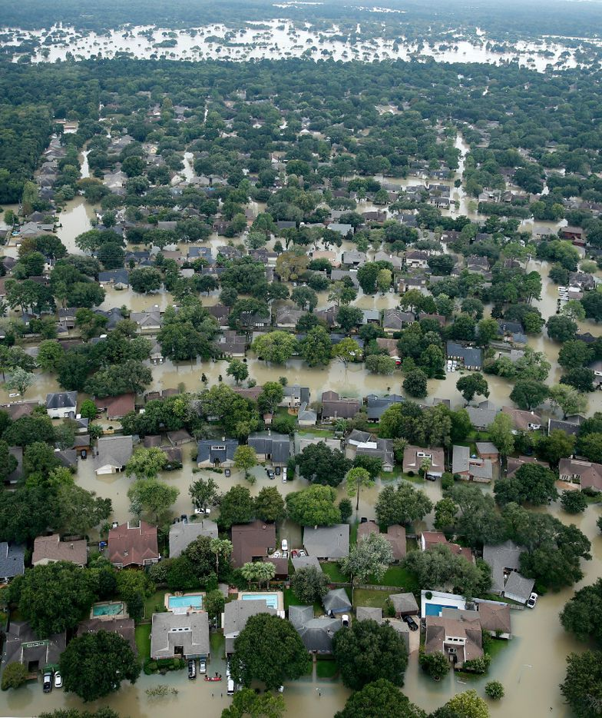
2/5A flooded neighborhood near the Addicks Reservoir in West Houston, Texas, was inundated with water, Wednesday, August 30, 2017. Hurricane Harvey inundated the Houston area with several feet of rain. (Tom Fox/The Dallas Morning News)(Tom Fox / Staff Photographer)
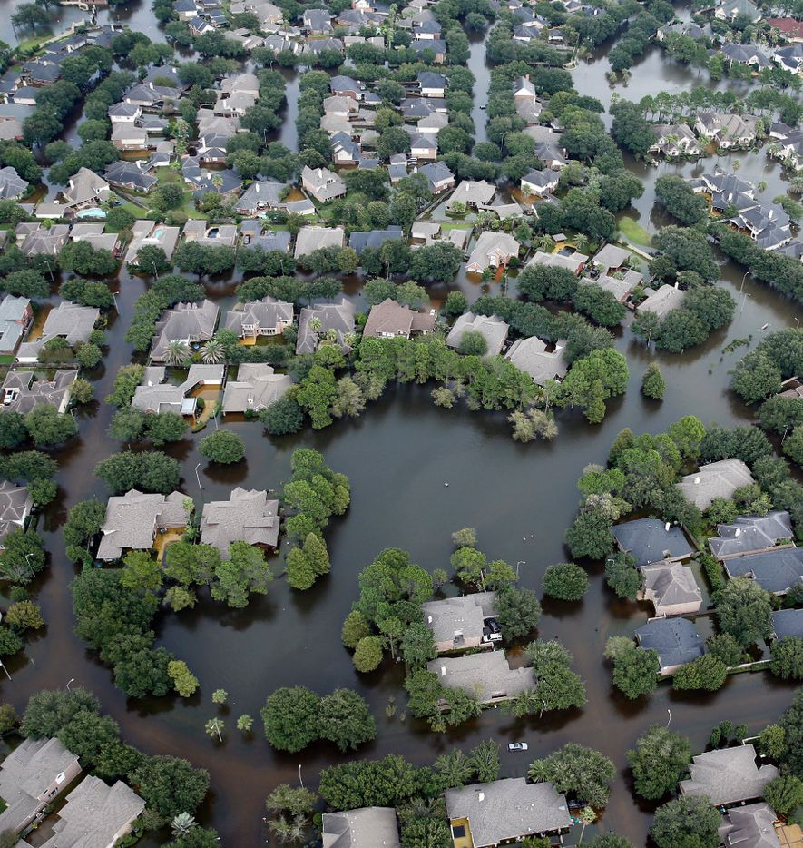
3/5A flooded neighborhood off North Eldridge Parkway near the Addicks Reservoir in West Houston, Texas, was inundated with water, Wednesday, August 30, 2017. Hurricane Harvey inundated the Houston area with several feet of rain. (Tom Fox/The Dallas Morning News)(Tom Fox / Staff Photographer)
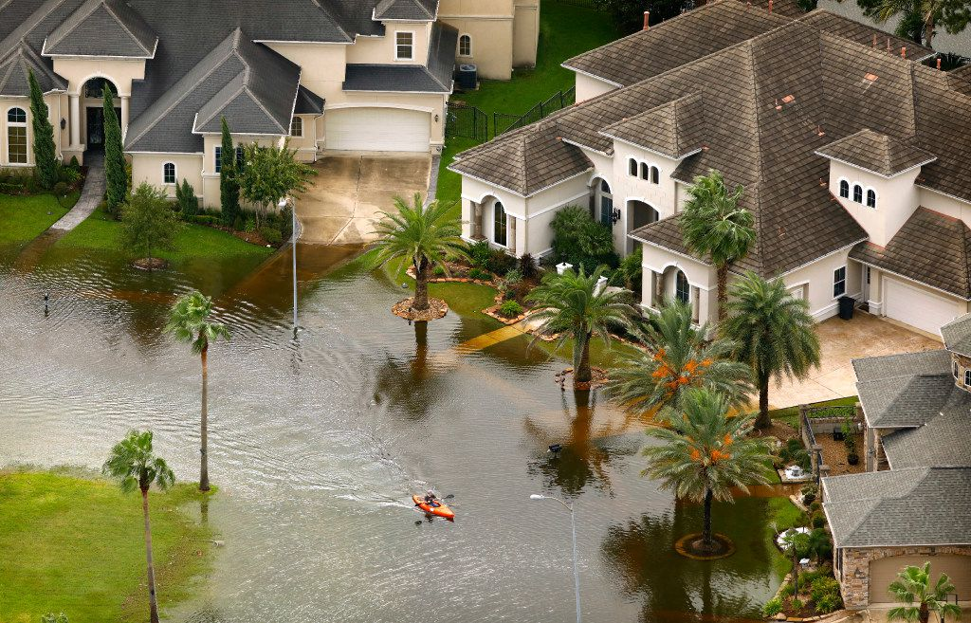
4/5A kayaker paddles through the flooded Lakes on Eldridge neighborhood near the Addicks Reservoir in Houston, Texas, Wednesday, August 30, 2017. Hurricane Harvey inundated the Houston area with several feet of rain. (Tom Fox/The Dallas Morning News)(Tom Fox / Staff Photographer)
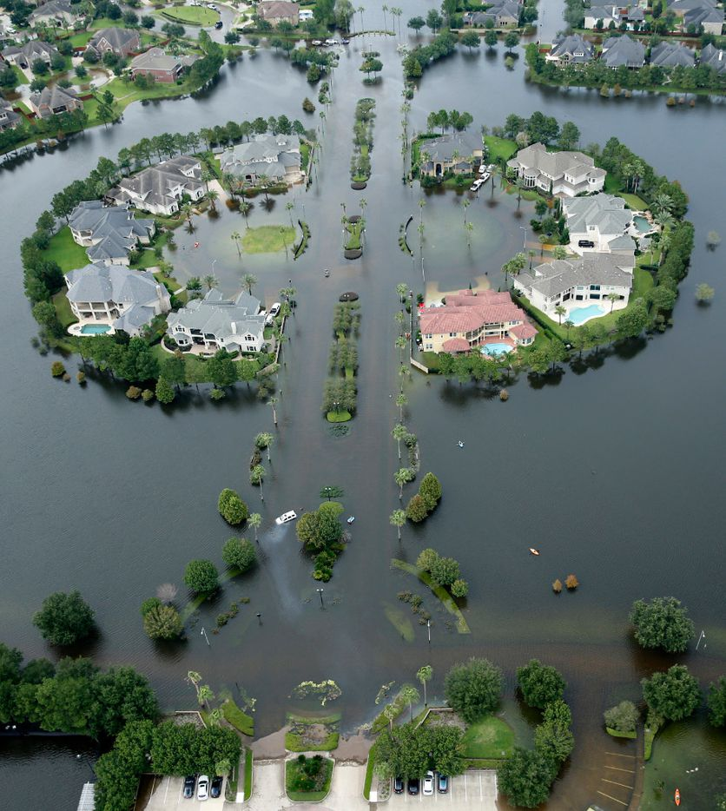
5/5Flood waters have risen into the Lakes on Eldridge North neighborhood near the Addicks Reservoir West Houston, Texas, Wednesday, August 30, 2017. Hurricane Harvey inundated the Houston area with several feet of rain. (Tom Fox/The Dallas Morning News)(Tom Fox / Staff Photographer)
***
Harris County Commissioner Steve Radack, whose precinct includes the reservoirs, acknowledged his county offered little notification about flood risks to residents within the pool. But Radack said he personally warned people in speeches and public meetings.
"What are we gonna do, put up billboards?" Radack said. "I have talked about this issue for over 20 years. There was nothing secret about it. To some people, it was too far-fetched."
Congress should have given the corps more funding to buy all the reservoir land, he said, so it wouldn't have been developed. The corps also should have constructed a $400 million tunnel to bring water from the reservoirs to the Houston Ship Channel, he said. The tunnel was proposed by Harris County flood control officials in 1996. That plan went nowhere.
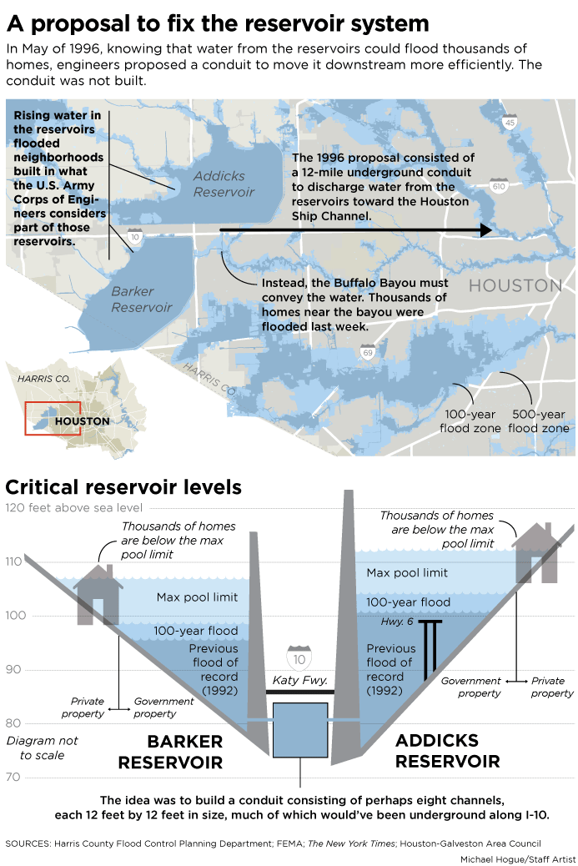
Why it went nowhere is hard to say, and there is plenty of blaming after the fact.
Radack said U.S. Rep. John Culberson, R-Houston, who has represented the reservoir area since 2001, has long known about these issues and should have taken more leadership.
"The congressman from that area, John Culberson, should've been asking for it continuously," Radack said.
In a statement, Culberson said he takes flood mitigation "very seriously" and has secured more than $391 million for such projects.
"It's disheartening to hear that any elected official would deflect or lay blame as we all work together to help our constituents pick up the pieces and get the help they need," Culberson said.
Richard Long, a corps specialist who has overseen the Addicks and Barker reservoirs for three decades, said that to his knowledge, the corps never requested funding from Congress to either purchase all the reservoir land or build the tunnel to carry water from the reservoirs.
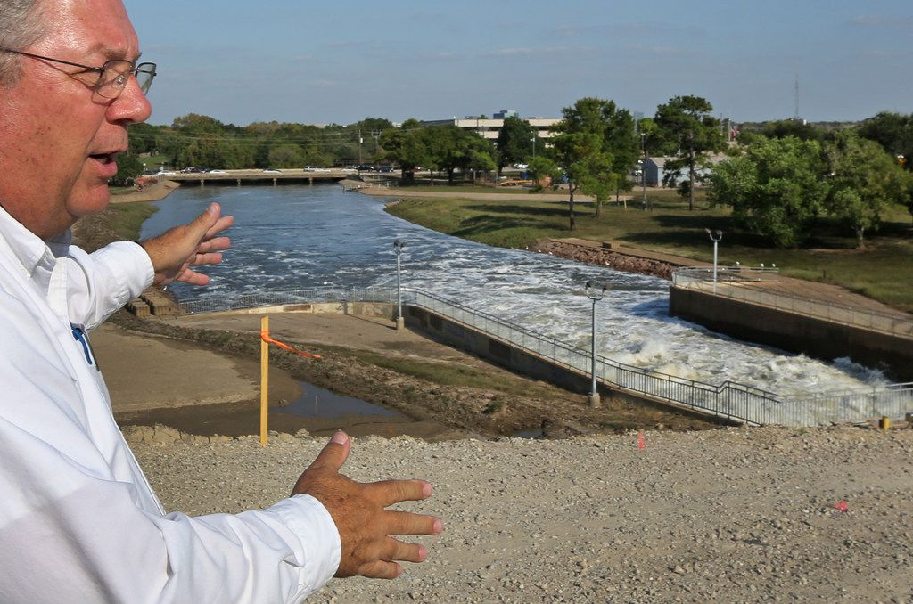
1/7Richard Long of the U.S. Army Corps of Engineers shows where the gates of the Barker Reservoir empty into Buffalo Bayou in West Houston. (Louis DeLuca / Staff Photographer)
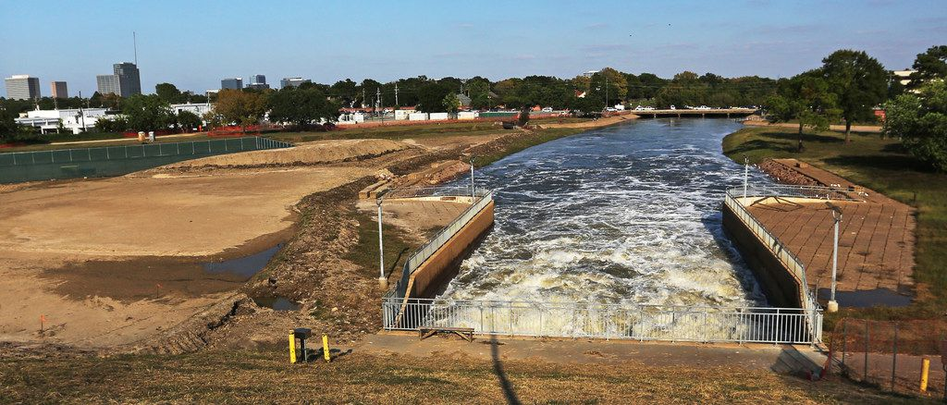
2/7Army Corps of Engineers' Richard Long shows where the gates of the Barker Reservoir empty into Buffalo Bayou in west Houston on Monday, September 11, 2017. (Louis DeLuca/The Dallas Morning News)(Louis DeLuca / Staff Photographer)
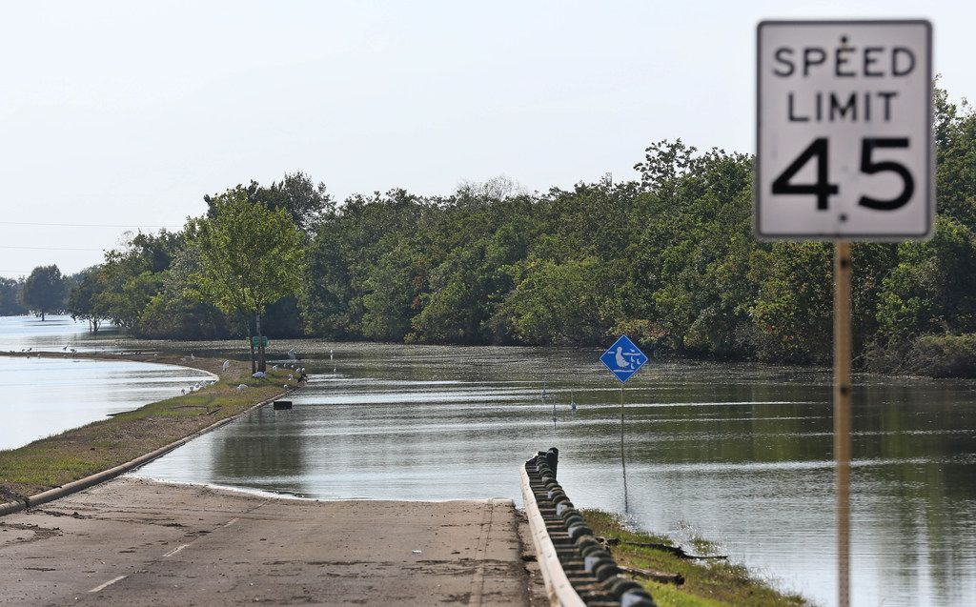
3/7A park on the edge of the Barker Reservoir still stands flooded in west Houston on Monday, September 11, 2017. (Louis DeLuca/The Dallas Morning News)(Louis DeLuca / Staff Photographer)
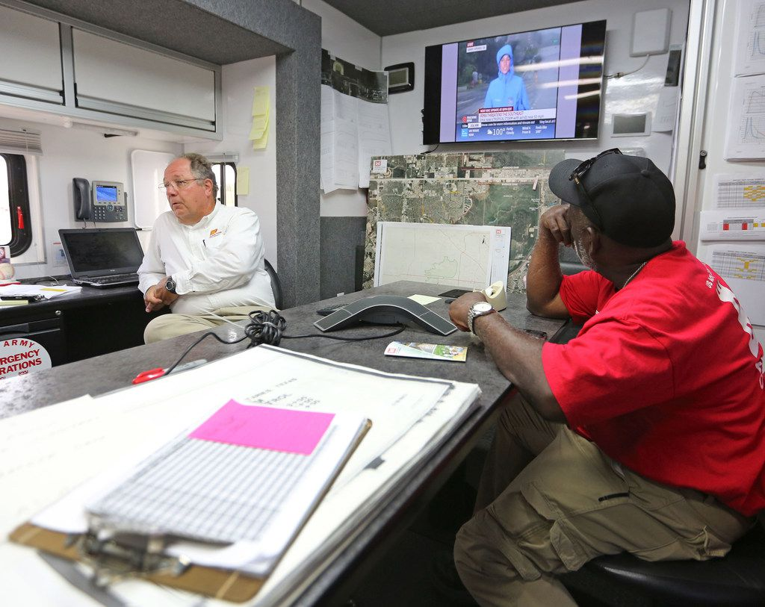
4/7Army Corps of Engineers' Richard Long, left, and Brooks Hubbard man the emergency center trailer at the Barker Reservoir in west Houston on Monday, September 11, 2017. (Louis DeLuca/The Dallas Morning News)(Louis DeLuca / Staff Photographer)
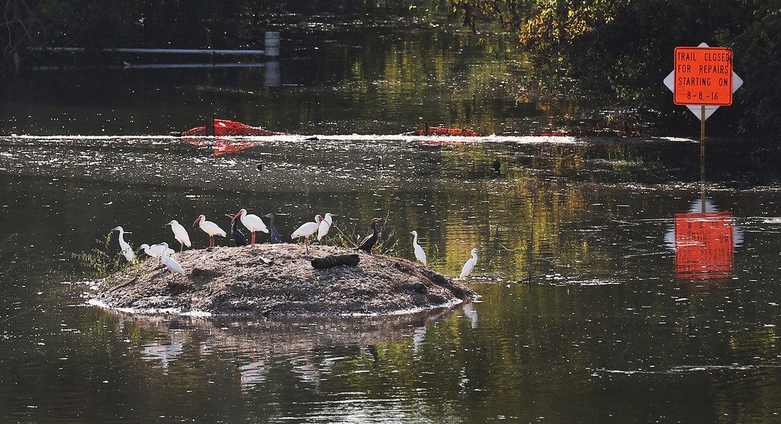
5/7A variety of birds find a dry perch in the Barker reservoir in west Houston on Monday, September 11, 2017. (Louis DeLuca/The Dallas Morning News)(Louis DeLuca / Staff Photographer)
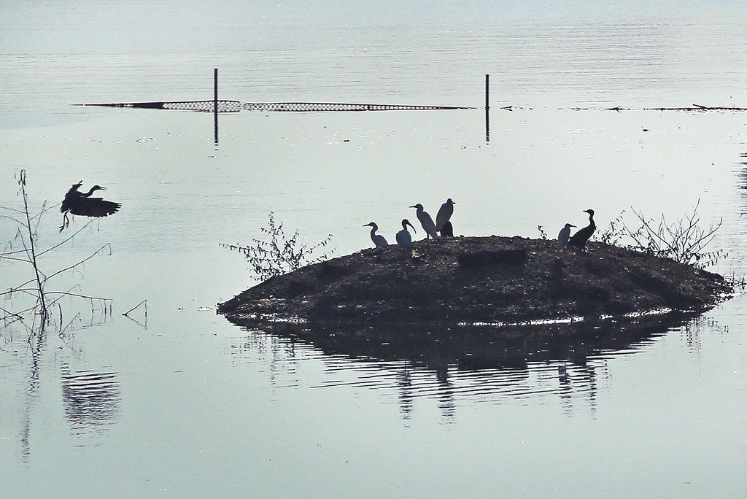
6/7A variety of fowl find a dry perch in the Barker reservoir in west Houston on Monday, September 11, 2017. (Louis DeLuca/The Dallas Morning News)(Louis DeLuca / Staff Photographer)
7/7Army Corps of Engineers' Richard Long gives a tour of the Barker reservoir in west Houston on Monday, September 11, 2017. (Louis DeLuca/The Dallas Morning News)(Louis DeLuca / Staff Photographer)
The corps did everything it could during Harvey to protect neighborhoods, he said. But the storm brought far more rain than the corps' resources were designed to withstand.
Long did lament that so many homes were built within the reservoir pools. Harris County could have done more to warn residents about their flood risk, the way Fort Bend County did on the plats, he said.
Long himself conducted public meetings in the subdivisions to discuss the corps' reservoirs, but he acknowledged he didn't reach a majority of the homeowners. Neither Harris County nor Fort Bend County held public meetings about flood risks, officials said.
***
Arthur Storey, who oversaw Harris County's flood control district from 1989 to 2015, saw his $1.5 million home destroyed by floodwaters after the corps released the reservoirs' waters downstream during Harvey.
The way Storey sees it, the corps mishandled the reservoir projects. The original plan in the 1940s was brilliant, Storey said, when two reservoirs, Addicks and Barker, were created to hold rainwater during storms. The water could be released slowly into Buffalo Bayou and down to the Houston Ship Channel. The reservoirs each held back water with earthen dams that rose 120 feet high on their southeastern sides. The goal was to protect metropolitan Houston, including its port and downtown, from catastrophic floods.
As Harvey dumped more than 40 inches of rain on Houston, the reservoirs, which can each hold 200,000 acres of one-foot-deep water, were filling fast. After two days, the corps opened the dams' floodgates to release lakes of water downstream, flooding people like Storey who thought they'd survived the storm without damage. Engineers wanted to avoid the waters overflowing around the sides of the dams, Long said, which they predicted would destroy a bigger geographical area downstream.
But Storey believes that corps officials felt guilty about the flooding in the subdivisions upstream — where people were being rescued off roofs — and so they "covered their butt" by also flooding neighborhoods downstream. He says the corps should have purchased all the land inside the reservoirs and never allowed development there.
"They picked, instead of being guilty of flooding people upstream with their dam — because they didn't own enough reservoir land — they flooded the very people they were put in place to protect," Storey said.
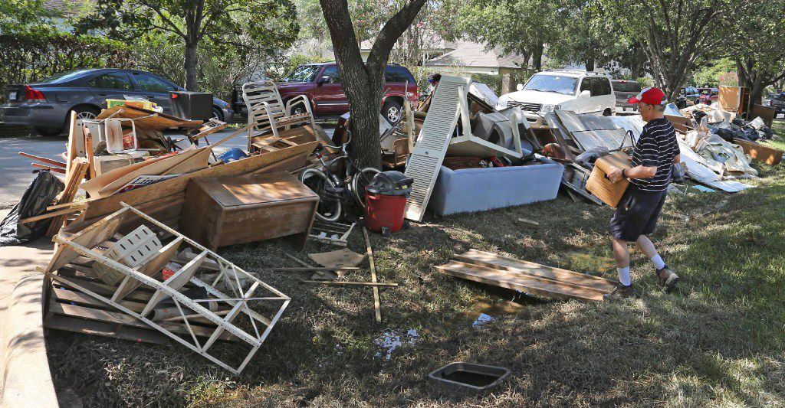
1/4Arthur Storey carries waterlogged personal items to the curb in the Memorial Drive Acres subdivision in Houston, which flooded as a result of water released from a dam. (Louis DeLuca / Staff Photographer)
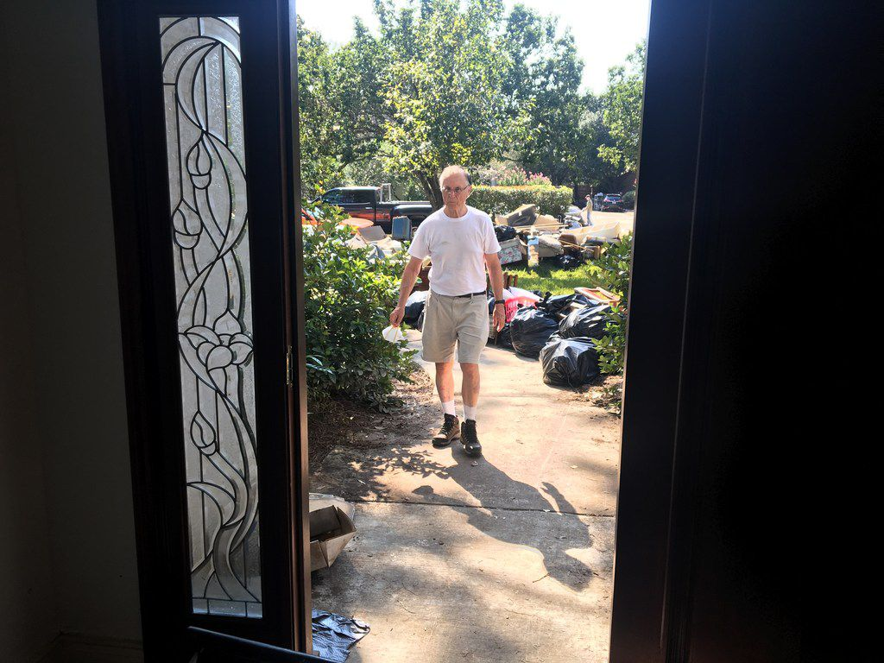
2/4Arthur Storey, the former head of the Harris County Flood Control District, surveys his flood-damaged home in Memorial Drive Acres in Houston on Sept. 9, 2017. (Naomi Martin/ Staff)(Naomi Martin/ Staff)
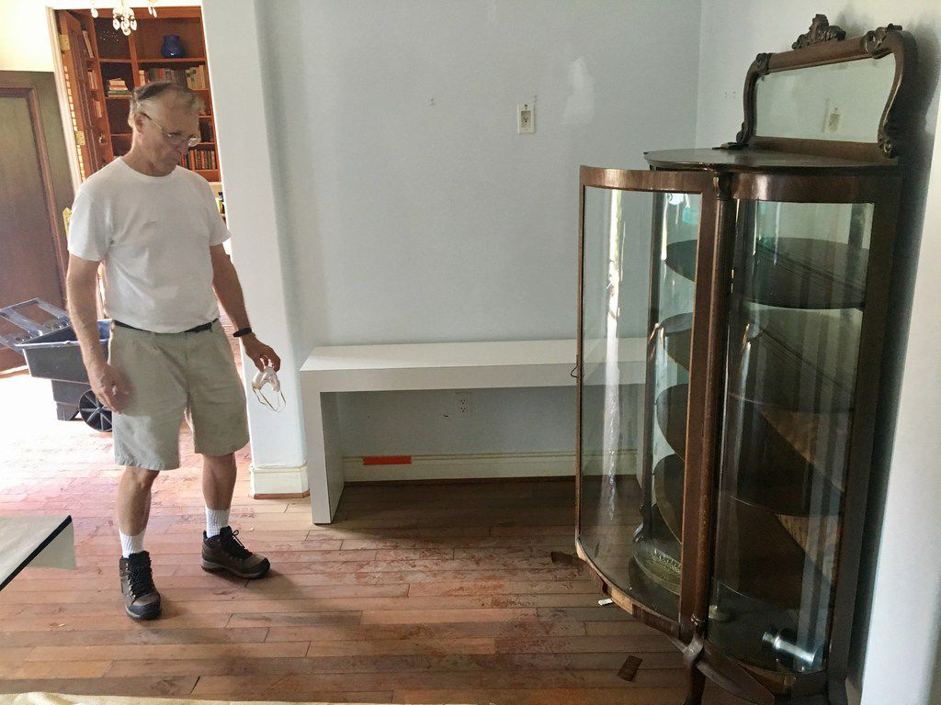
3/4Arthur Storey, the former head of the Harris County Flood Control District, looks at a flood-ruined family heirloom from the 1800s at his home in Memorial Drive Acres in Houston on Sept. 9, 2017. (Naomi Martin/ Staff)(Naomi Martin/ Staff)
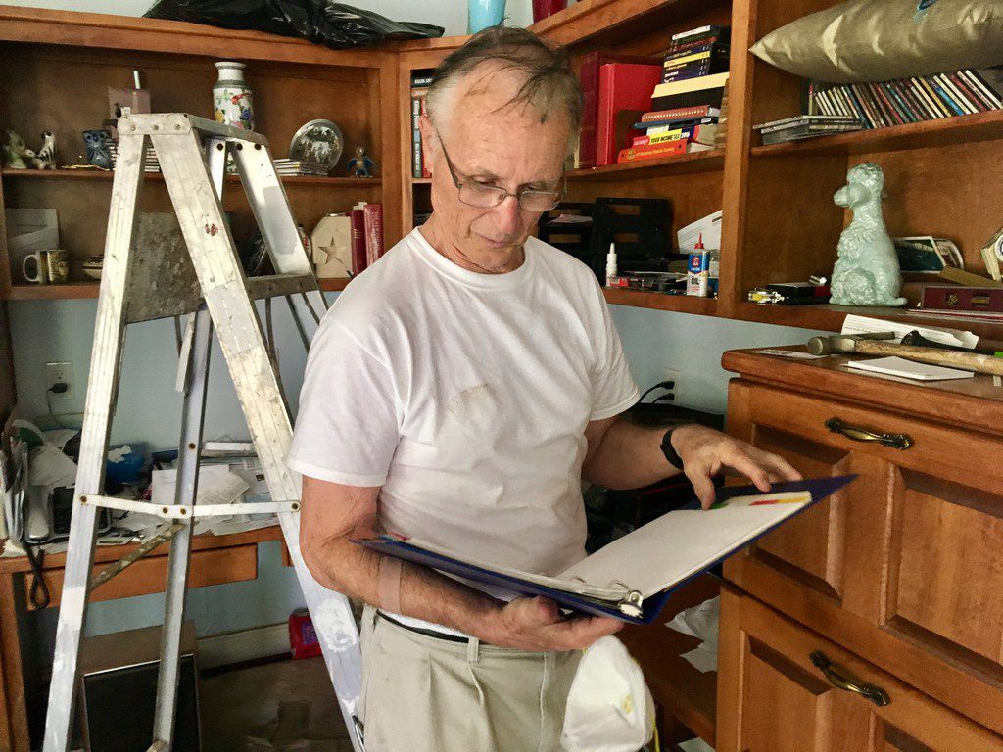
4/4Arthur Storey, the former head of the Harris County Flood Control District, flips through one of his most cherished possessions -- a ballroom dance step guide from when he and his wife met -- at his flood-damaged home in Memorial Drive Acres in Houston on Sept. 9, 2017. (Naomi Martin/ Staff)(Naomi Martin/ Staff)
The corps didn't feel the need to acquire all the land at the time the reservoirs were built, Long said, because that land was nothing but rice farms and fields where cattle grazed.
It didn't stay that way. In 1997, developers came before Fort Bend County government for approval to put subdivisions on the pastures. Aware of the flood risk to the area, the county was in a bind. It didn't have the authority to prohibit development or establish zoning rules, said County Judge Robert Hebert, who has been in office since 2003.
So the county insisted, "over great objection" by developers, on including a warning on the plat, Hebert said. The county, he said, "felt it was a defect on the land that should be pointed out."
***
But many Fort Bend County residents who lived in or near the reservoirs said they had no idea.
Hebert said the county didn't have the staff to knock on doors and talk to residents about flood risks, which "would pretty much be a full-time job."
To him, though, the county did its best to warn people.
"We did everything we could under the law and more when we put that statement on the plat," Hebert said. "That should have protected them, if it was properly communicated."
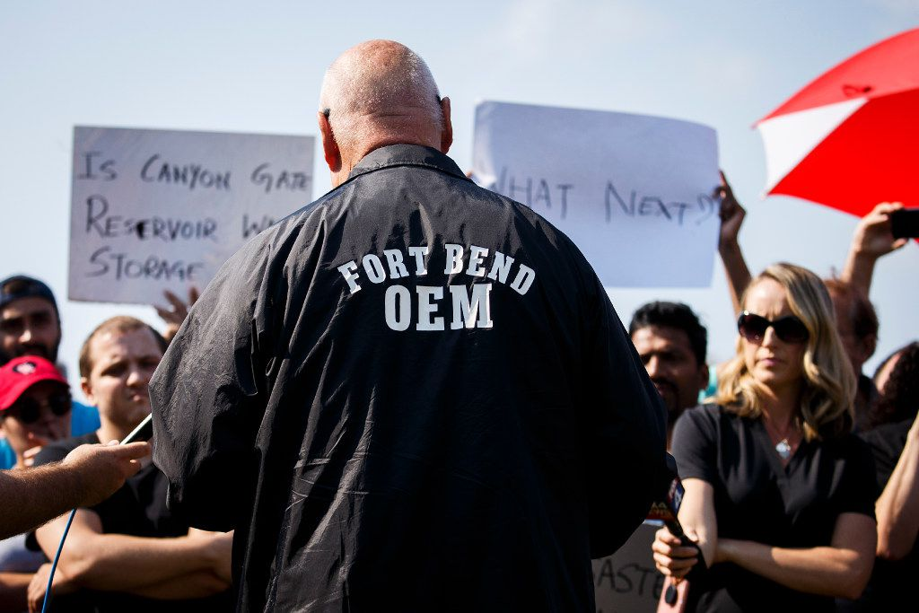
1/3Fort Bend County Judge Robert Hebert takes questions from Cinco Ranch Canyon Gate subdivision residents who gathered to demonstrate at a police roadblock outside their cordoned-off neighborhood on Sept. 2 in Katy. (Smiley N. Pool / Staff Photographer)
2/3Fort Bend County Judge Robert Hebert raises his hand as he takes questions from Cinco Ranch Canyon Gate subdivision residents who gathered to demonstrate at a police road clock outside their neighborhood on Saturday, Sept. 2, 2017, in Katy, Texas. The area remains cordoned off due to flood waters left by Hurricane Harvey. (Smiley N. Pool/The Dallas Morning News)(Smiley N. Pool / Staff Photographer)
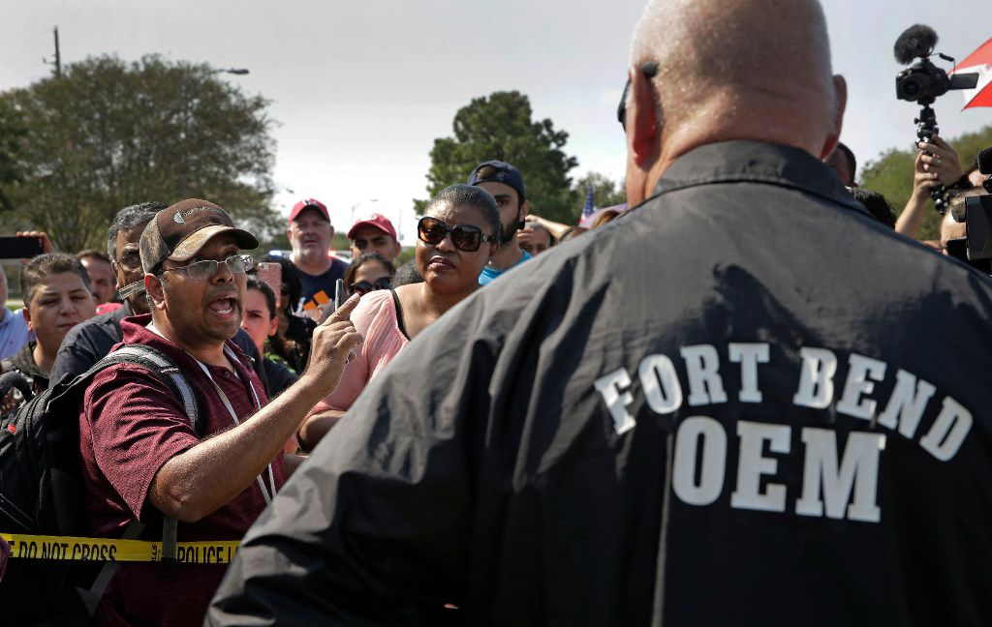
3/3Residents question Fort Bend County Judge Bob Hebert at a roadblock into their Canyon Gate neighborhood which was flooded when the Barker Reservoir reached capacity in the aftermath of Harvey Saturday, Sept. 2, 2017, in Katy, Texas. Residents gathered at the checkpoint to vent their frustrations about not being able to get back into their homes which will remain flooded for several more days while the reservoir drains. (AP Photo/Charlie Riedel)(Charlie Riedel / AP)
Hebert said the county expected title companies to tell homebuyers of the warnings on the plat at closing. But Hebert acknowledged that the disclosures may have been vague, or overlooked.
"Most people don't read all their documents at closing," Hebert said. "I'm one of those people."
Matthew Festa, a property law professor at South Texas College of Law-Houston, said sellers, real estate brokers and title companies don't have a duty to disclose warnings on a plat. In these cases, they may have referred to the public document and the buyer didn't know to look it up, Festa said.
"There's no affirmative obligation to wave your arms and jump up and down and say, 'Look at this plat,'" Festa said. "That's one of the weaknesses of real estate law."
The warning on the plat doesn't hurt residents' chances to win a lawsuit against the corps, Festa said. That's because the corps' actions could be considered "inverse condemnation," meaning the government took private property to serve the greater good, and thus must compensate the property owners.
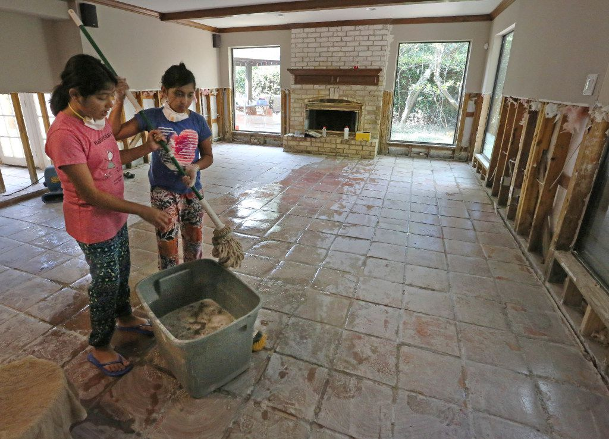
1/2Twin sisters Saloni and Sugani Singh, 10, share mopping duties as they work to clean up their home in the Memorial Drive Acres subdivision, which was flooded as a result of water released from the Army Corps of Engineers' dams upstream. (Louis DeLuca / Staff Photographer)
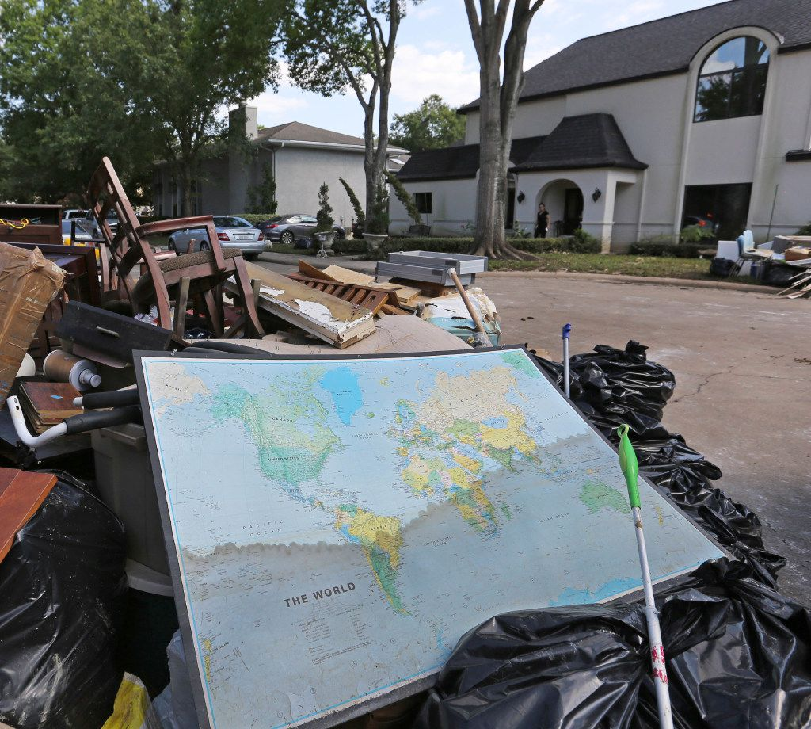
2/2A map of the world shows the waterline of the flood waters as it sits in the trash outside the Singh home in the Memorial Drive Acres subdivision, which was flooded as a result of water released from a dam, photographed on Sunday, September 10, 2017. (Louis DeLuca/The Dallas Morning News)(Louis DeLuca / Staff Photographer)
Residents all over are gearing up for lawsuits. At least three class actions have been filed.
Downstream, Areg Sahakian, 44, didn't have flood insurance on the roughly $700,000 home he and his wife have owned for seven years in Memorial Drive Acres.
"This wasn't a flood zone," Sahakian said. "The government used our property as a reservoir."
Naomi Martin. Naomi is an enterprise/ investigative reporter who has covered Dallas County government, Parkland Memorial Hospital, juvenile detention and the county jail. Before that, Naomi was a criminal justice reporter in Dallas, New Orleans and Baton Rouge. She received The Dallas Morning News’ Reporter of the Year award in 2016 and 2017. She has a degree in political economy from Tulane University.
nmartin@dallasnews.com /NaomiMartinJournalist @NaomiMartin

