LOCAL // HOUSTON

Harvey flood victims above dams make plea for government compensation
Gabrielle Banks Sep. 13, 2019 Updated: Sep. 13, 2019 10:36 p.m.
Comments
3
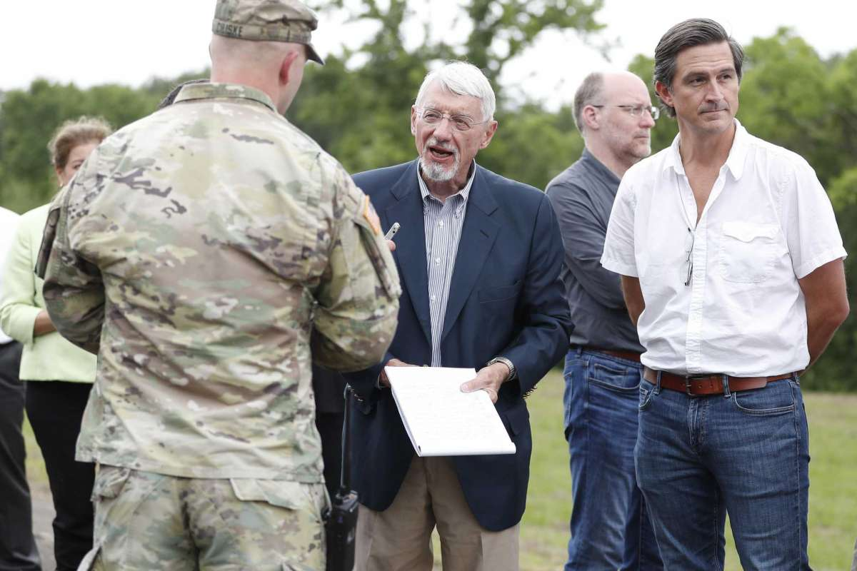
1of3U.S. Judge Charles Lettow listens as Capt. Charles Ciliske of the Army Corps of Engineers listen during testimony at the Addicks North spillway and end of Addicks dam area, as the homeowners suing after Harvey went out to view homes in the Addics and Barker Dam areas, in Houston, Wednesday, May 8, 2019.Photo: Karen Warren, Houston Chronicle / Staff photographer
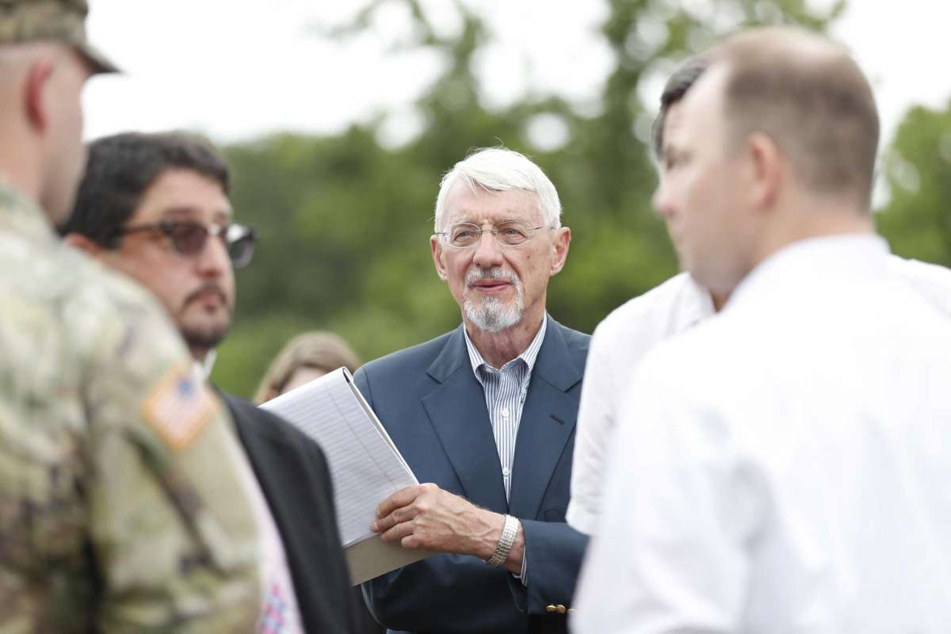
2of3U.S. Judge Charles Lettow, left, listens as Captain Charles Ciliske with the US Army Corps of Engineers listen during testimony at the Addicks North spillway and end of Addicks dam area, as the homeowners suing after Harvey went out to view homes in the Addics and Barker Dam areas, in Houston, Wednesday, May 8, 2019.Photo: Karen Warren, Houston Chronicle / Staff photographer
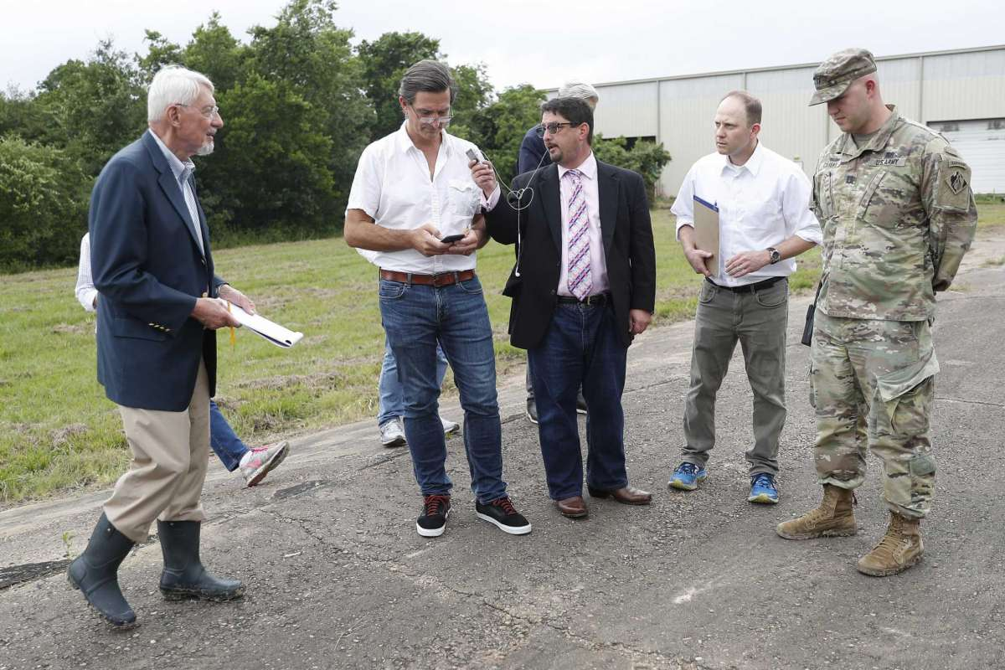
3of3U.S. Judge Charles Lettow, left, listens as Daniel Charest is audio-recorded by court reporter David Lee, center, while trial attorney Bradley Levine and Capt. Charles Ciliske of the Army Corps of Engineers listen during testimony in a federal trial over whether homeowners should be compensated by the U.S. government for storing floodwaters Photo: Karen Warren, Houston Chronicle / Staff photographer

Paramedics whisked Scott Holland by boat from his newly renovated rental home after Hurricane Harvey. When the disabled former police officer, who had been recovering from surgery, laid eyes on the place a few days later, it smelled like dead bodies.
“There’s nothing like being old and starting over,” he lamented on a video recorded that day.
Holland and his wife now live in a trailer and can’t afford to move back.
He is among about 2,000 flooded residents and business owners upstream of the Addicks and Barker dams who had their final say in a Washington, D.C., federal courtroom Friday in an effort to get the U.S. government to compensate them for storing floodwater on their properties amid the 2017 storm.
Lawyers for the U.S. Army Corps of Engineers argued that Harvey was an unprecedented event that engineers could not have foreseen when they designed the dams decades ago. The government was compelled to choose between inundating homes upstream or unleashing catastrophic harm downstream, they said.
The hearing marked a long-awaited moment of reckoning for flood victims whose properties sustained damage after Harvey, as water accumulated west of World War II-era earthen dams built to protect the city from dangerous rainfall.

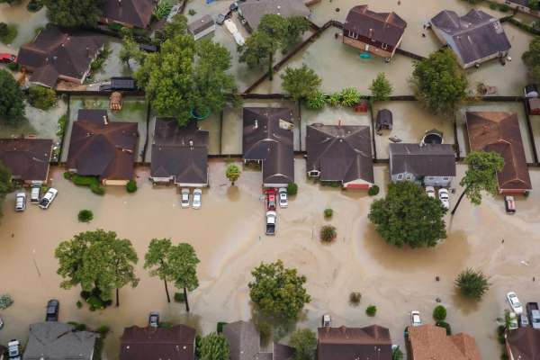

HOUSTON
The litigants did not question whether the government made the right choice by detaining water in the normally dry reservoirs. The court must only consider whether the reservoirs functioned as intended and whether the flooding west of them was foreseeable. If the judge rules the government is liable in the coming weeks, he will hold a second trial to assess damages.
If they prevail, lawyers for the plaintiffs estimate that owners or occupants of 10,000 to 12,000 houses, businesses and rental units may be eligible for compensation for sustaining more than $1 billion in damage.
The oral arguments before Judge Charles F. Lettow of the specialized U.S. Court of Federal Claims in Washington concluded a two-week trial held in Houston in May that explored the house-by-house details of the damage flood victims endured.
That trial included testimony from plaintiffs as well as experts in meteorology, hydrology, engineering, insurance and map-making. Lettow even donned Wellington boots on a soggy afternoon to accompany a small busload of lawyers to dams, spillways, businesses and homes — in various states of disrepair — that took on water after Harvey.
About 25 lawyers and homeowners gathered Friday inside the Houston federal courthouse to listen to a patchy, four-hour live audio transmission of the D.C. proceedings.
ALLEGE FAILURE TO WARN: Harvey victims say no one told them they were living in a flood pool
The “takings” case requires that a judge determine if the government intentionally took possession of private property for public use — or in this case, used the land to temporarily store water for the sake of saving downtown and the Houston Ship Channel from even worse flooding.
The arguments dipped into technical concepts including subsidence, hydrographs, pool levels, riverine flooding, controlled inundation and seepage.
But the big picture was hard to miss.
The lawyers for Holland and the owners of a dozen other test properties said their clients and thousands of others had no warning that Addicks and Barker were designed to hold back water on their property. Their homes appeared to be in typical suburban neighborhoods.
They told the court Harvey was not an aberration. Previous storms, including Claudette in 1979 and Allison in 2001, dropped similar amounts of rain in nearby watersheds. The Texas Gulf Coast is prone to flooding and the dams did what they were built to do, the plaintiffs said.
“The flooding was not accidental or incidental; the Corps knew that from the beginning,” said attorney Daniel Charest. He said many plaintiffs had no flood insurance nor any way of knowing they were buying property in a flood zone. Now their property values have decreased dramatically, he said.
Dueling experts during the trial agreed that 10 of the 13 test properties would not have flooded if not for the accumulated water in the flood pool.
In his argument Friday, William Shapiro, a Justice Department attorney, told the court that Harvey, which dumped up to 51 inches of rain on parts of the region, was beyond anything the Corps engineers contemplated.
“When Hurricane Harvey struck, the Corps found itself in a no-win situation,” Shapiro said, forced to choose between flooding residents above or below the dams. “It was a zero-sum game — you hurt one group or you hurt the other.”
The judge took a moment to acknowledge this conundrum and the choice the Corps made.
“The Corps’ operation when presented with a no-win situation, they did the best they could under those circumstances and the result was the saving of $7 billion (in damages) as well as protecting the safety and lives of the downstream property owners,” Lettow said.
“That really was a benefit,” the judge said. “Let’s not ignore that fact. The dams worked as expected and designed. … and it was a significant benefit to the community as a whole.”
Following the D.C. hearing, attorney Vuk Vujasinovic said he felt the argument went well for the flood victims.
“Our team was able to give a voice to thousands of Houstonians behind the dams who sacrificed their homes and belongings to save the heart of our city,” he said.
Lettow’s ruling on the liability question could come in the next month or so, lawyers said.
Properties downstream also were flooded after officials released water amid concerns that the dams could fail. A large group of property owners who flooded downstream of the two dams have filed a separate federal “takings” lawsuit before Senior U.S. Judge Loren A. Smith. A hearing is set for Oct. 17 and a trial for Feb. 10 in Houston federal court.
Gabrielle Banks covers federal court for the Houston Chronicle. Follow her on Twitter and send her tips at gabrielle.banks@chron.com.
gabrielle.banks@chron.com

Gabrielle Banks
Follow Gabrielle on:
https://www.facebook.com/gabrielle.banks.56GabMoBanks
Gabrielle Banks covers federal court for the Houston Chronicle. She has been a criminal justice and legal affairs reporter for nearly two decades, including staff work at the Pittsburgh Post-Gazette and The Los Angeles Times, and freelance work for The New York Times, The Mercury News, Newsday and The Miami Herald. She has a graduate degree in journalism from Columbia University. Before her years as a reporter, she worked as a teacher, social worker and organizer.

