LOCAL // HOUSTON

Harvey flood victims close case against Army Corps
Gabrielle Banks May 17, 2019 Updated: May 17, 2019 9:43 p.m.
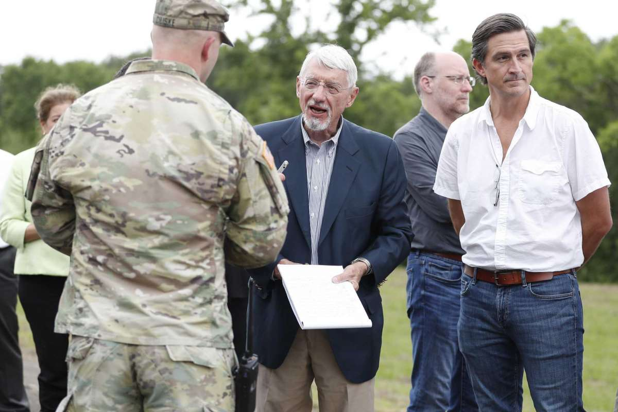
1of4In this May 8, 2019 photo, U.S. Judge Charles Lettow listens to testimony from Capt. Charles Ciliske of the Army Corps of Engineers during a field trip in the trial over whether homeowners should be compensated by the federal government for storing floodwaters on their properties during Hurricane Harvey.Photo: Karen Warren, Houston Chronicle / Staff photographer
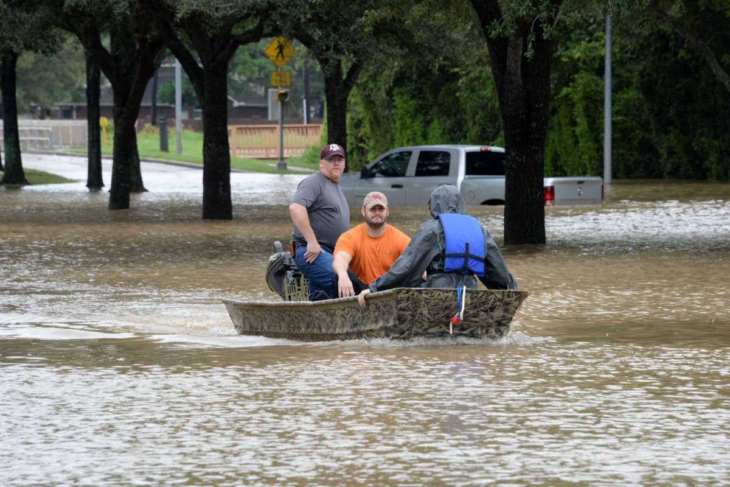
2of4Residents of the Cinco Ranch and Canyon Gate areas of Ft. Bend County evacuate from the west side of the Barker Reservoir along Mason Road in Katy, TX on August 29, 2017.Photo: Craig Moseley, Staff / Chronicle
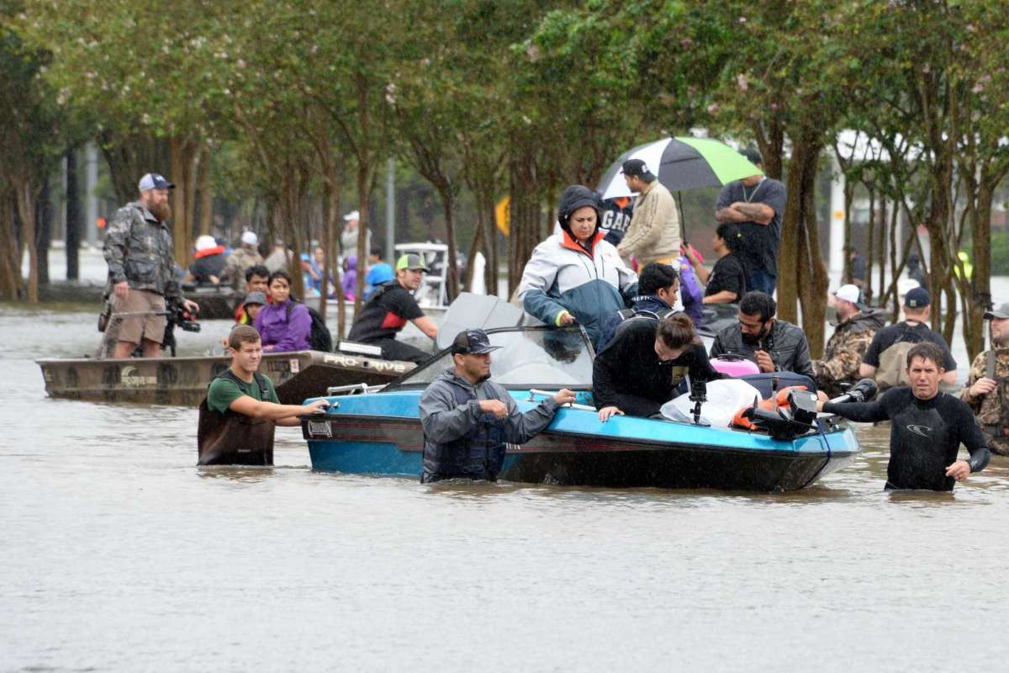
3of4Residents of the Cinco Ranch and Kelliwood areas of Ft. Bend and Harris Counties evacuate from the west side of the Barker Reservoir along Westheimer Parkway in Katy, TX on August 29, 2017.Photo: Craig Moseley, Staff / Chronicle
A two-week trial revisiting the anguish that flood victims experienced during Hurricane Harvey came to a close Friday in a lawsuit brought by property owners upstream of the Addicks and Barker reservoirs seeking compensation from the Army Corps of Engineers for using their land to store floodwater during the historic deluge.
The matter will be decided by a Washington, D.C.-based jurist from the specialized U.S. Court of Federal Claims who borrowed one of the stately upper-floor courtrooms used by district court judges in downtown Houston. An array of witnesses included home and real estate owners, a renter now living in a tiny trailer, an airport owner and a vast array of experts in hydrology, federal flood insurance and mapmaking. U.S. Judge Charles F. Lettow also donned Wellington boots on a soggy afternoon last week to accompany a small busload of lawyers to dams, spillways, businesses and homes — in various states of disrepair — that took on water after Harvey.
ALLEGE FAILURE TO WARN: Harvey victims tell judge no one told them they were living in a designated flood pool
The judge said he would review briefs from the lawyers and return to Houston on Sept. 13 to hear closing arguments in the case. Another large group of property owners, who were flooded downstream of the two dams, will be tried in a separate hearing later.
The consolidated upstream case in Houston involves 13 test properties inside federal reservoirs and upstream of the two World War II-era dams. These 13 locations will serve as stand-ins for more than 1,000 people who have sued the Corps under the Fifth Amendment’s “takings clause.” The residents and businesses claim that the government knowingly used their private property to detain water and that it therefore owes them “just compensation” for damage.
Testimony and evidence is now complete for the first phase of the trial. After hearing closings in September, the judge will determine if the Corps is liable for the flooding. If Lettow finds that it is, he will consider damages.
Multiple witnesses told the court over the trial that the dams and reservoirs were designed to prevent catastrophic flooding in Houston along Buffalo Bayou.
DAY IN COURT: Hurricane Harvey flooding victims get their day in federal court
The Barker dam detains storm water in George Bush Park, and Addicks uses Bear Creek Pioneers Park to impound accumulated rainwater. Witnesses told the court that Harvey’s protracted rainfall forced the flood pools to expand beyond the farthest reaches of these two parks into neighborhoods that were part of the designated flood pool.
At the time the dams were built, the vast watershed behind the parks was 98 percent undeveloped, according to a government witness, much of it prairie land and rice farms. By 2014, 59 percent of the nongovernmental land behind Addicks and 58 percent behind Barker remained undeveloped.
A team of about 10 lawyers for the plaintiffs and eight from the Justice Department called about 30 witnesses over 10 days and entered thousands of pages of documents, maps, photos and videos into evidence.
The lawyers for the Harvey victims made the case, through witness testimony, that the Corps followed its standard operating procedures during Harvey. The flooding upstream could have been averted, they contend, if the Corps had secured funding to buy all the land the Addicks and Barker reservoirs would need occupy with floodwaters behind the dams’ embankments.
According to court documents, in 1995 the Corps did a cost-benefit analysis and found that it was too expensive to buy the upstream land it would need to use if there was massive flooding. In 2003, witnesses said, the Corps took photographs and began collecting the names, addresses and first floor elevations of the families living behind Addicks and Barker, but it classified its findings as “sensitive information.”
RAINY DAY FIELD TRIP: Hurricane Harvey victims slog through mud with out-of-town judge
Property and business owners said they were not informed that they were buying land inside a reservoir.
A witness for the Corps told the judge that he had held dozens of meetings, send out postcards in multiple languages, and posted legal notices in newspapers advising people to attend informational meetings and to buy flood insurance if they lived behind the dams.
The government also called witnesses who testified about plats that explained that the land was subject to controlled flooding. That information was available for homeowners and business owners to discover, whether or not they knew it, the government said.
Its position is that the Corps exercised government power to prevent loss of life and worse damage to private property, including downstream properties in the City of Houston. The plaintiffs do not have a right to be free from flooding during a hurricane, Justice Department lawyers have said in court documents. The Harvey victims’ properties were naturally prone to flooding because of their proximity to the reservoirs.
In court documents, the lawyers wrote that Houston-area residents undeniably faced hardship during and after the extreme storm.
“Many continue to struggle, and the United States has expended significant resources to support Houston’s recovery,” the lawyers wrote. “It is impossible not to feel sympathy for plaintiffs’ losses. But the law does not support using the Fifth Amendment to recompense plaintiffs for their losses.”
But the lawyers for the Harvey victims said they were optimistic that the evidence showed they had a strong case.
Armistead Easterby, one of the lead lawyers for the upstream clients, said he hoped the case would be a catalyst for long-overdue changes to the Addicks and Barker Project.
“The city needs to be protected, but it’s wrong to put the burden resulting from intended project operations on the shoulders of the upstream families and businesses,” Easterby said. “I’m optimistic about the outcome of this trial and believe that, under the law that applies to this case, plaintiffs have a categorical right to receive just compensation under the Fifth Amendment.”
gabrielle.banks@chron.com

Gabrielle Banks
Follow Gabrielle on:
https://www.facebook.com/gabrielle.banks.56GabMoBanks
Gabrielle Banks covers federal court for the Houston Chronicle. She has been a criminal justice and legal affairs reporter for nearly two decades, including staff work at the Pittsburgh Post-Gazette and The Los Angeles Times, and freelance work for The New York Times, The Mercury News, Newsday and The Miami Herald. She has a graduate degree in journalism from Columbia University. Before her years as a reporter, she worked as a teacher, social worker and organizer.

Past Articles from this Author:
- District Attorney Kim Ogg summons police chiefs to oppose historic bail settlement
- Houston doctor convicted of fraudulently billing Medicare $16 million
- Jurors say Bagwell stiffed landscaping crew on ‘badass’ yard

