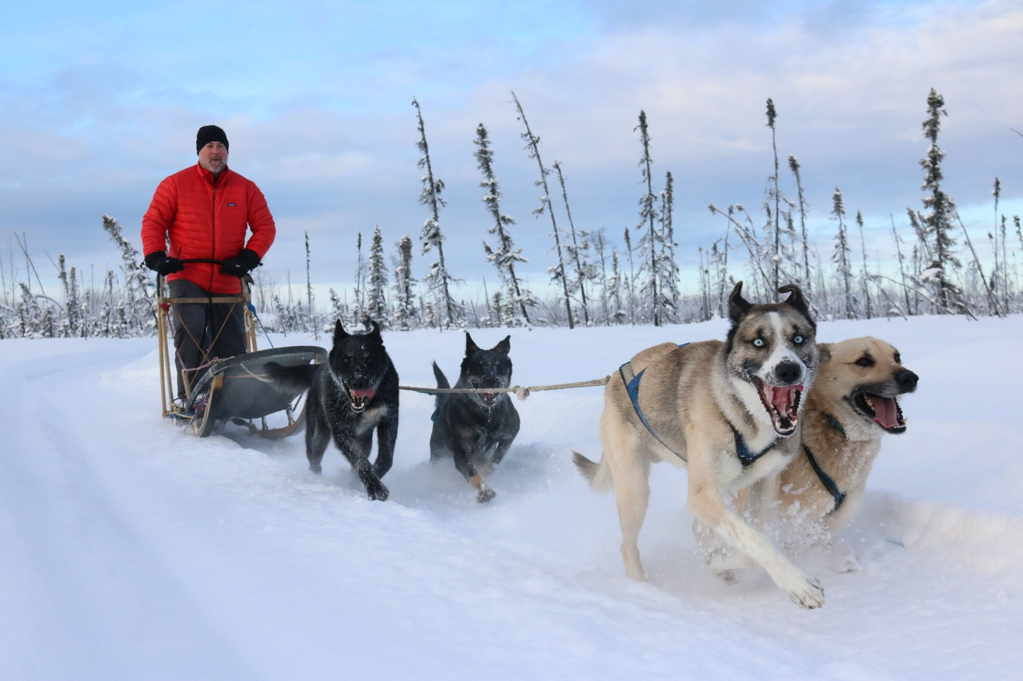

Exercise Physiology and Sports Medicine of Working Canines

Jan 12-15, 2021

Registration: $650 (includes CE, lunch each day, snacks and refreshments during lectures).

Name_______________________________________________________________________

Address_____________________________________________________________________

City, State, Zipcode____________________________________________________________

Contact email________________________________________________________________

Contact phone________________________________________________________________

Credit card number____________________________________________________________

Expiration date_____________________________CVI________________________________

____Yes, please pass my contact information to Happy Trails Kennels B&B to arrange lodging

____Yes, please pass my contact information to Alaska Dog Mushing School to arrange dog sled trips and training

Fax completed form to 405-844-4026 or email to Kathy@waypointvet.com