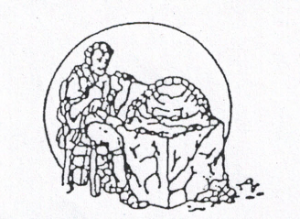
FOX’S
SPOKANE DENTURE CLINIC, ®
S. 1723 Ray Spokane, WA 99223
509-535-7434

Denture Repair Provider/Patient Agreement.
By signing this policy update, I agree to the following policy update effective 01/01/2022

- Fox’s Denture Clinic charges $100 as a flat fee for the repair.
  - Some repairs may require impressions for an accurate repair. This is an additional $75 per arch.
  - A tooth replacement is $65 per tooth.

- There is no guarantee on repairs, relines, or other altercations on dentures that were made outside of this clinic. It is recommended you have your dentures repaired and adjusted with your original manufacturer.

- We will contact you when the repair is completed. If we are unable to reach you it is your responsibility to follow up with our office to obtain your denture.

- While typically repairs are same day, it may be the case we need to hold it overnight if the repair requires additional lab processes.

- All fees for service are due at either repair drop off or repair pick up. We do not accept Medicaid/Molina/Apple Health for repairs. If you have another insurance company, we will bill your insurance after your payment and have the insurance payment mailed to you immediately after receiving it.

If you choose to purchase new dentures at our office, we will credit your repair charge to the cost of the denture if it is within 30 days of repair.

______________________________________________ __________
Patient Signature Date

Patient Information:
Name: _____________________________________________ DOB: ___________________
Phone Number: __________________________ Alternate Phone Number: ________________________________

