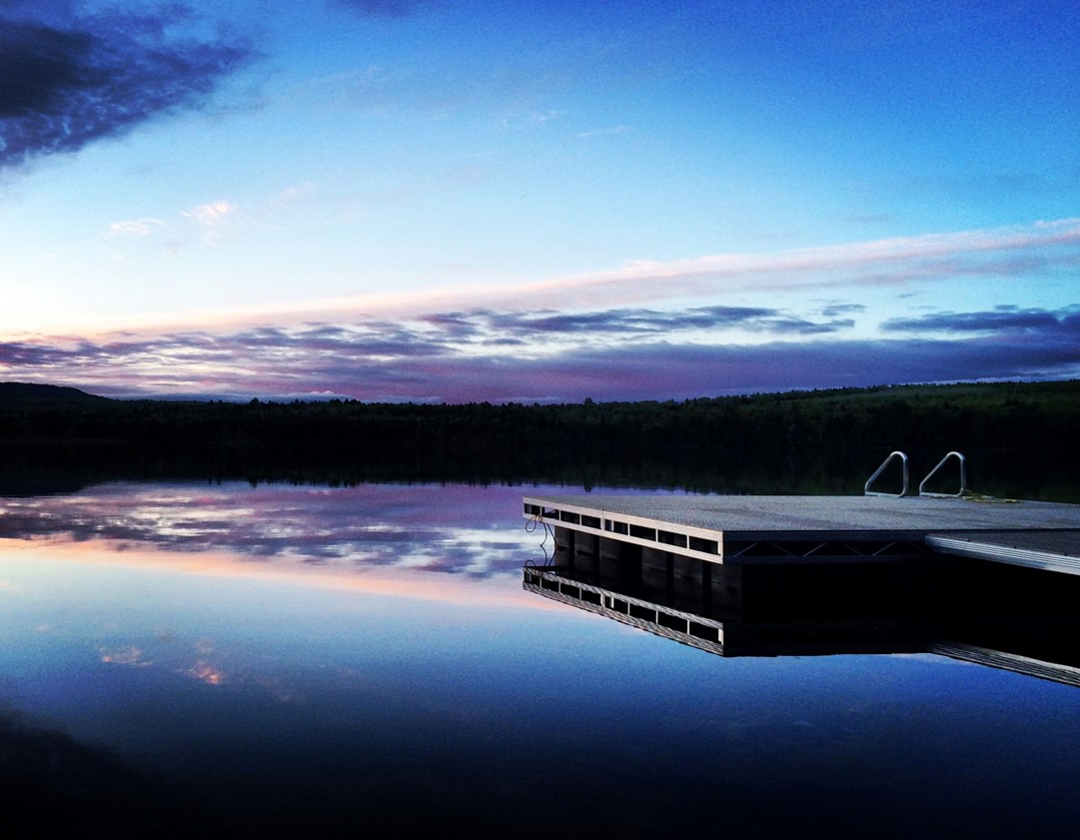
Manufactured by:
92 River Road
New Portland, Me 04961
207-628-4123
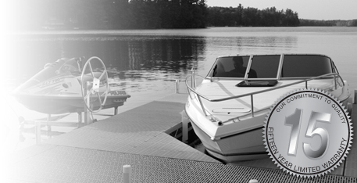
The AquaLounge’s commitment to quality extends far beyond the sale. With a fifteen-year limited warranty, we stand firmly behind our AquaLounge products to ensure that your dock system performs above your expectations for many years down the road.
The 15-year limited warranty is on all our aluminum structures and welding. SunWalk offers a 12-year warranty on paneling.
**For more information, please contact an authorized AguaLounge or SunWalk representative.
Producing superior products at competitive prices is our goal here at AquaLounge. We are not content with duplicating products already available on today’s market. Each dock is hand-crafted with the highest quality materials and construction to ensure they will meet your needs and withstand the test of time.
AquaLounge 15 Year Warranty
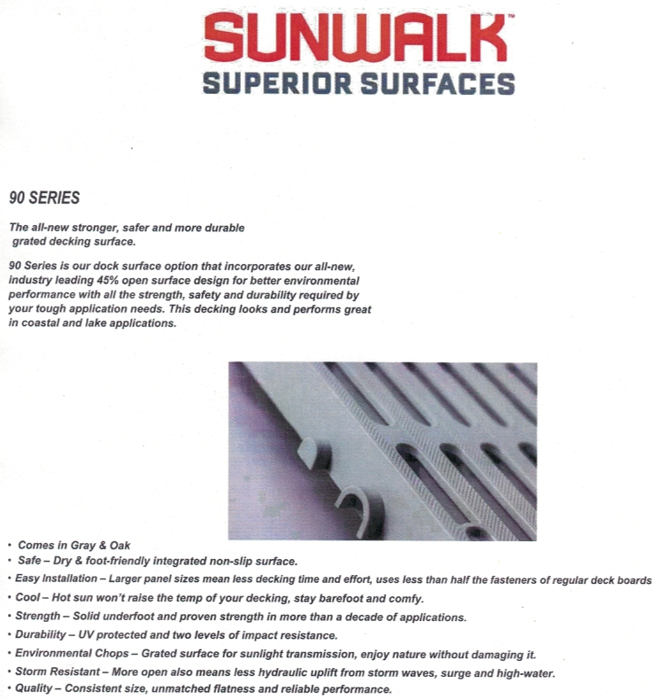

Standard Dock Systems

Combining revolutionary designs with the highest-grade materials and components available on the market today, we have developed a state-of-the-art system that provides quality, strength and most importantly... versatility. Whether you want a standing dock, a floating dock, or both, we can make the dock system that meets your needs. Each of our dock sections is built around aluminum truss-style framing, with fully welded corners for added strength, durability, and a polished look. AquaLounge docks are available with SunWalk decking or removable cedar panels. Each standing dock comes standard with two 5’ posts, feet, dock locks, and hardware.
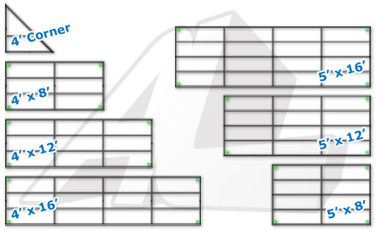
Dock-Lock
Using our signature DOCK-LOCK, you can arrange your dock in any configuration with minimal tools required. The dock panels simply drop into the DOCK-LOCK mating mechanism and tighten with a single set-bolt. Installation and dock expansion has never been easier.

Configuration 1
(2) 4' X 16' Dock Sections | (1) 4' X 8' Dock Section
(1) Corner Section | (1) Ladder
At AquaLounge, we understand that designing the right layout for your dock system can be a grueling task. Our aim is to help you make the right decisions to guarantee satisfaction from your AquaLounge dock products. Start with one of these suggestions or customize the perfect dock for your lifestyle.
Configuration 2
(2) 4' X 16' Dock Sections | (2) 4' X 12' Dock Sections
(2) Corner Sections | (1) Deluxe Stair System
(1) 4' Bench

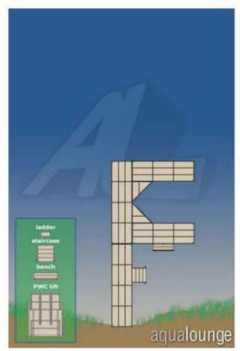
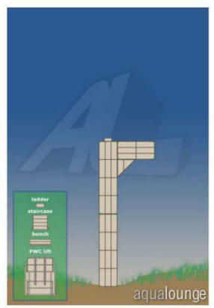
Configuration 3
(3) 4' X 16' Dock Sections | (2) Corner Sections
(1) Deluxe Stair System | (1) 4' Bench
(2) Ladders | (2) 4’ x 12’ Dock Sections
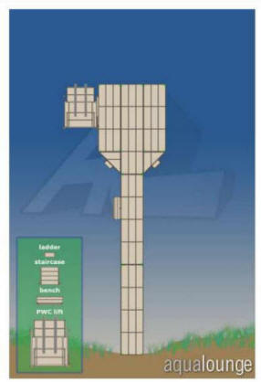
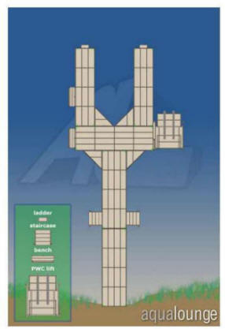
Configuration 4
(3) 5' X 16' Dock Sections | (2) 4' X 16' Dock Sections
(4) Corner Sections | (2) Ladders
(2) Deluxe Stair Systems | (2) 4' Benches

Configuration 5
(3) 5' X 16' Dock Sections | (1) 5' X 12' Dock Section
(6) 4' X 16' Dock Sections | (2) 4' X 12' Dock Sections
(2) 4' X 8" Dock Sections | (6) Corner Sections
(4) Ladders | (2) Deluxe Stair Systems
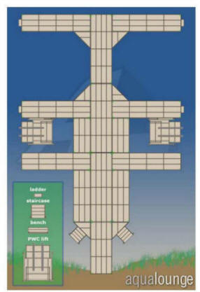

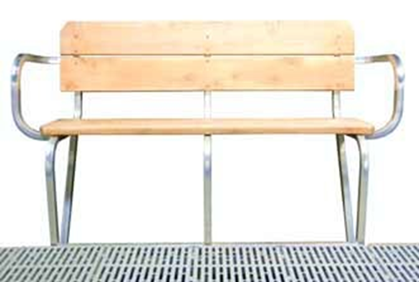
Benches
Our durable, lightweight bench construction allows for easy installation. Combining aluminum framework with top-quality cedar planking, these benches will perform and look great for years.
Accessories
Our quality dock sections provide the base for a great dock system, but options and accessories make it yours. Choose any number of our available add-ons and watch the utility of your dock grow by leaps and bounds. Accessories include ladders, benches, wheel kits, stairs, self-leveling systems, dock cleats, kayak racks and more!

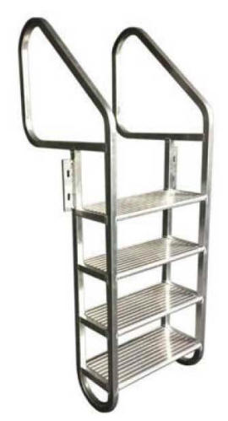
Ladders
No dock system is complete without the essentials, including a ladder. Designed to bolt anywhere on your dock, these products greatly increase the versatility of your dock system. Built standard with extruded aluminum steps. Our 4-step ladder will keep you sure-footed getting in or out of the water.
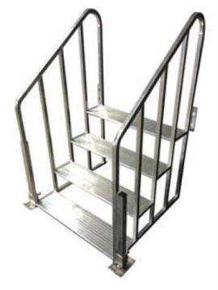
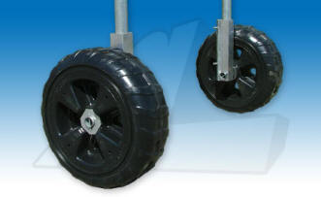
Deluxe Stair
Systems
Featuring all-aluminum framework, extruded aluminum steps and adjustable corner legs, this 24” system installs easily anywhere on your dock. With a finished look you will not find from competitive products; our stair system upgrades the versatility of your dock system and the appearance of your shoreline.
Wheel Kits
Our wheel kits are built around rotomolded polyethylene wheels, providing both maximum strength and zero maintenance. Designed with a wide footprint for easy roll-in, these wheels also feature intake holes that allow the wheel to fill with water when submerged, increasing stability to your dock system. Wheel kits are compatible with all standing dock system products.

Cleats
Standard and Solar LED cleats mount with ease to your AquaLounge dock.
Kayak Racks
AquaLounge racks offer great versatility. They are fully adjustable and can be mounted on any section of the dock. Available in multiple sizes to accommodate both kayaks and canoes.
Our docks and accessories feature:
Custom Options
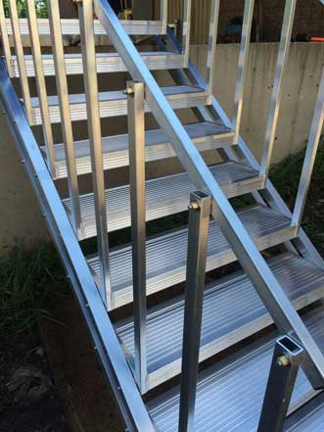
Self-Leveling Stairs
For use on land or in water, there unique design/construction allows them to automatically level the treads at virtually any angle. Simply anchor the top tread and lower down to your desired level.

Hammock
The hammock mount is another example of our custom work...if you do not see it in the brochure, please do not hesitate to ask!

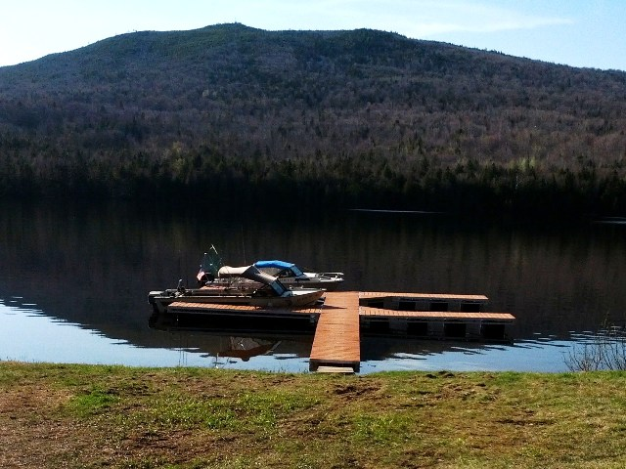

Manufactured by:

92 River Road
New Portland, Me 04961
207-628-4123
Floating System
Floating systems work best where water elevations fluctuate often, or it is simply too deep for a system on posts. The above floating AquaLounge system is one of many configurations available today... although designed for commercial applications, their ease of set-up and installation has made them extremely popular in residential applications as well. With endless variations available, contact us to get started designing your floating AquaLounge system.

