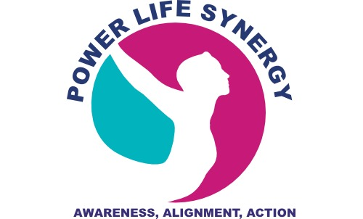 **POWER Life Synergy**

POWER Life Synergy™

Copyright © Powerlifesynergy.com - All Rights Reserved

**YOUR GRATITUDE GIFT!**

**Breathing in Gratitude and Giving**

Now let’s face it, sometimes we are in situations that do not put us in grateful mood! Remember, you don’t have to wait to be in the *mood* to be Grateful! Give **Intentional Action** to your Gratitude.

I use this exercise often in my coaching and HR practice. Now, I’m offering this **GRATITUDE GIFT TO YOU!**  Try it out, embellish it, make it your own and let the POWER Life Synergy Community know how it works for you. Follow us on **POWER Life Synergy FB** or send me a private email at [info@powerlifesynergy.com](mailto:info@powerlifesynergy.com).

**YOUR BRAIN HIGH ON STRESS**

You know that anxious feeling you get when you’re in a stressful situation? Maybe you’re experiencing changes in your life. Maybe you’re confronting a difficult situation and you’re fearful of the possible outcome? Your heart is pounding, palms sweating, you’re breathing fast and your muscles are tense.

***What going on?*** Your brain, specifically the amygdala is sending danger signals to the Hypothalamus, the brain’s “commander center” mentioned in my blog. The Hypothalamus tells the adrenal glands to release stress hormones into the bloodstream. ***What???*** Yep, you’re in **Fight-or-Flight mode**. It’s a great mechanism to have when real danger confronts us. Think *Lions,* *Tigers* and *Bears!* But in most situations we don’t need to fight or take flight. How do we get back to those happy little dolphins that swim around seeking more positive emotions? We can start by slowing down our breathing.

 **POWER Life Synergy**

POWER Life Synergy™

Copyright © Powerlifesynergy.com - All Rights Reserved.

**DESTRESS… GET YOUR BRAIN HIGH ON GRATITUDE!**

**EXERCISE:** Breathing Gratitude and Giving

**Step 1: Slow it down** and get back into AWARENESS. Interrupt the pattern for a minute. Take a break from the situation and drink water. Stress causes dehydration because you’re breathing more heavily and losing fluid. Drinking water slows down the automatic responses we have to stress. It slows down your heart rate and provides the hydration your need for your journey back to your POWER.

**Step 2: Breathe in Gratitude; Breathe out Giving:** The act of focused breathing will slow your heart rate and blood flow. Focusing on Gratitude and Giving will create positive shifts in your thinking and approach to a challenging situation.

**Example**: ***Use your own words to express your gratitude and giving.***

1). Breathe in through the nose, slow and steady, “I am grateful for_________ ”

2). Breathe out through the mouth, slow and steady, “I give compassion to this situation?”

3). Breathe in through nose, slow and steady, “I am grateful for________,”

4). Breathe out through nose, slow and steady, “I give love to ___________.”

REPEAT 4 TIMES or as many times as needed until you are breathing calmly.

Follow us on the POWER Life Synergy FB and share your experiences or send a private email to me at [info@powerlifesynergy.com](mailto:info@powerlifesynergy.com).