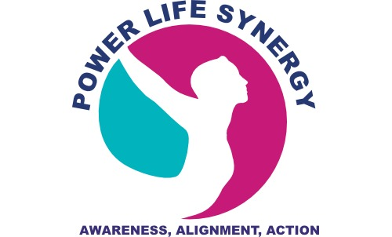 POWER Life Synergy
POWER Life Synergy™
Copyright © Powerlifesynergy.com - All Rights Reserved

GRATITUDE sets your POWER on Fire!
Here’s How it Works

Positive emotions: Words can make powerful shifts in our thinking and behavior. While it is important to explore negative events, exploring them with a positive openness to learning helps to evoke positive emotions. Positive words of gratitude generate positive thoughts. Positive thoughts take form in positive behavior and creative, problem solving actions.
Optimism: Your sense of Optimism grows as your gratitude and giving list gets longer and you are intentionally seeking positive solutions during the challenges times of your life. You will begin to intentionally anticipate better things yet to come.
Well-Being: When you’re feeling more positive and optimistic, anxiety levels go way down, your blood pressure lowers, you are able sleep more soundly and wake up refreshed, ready to take on another day of Gratitude! Intentionally seeking Well-Being keeps gratitude in the present.
Efficacy: When challenges come your way, the POWER Life Synergy system shows you how Positive Emotions can help navigate you through them. Optimism can move you from surviving to thriving. A state of Well-being helps keep you stay aligned with your human spirit, always in a natural state of gratitude and giving. This POWER Life Synergy system builds your Efficacy, your confidence in knowing that you can solve problems and manage the challenges that come your way in all aspects of life.
Resilience: When you work through the POWER Life Synergy system, you know that when life throws you a curve, it means you have more to learn. You may go back two steps to pick up the lessons you need to move five steps forward.
I hope you found this information useful. Stay tuned for my next blog, “The Learning Curve: Five to Thrive.” Learn more about POWER Life Synergy at https://www.powerlifesynergy.com or send a private message to me at info@powerlifesynergy.com.

