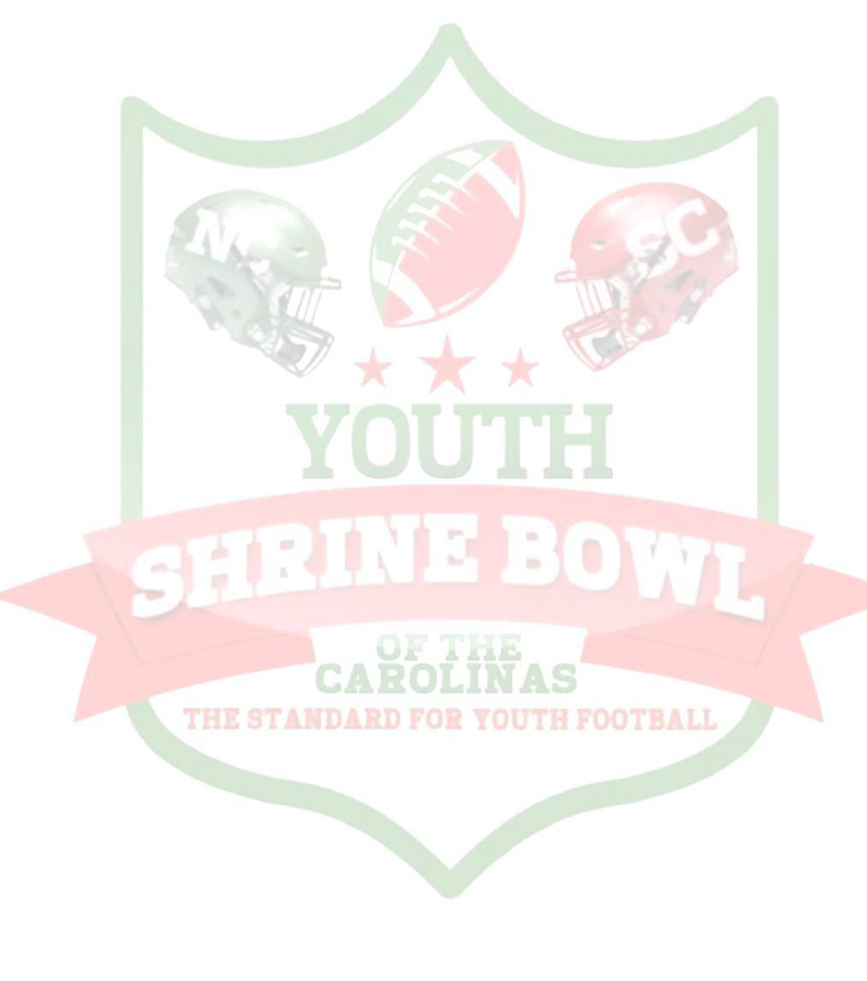
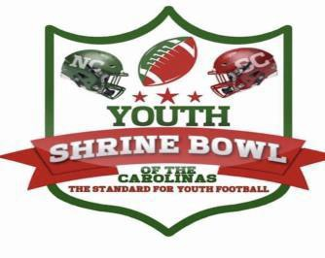

Parents/Players,

On Behalf of the Youth Shrine Bowl of the Carolinas, we would like to congratulate you on being selected to participate in the 2019 Youth Shrine Bowl. We are very honored and grateful that you will participating at our Battle of the Borders 6th, 7th, and 8th Youth Shrine Bowl Game.

The Shrine Bowl of the Carolinas was first played in Charlotte NC in December of 1937. This makes the Shrine Bowl the oldest high school all-star game in the nation. This annual tournament showcases many of the top players within both North and South Carolina. The game is played to benefit the Greenville South Carolina Shriners Hospital for Children. Since 2013, game receipts and temple contributions have raised over 1.7 million dollars for the Shriners Hospital.

Shriners Hospitals for Children has a mission to: Provide the highest quality care to children with neuro-musculoskeletal conditions, burn injuries and other special healthcare needs within a compassionate, family-centered and collaborative care environment. Provide for the education of physicians and other healthcare professionals. Conduct research to discover new knowledge that improves the quality of care and quality of life of children and families.
This mission is carried out without regard to race, color, creed, sex, disability, national origin or ability of a patient or family to pay.

We would like to inform you on a few items to remember to bring with you when you arrive at our event. Please ensure your athlete bring the following:
- practice gear,
- shoulder pads,
- pants,
- helmet,
- mouth piece,
- socks,
- cleats, etc.
Please make sure they also bring normal items they would use if they were staying overnight at a camp example: under clothes, t shirts, deodorant, shower shoes, etc., spending money (not necessary but if you like).

Tickets will go on sale for the games and banquet on November 10th, 2019. Banquet/Pep Rally tickets are $50 and due to limiting spacing will be sold on a first come, first serve basis to the first 200 purchasers. Game tickets are $25 in advance and $30 at the gate. One ticket will be good for all 3 game and each player will receive two tickets. If you need extra tickets, you can purchase them online. You can purchase all our tickets on www.youthshrinebowl.com

Finally, all documentations to include the letter to hospital, report card, physical form, and any other documentation you can't upload, please send it to our: PO BOX 740, Hope Mills NC 28348; or, scan it to our email ysb@youthshrinebowl.com. All ads should be turned in by December 1st, you can send the ads to ysbads@youthshrinebowl.com and jeff@unitedprintingnc.com

An event schedule will be coming out soon (can also be downloaded) and will emailed. Everyone needs to report to the Hilton Greenville, 45 W Orchard Park Dr, Greenville, SC 29615 for registration from 7:00 am - 12:00 pm on December 26th. It is very important you arrived during that time due to each player will need to take pictures, interviews, and meetings. You do not need to call the hotel for a room we have taken care of that and you will get your room once you get to registration. Two parents can stay with each athlete in the room. If you have other family or friends that want to book at room, that information is also on our website or they can just this information below to book their rooms.

We look forward to seeing you in December at the 2019 Youth Shrine Bowl.

Game will be held at the Historic Sirrine Stadium on December 29th 6th grade game @10:00 am, 7th @ 12:00 pm, and 8th at 2:00 pm.

Date: December 29, 2019
Time: 10:00 am
Location: Sirrine Stadium
Address: 100 Cleveland St
Greenville, SC 29601

https://www.hilton.com/en/hi/groups/personalized/G/GSPSCHF-YSB2-20191226/index.jhtml?WT.mc_id=POG
Group Name: Youth Shrine Bowl of the Carolinas
Group Code: YSB2
Check-in: 26-DEC-2019
Check-out: 29-DEC-2019
Hotel Name: Hilton Greenville

Sincerely,

Nigel Pate Sr.
Game Chairman
www.youthshrinebowl.com
ysb@youthshrinebowl.com

