**The animals need our help and we need your help!! Memberships and donations give homeless pets an opportunity for the life they deserve. Thanks so very much for supporting BCHS!!**

Note: For convenience of tracking, all BCHS **membership renewals are due on Jan. 1st of each year**.

**MEMBERSHIP/DONATION FORM**

Name:_______________________________Address___________________________________

City:_______________________State:________Zip Code:______Phone# _________________

E-Mail_________________________________________( ) It’s ok to use e-mail to contact me.

**Please indicate if you are interested in volunteering in our efforts YES_____ NO______**

New Membership__________ Renewal Membership_________

Student Membership: $10.00_____ Individual Membership: $25.00_______

Family Membership: $35.00_____Booster Membership: $50.00______

Sponsor Membership: $100.00 _____ Advocate Membership: $250.00____

Guardian Membership: $500.00_____ Protector Membership: $1,000.00 _____

Other Donation: ________________________

Memorial Donation: $_______ In Memory of__________________________________

Mail to: BCHS, 2393 Mallard Rd., Hiawatha, KS 66434. Make checks payable to BCHS.

Brown County Humane Society is a 501 C (3) non-profit organization. Donations are tax deductible.

Naomi is a purebred Treeing Walker Coonhound who is currently still up for adoption. She came into the shelter very pregnant and very skinny. About a week after she came into the shelter, she gave birth to ten sweet babies. Unfortunately, one of them didn’t survive but the other nine were healthy as could be! All nine of her ornery pups have been adopted since and all that is left is the sweet mother. She is very sweet and loves to play with other dogs. She is about 2 or 3 years old and weighs about 50 pounds. She is also great with kids. Listed here is a before and after picture.  
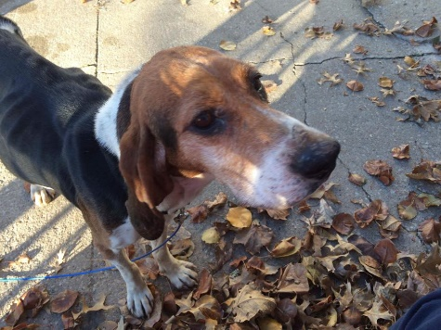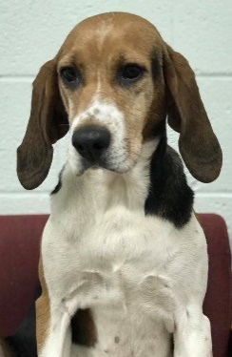

Puddin (now known as Mia) came into the shelter April 24, 2017. She was out of time at the Sabetha city pound. She was tied outside all the time with hardly any food or water and ended up with a broken leg from the chain wrapping around her leg. We took her to the vet and had her leg casted and eventually, it healed up great. We took her to PetSmart to try and get her adopted out and one of the employees there fell in love with her! Now he is home, and happy as ever with a healed leg! Listed below is a before and after picture.

