## #6 Deck off Kitchen/Outdoor Kitchen

|  |  |  |  |  |  |  |
| --- | --- | --- | --- | --- | --- | --- |
| **Item** | **Exhibit #** | **Purchased Dt** | **Condition** | **How many** | **Purchased from** | **Price** |
| Large chinoiserie pot | 6-1 | Less than 2 years | good | 1 |  | 435 |
| Table | 6-2 | Less than 2 years | good | 1 |  | 2695 |
| Yellow benches | 6-3 | Less than 2 years | good | 2@975.47 |  | 1950.94 |
|  | 6-4 |  |  |  |  |  |
| 6chairs | 6-5 | Less than 2 years | good | 3@865 |  | 2595. |
| Rock table | 6-6 | Less than 2 years | good | 1 |  | 2995 |
| stools | 6-7 | Less than 2 years | good | 1 | Charis  Cushions | 164  100 |
| Outdoor Privacy curtain | 6-8 | Less than 2 years | good | 1 |  | 1283.22 |
| two metal chairs and table | 6-9 | Less than 2 years | good | 1 |  | 438.99 |
| 4 pots | 6-10 | Less than 2 years | good | 4@299 |  | 1200 |
| bin | 6-11 | Less than 2 years | good | 1 |  | 30 |
| Storage bin | 6-12 | Less than 2 years | good | 1 |  | 229 |
| 2 wicker chairs | 6-13 | Less than 2 years | good | 2@464.49 |  | 928.98 |
| Smoker | 6-14 | Less than 2 years | good | 1 |  | 1400 |
| Water Pressure washer | 6-15 | Less than 2 years | good | 1 |  | 500 |
|  |  |  |  |  |  |  |
|  |  |  |  |  |  |  |
| Total |  |  |  |  |  | $16,945.13 |

**Exhibit #6-1**

**OUTDOOR KITCHEN**

**Pot as shown in adjuster’s pictures**

**Similar Damaged**

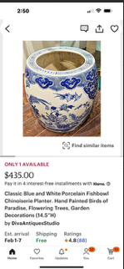

**Exhibit #6-2**

**OUTDOOR KITCHEN**

**Pot**

**Similar Damaged**

**Similar Damaged**

**Exhibit #6-3**

**OUTDOOR KITCHEN**

**2 yellow benches**

**Similar Damaged**

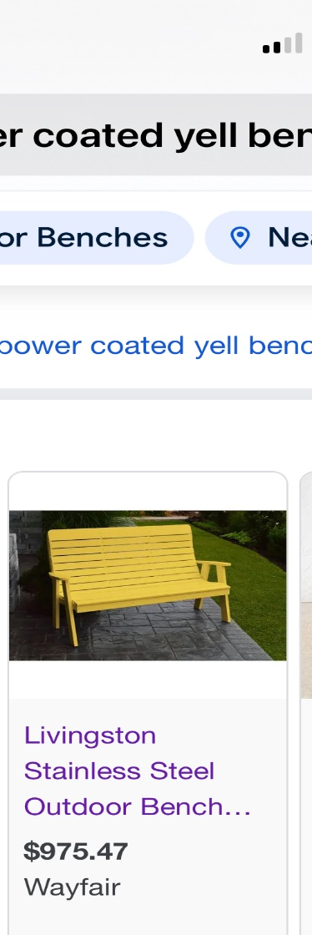

**Exhibit #6-1**

**OUTDOOR KITCHEN**

**Smoker**

**Similar Damaged**

**Exhibit #6-5**

**OUTDOOR KITCHEN**

**Chairs**

**Similar Damaged**

**Exhibit #6-6**

**OUTDOOR KITCHEN**

**table**

**Similar Damaged**

**

**Exhibit #6-7**

**OUTDOOR KITCHEN**

**Outdoor Stools**

**Similar**

**Plus cushions: $50 each Damaged**

**Exhibit #6-8**

**OUTDOOR KITCHEN**

**Outdoor Privacy curtain**

**Similar Damaged**

**Exhibit #6-9**

**OUTDOOR KITCHEN**

**two metal chairs and table**

**Similar Damaged**

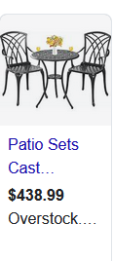

**Exhibit #6-10**

**OUTDOOR KITCHEN**

**4 lemon pots**

**Similar Damaged**

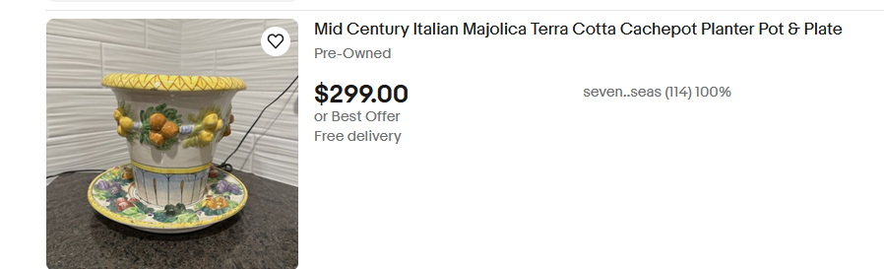

**Exhibit #6-11**

**OUTDOOR KITCHEN**

**two large bins for planting**

**Similar Damaged**

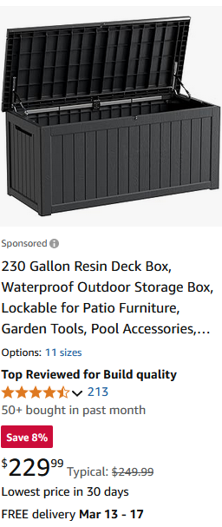

**Exhibit #6-13**

**OUTDOOR KITCHEN**

**Two wicker chairs**

**Similar Damaged**

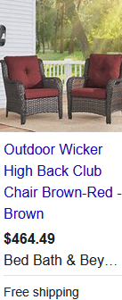

**Exhibit #6-13**

**OUTDOOR KITCHEN**

**Smoker**

**Similar Damaged**

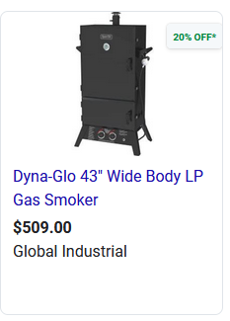

**Exhibit #6-13**

**OUTDOOR KITCHEN**

**Lights**

**Similar Damaged**

**Exhibit #6-14**

**OUTDOOR KITCHEN**

**Pressure Washer**

**Similar Damaged**

## #7 Deck off Mancave

Listed in back yard.