#14 Dining Room
Item | Exhibit # | Purchased Dt | Condition/age | How many |  | Purchased from | Price
Buffet | 14-1 | antique | Great | 1 |  |  | 5950
Table and Chairs | 14-2 | Within the last 3 years | Great | 1 |  |  | 1929
Dishes | 14-3 | Within the last 3 years | 12 Correlle  20 Frontgate @ $29  12 teal zgallerie |  | great |  | 49  580  70.70
Total |  |  |  |  |  |  | $8,578.70

Exhibit #14-1
Dining room
Buffet
Similar Damaged

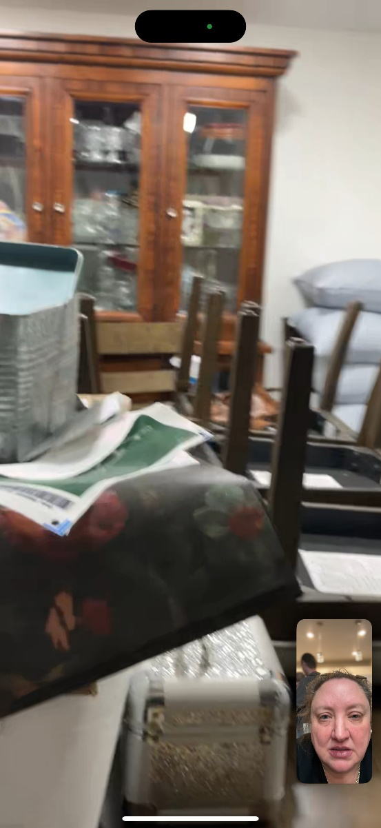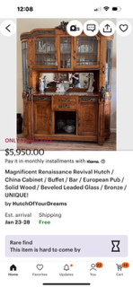

Exhibit #14-2
Dining room
Table
Similar Damaged
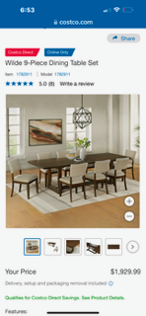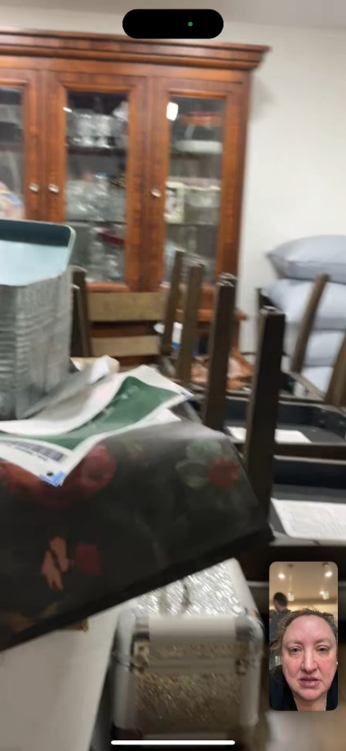
Exhibit #14-1
Dining room
Dishes
-Layna accidently dropped a stack of dishes when she lifted it out of buffet as she slipped on insulation.
Similar Damaged

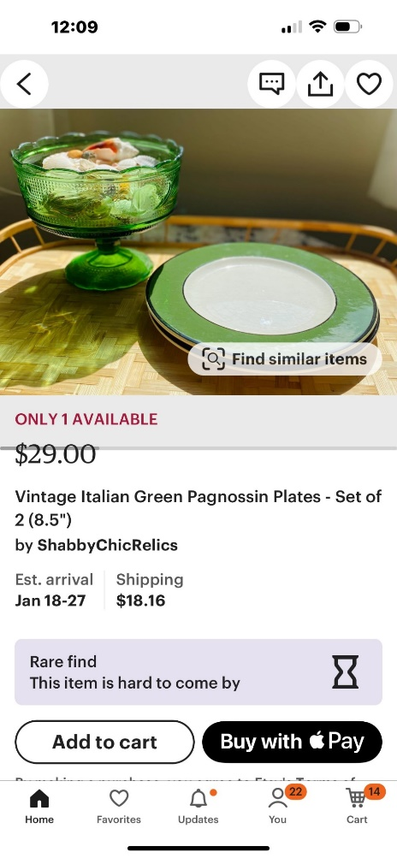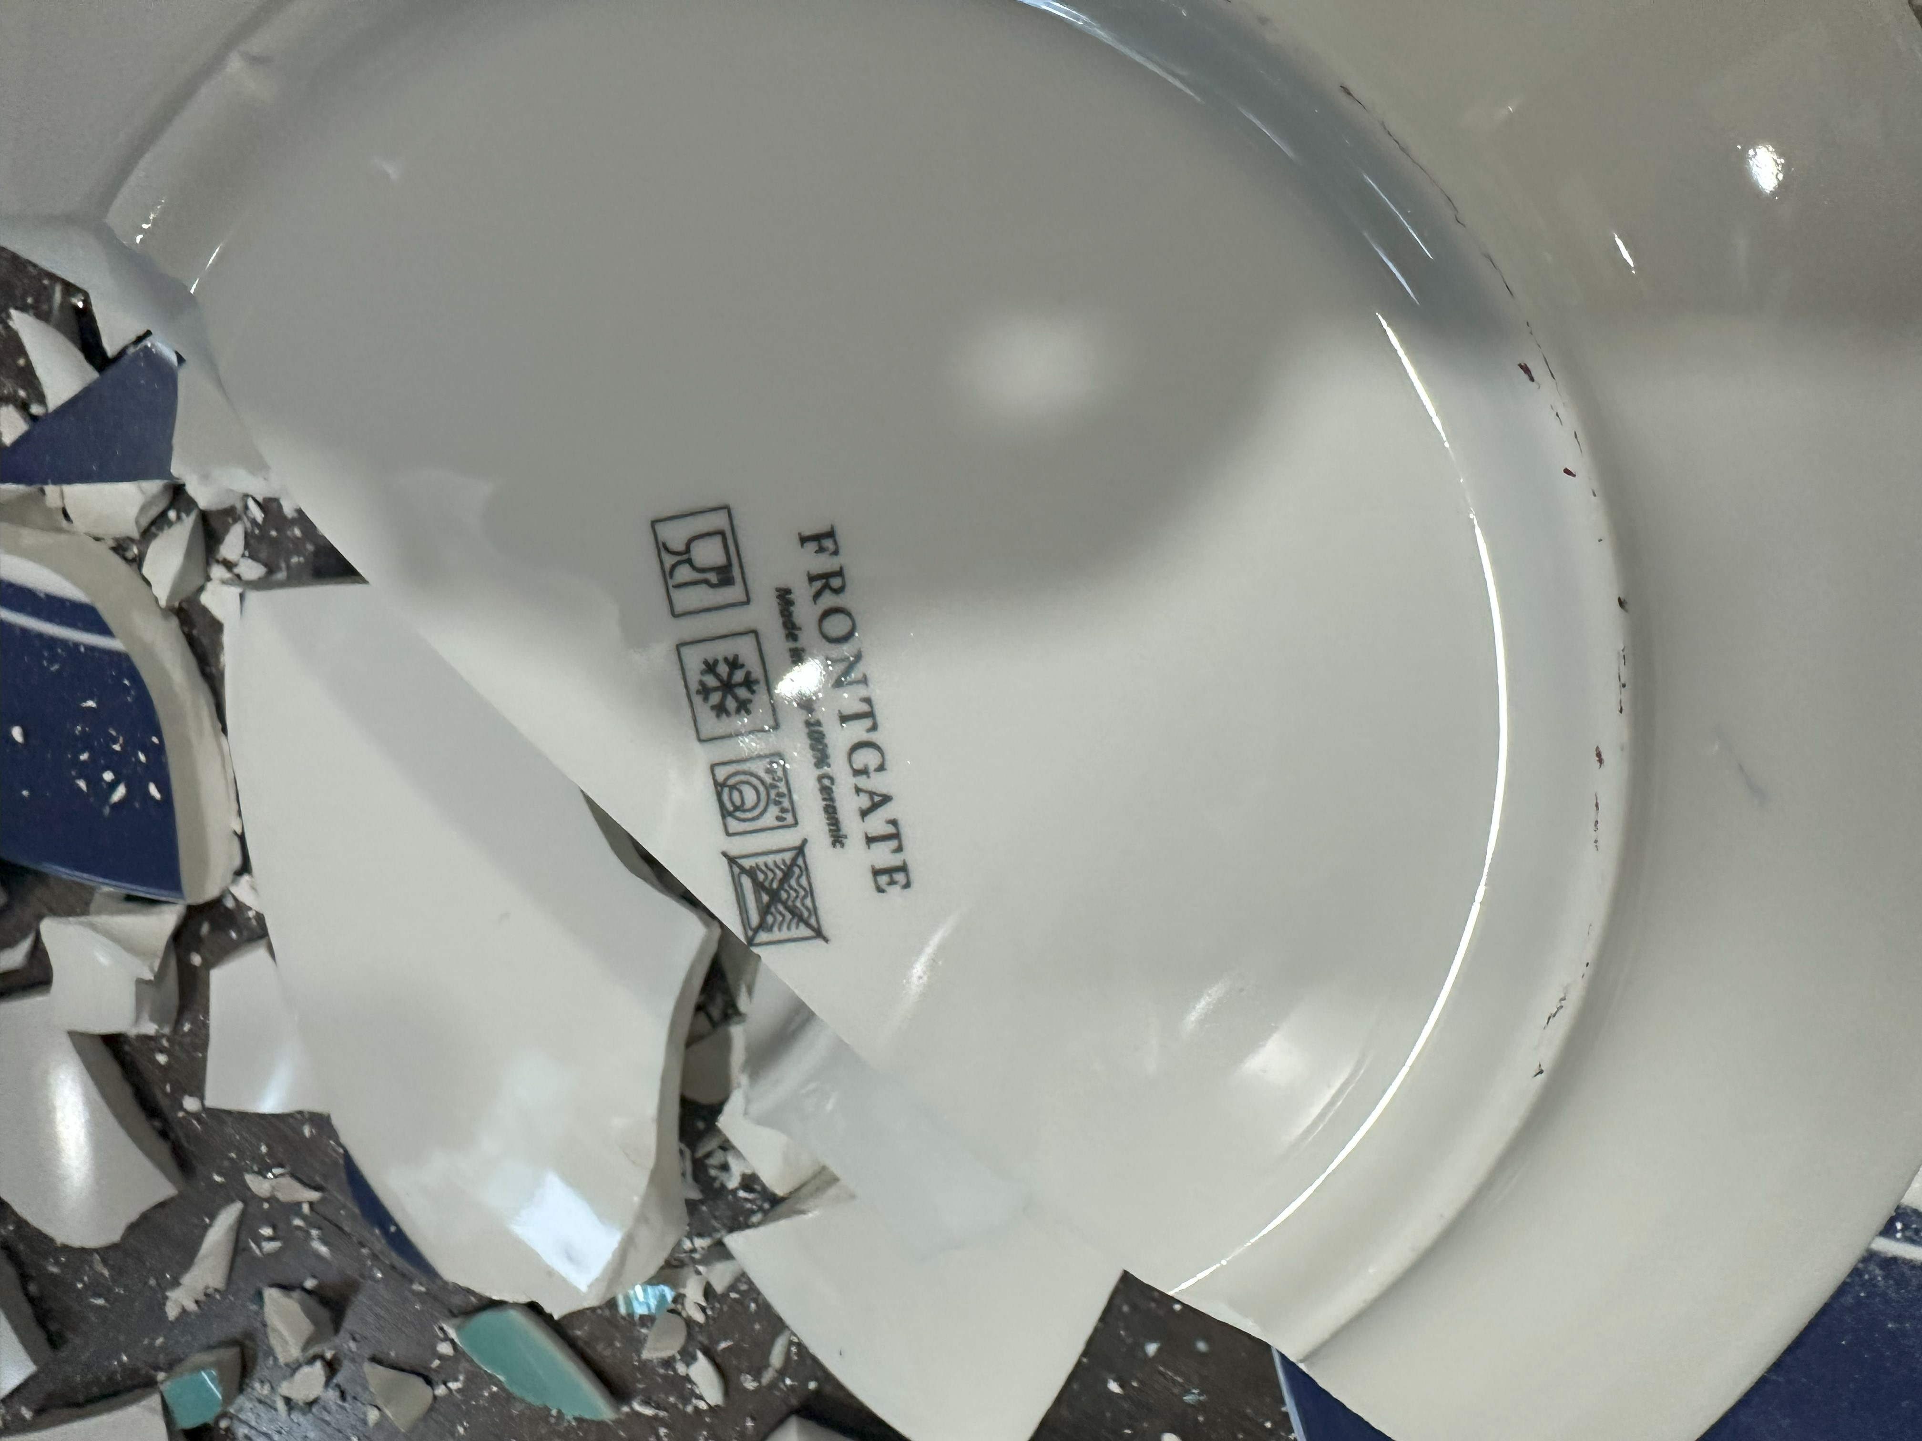


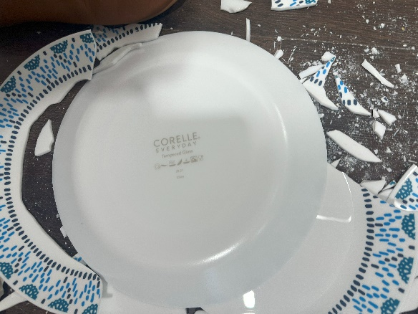
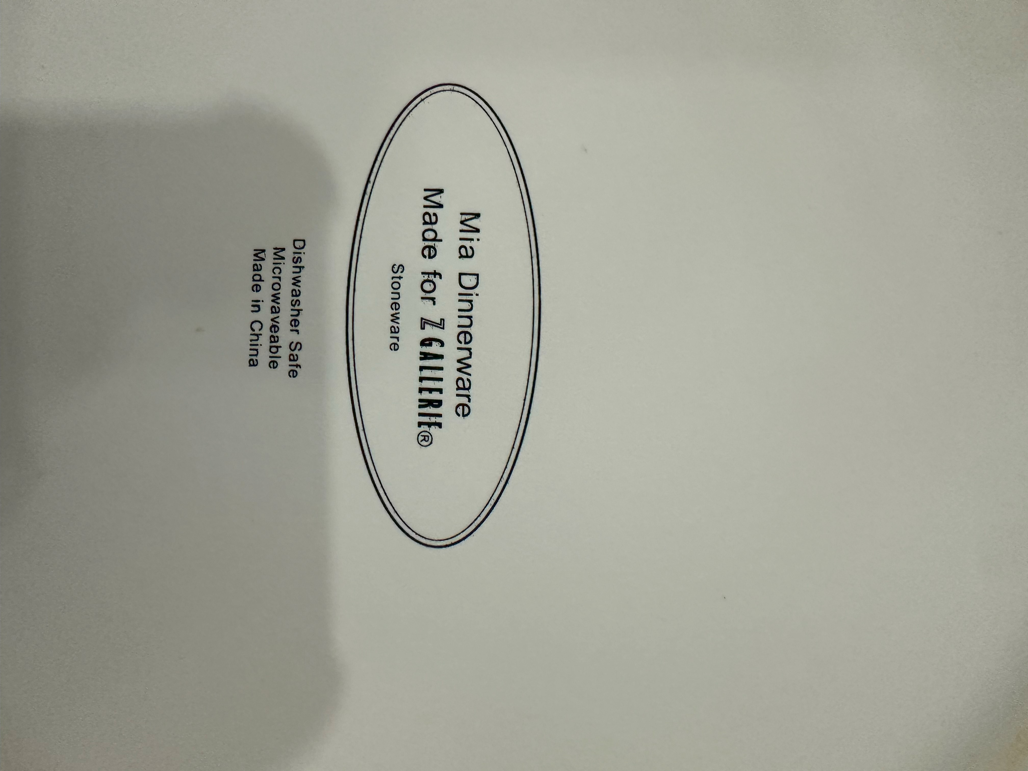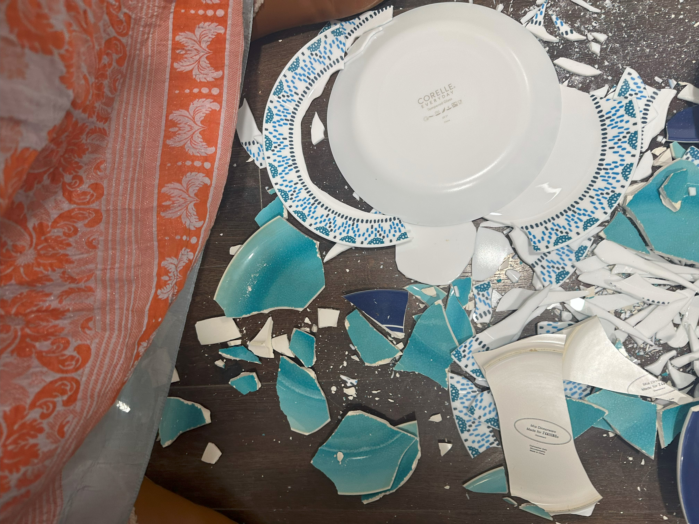
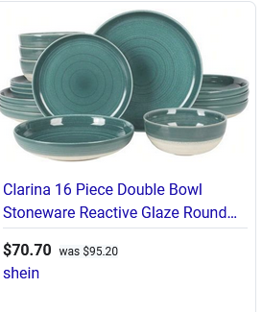

#15 Living Room
Item | Exhibit # | Purchased Dt | Condition/age | How many | Purchased from | Price
Blue Couch | 15-1 | Within the last 5 years | good | 1 |  | 4699.99
2 tables | 15-2 | Within the last 2 years | good | 2@560 |  | 1120
Coffee table/foos | 15-3 | antique | good |  |  | 969.99
2 green chairs | 15-4 | Within the last 2 years | good | 2@581 |  | 1162
Total |  |  |  |  |  | $7,951.98

Exhibit #15-1
Living Room
Blue Couch Thomasville
Similar Damaged
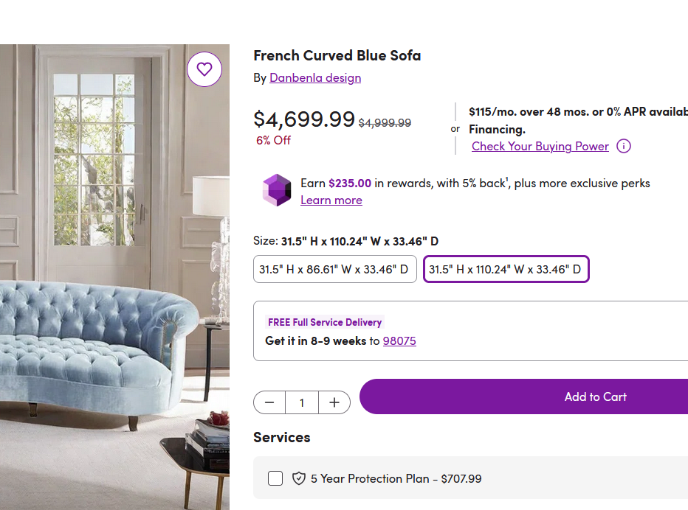
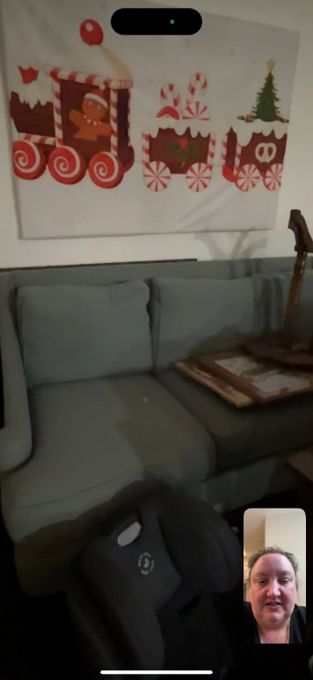
Exhibit #15-2
Living Room
2 Tables
Similar Damaged

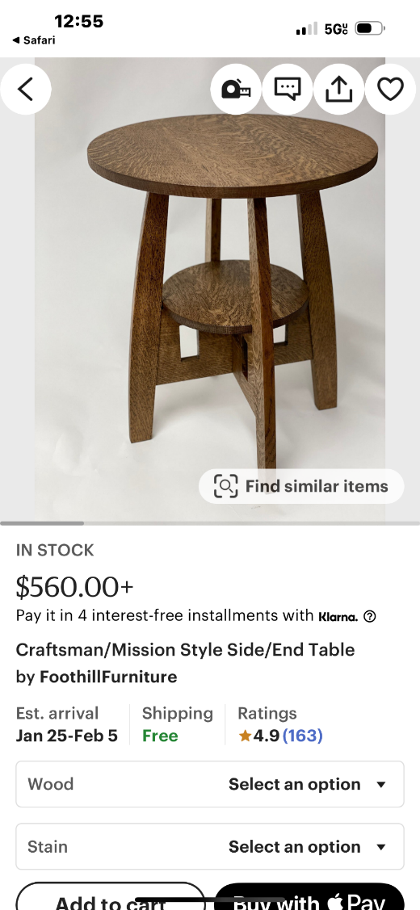
Exhibit #15-3
Living Room
Foos table
Similar Damaged
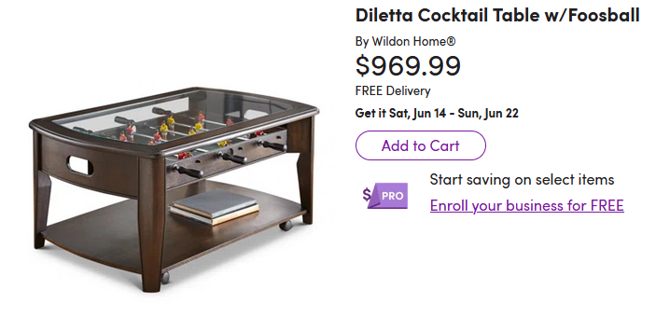
Exhibit #15-4
Living Room
2 Green Chairs
Similar Damaged

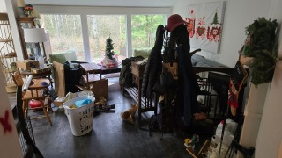
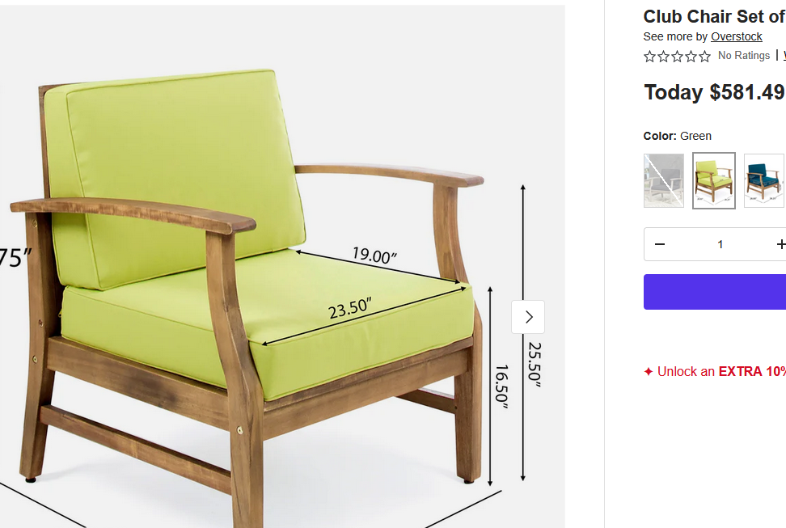

#16 Lily’s room
Item | Exhibit # | Purchased Dt | Condition/age | How many | Purchased from | Price
Dresser | 16-1 |  |  |  |  | 1799
Shelf | 16-2 |  |  |  |  | 313.99
Metal Bookcase | 16-3 |  |  |  |  | 100
Nightstand | 16-4 |  |  |  |  | 999.99
Decorations on shelf and drawer | 16-5 |  |  |  |  | Approx.500
Bed frame and headboard | 16-6 |  |  |  |  | 1266
Light | 16-7 |  |  |  |  | Approx 300
Mattress and sheets | 16-8
Pictures on wall | 16-9 |  |  |  |  | Approx. 600
chair | 16-10 |  |  |  |  | 600
Total |  |  |  |  |  | $7,478.97

Exhibit #16-1
Lily’s Room
Dresser
Similar Damaged
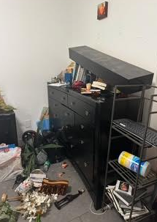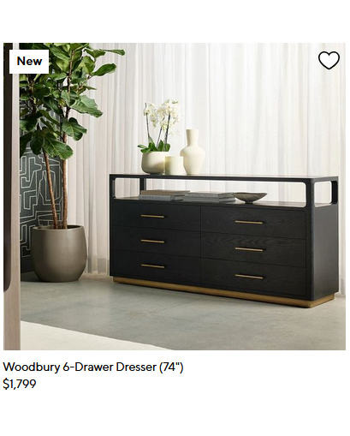

Exhibit #16-2
Lily’s Room
Shelf
Similar Damaged
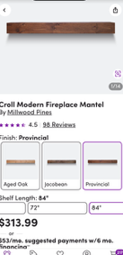

Exhibit #16-3
Lily’s Room
Metal Book case
Similar Damaged
Exhibit #16-4
Lily’s Room
Night stand
Similar Damaged

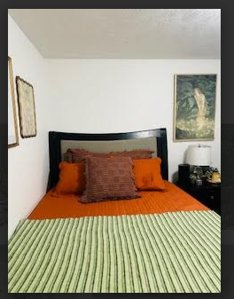
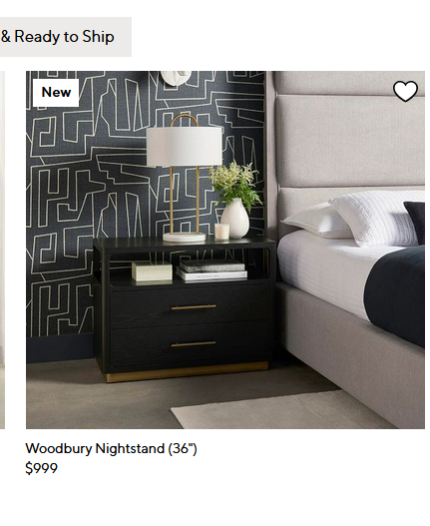
Exhibit #16-5
Lily’s Room
Decorations on shelf and drawer
Similar Damaged

Exhibit #16-6
Lily’s Room
Bed frame and headboard
Similar Damaged

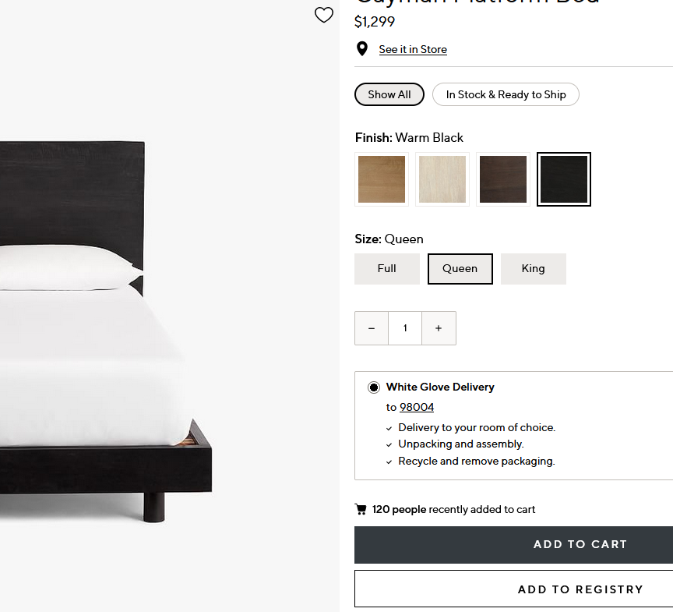

Exhibit #16-7
Lily’s Room
Light and nightstand decorations
Similar Damaged
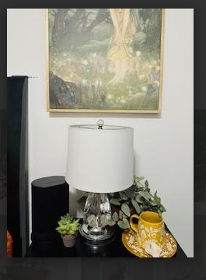
Exhibit #16-8

Lily’s Room
Mattress and sheets and bedding (Mattress is still in Ava’s room but it will be thrown away, it has water damage as well as insulation and wood all over it.)
Similar Damaged
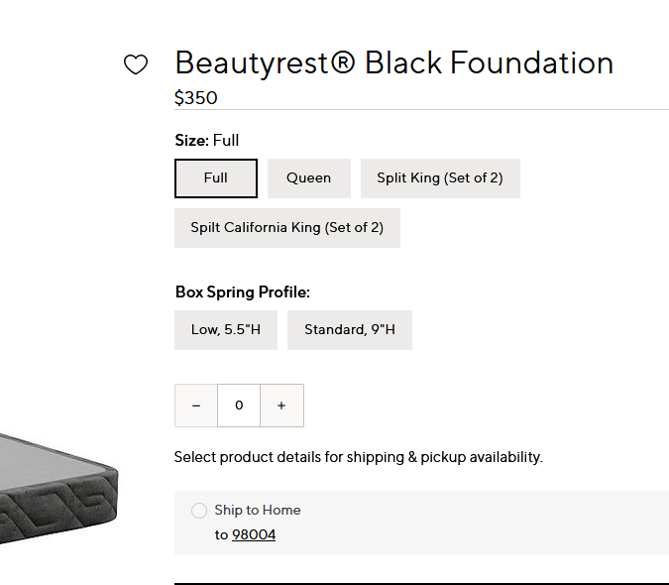

Exhibit #16-9
Lily’s Room
4 Pictures on wall (still hanging on wall but it will be thrown away, it has water damage as well as insulation and wood all over it.)
Similar Damaged
Exhibit #16-10
Lily’s Room
Chair and table, pillows, drapes, (still in room but it will be thrown away, it has water damage as well as insulation and wood all over it.)
Similar Damaged
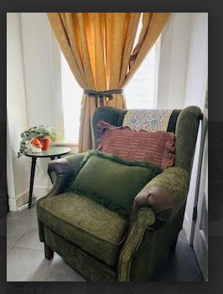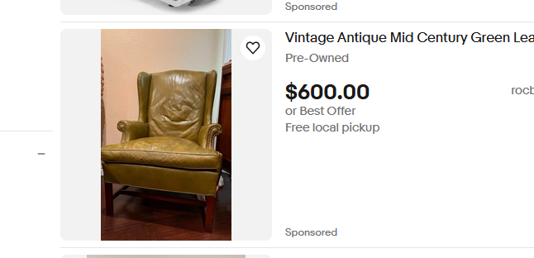

#17 Ava’s room
This room had a branch falling through it, with insulation and wood branches coming down and people walking all over items in the room. Entire room and contents were a complete loss.
Item | Exhibit # | Purchased Dt | Condition/age | How many | Purchased from | Price
Mattress, Headboard, sheets, Blankets, Pillows | 17-1 |  |  |  |  | Approx. 3500
Desk and Supplies and monitors | 17-2 |  |  |  |  | Approx 2100
Clothing | 17-3 |  |  |  |  | Approx  4500
2 Bookcases PotteryBarn | 17-4 |  |  |  |  | Approx  1200
Shelves and items on them | 17-5 |  |  |  |  | Approx 300
Decorations | 17-6 |  |  |  |  | Approx 600
Inside Closet | 17-7 |  |  |  |  | Approx 1200
2 Dressers PotteryBarn | 17-8 |  |  |  |  | Approx 3000
shoes | 17-9 |  |  |  |  | Aprox 1500
Total |  |  |  |  |  | $17,900

Exhibit #17-1
Ava’s Room
Mattress, Headboard, sheets, Blankets, Pillows
Similar Damaged
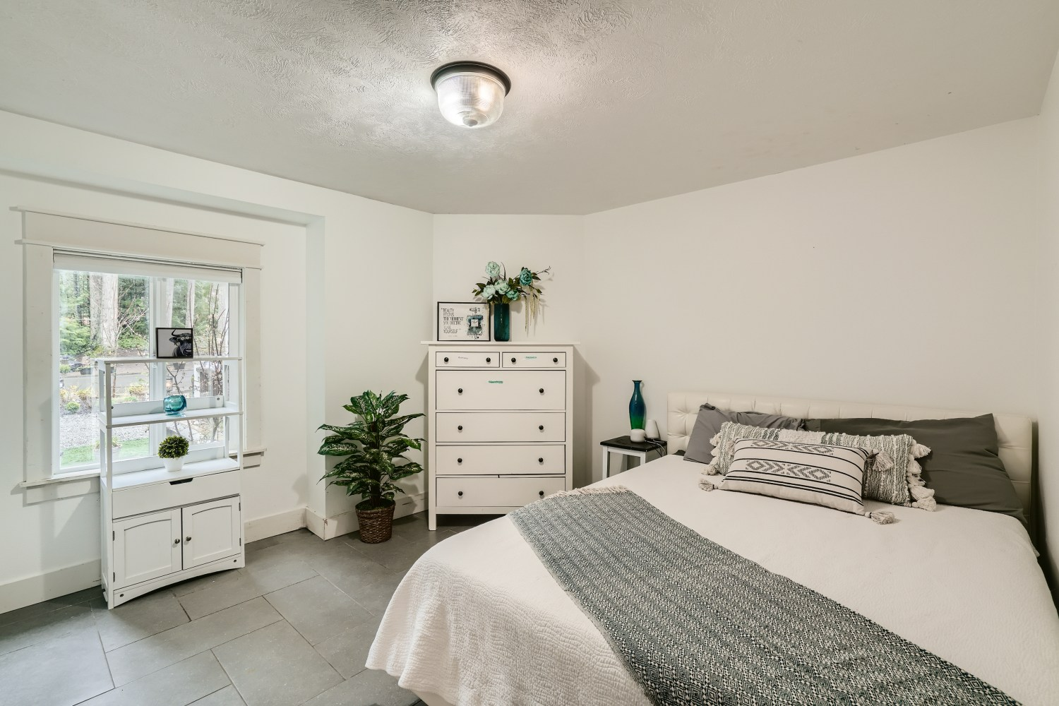
Exhibit #17-2
Ava’s Room
Desk and Supplies and monitors
Similar Damaged

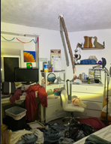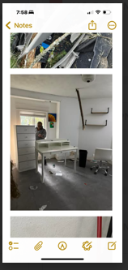
Exhibit #17-3
Ava’s Room
Clothing
Similar Damaged

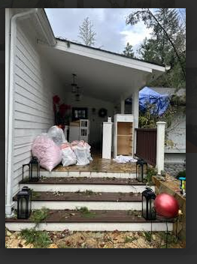
Exhibit #17-4
Ava’s Room
2 Bookcase
Similar Damaged

Exhibit #17-5
Ava’s Room
Shelves and items on them
Similar Damaged

Exhibit #17-6
Ava’s Room
Decorations
Similar Damaged

Exhibit #17-7
Ava’s Room
Inside closet
Similar Damaged
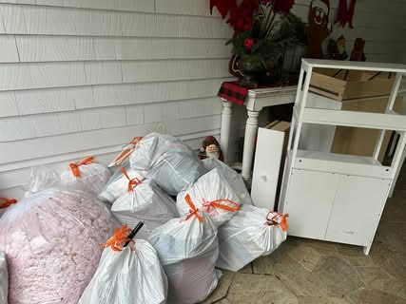

Exhibit #17-8
Ava’s Room
2 dressers
Similar Damaged
Exhibit #17-9
Ava’s Room
Shoes
Similar Damaged

#18 Main Bathroom
Removed items put them in POD.
Item | Exhibit # | Purchased Dt | Condition/age | How many | Purchased from | Price
 | 6-1

#19 Master bath
Removed items put them in POD.
Item | Exhibit # | Purchased Dt | Condition/age | How many | Purchased from | Price
 | 6-1

#20 Master Bedroom
Removed items put them in POD.
Item | Exhibit # | Purchased Dt | Condition/age | How many | Purchased from | Price
 | 6-1

#21 Reading Nook
Put this in with den.
Item | Exhibit # |  | Purchased Dt | Condition/age | How many | Purchased from | Price
 | 6-1

#22 Attic
Removed items put them in POD.
Item | Exhibit # | Purchased Dt | Condition/age | How many | Purchased from | Price
 | 22-1

#24 Christmas Decorations
Item | Exhibit # | Purchased Dt | Condition/age | How many | Purchased from | Price
Christmas Tree | 24-1 |  |  |  |  | 11,595
Elves | 24-2 |  |  | 12@150 |  | 1800
Large Polar Bear | 24-3 |  |  |  |  | 1880
4 xmas wreaths | 24-4 |  |  | 4@105 |  | 420
Table cloth and setting | 24-5 |  |  |  |  | Approx.. 600
Santa Collection | 24-6 |  |  |  |  | Approx  4500
Children’s Area | 24-7 |  |  |  |  | Approx. 800
Total |  |  |  |  |  | $21,595

Exhibit #24-1
Christmas Tree

Similar Similarly Damaged


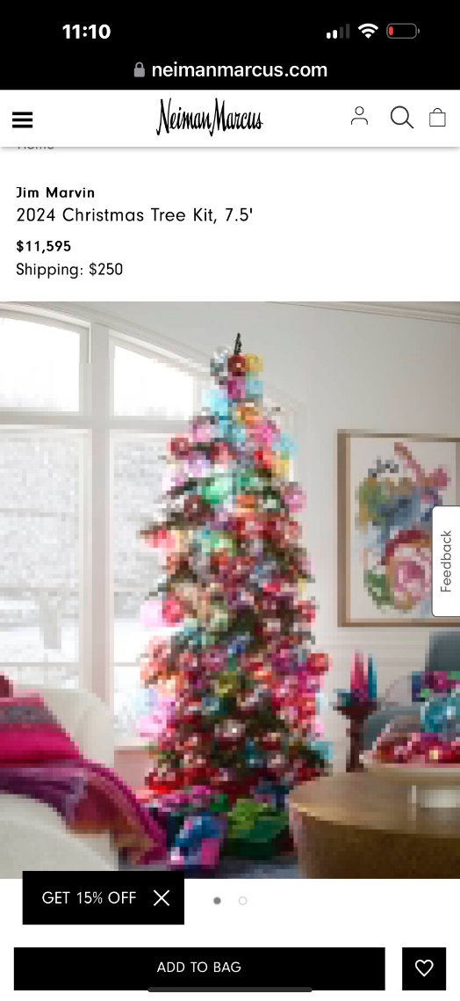
Exhibit #24-2
CHRISTMAS DECORATIONS
Elves

12 Elves

Similar Damaged
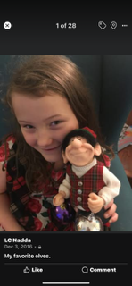

Exhibit #24-3
CHRISTMAS DECORATIONS
Polar Bear

Similar Damaged
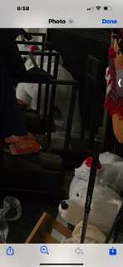
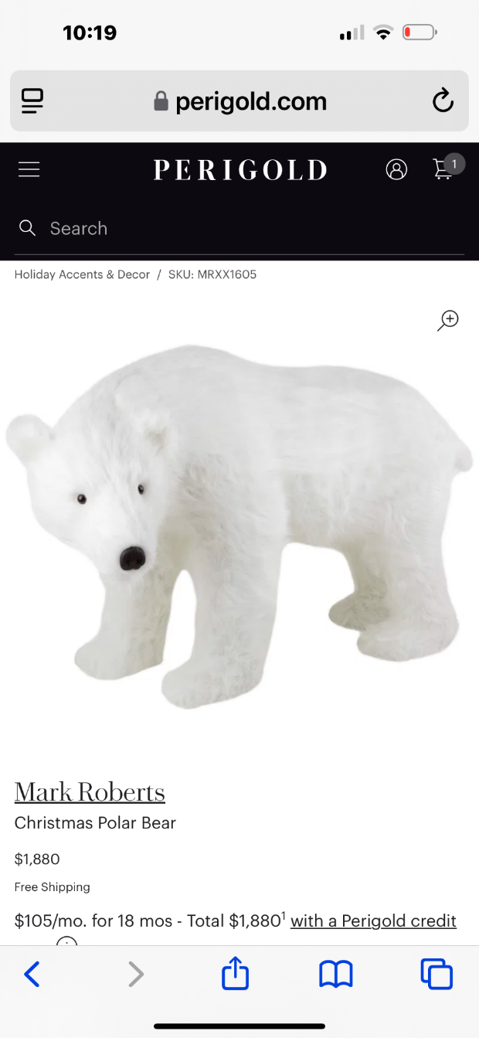

Exhibit #24-4
Christmas Decorations
4 Christmas wreaths
Similar Damaged
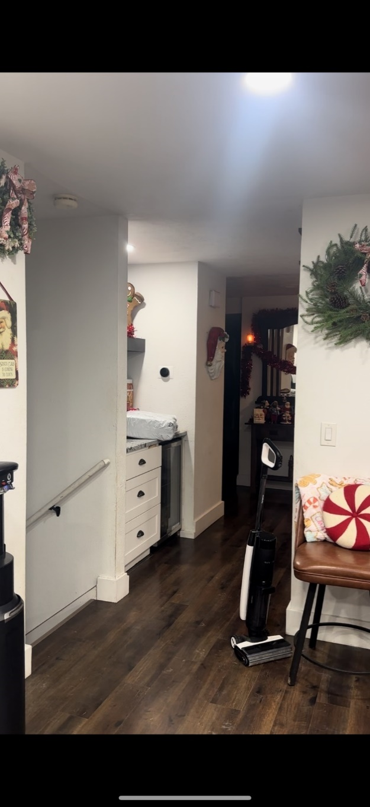


Exhibit #24-5
Christmas Decorations
Table
Similar Damaged
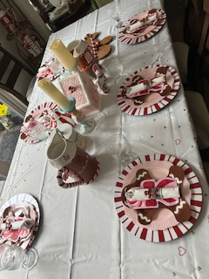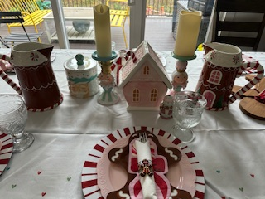

Exhibit #24-6
Santa Collection
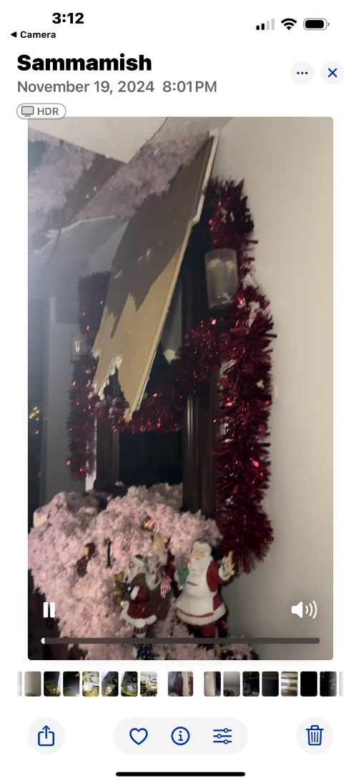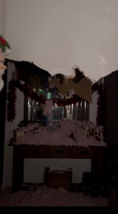
Santa Collection
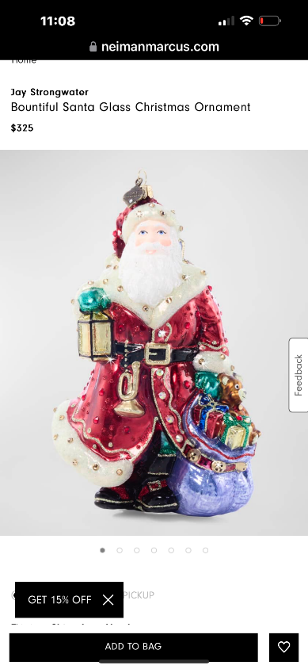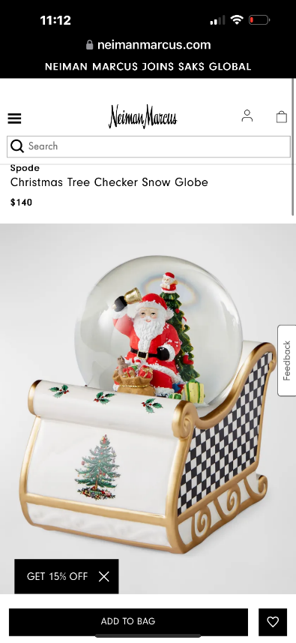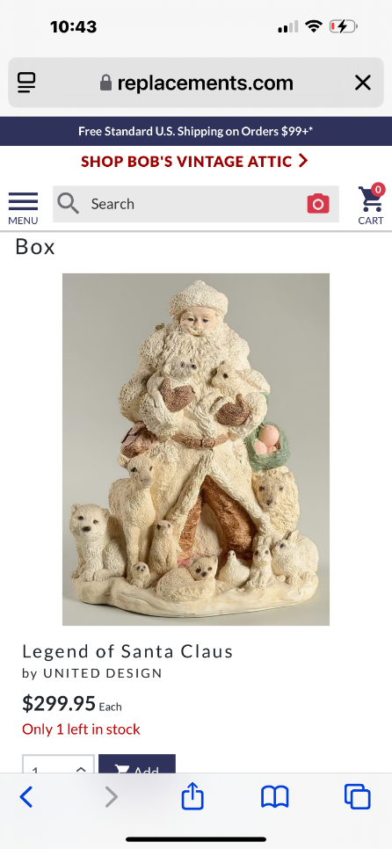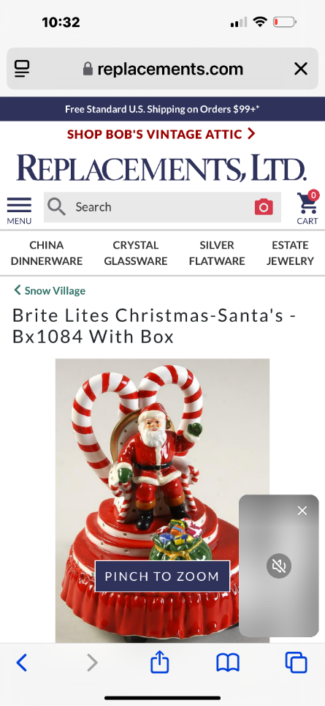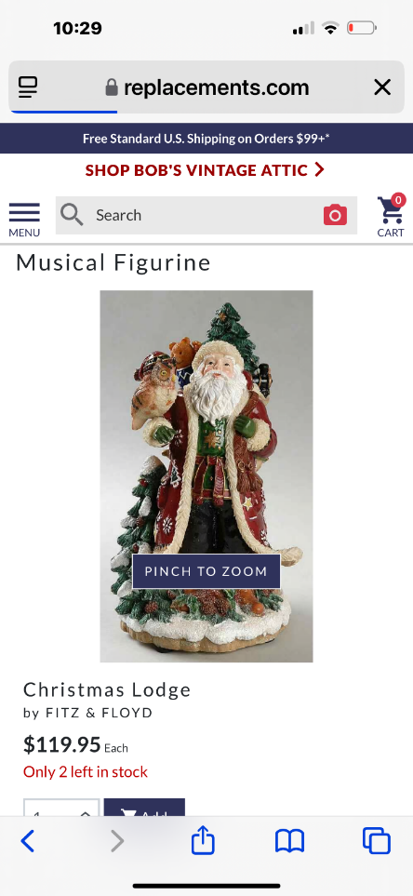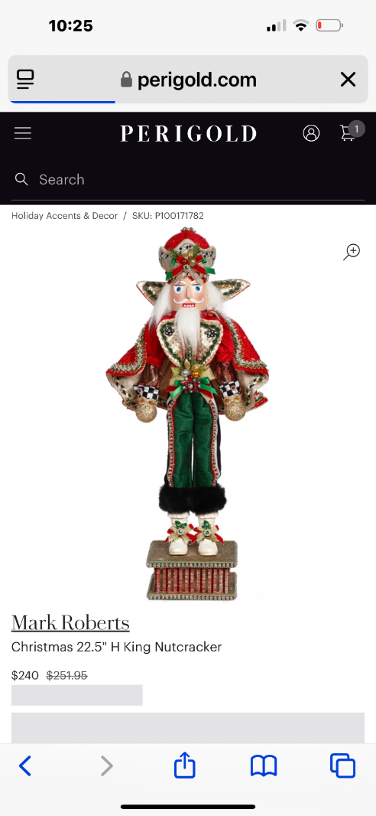
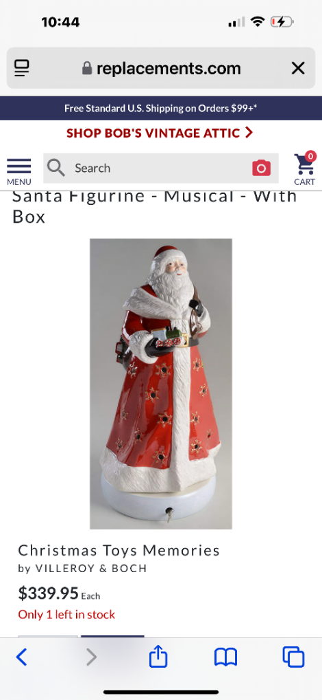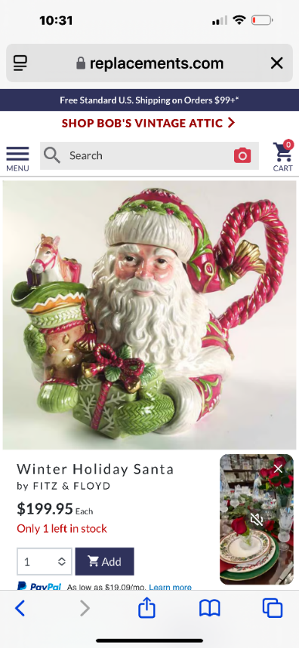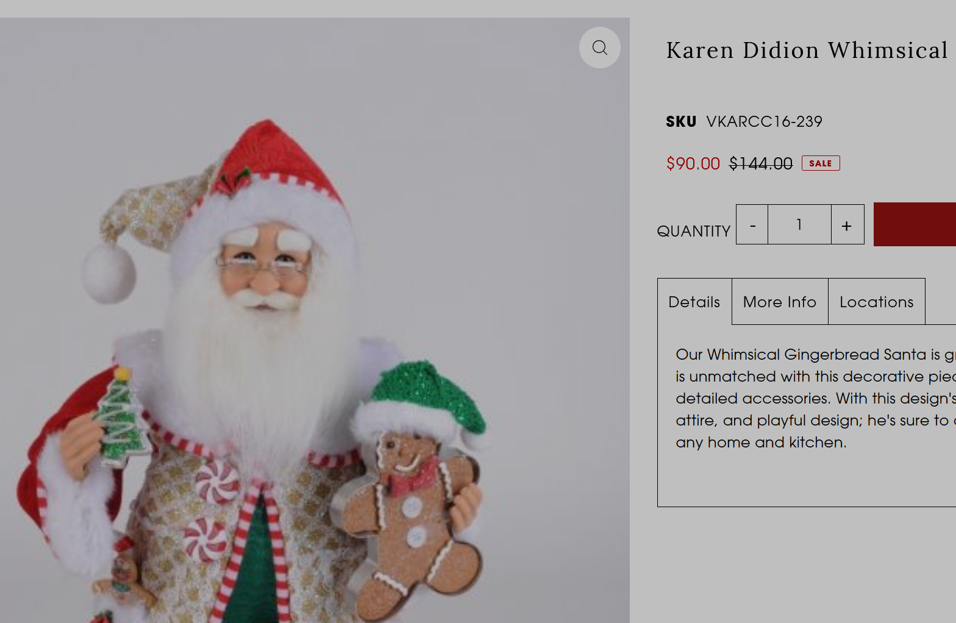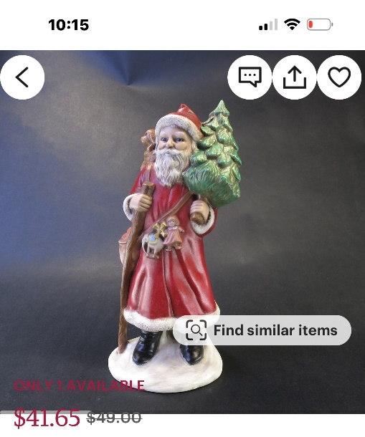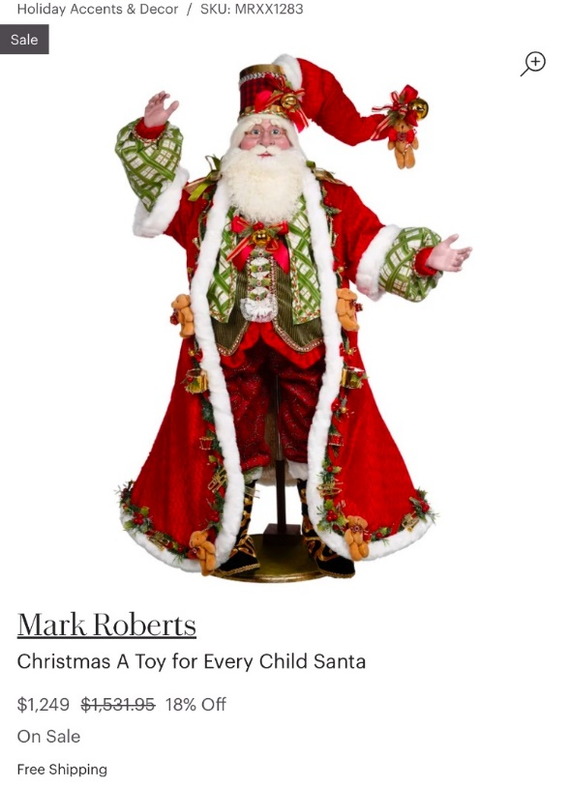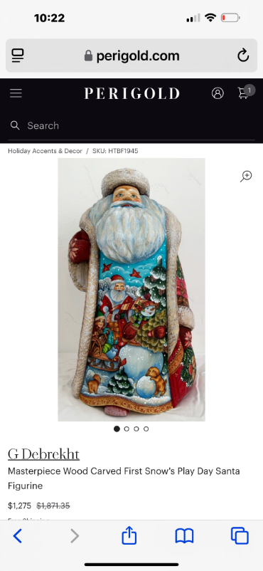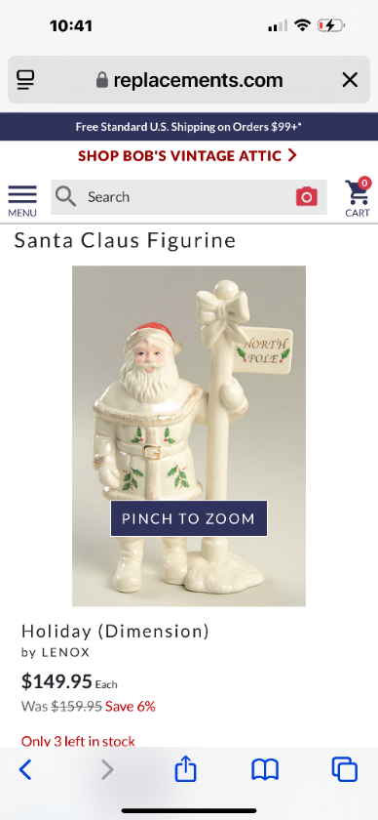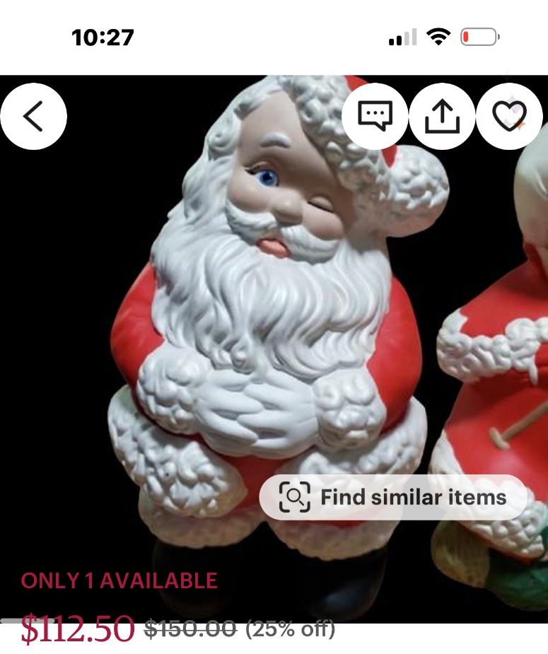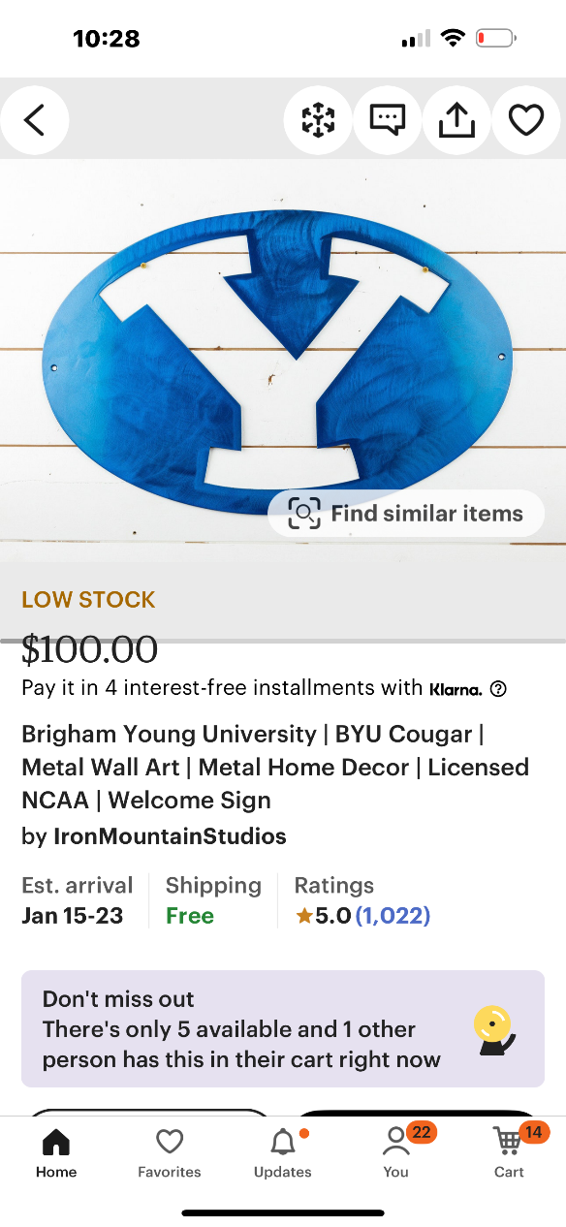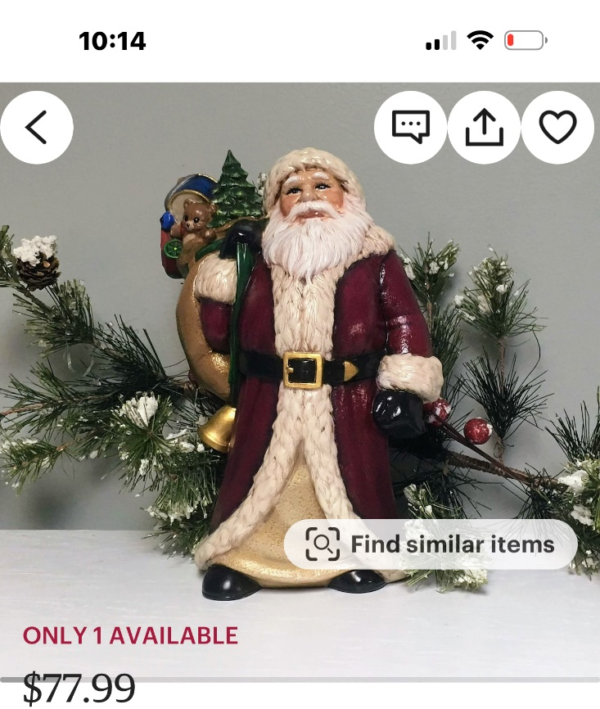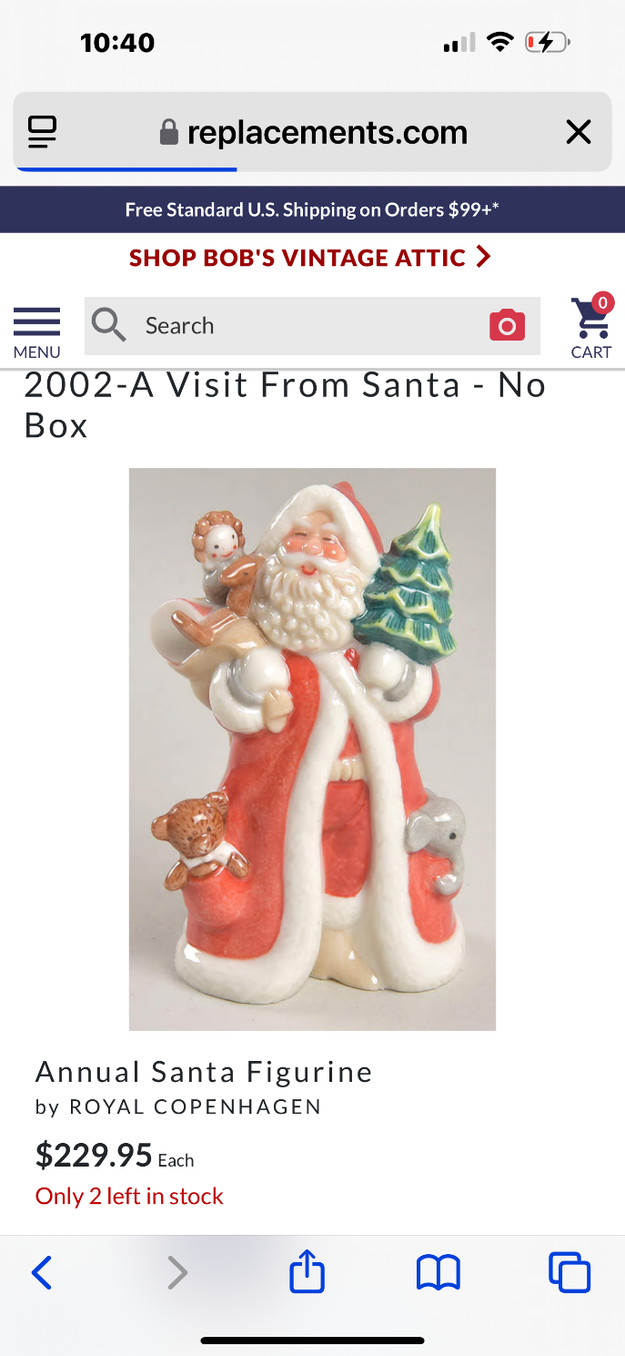

Exhibit #24-7
Children’s Area

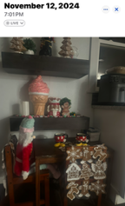

#25 Loss Miscellaneous:
Item | Exhibit # | Purchased Dt | Condition/age | How many | Purchased from | Price
Opal Ring | 25-1 |  | perfect | 1 | antique | 5335
Storage Room
-Freezer
Total |  |  |  |  |  | 5335

Exhibit #25-1
Entryway:
Opal ring lost in tree mess. Taking a picture of the damaged pan was the last time I saw it.
