#11 Hallway
Item | Exhibit # | Purchased Dt | Condition/age | How many | Purchased from | Price
Vacuum/mop | 11-1 | In the past 2 years | great | 1 |  | 6,652
Frame and pictures | 11-2 | In the past 2 years | good | 1 |  | 100
Decorations on hidden door | 11-3 | In the past 2 years | good | 1 |  | 300
Total |  |  |  |  |  | 7,652

Exhibit #11-1
Hallway
Vacuum / mop
Similar Damaged

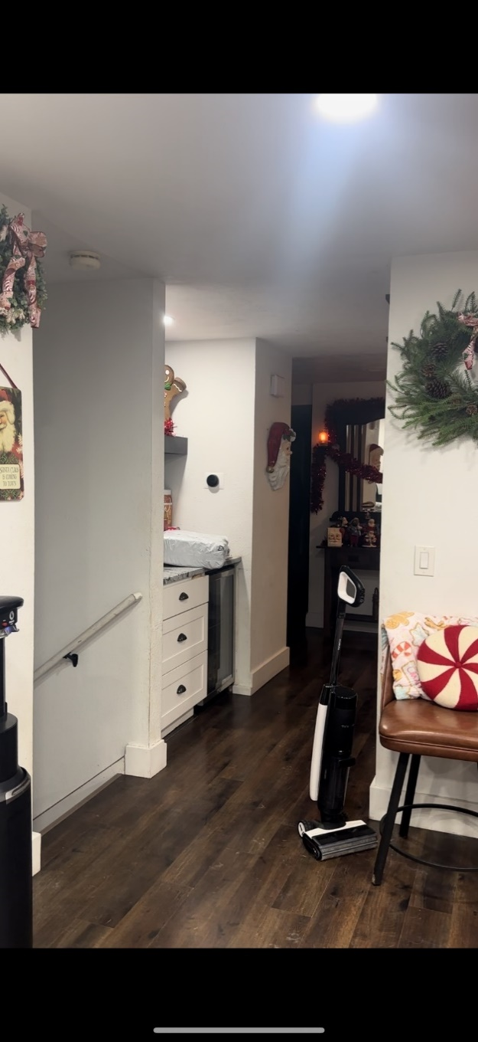
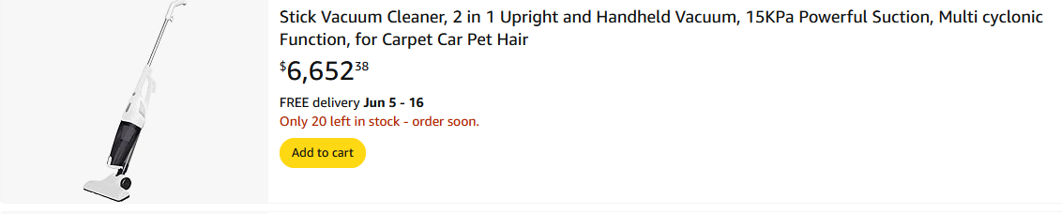

Exhibit #11-2
Hallway
Picture frame and pictures.
Approximately $50 to reprint pictures and $50 for frame.
Similar Damaged
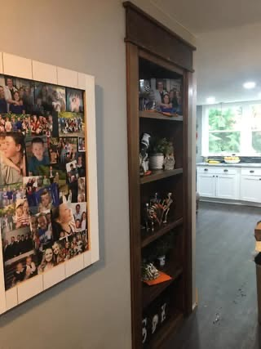
Exhibit #11-3
Hallway
Decorations on hidden shelf. Approximately $300
Similar Damaged

#12 Kitchen Food Itemized Food & Storage Loss Estimate – Total: $36,000
Everything (food) was a total loss, or directed to throw away. 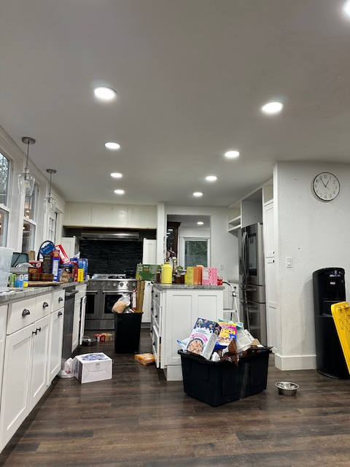

#12.1 Pantry (Dry Goods & Canned Items) – $9,800
- Organic grains, pasta, and flours (rice, oats, almond, coconut, cassava): $1,400
- Home-canned fruits, vegetables, and sauces (over 100 jars): $2,000
- Gluten-free and specialty baking ingredients: $1,100
- Organic spices, herbs, nutritional yeast, and seasoning blends: $900
- Nut butters, oils (olive, avocado, coconut), vinegars: $1,200
- Medicinal teas, supplements, and herbal tinctures: $1,400
- Canned beans, tomatoes, soups, and emergency storage goods: $1,800

Total Estimated Replacement Value: $36,000
This estimate reflects the actual pre-loss value of food and nutritional supplies required for a large family, including dietary restrictions and medical needs for Layna. All items were either lost due to contamination, power loss, disposal instructions, or lack of functional storage space due to displacement.

#12.2. Freezers (Upright and Chest) – $11,400
- Organic beef, chicken, fish, and game meats (bulk purchase): $4,000
- Frozen homemade meals, broths, stews, and bone broth containers: $2,100
- Gluten-free breads, tortillas, baked goods: $1,000
- Frozen fruits, vegetables, smoothie packs: $2,000
- Dairy substitutes (coconut milk, oat milk, non-dairy cheese): $1,100
- Frozen specialty items (tamales, dumplings, organic pizza): $1,200

#12.3. Refrigerators (Main + Secondary) – $9,200
- Organic dairy and non-dairy beverages: $1,200
- Farm eggs, condiments, pickles, and fermented items: $1,300
- Meal prep items, sauces, dressings, and fresh herbs: $2,000
- Insulin, probiotics, and refrigerated supplements/medical food: $1,500
- Fresh produce and specialty meats (delivered weekly): $1,500
- Yogurts, hummus, snack trays, nut milks, and plant-based protein: $1,700

#12.4. Cereal & Dry Snack Cupboard – $5,600
- Gluten-free, grain-free cereals and granola (bulk storage): $1,400
- Organic crackers, rice cakes, and shelf-stable snacks: $1,000
- Kids’ snack foods, bars, applesauce, dried fruit: $1,600
- Bulk nuts, seeds, trail mixes, protein powders: $1,600

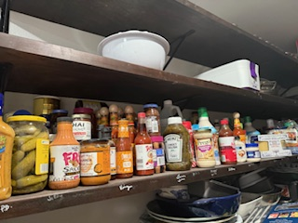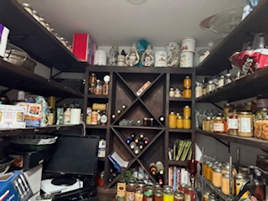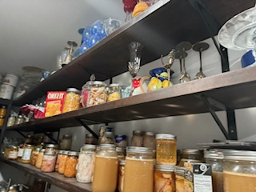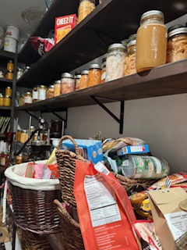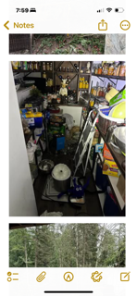
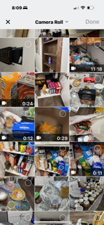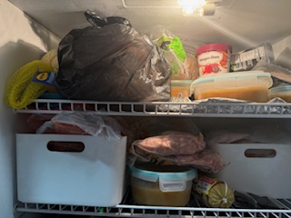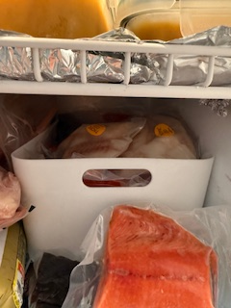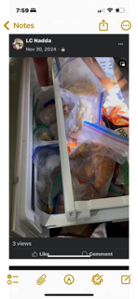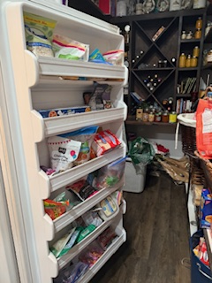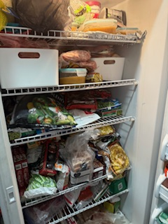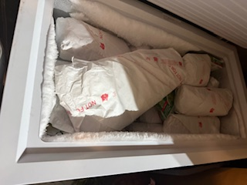

#13 Den
Item | Exhibit # | Purchased Dt | Condition/age | How many | Purchased from | Price
2 green chairs | 13-1 | Within 3 years |  | 2@1850 |  | 3,700
Sideboard | 13-2 | Within 3 years |  |  |  | 2877.33
2 Brown Cabinets | 13-3 | Within 3 years |  | 2@503.67 |  | 1007.34
2 leather brown chairs | 13-4 | Within 3 years |  | 2@374.25
Pellaton | 13-5 | Within 3 years |  | 1 |  | 2195
Treadmill | 13-6 | Within 3 years |  | 1 |  | 2299
Coffee table | 13-7 | Within 3 years |  | 1 |  | 560
Green Drapes | 13-8 | Within 3 years |  | 2@166.99 |  | 333.98
Front window Coverings | 13-9 | Within 3 years |  | 5@150 |  | 750
Brown Leather couches and ottomans | 13-10 | Within 3 years |  | 2@4979. |  | 9958
Decorations | 13-11 | Within 3 years |  | 20 |  | 600
Chess table | 13-12 | Within 3 years |  | 1 |  | 560
Metal Chess pieces | 13-13 | Within 3 years |  | 1 |  | 599.99
Book nook couch | 13-14 | Within 3 years |  | 1 |  | 1200
Custom made chess board | 13-15 | Within 3 years |  | 1 |  | 459
Floor lamp | 13-16 | Within 3 years |  | 1 |  | 338.89
Total |  |  |  |  |  | $27,438.53

Exhibit #13-1
Den
Green Chairs
Similar Damaged
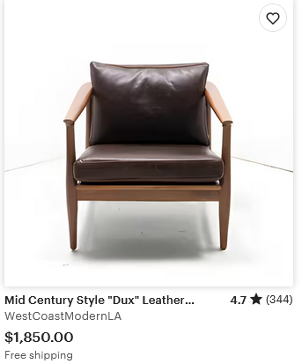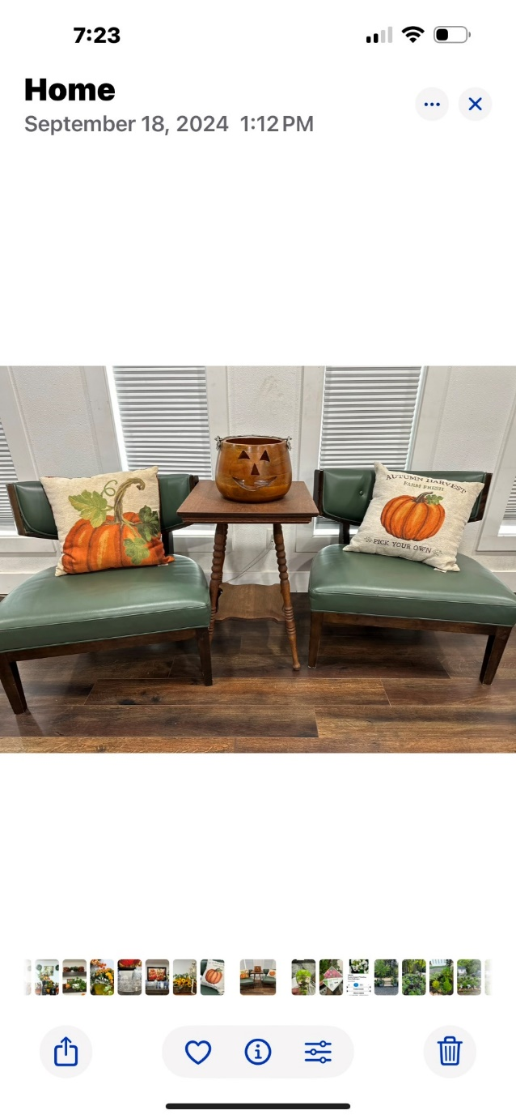

Exhibit #13-2
Den
Sideboard
Similar Damaged

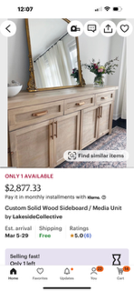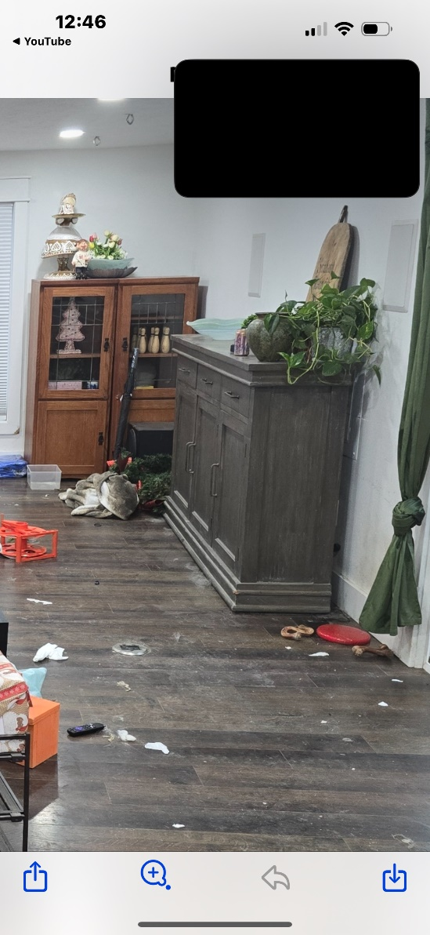

Exhibit #13-3
Den
Brown Cabinets
Similar Damaged
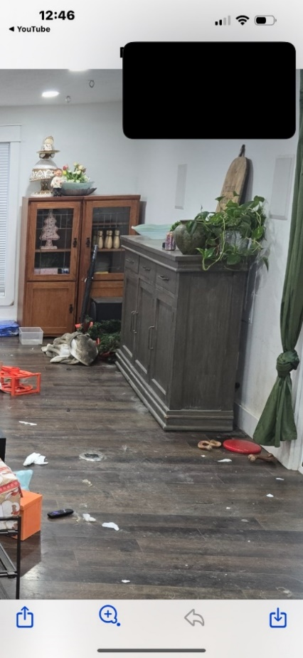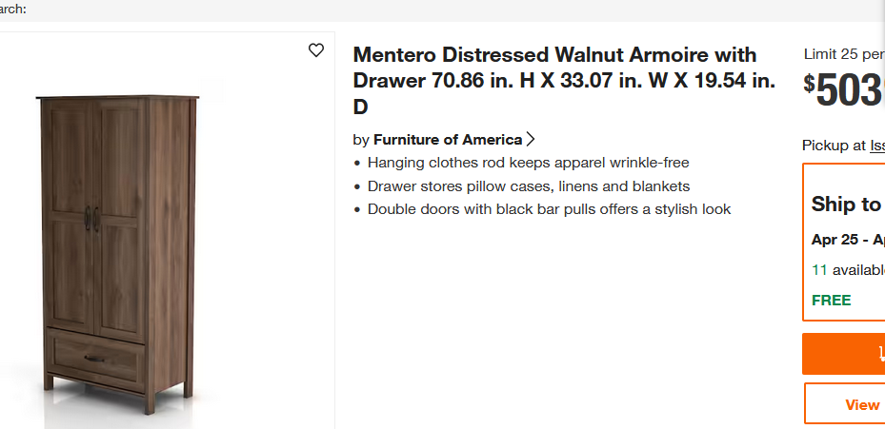

Exhibit #13-4
Den
2 Leather Brown Chairs
Similar Damaged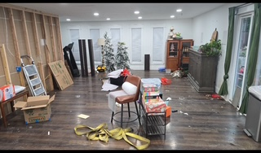
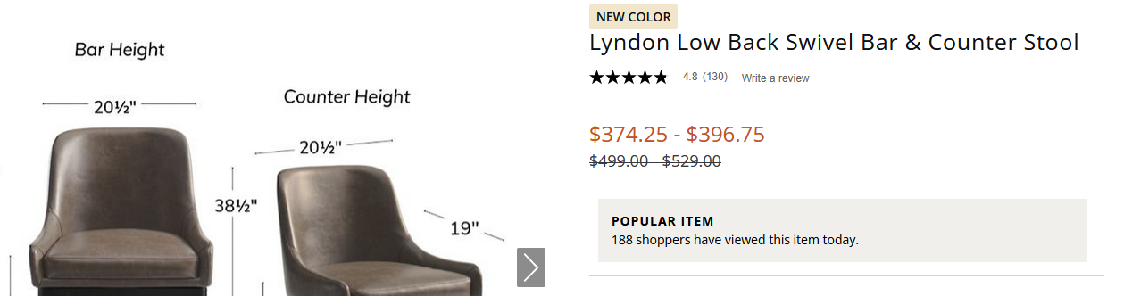

Exhibit #13-5
Den
Pellaton Bike
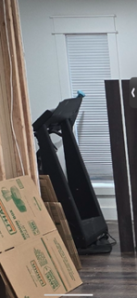
Similar Damaged
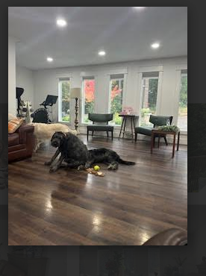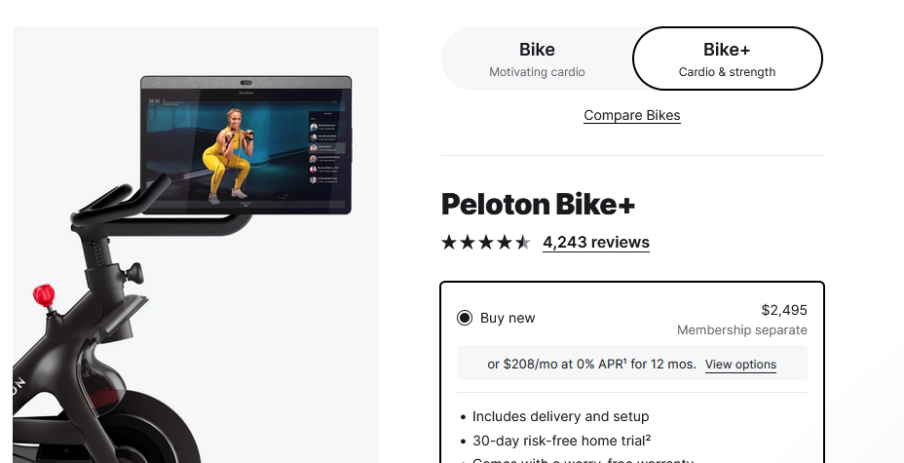
Exhibit #13-6
Den
Treadmill
Similar Damaged

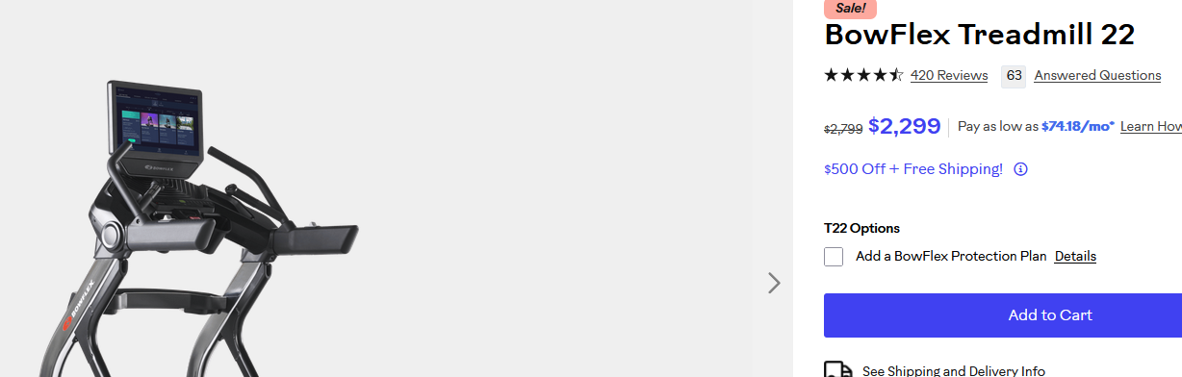

Exhibit #13-7
Den
Coffee Table
Similar Damaged
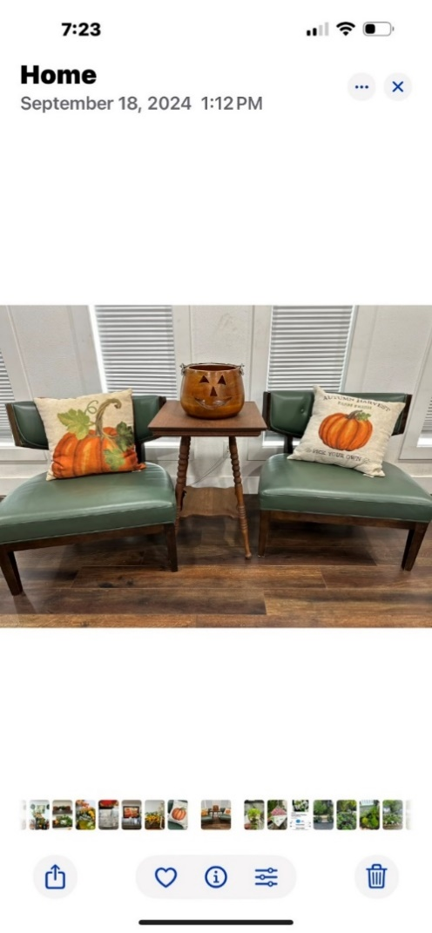
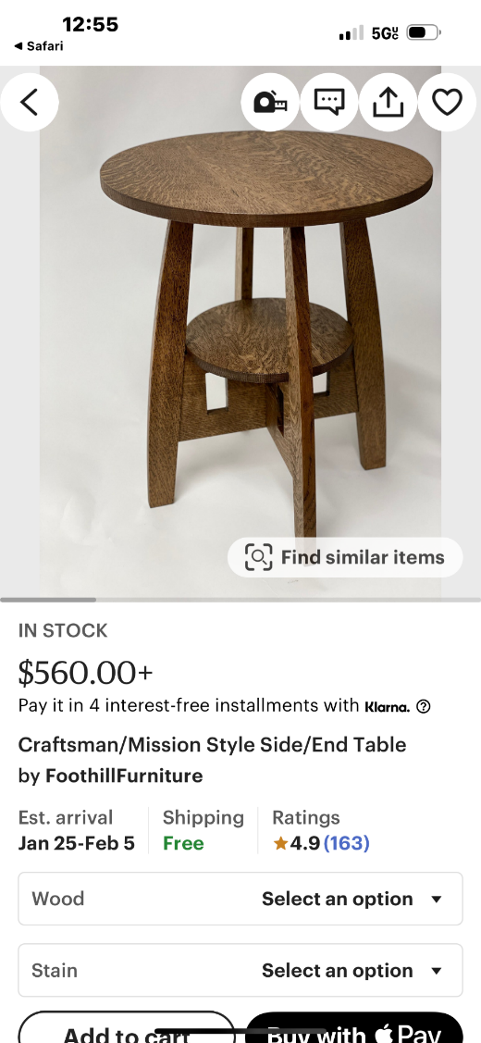
Exhibit #13-8
Den
2 Green Velvet Drapes
Similar Damaged



Exhibit #13-9
Den
5 White Window Coverings approximately $150 each
Similar Damaged

Exhibit #13-10
Den
2 Brown Leather Couches and 2 ottomans
Similar Damaged
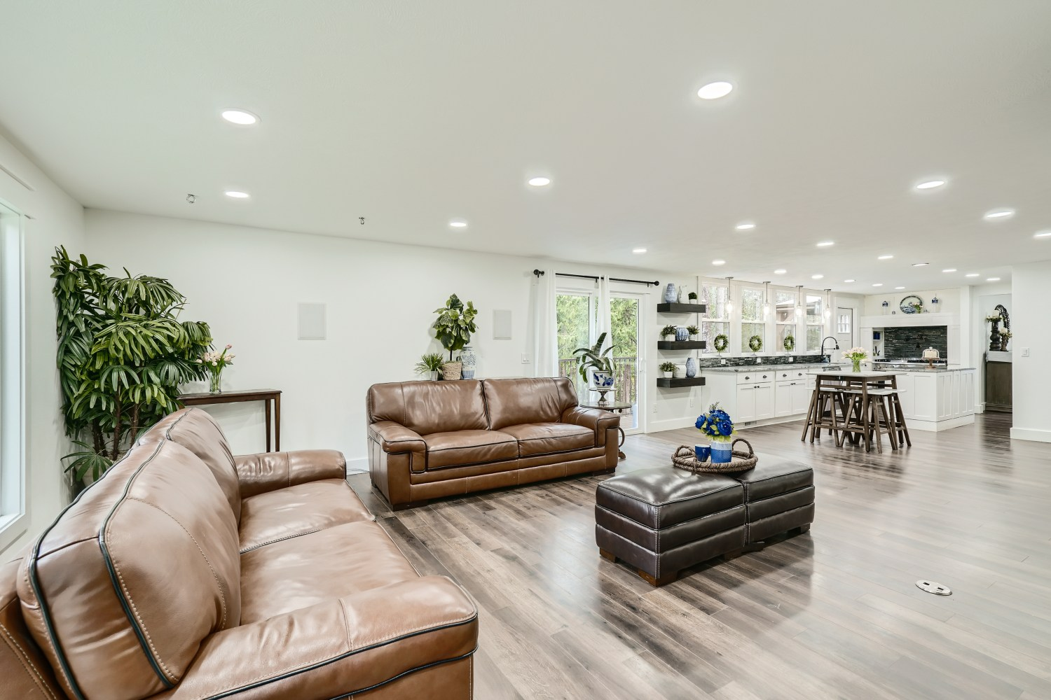

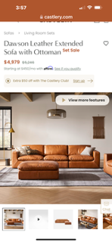
Exhibit #13-11
Den
Decorations in room approximately 20 decorations, $600
Similar Damaged

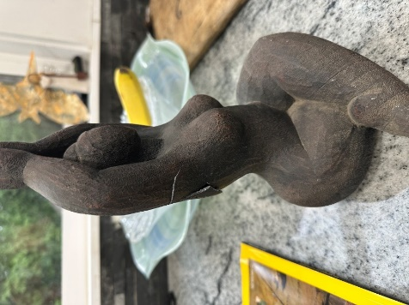

Exhibit #13-12
Den
Chess Table
Similar Damaged

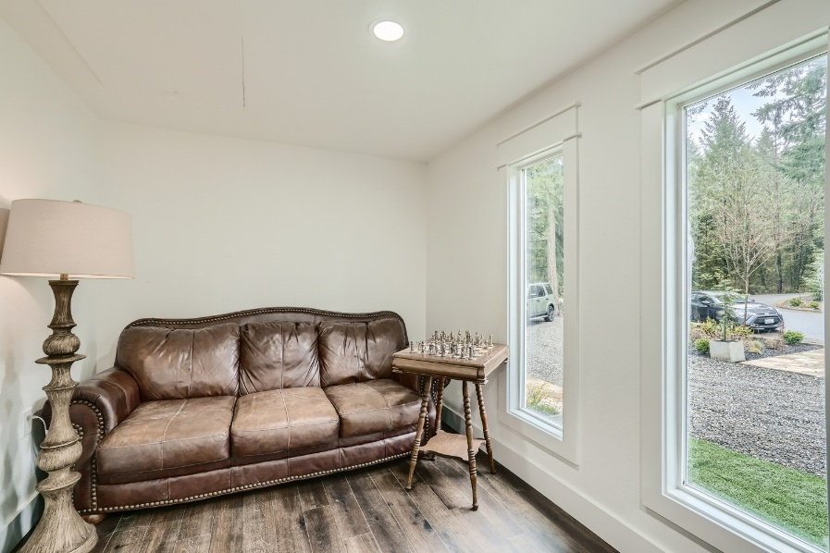
Exhibit #13-13
Den
Chess set metal pieces
Similar Damaged

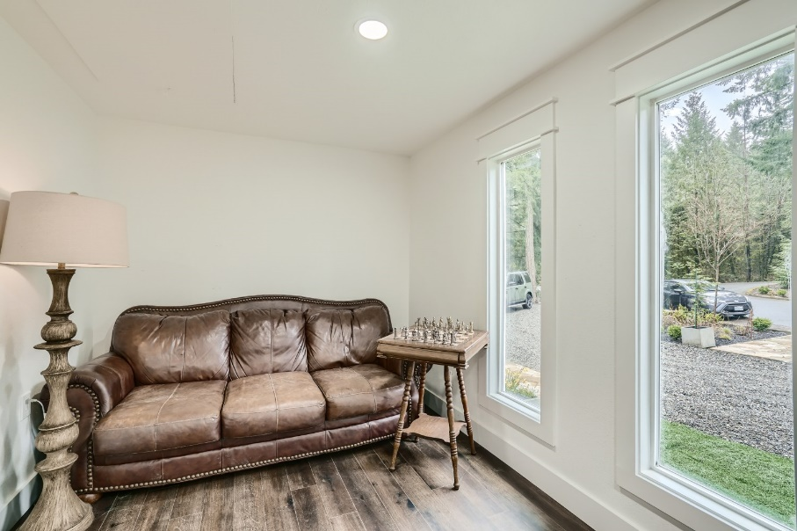
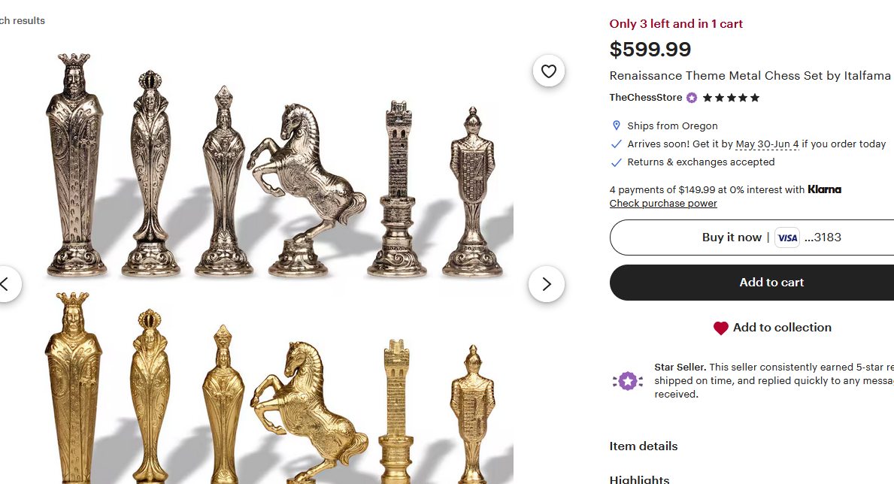
Exhibit #13-14
Den
Couch
Similar Damaged

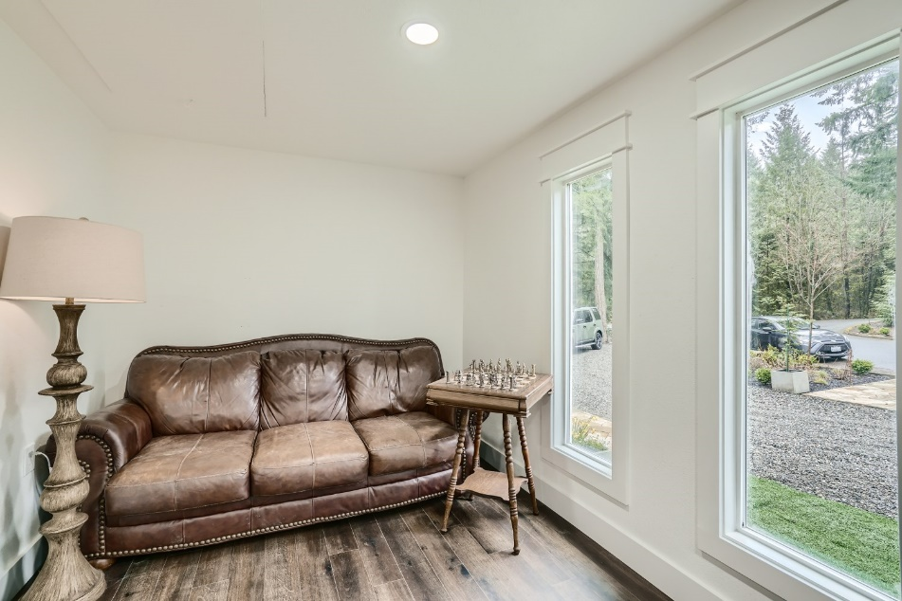
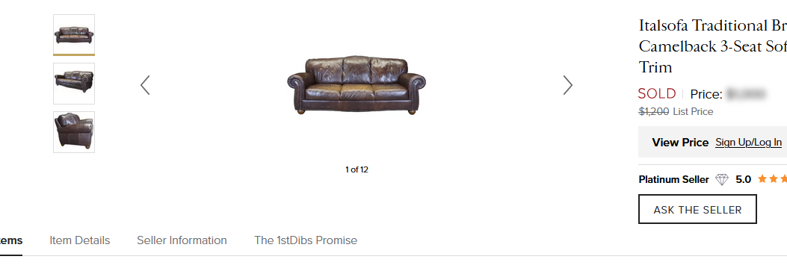
Exhibit #13-15
Den
Custom made Chess Board
Similar Damaged

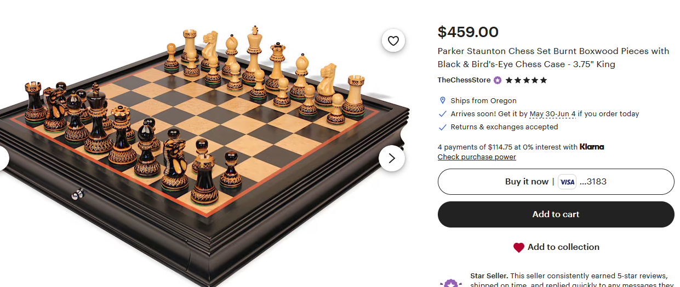

Exhibit #13-16
Den
Wood lamp
Similar Damaged
