# ACTS of BAD FAITH BY LIBERTY MUTUAL

### 1. Systematic Deceit and Obstruction from Day One

From the moment we filed our claim after a catastrophic event destroyed our home, Liberty Mutual (LM) has demonstrated an appalling pattern of delay, deception, and manipulation. We followed every instruction. We asked every question. I even sought guidance about hiring a public adjuster—Ursula, LM’s own representative, dissuaded me. I trusted her.

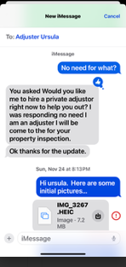

Adjuster Aaron assured me we could “work it out” privately. That was a trap. LM ghosted us. They ignored critical questions, ran down the clock, and then weaponized the “appraisal clause”—a clause never clearly explained to us—to strip us of rights and shield themselves from accountability.

After I told LM I was hiring an attorney they “invoked appraisal” clause which I as a homeowner did not understand. After learning about this, I understood that this was why LM was delaying, denying, and ignoring my claims. Aaron even went so far to tell me (even though he was a large loss adjustor) he did not have the ability to declare the full loss of my home because “the loss it was too large”. When I asked him who could declare it a full policy loss, he ignored me, then soon invoked the appraisal clause.

### 2. ALE has been **lowballed,** **delayed**, and has refused to negotiate in a reasonable manner, they could be in violation of **Washington’s unfair claims settlement practices**.

### 3. Slow to pay back

LM was slow to pay us for hotels and food (if they did). We thought this was their way of bleeding us dry as we had to pay upfront for the costs before they would refund us… which much we are still waiting for.

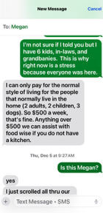 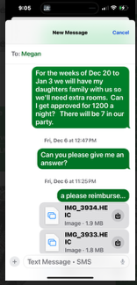 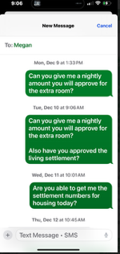 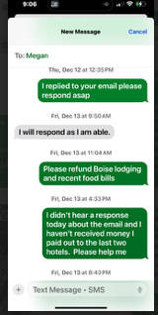

 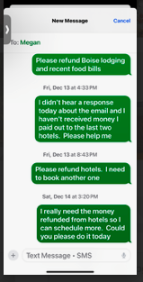 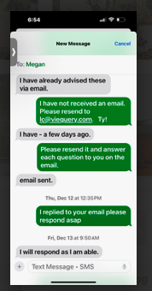 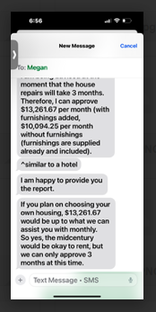 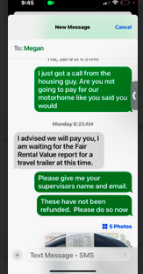

4. Checks “not going through” **From:** lc viequery.com <[lc@viequery.com](mailto:lc@viequery.com)>   
**Sent:** Tuesday, January 28, 2025 5:35 PM  
**To:** Marlow, Megan <[Megan.Marlow@libertymutual.com](mailto:Megan.Marlow@libertymutual.com)>; Andracsek, Mark <[mark.andracsek@libertymutual.com](mailto:mark.andracsek@libertymutual.com)>  
**Cc:** Jeremy <[jeremy@sandecs.com](mailto:jeremy@sandecs.com)>; Andracsek, Mark <[mark.andracsek@libertymutual.com](mailto:mark.andracsek@libertymutual.com)>  
**Subject:** {EXTERNAL} Re: ALE CLAIM 058296583-01

Mail it back (asap) after you have separated money due to us and you correctly put our names and addresses on the check.

22912 se 37th st sammamish, wa 98075

Sent from my iPhone

On Jan 28, 2025, at 1:06 PM, Marlow, Megan <[Megan.Marlow@libertymutual.com](mailto:Megan.Marlow@libertymutual.com)> wrote:

﻿

Jeremy,

We are mailing the check back to you, what address would you like it to go to?

Thank you,

**Megan Marlow**  
Sr. Claims Resolution Specialist I

Large Loss Property Claims  
────────────────────  
Liberty Mutual | Safeco Insurance  
PO Box 5014   
Scranton, PA 18505-5014  
Direct Dial: 469-997-3878

Facsimile: 888-268-8840

FL License#: W015490

**From:** lc viequery.com <[lc@viequery.com](mailto:lc@viequery.com)>   
**Sent:** Tuesday, January 28, 2025 1:41 PM  
**To:** Jeremy <[jeremy@sandecs.com](mailto:jeremy@sandecs.com)>  
**Cc:** Marlow, Megan <[Megan.Marlow@libertymutual.com](mailto:Megan.Marlow@libertymutual.com)>; Marlow, Megan <[Megan.Marlow@libertymutual.com](mailto:Megan.Marlow@libertymutual.com)>  
**Subject:** {EXTERNAL} Re: ALE CLAIM 058296583-01

Yes please issue it back.  Please put it directly in our account we set up.

Sent from my iPhone

On Jan 28, 2025, at 11:48 AM, Jeremy <[jeremy@sandecs.com](mailto:jeremy@sandecs.com)> wrote:

﻿

Hi Megan,

Yes, please reissue the check.

Jeremy

On 1/28/2025 10:24 AM, Marlow, Megan wrote:

Hi Layna,

Can you advise if we need to issue this check back to you? It was returned to our offices. Attached.

Thanks,

**Megan Marlow**  
Sr. Claims Resolution Specialist I

Large Loss Property Claims  
────────────────────  
Liberty Mutual | Safeco Insurance  
PO Box 5014   
Scranton, PA 18505-5014  
Direct Dial: 469-997-3878

Facsimile: 888-268-8840

FL License#: W015490

<image001.png>

### 4. Replacement of essential household items

previously approved and then denied.

### 5. Increase of Monthly living

as I proved my daughter and her family lived with us a week a month and Megan, LM refused to up our living stipend. Please double the monthly living stipend to be retroactive and to last 24 months.

   

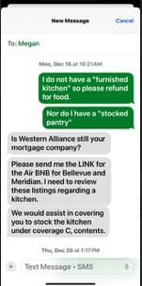 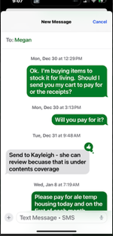 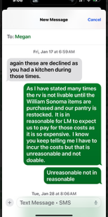

### 6. Endangerment and Trauma Through Unsafe Hotel Placements

LM placed my family—including 2 teen girls—in crime-ridden, unsanitary motels crawling with drug activity, prostitution, and structural violations. There were not enough beds for four, let alone all of my family in town for the holiday. I was left to endure trauma fog, triggered by these appalling conditions. When I moved my family to the Salish Lodge for safety over Thanksgiving, LM refused to reimburse it—showing they don’t care about our well-being, dignity, or lives.

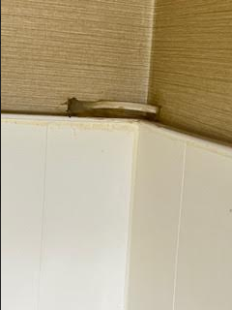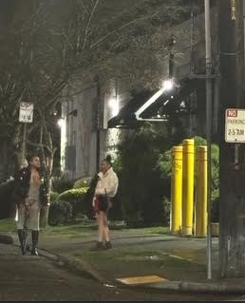

### 7. Deceptive and Discriminatory Housing Practices

Despite documented proof that we were a multi-generational household (four adults, two teens, one baby, frequent visitors, three dogs, and two pigs), LM limited our housing stipend to a fraction of what we needed. I provided airline tickets and records. Still, they denied the required $17,000/month housing, as that was the only suitable home we could find in the area. They agreed for us to live in a motorhome/van at the time we thought that was our best and only option of housing.

No one at LM disclosed the **hidden costs** of installing and operating a motorhome/van on-site—hookups, pad, satellite, maintenance. By the time I learned, I was thousands of dollars deep and **trapped with a van/motorhome that was unlivable.**

### 8. Inconsistent and Retaliatory Payment Policies

In a prior tree fall claim four years ago, LM paid $600/night for a hotel for four, a smaller family head count at the time. This time: only $500, for more people, and hotels had gone up 30-60%. When I pushed for fairness, they retaliated with stonewalling and silence refusing to up our nightly hotel stay and ALE monthly payments.



### 9. Fraudulent Denial Followed by Forced Admission

We purchased a van on verbal and written assurance from Adjuster Megan. Then LM turned around and accused us of lying. Only when I submitted screenshots and emails to her supervisor, did they begrudgingly reimburse—without apology for Megan’s gaslighting and bad faith obstruction.

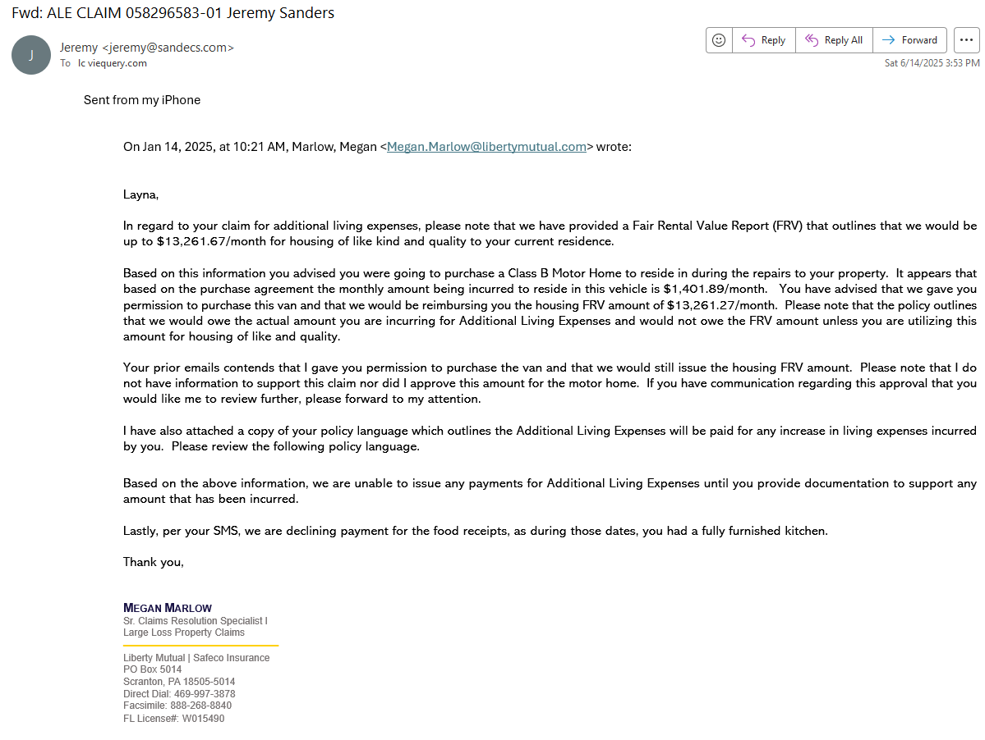



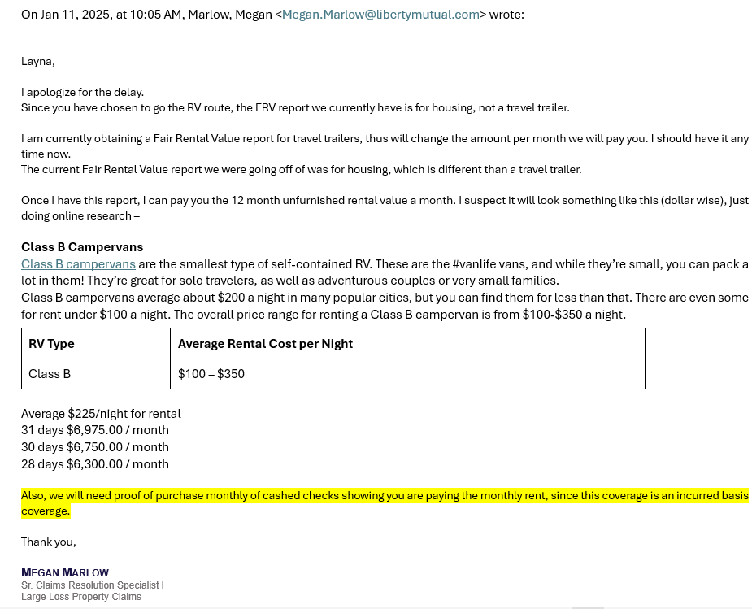

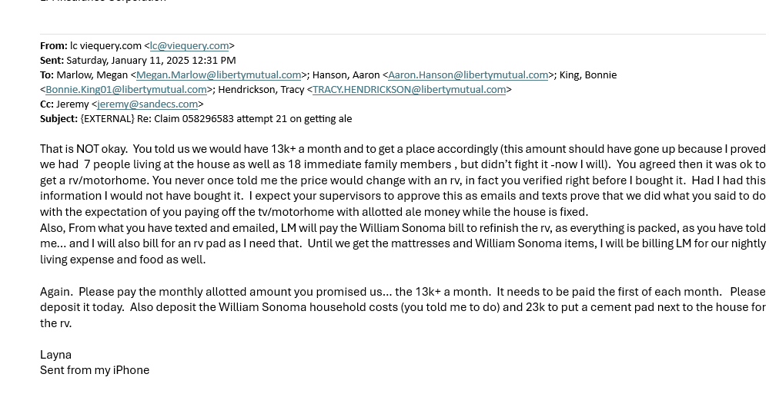

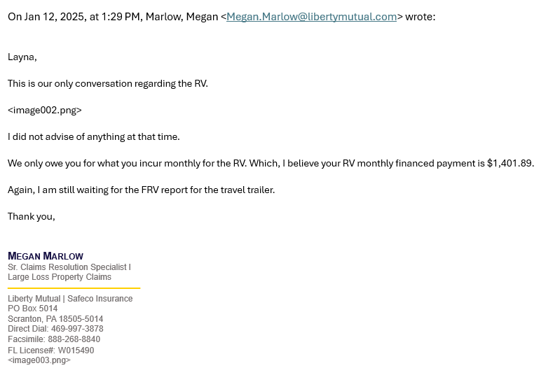

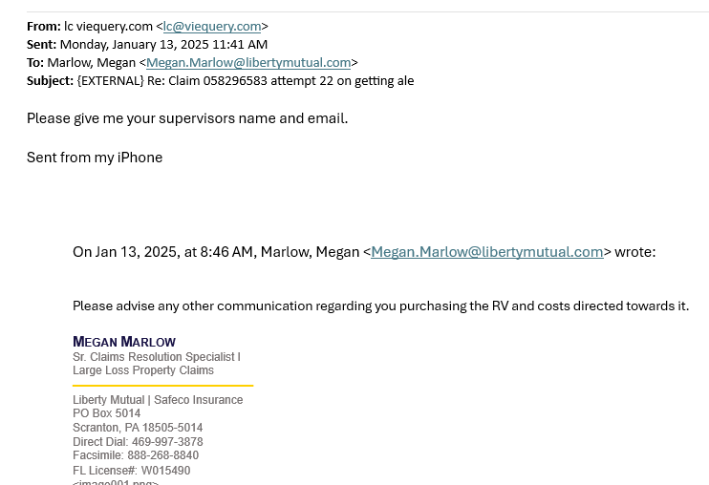

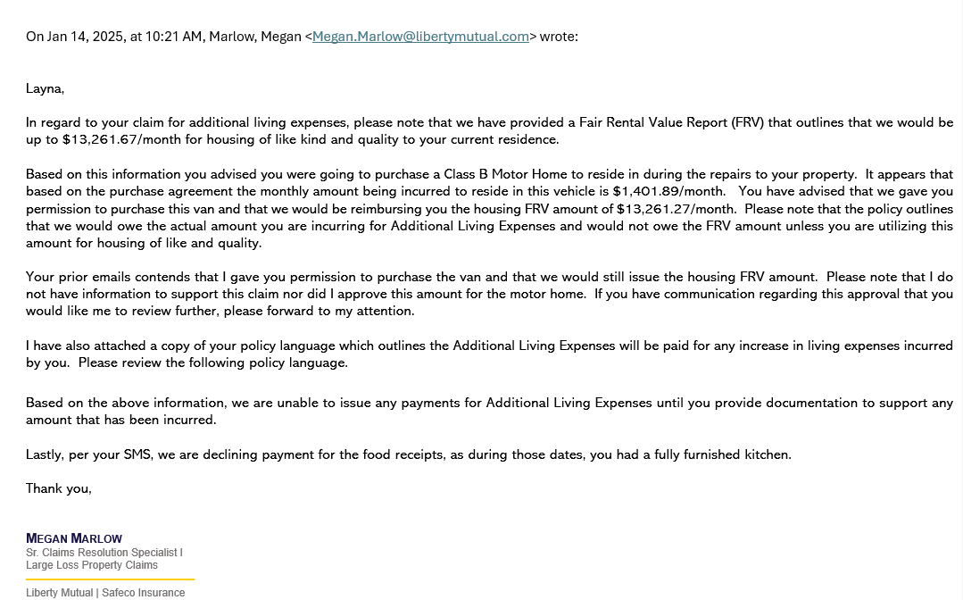

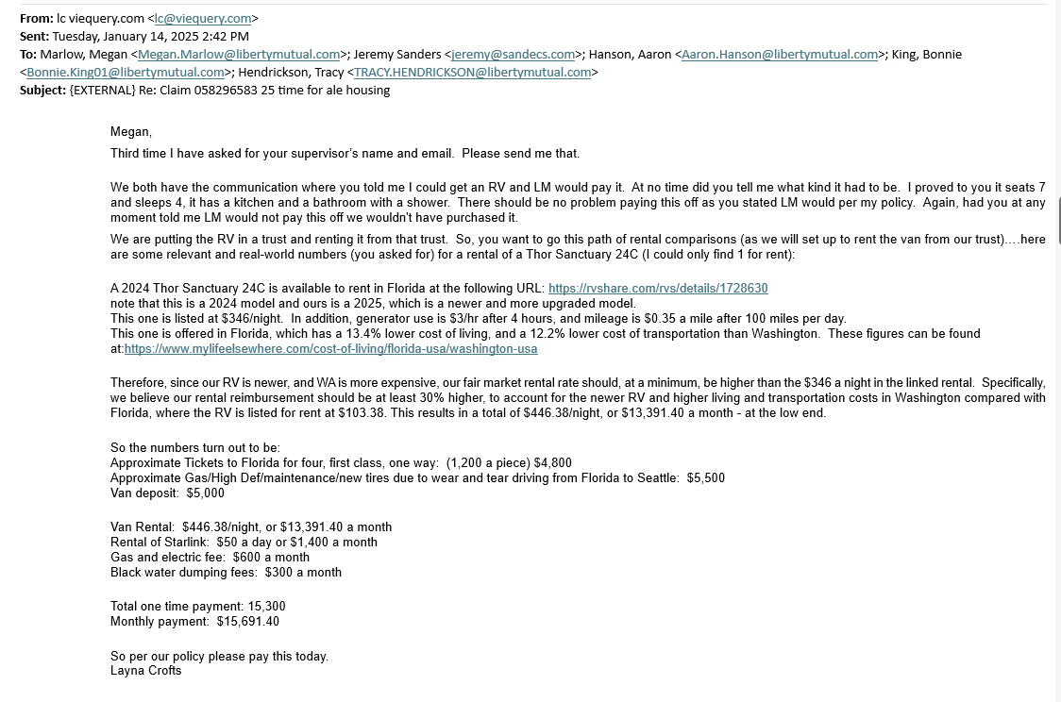

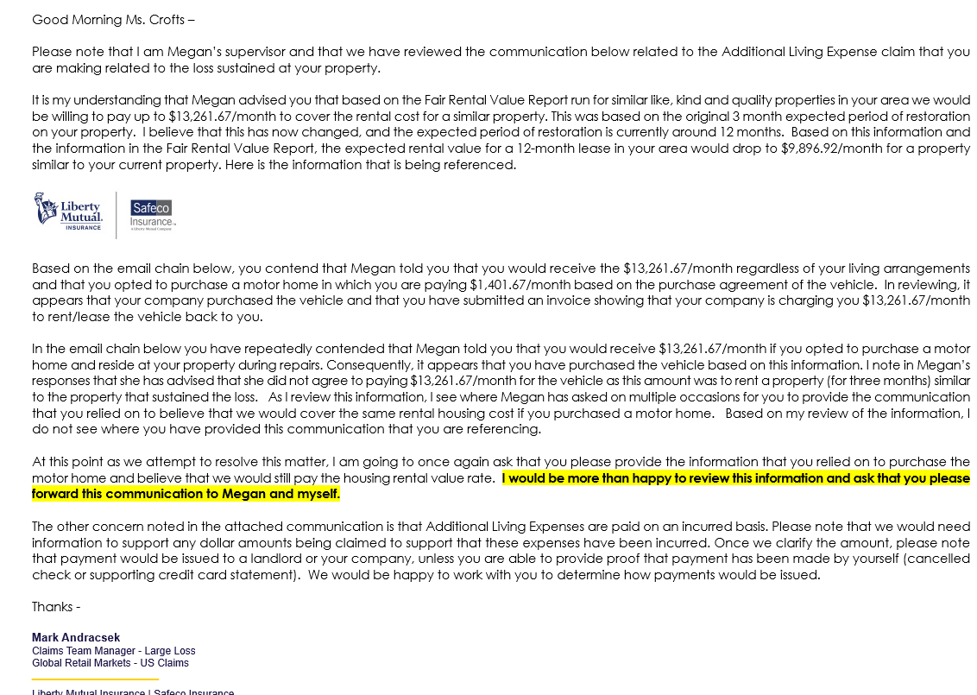

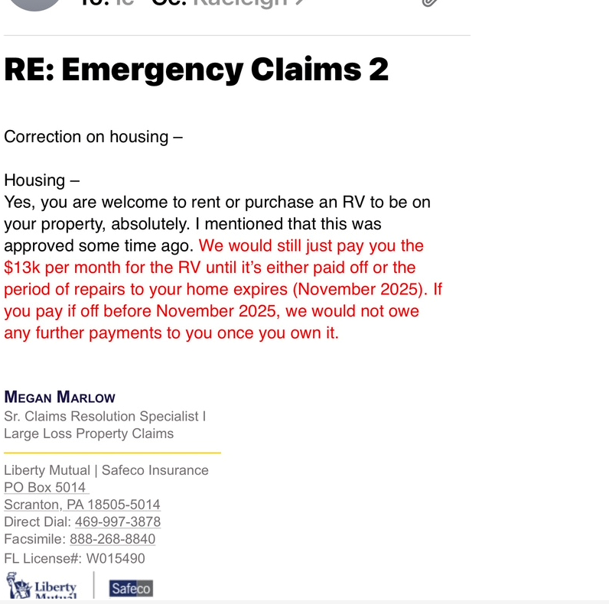

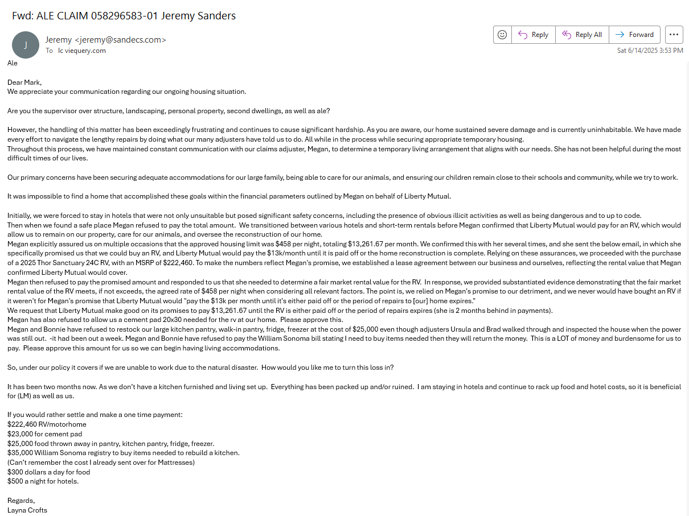

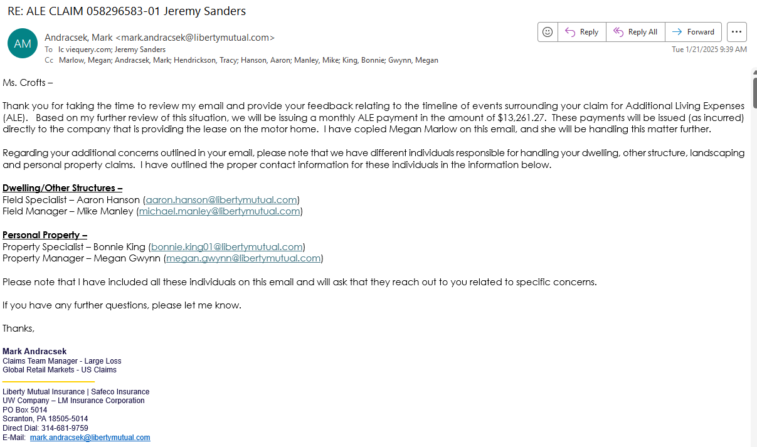

### 10. Theft by Deception: Food Reimbursement

LM instructed us to throw out all food due to power loss. We lost everything: thousands in pantry, fridge, and freezer inventory. I followed instructions, documented everything, and they offered $300—an insulting, criminal sum (that my family eats in a day). They denied we lost power, despite the fact that LM’s own adjusters visited during the outage. This wasn’t ignorance. This was fraud on their part.

### 11. Denial of Basic Human Needs

I submitted lists—at LM’s request—of essential living items we needed. They denied reimbursement. Because of this, we have spent over **$60,000** out-of-pocket for daily meals via Uber Eats and grocery runs and continue to pay out of pocket because of them not willing to honor our contract of reasonable living.

### 12. Negligent Structural Assessment That Put Us in Danger

LM refused my qualified structural engineer and sent an unqualified inspector who missed a main 4x6 beam, cracked foundational elements, water in the storage room from cracked foundation, and a collapsed retaining wall. Their negligence and delay led to emergency mitigation costs, more damage occurring, and life-threatening hazards.

### 13. East Side Emergency Built Retaining Wall Rocks

It wasn’t until May of 2025, that Crofts noticed the east side of the house foundation problems. LM’s structural engineer had not mentioned this, although he had been out two previous times. Immediate emergency work was done to support the house as seen by the inspectors, adjustors, contractors, and LM’s structural engineer.

### 14. Denial of Emergency Mitigation and Repairs

No other contractors were available when the storm hit my house. My company, PNW Home and Garden, had to handle emergency stabilization. LM refused to pay—despite documented necessity and lack of alternatives. This is willful negligence.

### 15. Roofing Sabotage

LM’s tarp failed. Holes remained. Brad, their own adjuster, told me (on video) to have it redone. I did. Now they refuse to reimburse—even with video evidence. **How is this not deliberate theft?**

### 16. Bait-and-Switch on Personal Property Claims

I was instructed by LM to submit fake grass in the front yard under personal loss. After doing so, I got a bid to replace it, which was more money than they thought, so they reversed their position—**deliberately shifting it to a category already maxed out under the extra structure policy.** This is **coordinated denial.**

### 17. Tree Removal: Arbitrary Refusal

Four years ago when a tree fell on the shed, they approved $50,000 for one tree and debris removal. This time, four fallen trees and catastrophic debris? Denied. Same company. Same insurer. Different result. That’s bad faith.

### 18. Structural Engineer

**From the beginning it was obvious we needed a structural engineer. LM delayed delayed and then delayed for a structural engineer to come out.**

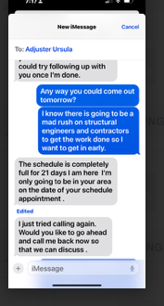

**He proved he was ineffective as he missed the main beam support going across both rooms.**

**He then missed the Structural damage cracks on the outside of the home, until I pointed them out to him in May 2025.**

**-See Structural Engineer’s Bid for work.**

**He then missed the broken home supports on the west side of the home.**

**-See Structural Engineer’s Bid for work.**

**He missed the crack in the foundation causing water in the storage room:**

**-See Structural Engineer’s Bid for work.**

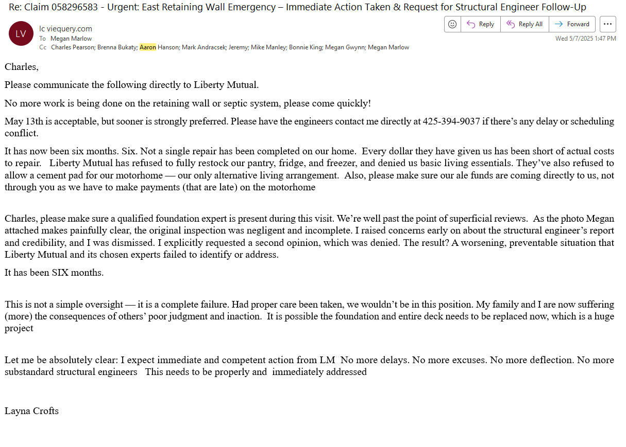

**It is now June, and I still have not received a permit from him to take to the city.**

### 19. Parade of Incompetence: 9+ Adjusters, No Help

We were cycled through a **carousel of adjusters**, each less informed than the last:

* Ursula: First adjustor. Disappeared. I sent her over 50 text messages, she responded a couple of times.
* Brad: Acknowledged our safety issues on video.
* Megan: Lied repeatedly.
* Kayleigh: Invaded our privacy and rummaged through personal items.
* Bonnie: Denied obvious losses.
* Aaron: Couldn’t authorize anything.
* Alex and others: Gone in a day.

**This is not just chaos. It’s intentional sabotage designed to wear us down.**

### 20. $300,000+ of Personal Financial Devastation

* **Hotels:** LM demanded we “pay first.” Then refused to reimburse.
* **LM gave us an “allowance” of $500 a night for seven people, but four years ago they gave us a nightly allowance of $600 a night for four people.**
* **Food:** Denied pantry/fridge restocks. $60,000+ out-of-pocket to feed family.
* **Repairs:** LM left us on the hook for tree removal, yard cleanup, roof and structural repairs, and emergency stabilization: over **$200,000** and growing.
* **Sleeping arrangements:** No beds, no kitchen, no comfort—forced to rotate between hotels, friends’ homes, and unsafe setups.

### 21. Liberty Mutual’s conduct violates the most basic principles of contract law, fiduciary duty, and human decency.

Under Washington law, they may be liable for:

* **Triple damages** under RCW 48.30.015 for unreasonable denial of a claim.
* **Consumer Protection Act** violations for deceptive practices.
* **Emotional distress**, **financial harm**, and **loss of use and enjoyment of property**.
* **Attorney’s fees and litigation costs.**

### 22. ALE Rejections

**Subject: ALE – Final Request**

Dear Mark and Stakeholders,

I am writing to formally submit an in-house complaint regarding the mishandling of my homeowner’s insurance claim (Policy No. 058296583-01) for the large-loss damages resulting from the bomb cyclone storm that struck my home in Sammamish, Washington, on November 19, 2024.

This is my final attempt to resolve this matter directly. If Liberty Mutual does not pay the ALE portion of my claim, I will be turning the case over to Esq. Pearson, who is fully prepared to take legal action on our behalf.

It has now been five months since this devastating event disrupted our lives. Despite my cooperation, thorough documentation, and repeated outreach, Liberty Mutual has failed to fulfill its responsibility—especially and at the forefront,  the Additional Living Expenses (ALE) coverage clearly outlined in our policy. As the primary caregiver for a large household, I have the responsibility to ensure a safe, stable living environment for my family. Liberty Mutual’s continued failure to honor this essential part of the policy has created unnecessary hardship, forced displacement, financial instability, and emotional trauma.

Today, I received $7,000 toward freezer losses—an expense LM previously refused to acknowledge. While I appreciate this partial recognition, it is nowhere near the documented loss confirmed by photos,  adjustor’s witnessing loss,  video, and itemized records. I am requesting full reimbursement for the ALE-related expenses detailed in the attached "Letter for ALE to Mark for Resolution."

I would like you to know that our family has suffered greatly because of LM unwillingness to cover ALE costs.

**Our Family’s Ongoing Hardship Due to ALE Denial**

* **Inability to Cook or Eat at Home:**  
  We have lived without a stocked pantry or even basic kitchen essentials for five months. This has forced us to rely on costly and unsustainable daily food delivery and dining out.
* **Loss of Home Comforts and Stability:**  
  Our routines, peace, and sense of safety have been erased. Our children have no consistent space to sleep, study, or feel secure. The emotional toll is growing by the day.
* **Motorhome/Van Mismanagement:**  
  Liberty Mutual not only approved the use of a motorhome/van as temporary housing but failed to inform us of the enormous hidden costs involved—electrical hookups, parking infrastructure, internet access, tax,  and maintenance. These have all come out of our pocket, despite being part of what ALE should reasonably cover.
* **Out-of-Pocket Costs Continue to Climb:**  
  We are paying every single day—on food, hotels, necessities—all while Liberty Mutual withholds reimbursement for legitimate, documented ALE needs.
* **Separation from Family:**  
  We have been unable to host our close family members due to lack of space and suitable living conditions. This has broken family bonds and support systems during one of the most difficult periods of our lives.

**To the Stakeholders of Liberty Mutual:**

You are being asked to evaluate this claim because the internal systems meant to protect policyholders have failed. There has been a repeated pattern of:

* Delays and denials without clear justification
* Misleading or contradictory guidance
* Failure to honor written or verbal commitments
* Inadequate compensation for documented losses
* Emotional and financial harm due to continued inaction

This is not just a failure of service. It is a pattern of **bad faith behavior**, to which I needed to hire an attorney. I avoided this path for months in the hope that Liberty Mutual would honor its word.

**The Emotional Damage Is Real**

We have endured:

1. **Prolonged stress and anxiety** from uncertainty and lack of support
2. **Loss of dignity and normalcy** due to ALE.
3. **Broken family connections** because loved ones can no longer stay with us
4. **Emotional distress**, affecting behavior and well-being
5. **Mental exhaustion** from endless paperwork and lack of closure
6. **Isolation and emotional withdrawal** from feeling unseen and dismissed
7. **A total loss of trust** in the insurance system meant to protect us

This is your final opportunity to resolve this claim with integrity, with me, the policy holder. I urge you to conduct an immediate review and issue **full reimbursement** for the ALE expenses—expenses that are within policy limits.

Sincerely,  
**Layna Crofts**

### 23. House damage items not listed as “loss” by insurance

* Structural damage
* Pergola outside of office (connected to house)
* Deck and outdoor kitchen
* Outside paint of entire house
* Outside exterior of house, rocks, james hardi, cedar planks.
* Full Kitchen.
* Attic repairs.
* All interior doors.
* All exterior doors.
* Windows
* Structure cracks in office
* Carpet downstairs
* Plumbing Problems

### 24. Newly found damage not discovered until May 2025 by Crofts.

(Structural Engineer should have seen this.)

* Structure damage
* 1 room downstairs carpet ruined
* Damage to the foundation support on west side of house.
* Damage to supports of deck.

### 25. Newly Found damage in June 2025

Since the public adjusters came in May 2025, it has been discovered:

(Structural Engineer should have seen this.)

* More roofing problems than first believed.
* Pantry/Laundry ceiling
* Storage room structural damage
* Office structural damage
* Structure damage
* 3 rooms downstairs carpet ruined

### 26. LM refuses to negotiate and work out our ALE for our family needs, even after attorney gives permission

**Subject: Request for Resolution and Payout of Outstanding ALE Claims Claim#:058296583-01**

Dear Mark,

Please help me. It has now been *four months*, and throughout this time Megan has repeatedly delayed responses, misrepresented information, and continues to deny my rightful ALE (Additional Living Expenses) coverage. I am beyond frustrated and exhausted—this process has been deeply demoralizing.

Due to the lack of support, I have had to retain an attorney, Charles, to assist me. However, he has agreed to allow me to continue working on the ALE portion directly for now in hopes of resolving it amicably.

We have a very large family, including six children, their spouses, grandchildren, and extended relatives who frequently stay with us. From the beginning, it was determined that we spend approximately $500 per week on food, this is with a fully stocked pantry, freezers, and canned goods. Despite this, I have not been given an allotment to restock these essentials, forcing us to rely on dining out or food delivery—adding further strain and unnecessary cost.

We also have not been provided with what’s needed to reestablish basic home living needs. As a result, we often resort to staying in hotels or with friends and family.

Until the pantry and kitchen are restocked, the necessary living arrangements are established, and the cement pad is completed (which is essential for setting up a livable space), I will continue to accrue daily expenses for hotels and food. These receipts will be submitted to Liberty Mutual for reimbursement, as these ongoing costs are a direct result of ALE needs not being met.

I’m asking/pleading you directly for support in resolving this. Thank you for your time and understanding.

Sincerely,  
Layna Crofts

