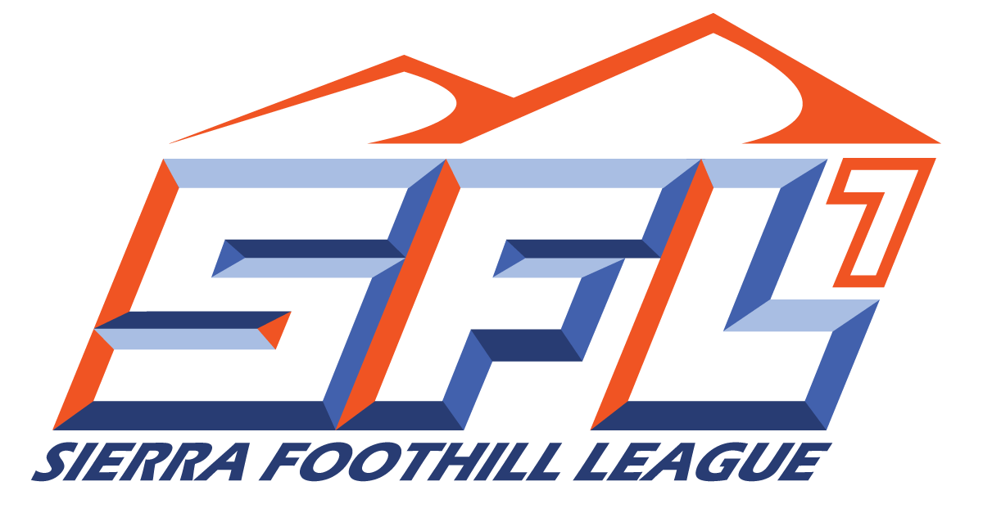
Sierra Foothill League Swim and Dive
2023 Schedule
Starting Time 3:30/4:00

Thursday, March 9th
Folsom at Rocklin
Del Oro at Whitney
Granite Bay at Oak Ridge
Thursday, March 16th
Whitney at Folsom
Rocklin at Granite Bay
Del Oro at Oak Ridge
Thursday, March 23rd
Granite Bay at Folsom
Rocklin at Del Oro
Whitney at Oak Ridge
Thursday March 30th
Folsom at Del Oro
Oak Ridge at Rocklin
Granite Bay at Whitney
Thursday, April 13th
Rocklin at Whitney
Del Oro at Granite Bay
Oak Ridge at Folsom

League Rep: John Sherman, Granite Bay
SFL Championships: April 21-22
Practice Begins: February 6th
1st Scrimmage: February 17th
1st Contest February 24th
Sit-Out Period: March 25th
Last Contest: April 22nd

2/9/2022

