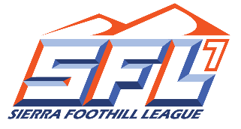

**Sierra Foothill League**

2023 Competitive Sport Cheer Schedule

**Start Time: 5:30, 6:30, 7:30**

|  |  |  |
| --- | --- | --- |
| **Friday, February 24th** |  | **Friday, March 24th** |
| **All SFL at Granite Bay**  Folsom vs Oak Ridge 5:30  Rocklin vs Del Oro 6:30  Granite Bay vs Whitney 7:30 |  | **All SFL at Oak Ridge**  Granite Bay vs. Whitney 5:30 Rocklin vs Folsom 6:30 Del Oro vs Oak Ridge 7:30 |
| **Friday, March 3rd** |  | **Friday, March 31st** |
| Del Oro/TBA at Folsom  Oak Ridge/TBA at Granite Bay  Whitney/TBA at Rocklin |  | Rocklin/Granite Bay at Del Oro  Oak Ridge/Whitney at Folsom |
| **Friday, March 10th** |  | **Friday, April 14th** |
| Granite Bay/TBA at Oak Ridge  Folsom/TBA at Rocklin  Whitney/TBA at Del Oro |  | Folsom/TBA at Whitney  Oak Ridge/TBA at Del Oro  Granite Bay/TBA at Rocklin |
| **Friday, March 17th** |  | **Friday, April 21st** |
| Del Oro/Folsom at Granite Bay  Whitney/Rocklin at Oak Ridge |  | **All SFL at Whitney**  Granite Bay vs. Folsom 5:30 Rocklin vs Oak Ridge 6:30 Whitney vs Del Oro 7:30 |

**League Rep--Debi DeVinna**

**Practice Begins---February 6th**

**1st Scrimmage—February 17th**

**1st Contest---February 24th**

**Sit-Out Period Date---March 27th**

**Last Contest---April 26th**

**End of Season Dead Period---May 31st**

**2/9/2022**