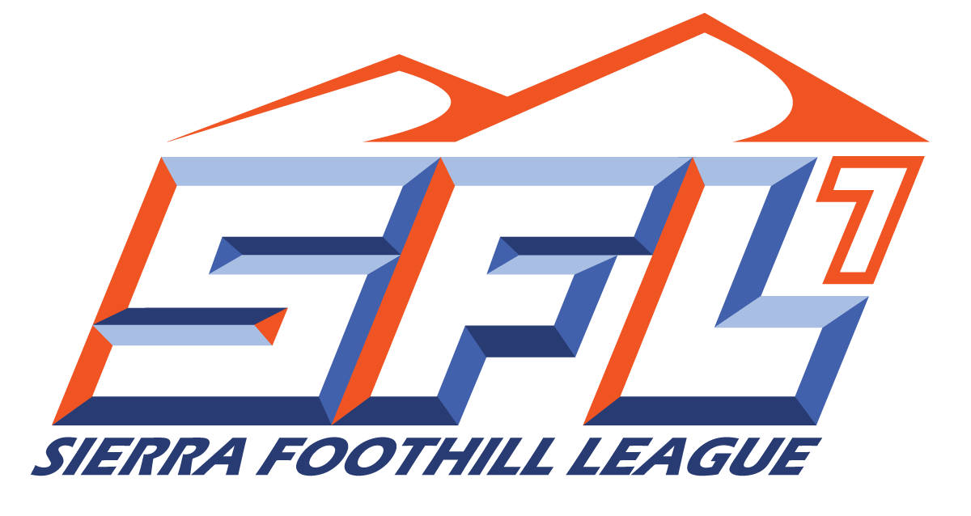

**Sierra Foothill League**

**Cross Country 2022 Schedule**

**League Meet #1 Wednesday, September 21st at Johnson-Springview TBA**

**League Championships, Saturday, October 29th at William Jessup University TBA**

**League Rep: Steve Kinoshita, Folsom**

**Dead Period Begins July 11th**

**Practice Begins August 1st**

**1st Scrimmage August 12th**

**1st Contest August 19th**

**Sit Out Period September 22nd**

**Last Contest October 29th**

**12/27/2021**