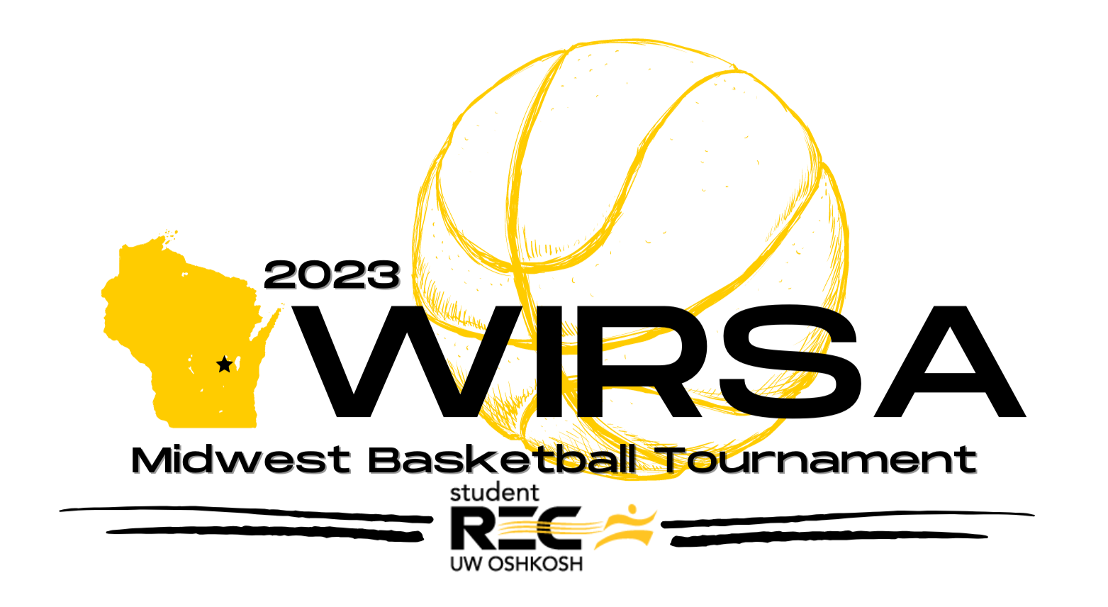
Official’s Information
All officials interested in working at the tournament must complete and submit the Official’s Application. The officials application must be filled out via the Google Form (https://docs.google.com/forms/d/1WRUvVeh9XQEVBaQCQ41voWEbuVrlWMjTU10oRRPvi-U/edit) and submitted no later than Friday, February 3rd.
What should you bring to the tournament?
We suggest that everyone brings NFHS approved officiating gear. All officials must bring the following items with them:
- V‐neck, short‐sleeve black and white striped shirt(s) without side panels.
- Black undershirt, socks, shoes, pants (beltless, cuffless, pleated preferred)
- Whistle/lanyard (bring a back-up just in case)
- Great attitude
- Willingness to learn, open mind, and ability to receive constructive feedback

What do you get for working the tournament?
- $60 stipend for the tournament
  - Checks will be mailed to your Intramural Coordinator after the event
- Experience, training, and discussion in working with 3-person mechanics
- Complimentary hotel on Saturday (Friday – as needed – if traveling a long distance).
- Continental breakfast at the hotel
- Official’s Workshop on Saturday morning constructed by experienced recreational professionals and high-level officials throughout the area
- Breakfast/lunch on Saturday and Sunday provided
- Tournament Staff Social on Saturday night
- Evaluations and immediate feedback on crew/individual mechanics and rule interpretations
- Networking opportunities with recreational sports professionals and other officials

Each official must complete and submit the Official’s Application by February 3rd, 2023. Once your information is received, we will e-mail you confirmation of your attendance and provide additional need-to-know information.

