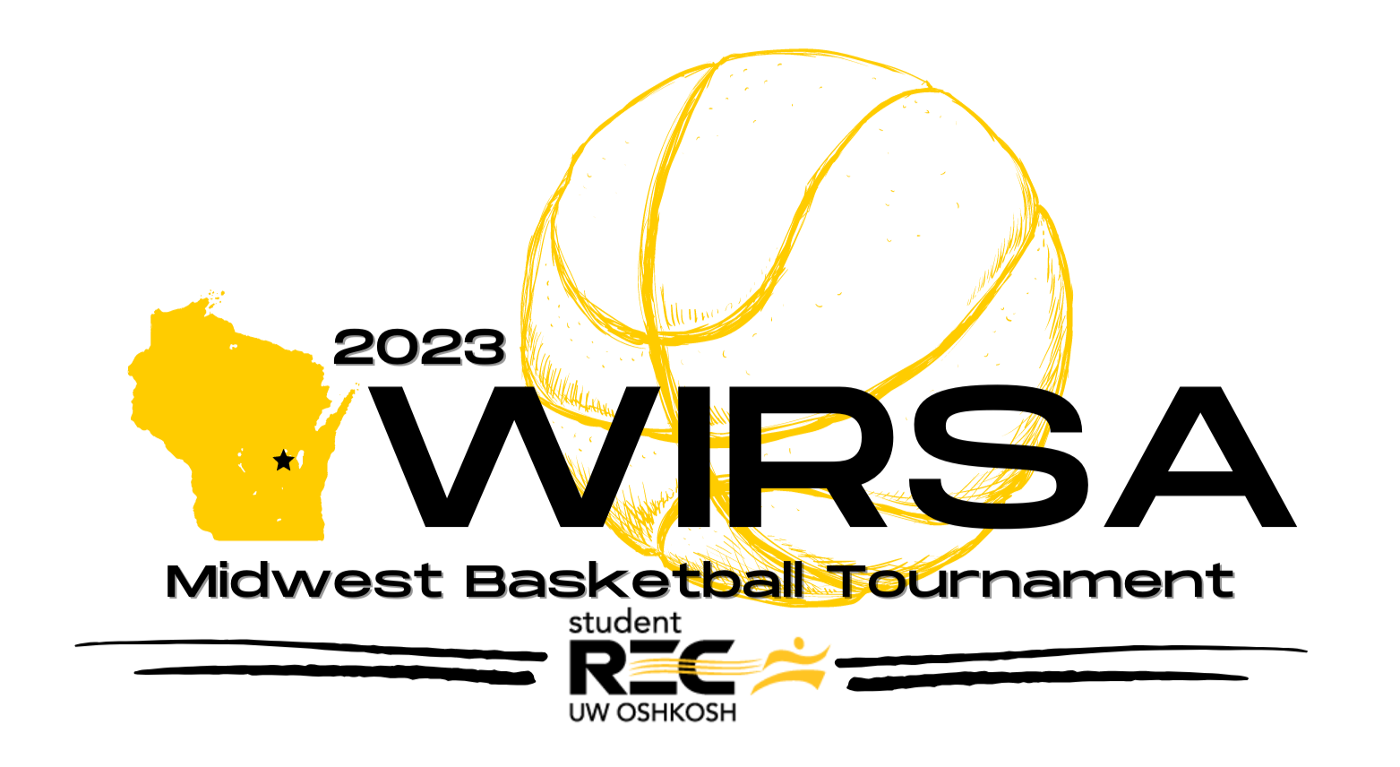
TOURNAMENT INFORMATION
WHAT: 2023 WIRSA Midwest Basketball Tournament with Men’s and Women’s leagues offered to all affiliated collegiate intramural and club sport basketball teams in the Midwest region.
WHERE: University of Wisconsin-Oshkosh
Student Wellness and Recreation Center
735 Pearl Ave.
Oshkosh, WI 54901
WHEN: Saturday, February 11th and Sunday, February 12th
AWARDS: Men’s and Women’s champions will receive the distinguished traveling championship trophy to be hosted by their school until the next WIRSA basketball tournament as well as a 25% off coupon for the 2024 WIRSA Basketball Tournament. Members of the championship teams and individuals selected for the all-tournament team will also receive various awards and prizes.
ENTRY FEE:
$250 - submitted via IMLeagues on or before Monday, January 30th
$300 - submitted via IMLeagues on or before Monday, February 6th

*Institutions who send more than two (2) teams will receive a prorated discount of 25% off for their 3rd team, 50% off for their 4th team, and 75% off for all teams thereafter. Coupon code can be requested from tournament director Nik Sandona.

REGISTRATION: Teams must register and pay their fee ONLINE via the WIRSA State Basketball IMLeagues portal. Instructions are included for how participants can add themselves to this network. Team entry form needs to be submitted prior to, or at, the first day of the tournament and must match team’s IMLeagues roster.
REQUIREMENTS: Please bring two sets of uniforms (light + dark) with legal numbers on the back – at minimum. All team members must present a valid school ID card at each game. WIAA guidelines surrounding other apparel, jewelry, headwear, etc. will apply.
MEETING: Teams must be represented at the mandatory captains meeting on Saturday, February 11th. The time is TBD dependent on the number of team registrations.
Website: WIRSA: https://mywirsa.com/basketball-tournament
IMLeagues: www.imleagues.com/spa/sport/c9fde5acd6e740689c4b26e348e6c9e7/home#sportname

CONTACTS: Tournament Director
Nik Sandona
Competitive Sports Coordinator
735 Pearl Ave.
Oshkosh, WI 54901
Phone: 920 328 7900
E-mail: SandonaN@uwosh.edu

