OHIO REGIMENT YOUNG MARINES 2019 REGIMENTAL GAMES

Competitions
Cardinal Cup Events Buckeye Cup Events

Junior Drill Team Senior Drill Team
Junior Color Guard Senior Color Guard
Junior Swim Event Senior Swim Event
Junior Team DDR Senior Team DDR
Junior Land Navigation Competition Senior Land Navigation Competition
Junior PFT Event Senior PFT Event
Junior Knock-Out Drill Competition Senior Knock-Out Competition
Field Skills Competition

Junior Teams will compete for the Junior Buckeye Cup (ages 8 to 12)
Senior Teams will compete for the Senior Buckeye Cup (ages 13 to 18)

If a unit doesn’t have enough Young Marines to field a team, they may be joined with members from another smaller unit. The spirit of the games is so every Young Marine can compete.

Disclaimer: any and all appeals to the scoring of events, or results of any events must be brought to the attention of the Regimental Commander for a final decision.

Drill Team Competition

Senior Drill Team: 7 members, 6 drillers and one Lead,
Members should be 13 and older if the unit is providing 2 teams.
Junior Drill Team: 7 members, 6 drillers and one Lead,
Members should be 12 and under if the unit is providing 2 teams.

*If the unit has only enough members to provide one drill team, they will compete in the Senior Category.
*units may combine their members with other unit members to create a team so that the Young Marines can compete.
*if you have less than the desired members, simply bring what you have. It’s OK!

The Lead may carry a drill card on the course if they do not have it memorized.

Scoring:
1st place: 12 points  2nd place: 11 points  3rd place: 10 points  4th place: 9 points  5th place: 8 points  6th place: 7 points | 7th place: 6 points  8th place: 5 points  9th place: 4 points  10th place: 3 points  11th place: 2 points  12th place: 1 points

If a tie exists, the Regimental Commander will be the tie breaker, along with the judges.

Awards: Young Marine competing in either Junior or Senior Drill Team will rate the Drill Team Competition Award with Silver Palm Device.

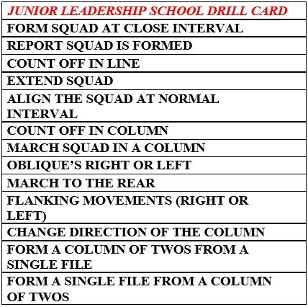
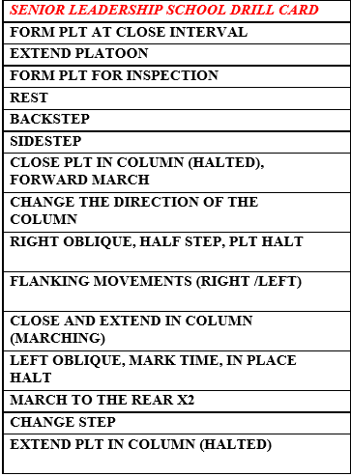

Color Guard Competition

Senior Color Guard: 4 members, Unit Commanders decide which member gives the commands
Members should be 13 and older if the unit is providing 2 teams.
Junior Color Guard: 4 members, Unit Commanders decide which member gives the commands
Members should be 12 and under if the unit is providing 2 teams.

*If the unit has only enough members to provide one color guard, they will compete in the Senior Category.
*units may combine their members with other unit members to create a team so that the Young Marines can compete.

The Command giver may tape a command card to a flag staff if they do not have it memorized. The Color Guard drill below will be used.

Scoring:
1st place: 12 points  2nd place: 11 points  3rd place: 10 points  4th place: 9 points  5th place: 8 points  6th place: 7 points | 7th place: 6 points  8th place: 5 points  9th place: 4 points  10th place: 3 points  11th place: 2 points  12th place: 1 points

If a tie exists, the Regimental Commander will be the tie breaker, along with the judges.

Awards: Young Marine competing in either Junior or Senior Drill Team will rate the Drill Team Competition Award with Silver Palm Device.
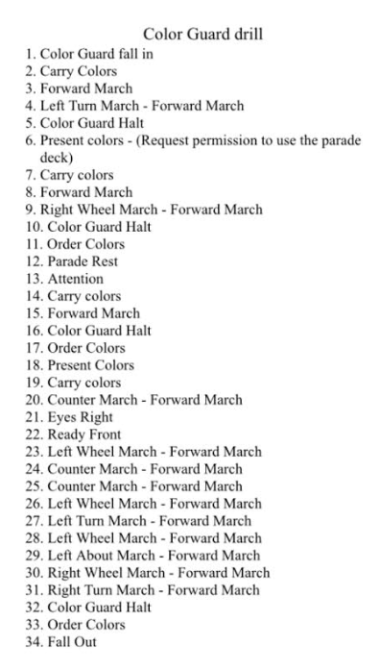

Field Skills Competition

Teams will consist of 6 Young Marines. 2 for Fire Building, 2 for Knot Tying, 2 for 1st Aid. There is no age requirement/restriction for this event but the points earned in this event will go toward the Buckeye Cup and not the Cardinal Cup.

Scoring:
The team will be awarded points based on their placing in each of the 3 events. This is a relay race. The 1st Aid YMs will compete in matching cards that describe a 1st Aid situation and how to handle the situation. Once they have matched all the cards correctly then they will be allowed to run to their own fire starting team and tag them. The fire starting team will attempt to start their fire. When they have been told their fire is good, they will put it out and then run to their own Knot Tying team and tag them. The Knot Typing team will be given a card with several knots on it. They must complete the knots, in the order given, and be the fastest at doing it. When they have been given word that they are finished they will run to the end. The fastest team wins. The 2nd fastest team gets less points, the 3rd fastest team gets less points and so on.

1st place: 12 points  2nd place: 11 points  3rd place: 10 points  4th place: 9 points  5th place: 8 points  6th place: 7 points | 7th place: 6 points  8th place: 5 points  9th place: 4 points  10th place: 3 points  11th place: 2 points  12th place: 1 points

First Aid

Cards will be placed on a table. One card will have a picture on it showing a 1st Aid situation. The 2nd card will have a word description of how to treat that 1st aid situation. All cards must be matched before the team will be allowed to go tag their Fire Building Team.

Fire Building

When the team has been tagged they will start building at the same time, racing against other teams, using the materials given in the Regimental Field Skills box. Other materials are not allowed. Once a team believes they have a fire started that will sustain on its own for two minutes they will all stand up with their hands in the air. This will signal the judge to start a timer for that team. If a flame (not smoke) is visible after 2 minutes have passed, the team’s time will be written down and the other teams will continue until completion. If a team decides their fire isn’t finished after starting the timer, they can go back to tending to their fire at will. However, the timer will reset and they will begin a new 2 minute timer when they stop again. When given the signal that the fire passed the 2-minute time, the team will fully extinguish the fire. When given the clear that the fire is properly extinguished, the team will be allow to go tag the knot typing team.
Knot Tying

All Knots from all Guidebooks be used.

Land Navigation Competition

Teams will consist of 2 Young Marines per age category who will travel as a pair throughout the course.

Senior Competition is for 13 and above
Junior Competition is for 12 and younger

The Senior Competition will consist of 10 points starting from inside the conference room of the Camp Lazarus HQ building. The timer will stop once both member of the team return to the judges table within that room with the code number from each point written on their map.

The Junior Competition will consist of 5 points starting from inside the conference room of the Camp Lazarus HQ building. The timer will stop once both members of the team return to the judges table within that room with the code number from each point written on their map.

Teams will be sent out in heats every 3 minutes with one Senior Team and one Junior Team (from different Units) being sent out.

Scoring:

Teams will be ranked by fastest time for each of the two age categories and points awarded as follows:

1st place: 12 points  2nd place: 11 points  3rd place: 10 points  4th place: 9 points  5th place: 8 points  6th place: 7 points | 7th place: 6 points  8th place: 5 points  9th place: 4 points  10th place: 3 points  11th place: 2 points  12th place: 1 points

Swim Event

Each unit will provide 2 swimmers per team. One for each event. The same YM can NOT perform both events.

There are 2 events in the Swim Event.

Event 1: Tread Water.

The YM needs to be able to tread water. The event will be timed. The YM may not touch any other object such as a wall. The chin must stay above the water. The YM must have passed the swim qual within 1 year from the Encampment.

There will be 3 rounds of treading water. Young Marines from each unit will be put into two groups (random selection). Groups will be treading water separately.
The top 2 swimmers from group 1 and group 2 will go to group 3. Time stops when only one YM is left treading or a time limit has passed. 15 minute time limit for Junior Teams, 25 minutes for senior teams.

The winner will be announced from group 3. Time stops when only one YM is left treading or a time limit has passed. 15 minute time limit for Junior Teams, 25 minutes for senior teams.

This event could end in a tie.

Event 2: Blouses.

Junior Team: the YM will have a t-shirt (will be provided) and will start standing outside of the water with the t-shirt on. When the command “JUMP” is given, the YM will jump into the water, completely submerging themselves. They will take the t-shirt off and carry it in their hand. They will be jumping in on one end of the pool and after removing the t-shirt they will swim to the other side of the pool (long ways). Fastest time wins.

Senior Team: the YM will have a cami blouse (to be provided by the Regiment) and will start standing outside of the water with the blouse on. When the command “JUMP” is given, the YM will jump into the water, completely submerging themselves. They will take the blouse off and tie it around their waist. They will be jumping in on one end of the pool and after removing the blouse and tying it around their waist, they will swim to the other side of the pool (long ways). Fastest time wins.

Scoring:

The top placing Unit Team will be assigned points depending on where they place. A unit can only earn points once in this event.

1st place: 12 points  2nd place: 11 points  3rd place: 10 points  4th place: 9 points  5th place: 8 points  6th place: 7 points | 7th place: 6 points  8th place: 5 points  9th place: 4 points  10th place: 3 points  11th place: 2 points  12th place: 1 points
PFT Event

There will be 5 members per unit. A YM can NOT perform more than 1 event in the PFT.
There will be a Junior Team PFT and a Senior Team PFT.

1-mile run
Pull-Ups/Flexed Arm Hang
Curl Ups
Sit and Reach
Shuttle Run

The PFT will be run per YM standards, but using 5 YM’s per team instead of 1 YM. This event will be scored by YM PFT standards in regard to age/gender.

Scoring:

The top placing Unit Team will be assigned points depending on where they place. A unit can only earn points once in this event.

1st place: 12 points  2nd place: 11 points  3rd place: 10 points  4th place: 9 points  5th place: 8 points  6th place: 7 points | 7th place: 6 points  8th place: 5 points  9th place: 4 points  10th place: 3 points  11th place: 2 points  12th place: 1 points

Team DDR

Junior Team DDR and Senior Team DDR will be held separately but the games will be the same. This will be a DDR Jeopardy game. 5 subjects, 5 questions for each topic. Round Robin Play between two units, until all units have competed in the first round. Winners from each round move on to the next round until a final winner is declared.

Other teams will not be allowed to watch games if they are not actively participating. This prevents the questions from leaking out to other teams. This event will take all weekend to complete so please watch the schedule closely for your unit’s time slot.

The top placing Unit Team will be assigned points depending on where they place. A unit can only earn points once in this event.

1st place: 12 points  2nd place: 11 points  3rd place: 10 points  4th place: 9 points  5th place: 8 points  6th place: 7 points | 7th place: 6 points  8th place: 5 points  9th place: 4 points  10th place: 3 points  11th place: 2 points  12th place: 1 points

Knockout Drill Competition

All Young Marines will compete in this competition! There will be two groups!

Senior Competition is for 13 and above
Junior Competition is for 12 and younger

All commands will be given with the word “Regiment”. If you do not hear the word “Regiment” do not execute the command. Young Marines will be eliminated if they perform any of the following:

- Execute a drill movement that wasn’t preceded by the word “Regiment”
- Perform a drill movement incorrectly
- Hesitate before performing a drill movement
- Lose their bearing and move around (even their eyes) between movements

We will have outside judges for this event so adult volunteers will not be used. The Regimental Commander has the final say if there is an issue.

Scoring:

The top placing Young Marine for each unit will be assigned points depending on where they place. A unit can only earn points once in this event, even if they have the top 10 finishers.

1st place: 12 points  2nd place: 11 points  3rd place: 10 points  4th place: 9 points  5th place: 8 points  6th place: 7 points | 7th place: 6 points  8th place: 5 points  9th place: 4 points  10th place: 3 points  11th place: 2 points  12th place: 1 points

