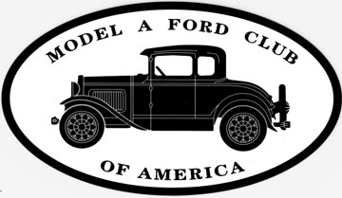
Free 1st Year Membership 2023
USA Application

Please Print
Name:________________________________________________________________
Spouse:______________________________________________________________
Address:______________________________________________________________
City, State, Zip:_________________________________________________________
Sponsoring MAFCA Chapter:______________________________________________

- Provide Digital Copy of The Restorer (email required): Yes____ No____
  - Email:___________________________________
- I give MAFCA permission to publish my name and contact information: Yes___ No___
Requirements For Free Membership
- Only families never having held membership in MAFCA may apply for free membership.
- Must be sponsored by a MAFCA chapter.
- Free membership includes The Restorer magazine from the time the application is received by the MAFCA Office until October 20, 2023.

Visit MAFCA.com to view merchandise store
Popular MAFCA Store Items Include:
- The Coupe Book, Tudor Book, The Victoria Book
- Mechanics handbook Vol. I, Vol II and the Trouble Shooting Guide by Les Andrews
- Model A Restoration Guidelines and Judging Standards
- Model A & AA Paint & Finish Guide and the New How to Restore Your Model A Vol 10

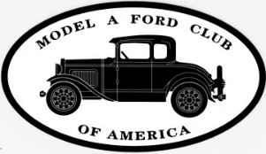
Mail Application to:
Model A Ford Club of America
250 S. Cypress St.
La Habra, CA 90631-5515

