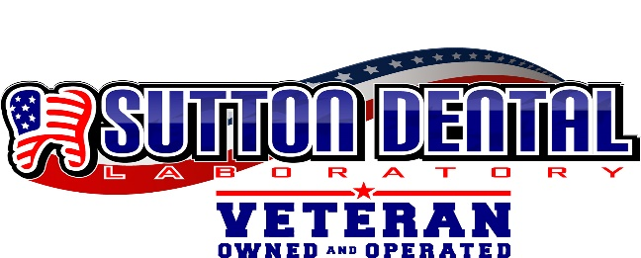

***813 Ingleside Avenue***

***Athens, TN 37303***

***Phone: 423-453-2054***

Patient: _____________________________________________ Date Sent:_______________________________

Pan #: **______________________________________________ Lab’s Email:** suttondentallaboratory@gmail.com

|  |  |  |
| --- | --- | --- |
| **Porcelain Fused to:**   * Non-Precious * Semi-Precious * White-Precious (40%) * Captek   **All Ceramic Restorations:**   * IPS e.max * Zirconia (layered) * Full Contour Zirconia   **Full Cast Restorations:**   * Non-Precious * Semi-Precious * 40% Gold (white) * 60% Gold (yellow)   **Miscellaneous:**  Temp Crown  Metal Occlusion  Porcelain Butt Margin  Rest  Diagnostic Wax Up  Cast Implant Abut (UCLA)  **Ortho**   * Hawley Retainer * Spring Aligned Retainer * Nance Appliance * Lingual Arch * Space Maintainer * Habit Device * Hyrax Rapid Expander * Bonded Retainer 3x3 * Bonded Retainer 3x3 w/Pad * Clear Retainer * Herbst Appliance * TAP 3 Elite * EMA Sleep Apnea Device * NTI Device      Bleaching Tray   Hard Mouth Guard     Hard/Soft Mouth Guard | **Basic Shade:**    **Custom Shade Design:**          _______________        **Margin Design:**        No Metal Collar      180  Metal Collar      360  Metal Collar              **Pontic Design:**      **Anterior Design:**      **Posterior Design:**    **Occlusal Clearance:**        **Contacts:**        Light      Normal    **Tooth Number**     Light   * Tight  Open Heavy   **Occlusal Stain:**   * None  Light  Medium  Heavy     **Fit (Die Spacer coats):**  x1  x2  x3  **If Insufficient Room: (must select )**   Reduce Opposing  Place metal Island/Occ  Reduction Coping | **Removable Prosthetics:**      * UPPER * LOWER   **Tissue Shade:**   * Clear * Light Pink  * Regular Pink * Dark Pink * Ethnic (Meharry)     Mild Moderate Heavy    **Tooth Shade:**    **___________________**  **Partial Denture:**    **Type of Material:**   * Valplast * TCS * Cr Co * Vitallium * Framework only * Set Teeth Try-in * Finish * Complete (without Try-in)   **Full Denture:**   * Wax Try-in * Finish * Complete (Without Try-in) * Acrylic (Immediate) Denture **Removable Extras:**   Bite Rims Custom Trays  Flipper Repair  Reline Rebase  Add Valplast Clasp  Add Clear Clasp  Add Cast Clasp Add Ball Clasp  Surgical Stent ID In Denture |
|  |