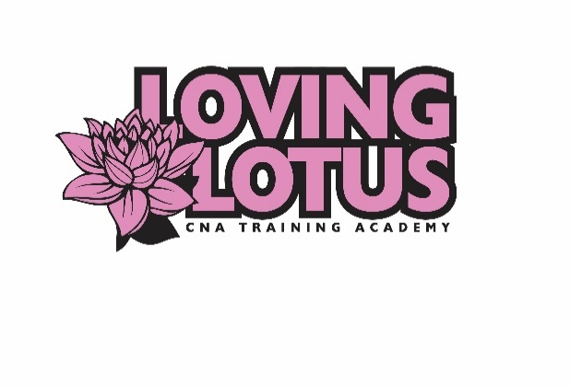
Loving Lotus CNA Training Academy, LLC
2419 Margaret Street Suite 100
North St. Paul, MN 55108
Phone: 651-321-7500 Fax: 651-389-9147
Website: www.lovinglotuscna.com
Email: lovinglotuscna@gmail.com

ENROLLMENT APPLICATION, CANCELLATION CONTRACT, AND BACKGROUND CHECK CONSENT FORM
(Please PRINT LEGIBLY and complete all sections)

Date of class to be enrolled __________________________________________
Full Legal Name______________________________________________________________________
Drivers License Number/ID_______________________ Social Security #________________________
Street Address: ___________________________________________________Apt No._____________
City, State, Zip Code: __________________________________________________________________
Phone: _____________________________________________________________________________
Email Address:_______________________________________________________________________
Date of Birth: ____________________Race___________________________Sex__________________
Maiden names or previously used names___________________________________________________
Emergency Contact:__________________________________ Relationship:______________________
Phone Number: ______________________________________________________________________
Please answer the following question:
Are you able to lift a minimum of 50 pounds? YES NO
Do you have any medical restrictions or conditions? YES NO
Have you been fully vaccinated for Covid 19? YES NO
Are you a High School or GED recipient and can provide proof? YES NO
Have you ever been convicted of a felony or misdemeanor? YES NO
If so, please explain:
I consent to have a background check completed by the school and am aware that this background check must be clear to attend clinical sites. I authorize Loving Lotus CNA Training Academy, LLC, and its employees to provide a copy of my background check to the clinical site.
_______________________________________________________________ __________________ Signature of Applicant Date
Applicant’s tuition fee will be $1,400.00. A deposit of $400 must be paid at time of registration to reserve a seat in the program. Tuition cost does not include the testing fee for your state exam. The balance is due by the end of the first day of class or dates that was agreed upon in payment arrangement. To receive a certificate of completion, all fees must be paid and all equipment on loan from the school must be returned in satisfactory condition.
If you need to cancel your registration you will receive a full refund minus the $400 non-refundable deposit if this is done 16 days or more before class start date. If the course key has been activated, you will not be refunded the cost of the online course which is $500 plus the non-refundable deposit.
If you need to cancel your registration you will receive a 50% refund minus the $400 non-refundable deposit if this is done 7-16 days before the class start date. If the course key has been activated, you will not be refunded the cost of the online course which is $500 plus the non-refundable deposit.
If you cancel 7 days or less from the start date of class, you will not be refunded your tuition payment. Refunds will be issued within 30 days. If a student has attended and wishes to withdraw from class, no refund shall be issued regardless of the time passed. Students must appear in person to receive a refund – they will not be mailed out per school policy. If a student does not pass the background check, the student will receive a full refund minus a $50 background check fee.
ALL IN-PERSON DAYS ARE MANDANTORY!!! If you cannot attend the in-person class, you will need to attend a make-up session. Make-up sessions cost $200 per session.
The student must provide program with a copy of their driver’s license or state-issued photo ID and social security card with the results of a negative TB skin test and Covid vaccination card (if applicable) upon approval of application. All information provided to the school shall be kept confidential.
________ I have received a copy of the school catalog and policies and procedures. (initials)
How did you hear about us? _____Internet _____Social Media ______Friend _____Workforce Center _____Newspaper ______Other: ________________________
I have read this contract and agree to the terms. I understand that clinical or supervised practical training dates and times are subject to the discretion of the clinical director and the facility at which clinical will take place.
Signature of Applicant Date
For Office Use Only (Do not write below this line)
Tuition Payment _____________________________Payment Date______________________________
Tuition Refund ______________________________Refund Date ________________________________
Drivers License______________________________Background Check____________________________
TB Skin Test________________________________ Processed On/By ____________________________

