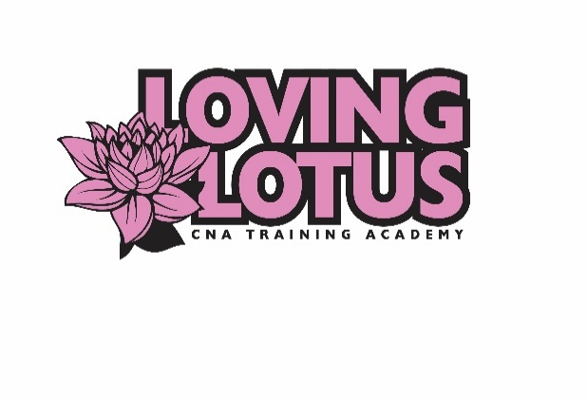

Loving Lotus CNA Training Academy, LLC
2419 Margaret Street Suite 100
North St. Paul, MN 55108
Phone: 651-321-7500 Fax: 651-389-9147
Website: www.lovinglotuscna.com
Email: lovinglotuscna@gmail.com

Payment Plan Contract Form
Student Name: ____________________________
Student Date of Birth: _______________________
Social Security Number: ______________________
Class Start Date: ____________________________
By this contract, I ________________________ agree to pay for training rendered by Loving Lotus CNA Training Academy and I understand that I am financially responsible for the payment of all services rendered to me. I understand that I am responsible for upholding these terms. It is agreed that I will make payments as listed below:
First payment date: ___________ Amount: _________
Second payment date_________ Amount: _________ (if applicable).
This agreement is binding and failure to meet these terms may result in dismissal from all classes or my ability to take my state exam. Late payments will incur a $5 per day charge. By signing this agreement all parties agree to the terms above. Alterations to this agreement must be made by both parties.
Sign and Date __________________________ _________________________

