Abigail Hale Horses
Introduction to Liberty
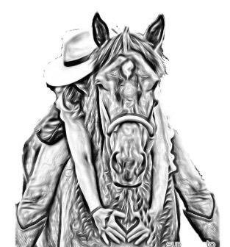
Building a stronger relationship and connection with your horse

Clinic Outline
Time | Activity | Outcomes
10:00-10:30 | Liberty Demo with BLM Mustang Pippa’s Promise | Abby will perform a liberty demonstration with Pippa, then take some time to explain some basic philosophies behind her methods and liberty training
10:30-11:00 | Breakdown of first two exercises with demo horse  - Draw  - Drive | Abby will use a participant’s horse to discuss the first two of five foundational exercises used to begin liberty training
11:00-11:15 | Participants go get horses and bring to arena to begin hands on learning  Tools: Halter, leadrope and one dressage or carriage length whip
11:15-12:30 | Group Instruction with participant’s horses working on draw and drive exercises
12:30-1:00 | LUNCH
1:00-1:30 | Breakdown of exercises 3-5 with demo horse  - Partial Hindquarter Yield  - Drawback Circles  - Putting it all together- Liberty Circle | Abby will use a participant’s horse to discuss the next three foundational exercises used to begin liberty training
1:35-1:45 | Participants go get horses and bring to arena to begin hands on learning  Tools: Halter, leadrope and TWO whips, one of which should be dressage length and the second carriage length
1:45-2:15 | Participants will work on exercise three, partial hindquarter yield with their horses | Abby will teach the group and then go around and give some 1:1 instruction
2:15-2:45 | Participants will work on exercise four, drawback circles with their horses | Abby will teach the group and then go around and give some 1:1 instruction
2:45-3:00 | Water Break
3:00-3:30 | Participants will work on putting it all together- liberty circles! | Abby will teach the group and then go around and give some 1:1 instruction
3:30-4:00 | Time alloted for questions and extra help

TOOLS NEEDED:

- Halter (rope halter preferred)
- Lead rope 10-20 ft in length
- Dressage length Whip
- Carriage length Whip

