**Configuration of static routing with classful addressing in Cisco Packet Tracer**

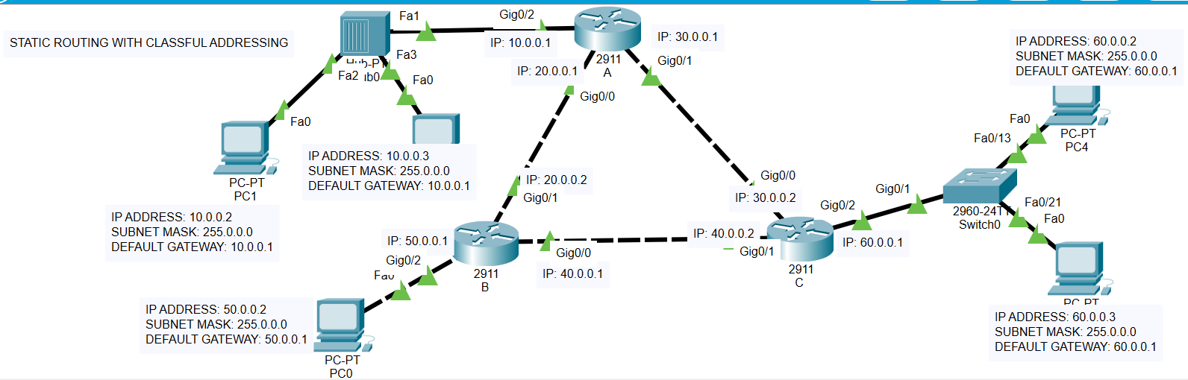

The number of networks is 6, and the number of gateways is 3.

Router: A

--- System Configuration Dialog ---

Would you like to enter the initial configuration dialog? [yes/no]: no

Press RETURN to get started!

Router>

Router>enable

Router#configure terminal

Enter configuration commands, one per line. End with CNTL/Z.

Router(config)#interface gig0/2

Router(config-if)#ip address 10.0.0.1 255.0.0.0

Router(config-if)#no shutdown

Router(config-if)#

%LINK-5-CHANGED: Interface GigabitEthernet0/2, changed state to up

%LINEPROTO-5-UPDOWN: Line protocol on Interface GigabitEthernet0/2, changed state to up

Router(config)#interface gig0/0

Router(config-if)#ip address 20.0.0.1 255.0.0.0

Router(config-if)#no shutdown

Router(config-if)#

%LINK-5-CHANGED: Interface GigabitEthernet0/0, changed state to up

Router(config)#interface gig0/1

Router(config-if)#ip address 30.0.0.1 255.0.0.0

Router(config-if)#no shutdown

Router(config-if)#

%LINK-5-CHANGED: Interface GigabitEthernet0/1, changed state to up

Router>

Router>enable

Router#configure terminal

Enter configuration commands, one per line. End with CNTL/Z.

**Router(config)#ip route 60.0.0.0 255.0.0.0 30.0.0.2**

Router: B

--- System Configuration Dialog ---

Would you like to enter the initial configuration dialog? [yes/no]: no

Press RETURN to get started!

Router>

Router>

Router>

Router>enable

Router#configure terminal

Enter configuration commands, one per line. End with CNTL/Z.

Router(config)#interface gig0/2

Router(config-if)#ip address 50.0.0.1 255.0.0.0

Router(config-if)#no shutdown

Router(config-if)#

%LINK-5-CHANGED: Interface GigabitEthernet0/2, changed state to up

%LINEPROTO-5-UPDOWN: Line protocol on Interface GigabitEthernet0/2, changed state to up

Router(config-if)#interface gig0/1

Router(config-if)#ip address 20.0.0.2 255.0.0.0

Router(config-if)#no shutdown

Router(config-if)#

%LINK-5-CHANGED: Interface GigabitEthernet0/1, changed state to up

%LINEPROTO-5-UPDOWN: Line protocol on Interface GigabitEthernet0/1, changed state to up

Router(config-if)#interface gig0/0

Router(config-if)#ip address 40.0.0.1 255.0.0.0

Router(config-if)#no shutdown

Router(config-if)#

%LINK-5-CHANGED: Interface GigabitEthernet0/0, changed state to up

Router: C

--- System Configuration Dialog ---

Would you like to enter the initial configuration dialog? [yes/no]: no

Press RETURN to get started!

Router>enable

Router#configure terminal

Enter configuration commands, one per line. End with CNTL/Z.

Router(config)#interface gig0/0

Router(config-if)#ip address 30.0.0.2 255.0.0.0

Router(config-if)#no shutdown

Router(config-if)#

%LINK-5-CHANGED: Interface GigabitEthernet0/0, changed state to up

%LINEPROTO-5-UPDOWN: Line protocol on Interface GigabitEthernet0/0, changed state to up

Router(config-if)#interface gig0/1

Router(config-if)#ip address 40.0.0.2 255.0.0.0

Router(config-if)#no shutdown

Router(config-if)#

%LINK-5-CHANGED: Interface GigabitEthernet0/1, changed state to up

%LINEPROTO-5-UPDOWN: Line protocol on Interface GigabitEthernet0/1, changed state to up

Router(config-if)#interface gig0/2

Router(config-if)#ip address 60.0.0.1 255.0.0.0

Router(config-if)#no shutdown

Router(config-if)#

%LINK-5-CHANGED: Interface GigabitEthernet0/2, changed state to up

%LINEPROTO-5-UPDOWN: Line protocol on Interface GigabitEthernet0/2, changed state to up

Router>

Router>enable

Router#configure terminal

Enter configuration commands, one per line. End with CNTL/Z.

**Router(config)#ip route 10.0.0.0 255.0.0.0 30.0.0.1**

**PC**

C:\>ping 10.0.0.3

Pinging 10.0.0.3 with 32 bytes of data:

Reply from 10.0.0.3: bytes=32 time<1ms TTL=126

Reply from 10.0.0.3: bytes=32 time=1ms TTL=126

Reply from 10.0.0.3: bytes=32 time<1ms TTL=126

Reply from 10.0.0.3: bytes=32 time<1ms TTL=126

Ping statistics for 10.0.0.3:

Packets: Sent = 4, Received = 4, Lost = 0 (0% loss),

Approximate round trip times in milli-seconds:

Minimum = 0ms, Maximum = 1ms, Average = 0ms

C:\>tracert 10.0.0.3

Tracing route to 10.0.0.3 over a maximum of 30 hops:

1 0 ms 1 ms 1 ms 60.0.0.1

2 2 ms 1 ms 0 ms 30.0.0.1

3 0 ms 0 ms 1 ms 10.0.0.3

Trace complete.

C:\>