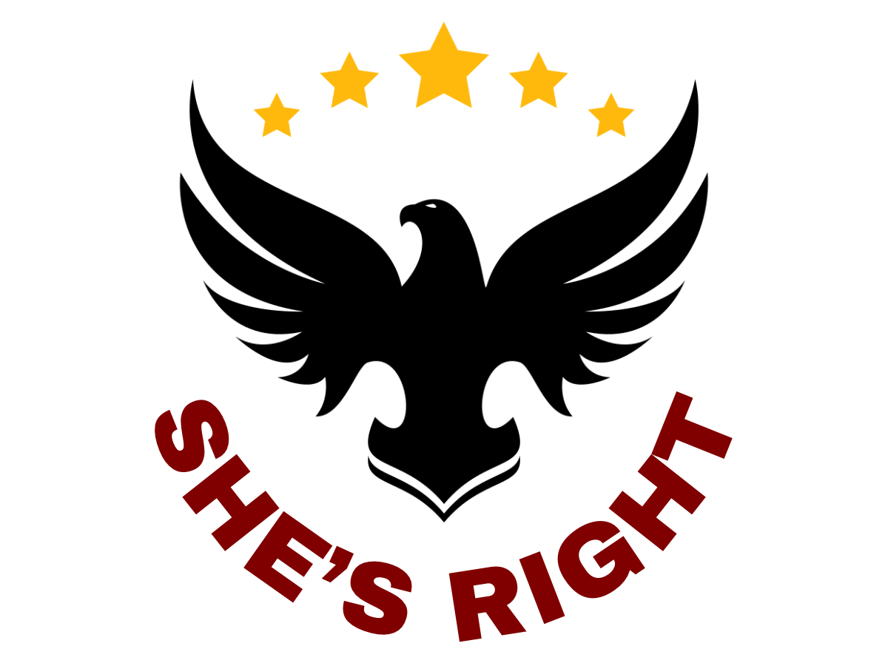
THE ACTUAL ORIGINS OF GUN CONTROL IN AMERICA
A Sourced & Documented Historical Record
Presented by She's Right | shesright1776.com | shesright@shesright1776.com | @shesright1776

The mainstream narrative claims gun control is a modern, compassionate policy response to crime and violence. The historical record tells a very different story. Gun control in America was born not from public safety — but from the desire to control, disarm, and subjugate specific populations: enslaved people, freed Black Americans, Native Americans, political dissenters, and the poor. This document presents the documented, sourced history of how and why gun control began in the United States.

PART I: PRE-FOUNDING ORIGINS (1600s–1776)

Long before the United States existed as an independent nation, American colonies were already enacting laws that restricted who could own and carry firearms. These were not safety measures — they were instruments of control. The earliest gun laws specifically targeted enslaved Africans, Native Americans, Catholics, and political dissidents.

[1619] Virginia: First Colonial Gun Restriction — Targeting Native Americans
The Virginia Colony enacted one of the earliest known gun laws in North America, prohibiting the sale or trade of firearms to Native Americans. This was a strategic disarmament of an entire population perceived as a military threat — not a public safety measure.
Source: Robert J. Spitzer, 'Gun Law History in the United States and Second Amendment Rights,' Law and Contemporary Problems 80, no. 2 (2017): 55–83. Duke Law. scholarship.law.duke.edu

[1637] Massachusetts Colony: Disarming Political & Religious Dissidents
The Massachusetts Colony passed a law requiring named individuals who expressed 'opinions & revelations' that 'seduced & led into dangerous errors many of the people' to surrender all 'guns, pistols, swords, powder, shot, & match.' Restoration of firearms required court approval. This was the first use of gun confiscation as a tool of political and religious suppression in America.
Source: Spitzer, 'Gun Law History in the United States,' Duke Law Scholarship Repository, 2017. scholarship.law.duke.edu

[1680s–1750s] Colonial Laws Systematically Disarming Enslaved & Free Black Americans
Across the colonies, laws were enacted to prevent enslaved and free Black Americans from owning or carrying firearms. These laws were explicitly about control and suppression of potential rebellion — not public safety. Virginia, South Carolina, Georgia, and others passed statutes during this era specifically targeting Black firearm ownership.
Source: Clayton Cramer, 'The Racist Roots of Gun Control,' Kansas Journal of Law & Public Policy (1995); Heritage Foundation analysis, heritage.org/the-essential-second-amendment/the-racist-roots-gun-control

[1756] Maryland: Disarming Catholics
Maryland passed a law ordering the confiscation of 'all Arms Gunpowder and Ammunition of what kind soever any Papist or reputed Papist within this Providence hath or shall have in his House or Houses.' Religious affiliation, not behavior, was grounds for disarmament.
Source: US Concealed Carry Association, 'The History of Gun Control in the United States,' usconcealedcarry.com

[1770s] Pennsylvania: Disarming Political Opponents
Pennsylvania enacted a law to strip firearms from those who refused to swear loyalty to the new American government during the Revolutionary period. Allegiance to the state became a condition for exercising what would soon be declared a natural right.
Source: Spitzer, 'Gun Law History in the United States,' Duke Law, 2017.

PART II: POST-CIVIL WAR & RECONSTRUCTION (1865–1900)

The post-Civil War era produced the most overtly racist gun control laws in American history. Southern states, desperate to maintain white supremacy after emancipation, enacted the 'Black Codes' — comprehensive laws designed to keep freed Black Americans in a condition of economic and physical subjugation. Disarmament was central to this project. The Ku Klux Klan enforced these laws through terror.

[1865] Mississippi Black Code: Banning Firearms for Freedmen
Mississippi's Black Code stated no freedman 'shall keep or carry fire-arms of any kind, or any ammunition' without police permission. This was one of dozens of such laws passed immediately after the Civil War to prevent the newly freed from defending themselves.
Source: Slate, 'What Reconstruction and Its End Meant for Black Americans Who Had Fought for the Right to Keep and Bear Arms,' February 10, 2018. slate.com

[1865] Alabama & Florida Black Codes: Disarming Freed People by Force
Alabama prohibited 'any freedman, mulatto or free person of color in this state, to own firearms, or carry about this person a pistol or other deadly weapon.' Florida's law prohibited Black Americans from possessing guns without a judge-issued license — with violators subject to public whipping of up to 39 lashes.
Source: Slate, 'What Reconstruction and Its End Meant for Black Americans,' 2018. slate.com

[1865–1871] The KKK: America's First Gun Control Enforcers
Following the Civil War, the Ku Klux Klan emerged in Tennessee (1866) and spread throughout the South. Civil rights attorney Albion Tourgée — who later represented Homer Plessy in Plessy v. Ferguson — documented that 'almost universally the first thing done was to disarm the negroes and leave them defenseless.' The Klan was, in effect, America's first domestic gun control enforcement organization — operating through murder, terrorism, and confiscation.
Source: Clayton Cramer, 'The Racist Roots of Gun Control,' Encounter Books. encounterbooks.com/features/racist-roots-gun-control

[1871] Tennessee 'Army and Navy' Law: Facially Neutral, Racially Targeted
After Reconstruction forced the repeal of explicitly race-based laws, the white supremacist Tennessee legislature enacted the 'Army and Navy' law — banning the sale of handguns except expensive military-grade models. Ex-Confederate soldiers already owned these weapons. Cash-poor freedmen could only afford cheaper models. As a Florida Supreme Court justice later admitted in Watson v. Stone (1941), such laws were 'passed for the purpose of disarming the negro laborers' and 'never intended to be applied to the white population.'
Source: Encounter Books, 'The Racist Roots of Gun Control.' encounterbooks.com; Watson v. Stone, 148 Fla. 516 (1941)

PART III: PROHIBITION ERA & FEDERAL GUN CONTROL (1920s–1938)

The first federal gun control laws arose not from grassroots public demand, but from the violence spawned by federal Prohibition policy — the government's own ban on alcohol that created organized crime. Rather than repealing the failed policy that caused the violence, Congress moved to restrict firearms.

[1934] National Firearms Act (NFA): The First Federal Gun Law
The NFA was the first federal law regulating firearms possession. Passed in response to the gang violence of the Prohibition era — most associated with Al Capone and the St. Valentine's Day Massacre — it imposed registration and taxation on machine guns, sawed-off shotguns, and silencers. Early drafts included handguns but that provision was dropped at the NRA's urging. The law did not arise from a constitutional mandate or broad public safety concern — it arose from the consequences of government's own failed Prohibition experiment.
Source: Violence Policy Center, 'A Brief History of Firearms Law.' vpc.org; History News Network, 'Understanding America's History of Gun Control.' historynewsnetwork.org

[1938] Federal Firearms Act (FFA)
The FFA extended federal regulation by requiring dealers and manufacturers to be licensed and prohibiting sales to convicted felons. This built on the NFA framework established four years earlier. At this point, no broad civilian disarmament effort existed at the federal level — restrictions remained narrow and targeted.
Source: The Trace, 'A Timeline of American Gun History.' thetrace.org

PART IV: THE MODERN GUN CONTROL MOVEMENT (1968–PRESENT)

The modern gun control movement as Americans know it today was born in 1968 — catalyzed by the assassinations of President John F. Kennedy (1963), Dr. Martin Luther King Jr. (1968), and Senator Robert F. Kennedy (1968). Ironically, one of the law's effects was again disproportionate enforcement against minority and poor communities. The pattern established in the 1600s continued.

[1968] Gun Control Act of 1968 (GCA)
President Lyndon B. Johnson pushed the GCA through Congress following three major assassinations. The law banned interstate sales of handguns, rifles, and shotguns except through federally licensed dealers; set minimum age requirements (18 for long guns, 21 for handguns); established licensing and record-keeping standards; and banned sales to felons, drug users, and those 'mentally incompetent.' The law replaced the 1938 FFA and expanded NFA provisions.
Source: Time Magazine, 'Here's a Timeline of Major Gun Control Laws in America.' time.com; Violence Policy Center, vpc.org

[1986] Firearms Owners' Protection Act (FOPA)
In 1986, Congress passed FOPA, which rolled back significant portions of the 1968 GCA, eliminated the national registry of gun owners, and — in a floor amendment — permanently banned civilian ownership of new machine guns manufactured after the date of enactment. It was a mixed result for gun rights, expanding some protections while closing others.
Source: History News Network, 'Understanding America's History of Gun Control.' historynewsnetwork.org

[2008] District of Columbia v. Heller: Supreme Court Affirms Individual Right
In a landmark 5–4 ruling, the Supreme Court held that the Second Amendment protects an individual right to possess firearms for self-defense, independent of militia service. The Court simultaneously affirmed that this right is not unlimited and that many categories of regulation remain constitutionally permissible.
Source: District of Columbia v. Heller, 554 U.S. 570 (2008)

[2022] New York State Rifle & Pistol Assoc. v. Bruen
The Supreme Court ruled that the right to carry handguns in public for self-defense is constitutionally protected, and that future gun regulations must be consistent with the nation's historical tradition of firearm regulation. This decision has since prompted extensive new research into America's early gun laws — research confirming that gun regulations have existed since the colonial era and were frequently used as tools of oppression.
Source: New York State Rifle & Pistol Association, Inc. v. Bruen, 597 U.S. 1 (2022)

CONCLUSION: WHAT THE RECORD SHOWS

The documented history of gun control in the United States reveals a consistent and troubling pattern. As Professor Robert J. Spitzer's comprehensive study of over 1,000 early gun laws concludes, 'the common notions that gun laws are largely a function of modern, industrial America, that gun laws are incompatible with American history and its practices or values... are all patently false.' But crucially, the early laws that did exist were not enacted to protect public safety equally — they were tools of racial, religious, and political control.

Key conclusions supported by the historical record:

- The first gun control laws in America targeted enslaved people, Native Americans, Catholics, and political dissidents — not violent criminals.
- Post-Civil War Black Codes represented the most systematic use of gun control as racial oppression in American history. Disarmament preceded subjugation.
- The first federal gun control law (1934) was a response to violence created by the government's own Prohibition policy — not a grassroots public safety initiative.
- The KKK was, by documented historical account, America's first gun control enforcement organization.
- The Second Amendment was included in the Bill of Rights precisely because the Founders understood that the right to bear arms is the ultimate check on government tyranny and the last line of individual self-defense.

PRIMARY SOURCES & BIBLIOGRAPHY

The following sources were used in compiling this document:

1. Spitzer, Robert J. 'Gun Law History in the United States and Second Amendment Rights.' Law and Contemporary Problems 80, no. 2 (2017): 55–83. Duke Law Scholarship Repository. scholarship.law.duke.edu

2. Cramer, Clayton. 'The Racist Roots of Gun Control.' Kansas Journal of Law & Public Policy (1995). Published via Encounter Books. encounterbooks.com/features/racist-roots-gun-control

3. Cornell, Saul. A Well-Regulated Militia: The Founding Fathers and the Origins of Gun Control in America. Oxford University Press, 2006.

4. US Concealed Carry Association. 'The History of Gun Control in the United States, Parts 1 & 2.' usconcealedcarry.com

5. The Trace. 'A Timeline of American Gun History.' thetrace.org

6. Violence Policy Center. 'A Brief History of Firearms Law.' vpc.org

7. Slate. 'What Reconstruction and Its End Meant for Black Americans Who Had Fought for the Right to Keep and Bear Arms.' February 10, 2018. slate.com

8. Heritage Foundation. 'The Racist Roots of Gun Control.' heritage.org/the-essential-second-amendment/the-racist-roots-gun-control

9. Origins (Ohio State University). 'Top Ten Origins: Gun Regulation.' February 7, 2019. origins.osu.edu

10. Rockefeller Institute of Government. 'Gun Law History in the United States and Second Amendment Rights.' rockinst.org

11. Watson v. Stone, 148 Fla. 516, 4 So. 2d 700 (1941) — Florida Supreme Court concurring opinion.

12. District of Columbia v. Heller, 554 U.S. 570 (2008). Supreme Court of the United States.

13. New York State Rifle & Pistol Association, Inc. v. Bruen, 597 U.S. 1 (2022). Supreme Court of the United States.

14. History News Network. 'Understanding America's History of Gun Control.' historynewsnetwork.org

15. Gettysburg College Journal of the Civil War Era. 'Freedmen with Firearms: White Terrorism and Black Disarmament During Reconstruction.' cupola.gettysburg.edu

She's Right | shesright1776.com | shesright@shesright1776.com | YouTube: @shesright1776
This document is for educational purposes. All facts are sourced from publicly available academic, legal, and historical records.

