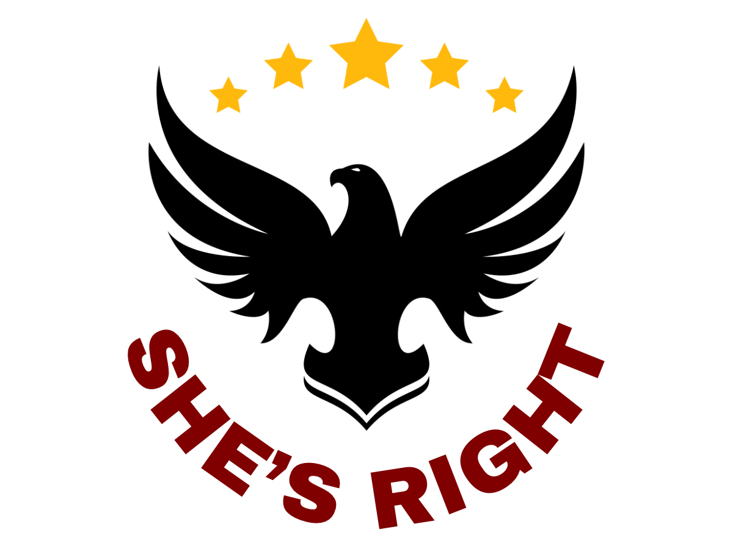
U.S. SUPREME COURT
2025–2026 TERM DOCKET REPORT
October 6, 2025 – Late June/Early July 2026
🌐 shesright1776.com | 📧 shesright@shesright1776.com | ▶ YouTube: @shesright1776

ABOUT THE 2025–2026 TERM

The Supreme Court's 2025–2026 term began on October 6, 2025 and runs through late June or early July 2026. The Court agreed to hear approximately 65 cases this term — one of the most consequential in recent memory. Major issues include presidential tariff authority, birthright citizenship, transgender athletes, voting rights, Second Amendment gun laws, and the independence of federal agencies. All decisions are expected before the July Fourth recess.

RECENTLY DECIDED CASES

Learning Resources, Inc. v. Trump [DECIDED]
Docket: 24-1287 | Topic: Presidential Authority / Tariffs
Challenged whether the International Emergency Economic Powers Act (IEEPA) of 1977 authorizes the President to impose tariffs. Twelve states and five small businesses argued the law never mentions tariffs and had never been used for that purpose in its 48-year history. Argued November 5, 2025. Decided February 20, 2026.
Decision: 6-3: IEEPA does NOT authorize the President to impose tariffs. Chief Justice Roberts wrote the majority opinion joined by Justices Sotomayor, Kagan, Gorsuch, Barrett, and Jackson. Justices Thomas, Kavanaugh, and Alito dissented. The ruling invalidated both the 'Reciprocal Tariffs' and the fentanyl-related tariffs, opening the door to refunds of approximately $166–179 billion in collected duties.

Chiles v. Salazar [DECIDED]
Docket: 24-539 | Topic: First Amendment / LGBTQ+ Policy
A licensed mental health counselor in Colorado challenged the state's ban on conversion therapy for minors, arguing it violated her First Amendment free speech rights. Argued October 2025. Decided March 31, 2026.
Decision: 8-1: Ruled in favor of Chiles. The Court found that conversion therapy practices as described can constitute protected speech under the First Amendment. The case was remanded for lower courts to re-evaluate Colorado's law under a heightened standard of scrutiny requiring viewpoint neutrality.

Louisiana v. Callais [DECIDED]
Docket: 24-109 | Topic: Voting Rights Act / Redistricting
Louisiana redrew its congressional map after courts found its earlier map likely violated Section 2 of the Voting Rights Act of 1965. The new map included a second majority-Black district. A group of non-Black voters challenged the new map as an unconstitutional racial gerrymander. Argued October 15, 2025. Decided April 29, 2026.
Decision: 6-3: Struck down Louisiana's congressional map. Justice Alito wrote the majority opinion. The ruling dramatically narrowed Section 2 of the Voting Rights Act, making it significantly harder for minority voters to successfully challenge racially discriminatory maps. Justices Kagan, Sotomayor, and Jackson dissented, with Kagan writing that the ruling rendered Section 2 'all but a dead letter.'

First Choice Women's Resource Centers, Inc. v. Davenport [DECIDED]
Docket: 24-781 | Topic: First Amendment / Associational Rights
A religious nonprofit in New Jersey that provides counseling to pregnant women challenged a subpoena from the New Jersey Attorney General demanding documents and donor information. Decided April 29, 2026.
Decision: The Court ruled that First Choice had established a present injury to its First Amendment associational rights sufficient to confer standing to sue in federal court.

District of Columbia v. R.W. [DECIDED]
Docket: 25-248 | Topic: Fourth Amendment / Law Enforcement
A Metropolitan Police officer responded to a report about a suspicious vehicle. The case examined the constitutionality of a vehicle stop and whether the officer had reasonable suspicion. Decided April 20, 2026.
Decision: Per Curiam: Because Officer Vanterpool clearly had reasonable suspicion to stop R.W., the judgment of the D.C. Court of Appeals was reversed and remanded.

Bost v. Illinois State Board of Elections [DECIDED]
Docket: 24-XXX | Topic: Election Law / Standing
Congressman Michael Bost and Republican presidential electors challenged Illinois rules governing the counting of votes in his election. Decided January 14, 2026.
Decision: 7-2: The Supreme Court ruled that Congressman Bost has standing to challenge the vote-counting rules. Justices Jackson and Sotomayor dissented, arguing the majority treated election candidates more favorably than other litigants.

Case v. Montana [DECIDED]
Docket: 24-624 | Topic: Fourth Amendment / Emergency Entry
Law enforcement officers entered a home after receiving a report that the occupant may have shot himself. The case examined the standard for warrantless emergency entry into a home. Decided January 14, 2026.
Decision: Unanimous (9-0): Written by Justice Kagan. Officers only need an objectively reasonable basis for believing an occupant faces serious injury or imminent threat, and that entry is needed to render emergency assistance. The Court declined to impose a higher probable cause standard.

Hencely v. Fluor Corp. [DECIDED]
Docket: 24-924 | Topic: Military Contractor Liability
A former Army specialist was seriously injured in a suicide bombing at a U.S. military base in Afghanistan. The attack was carried out by a Taliban operative hired by military contractor Fluor Corporation. Decided April 22, 2026.
Decision: Ruled on questions of contractor liability in military contexts overseas.

PENDING CASES — DECISIONS EXPECTED BY LATE JUNE/JULY 2026

Trump v. Barbara [PENDING]
Docket: 25-365 | Topic: Immigration / 14th Amendment / Birthright Citizenship
Challenges President Trump's executive order ending birthright citizenship for children born in the U.S. to parents who are undocumented or on temporary visas. The administration argues the 14th Amendment's citizenship clause was adopted specifically for formerly enslaved people and does not extend to children of those unlawfully present. Lower courts uniformly blocked the policy. Trump attended oral arguments on April 1, 2026 — a historic first for a sitting president. Court observers broadly expect the Court to side against the administration based on oral argument questioning.

Trump v. Slaughter [PENDING]
Docket: 25-XXX | Topic: Separation of Powers / Executive Removal Authority
President Trump fired Federal Trade Commissioner Rebecca Kelly Slaughter and Commissioner Alvaro Bedoya without cause. The FTC Act limits removal of commissioners to cases of 'inefficiency, neglect of duty, or malfeasance in office.' The case asks whether Congress can protect members of independent agencies from at-will removal, potentially overturning precedent dating to 1935. Argued December 8, 2025. Conservative justices signaled willingness to expand presidential removal authority.

West Virginia v. B.P.J. [PENDING]
Docket: 23-XXX | Topic: Transgender Rights / Title IX / Equal Protection
Challenges West Virginia's law barring transgender girls and women from participating in female sports teams. Becky Pepper-Jackson, a transgender student, argued the ban violates Title IX and the Equal Protection Clause. Argued January 13, 2026. The Court appeared skeptical of arguments in favor of transgender inclusion, with several justices raising concerns about fairness in women's sports.

Little v. Hecox [PENDING]
Docket: 24-XXX | Topic: Transgender Rights / Title IX / Equal Protection
Companion case to West Virginia v. B.P.J. Challenges Idaho's law prohibiting transgender girls and women from participating in female sports. Lower courts blocked the Idaho law as violating the Equal Protection Clause. Argued January 13, 2026 alongside the West Virginia case. Chief Justice Roberts appeared skeptical of arguments for transgender inclusion.

Watson v. Republican National Committee [PENDING]
Docket: 25-XXX | Topic: Election Law / Mail-in Ballots
Addresses whether states can lawfully count mail-in ballots that are postmarked by Election Day but received afterward. A decision could have significant ramifications for close elections and absentee ballot procedures across the country ahead of the 2026 midterms.

United States v. Hemani [PENDING]
Docket: 24-XXX | Topic: Second Amendment / Drug Users & Firearms
Challenges a federal law prohibiting firearm possession by individuals who are unlawful users of or addicted to controlled substances. The Fifth Circuit held the law was unconstitutional in most instances. The Trump administration petitioned the Court to hear the case. The administration argues in favor of upholding the law, putting it in the unusual position of advocating against broad gun rights. Gained national attention after the law was used to convict Hunter Biden.

Wolford v. Lopez [PENDING]
Docket: 24-XXX | Topic: Second Amendment / Concealed Carry Restrictions
Hawaii law makes it a crime for a person with a concealed carry permit to carry a handgun on private property without 'express authorization' from the property owner, operator, or manager. The Ninth Circuit ruled in favor of Hawaii. Petitioners cited a Second Circuit ruling striking down a similar law. Argued January 20, 2026.

Trump v. Cook [PENDING]
Docket: 25-XXX | Topic: Federal Reserve Independence / Executive Removal
President Trump attempted to fire Lisa Cook, a member of the Federal Reserve Board of Governors, alleging mortgage fraud prior to her 2023 appointment. The Federal Reserve Act allows removal only 'for cause.' The case raises questions about whether the Federal Reserve's independence is constitutionally protected. Argued January 21, 2026.

Chevron USA Inc. v. Plaquemines Parish [DECIDED]
Docket: 24-813 | Topic: Energy / State Litigation vs. Federal Permits
Concerns whether a Louisiana state court can impose liability on Chevron for oil production operations conducted under federal permits during and after World War II. A Plaquemines Parish jury awarded $744 million in damages for coastal wetland degradation. Decided April 17, 2026.
Decision: The Court addressed the scope of state court jurisdiction over federally permitted energy operations.

Enbridge Energy, LP v. Nessel [DECIDED]
Docket: 24-783 | Topic: Energy / Pipeline / State vs. Federal Authority
Concerns a dispute over the operation of Line 5, a petroleum pipeline owned by Enbridge that traverses the Straits of Mackinac in Michigan under a 1953 easement. Michigan sought to revoke the easement. Decided April 22, 2026.
Decision: The Court ruled on the scope of state authority over federally regulated interstate pipelines.

CURRENT SUPREME COURT JUSTICES (2025–2026)

Justice | Position | Appointed By | Since
John G. Roberts Jr. | Chief Justice | G.W. Bush | 2005
Clarence Thomas | Associate Justice | G.H.W. Bush | 1991
Samuel Alito | Associate Justice | G.W. Bush | 2006
Sonia Sotomayor | Associate Justice | Obama | 2009
Elena Kagan | Associate Justice | Obama | 2010
Neil Gorsuch | Associate Justice | Trump (1st) | 2017
Brett Kavanaugh | Associate Justice | Trump (1st) | 2018
Amy Coney Barrett | Associate Justice | Trump (1st) | 2020
Ketanji Brown Jackson | Associate Justice | Biden | 2022

[DECIDED] = Ruling issued | [PENDING] = Awaiting decision | Decisions expected by July 4, 2026

Report compiled as of May 4, 2026. All pending cases expected to be decided before the Court's summer recess (late June/early July 2026).
She's Right
shesright1776.com | shesright@shesright1776.com | YouTube: @shesright1776

