NORTHERN AZ BOWLERETTES

|  |  |  |  |
| --- | --- | --- | --- |
| JOHNSON LANES SPORTS PAVILION | TOURNAMENT NUMBER 2 | LANE FEES | $ 9.00 |
| 19803 N. RH JOHNSON BLVD. | October 19, 2024 | PRIZE FUND | $16.00 |
| SUN CITY WEST AZ 85375 | SIGN IN AT 10:00 A.M. BOWL AT 11:00 A.M. | TOTAL | $25.00 |
| 623-544-6140 |  |  |  |

# THIS TOURNAMENT WILL BE 3 REGULAR GAMES.

ENTRY DEADLINE: Oct. 15, 2024 

NO REFUNDS AFTER: Oct. 17, 2024

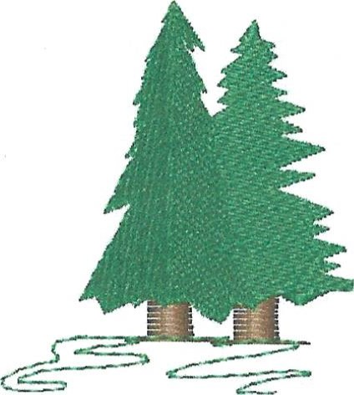MAKE CHECK PAYABLE TO: NORTHERN AZ BOWLERETTES

## MAIL ENTRIES TO: PAM CIRASOLE

1575 W RD 4 N

## CHINO VALLEY, AZ 86323

PH: 928 227 1258

This is a Northern AZ Bowlerettes tournament for NAZB members ONLY! ALL MEMBERS WELCOME!

Website:

<https://nothernazbowlerettes.com/>

Facebook page:

<https://m.facebook.com/groups/440727224248320?group_view_referrer=search>

PLEASE REMEMBER: If there is someone you want to bowl with please either mail in your entries together OR write their name on your entry form. I will do my best to put you together on the same pair of lanes!

**PLEASE RETAIN THE ABOVE FOR TOURNAMENT INFORMATION AND RETURN THE ENTRY BELOW TO PAM CIRASOLE. IF SOMETHING HAS CHANGED** SUCH AS ADDRESS, EMAIL OR PHONE NUMBER PLEASE WRITE IT ON THE BACK OF THE BELOW ENTRY FORM.

JOHNSON LANES SPORTS PAVILION October 19, 2024

NAME

10:00 a.m. Check-in starts 11:00 a.m. Bowling begins