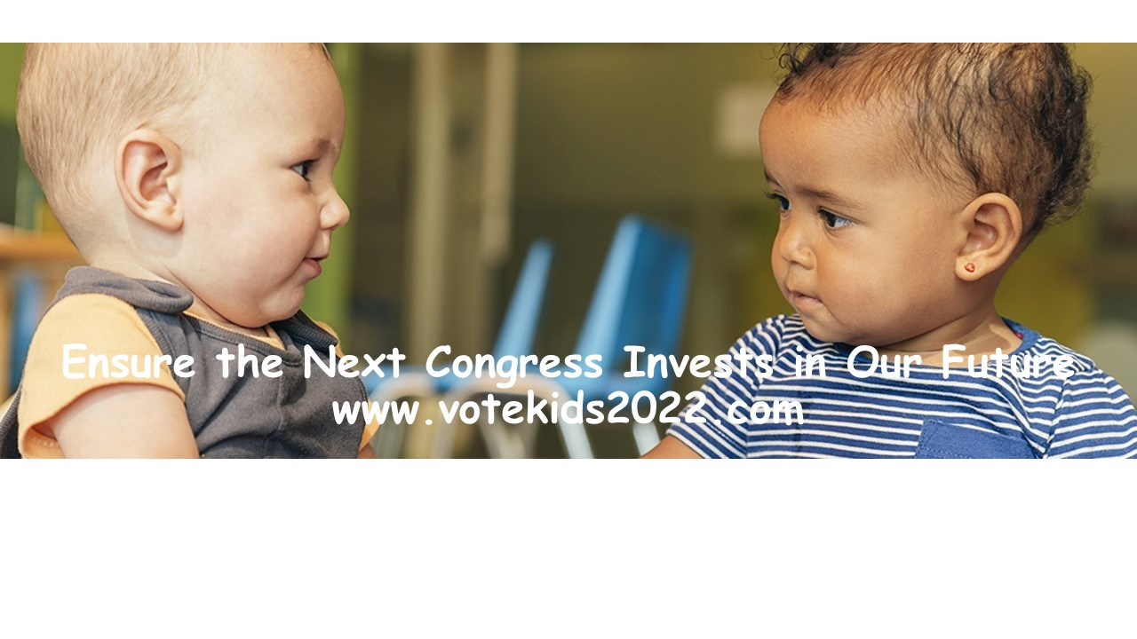

POLLS AND FORECASTS:
VOTE KIDS 2022 HOUSE CANDIDATES IN KEY RACES FOR CONTROL OF CONGRESS
Vote Kids 2022 Status Update, October 24, 2022
Most pollsters are stating that the 2022 elections represent the most difficult election to forecast in recent history, because of questions of how undecided voter ultimately will swing (with multiple issues that could be determine that), how voter turnout will be affected by voter passion and new election laws, and how reapportionment and redrawn districts will shift where and how many competitive races exist. In terms of the United States Congress, however, pollsters generally agree that a small number of seats will decide who controls the U.S. House.
While the latest 538 forecast for control of Congress (October 23) gives the Republicans an 80 percent chance of taking over the House, 538 notes that “the fate of the House likely rests on the outcome of a handful of key seats, including Iowa’s 3rd district, North Carolina’s 13th district, and Colorado’s 8th district.”
Vote Kids 2022 candidates include those from North Carolina’s 13th district and Colorado’s 8th district among its fourteen key House races. Vote Kids 2022 also includes Iowa’s 2nd district (Iowa’s 3rd district is held by a Democratic incumbent, and Vote Kids 2022 focused only upon competitive races without a Democratic incumbent). While polling is limited at the specific Congressional district level, polls that are available show that Vote Kids 2022 candidate selections clearly are in tight but winnable elections and will help determine who controls Congress.
In Iowa, a very recent Des Moines Register Iowa poll, conducted by Selzer and Associates and one of only three polling firms given an A+ rating by 538, shows Iowa’s second as well as third district both in virtual dead heats. In the 2nd district, Vote Kids 2022 candidate Liz Mathis now leads incumbent Ashley Hinson by 46 to 44 percent, slightly more than incumbent Cindy Axney leads Brad Zann in Iowa’s third House district, 45 to 44 percent. Clearly, in terms of both races, these represent toss-up races likely to be determined by what transpires in the last two weeks of the campaign.
In North Carolina’s open 13th district, a September Global Strategies Group poll showed Vote Kids 2022 candidate Wiley Nickel with a 44 to 40 percent lead over his opponent, Bo Hines.
In Colorado’s new 8th district, an mid-October (11th-16th) poll from Global Strategies Group showed Vote Kids 2022 candidate Yadira Caraveo trailing, 44 to 46 percent, her opponent, Barbara Kirkmeyer.
In other races where there has been relatively recent polling, Impact Research’s mid-September poll showed Vote Kids 2022 Ohio candidate Greg Landsman with a 49 to 46 percent lead over incumbent Greg Chabot. A Spectrum News/Siena College Poll released in mid-October, showed Vote Kids 2022 candidate Josh Riley with a 46 to 41 percent lead Marc Molinaro for New York's 19th District seat. In New Mexico’s 2nd District, Vote Kids 2022 candidate Gabe Vasquez led his opponent Yvette Harrell by one percent in a July poll, also by Global Strategies Group. In Oregon’s 5t^{h} district, Vote Kids 2022 candidate Jamie McCleod-Skinner led opponent Lori Chavez-DeRemer 42 to 39 percent in a Global Strategies Group September poll. Re conside
In all these polls, who leads is statistically within the margin of polling error, meaning that all these races are considered statistical “dead heats.”
Vote Kids 2022 searched for polling for its other house races (by candidate name and polling) but could not find any specific to those races. While there has been extensive polling related to most Senate races, polling in Congressional races is limited.
In terms of forecasting, the Cook report lists 8 of the Vote Kids 2022 races as toss-up, with 3 as leans Democrat and 2 as leans Republican, with one as likely Republican (Mathis in Iowa). Likewise, these races tend to be considered among the most competitive by 538, Politico, and other forecasting groups.
Vote Kids 2022 will continue to track polling and forecasting activity, but Vote Kids 2022 believes that this information reinforces its selection not only of champions for children but candidates who can be difference makers in the establishing a working majority for kids in the United States House and a “freshman class for the future.”

