Groupe CHAUCASE Inc.

14/10/2018

ChauCASE

Shoes and Accessories show

February 4th to 6th, 2020

Fall – Winter Collections

Exhibitors Guide

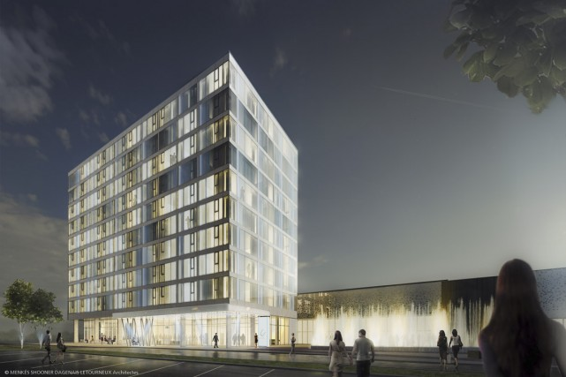

Contact:

Marc Esculier

C: 514 971-6272

mesculier@gmail.com

CENTRE COGECO

DRUMMONDVILLE

Table of content

**Information** 1

**CENTREXPO COGECO** 1

**Address** 1

**Parking** 1

**Directions** 1

**Food and relaxation area** 2

**Coat room** 2

**Other commodities offered** 2

**CHAUCASE Event** 2

**Warehousing needs for the show** 2

**Internet Wi-Fi** 2

**Booth clean-up** 2

**Official supplier / show services** 3

**Merchandise delivery** 3

**Contact CENTREXPO COGECO** 3

**General information** 3

**Merchandise identification** 3

**Delivery and access to the loading dock** 3

**Schedule** 4

**Show set-up** 4

**Show operating** 4

**Dismantling schedule** 4

**Rules** 5

**Advertising** 7

**Lodging** 8

**Hôtel Grand Times** 8

**Other hôtels** 9

Hôtel le Dauphin, Best Western Plus Hôtel Universel 9

Hotel Comfort Inn, Motel/Hôtel Blanchet 9

# **Information**

## **CENTREXPO COGECO**

### **Address**

550, Saint-Amant street, Drummondville (Québec) J2C 6E3

### **Parking**

1 200 free parking spaces available for visitors and exhibitors

### **Directions**

#### From highway 20

* In Drummondville, take exit 177 in the direction of the Boulevard Saint-Joseph/QC-143 S
* From Montreal, turn right on St-Joseph Blvd.
* From Quebec City, turn left on St-Joseph Blvd.
* Turn left onto René-Lévesque boulevard
* Turn right onto boulevard of the pines
* Take the 2e entrance for access to the main parking lot

#### From highway 55 north

* Follow Highway 55 N
* Take the exit 128 for Highway 20 E / highway 55 N in the direction of Quebec
* Follow Highway 20 E
* At Drummondville, take the exit 177 in the direction of the Boulevard Saint-Joseph/QC-143 S
* Turn right on St-Joseph Blvd.
* Turn left on René-Lévesque boulevard
* Turn right onto boulevard of the pines
* Take the 2e entrance for access to the main parking lot

#### From highway 55 south

* Follow Hwy 55 S
* Take the exit 145 to join Hwy 20 W in the direction of Drummondville/Montréal
* Follow Hwy 20 W
* At Drummondville, take the exit 177 in the direction of the Boulevard Saint-Joseph/QC-143 S
* Turn left on St-Joseph Blvd.
* Turn left on René-Lévesque boulevard
* Turn right onto boulevard of the pines; Take 2nd entrance to access the main parking lot

### **Food and relaxation area**

* Restaurant with 250 places adjacent to the lobby
* Bars in the Lobby signature and in the exhibition halls
* Snack bar located in the exhibition halls

### **Coat room**

Coat room service is available and operating hours vary with each event.

### **Other commodities offered**

* Elevator in the center of the lobby to access the 2nd floor boardrooms as well as the Grand Times Hotel.
* Baby feeding room of 100 square feet
* First-Aid room

## **CHAUCASE Event**

### **Warehousing needs for the show**

After the set-up, any exhibitor who wish to warehouse some material, must identify the merchandise and leave it at the area of the loading dock reserved for the show.

By respect for your colleagues and visitors still on the floor, it is not permitted to begin dismantling of a booth before 16:00, the official closure of the show. As soon as the carpets in the isles have been removed, the loading dock doors will be opened to give access to you warehoused merchandise.

All material left behind will be handled and shipped to the owner of the material by the official carrier of CENTREXPO COGECO Drummondville and all the costs associated with this situation will be invoiced to the owner of the material.

### **Internet Wi-Fi**

Included in the cost of the booth space rental. The connection information will be given out at the show or before if available.

### **Booth clean-up**

Please note that you are responsible for the clean-up of your booth. Should you wish to outsource a service, enquire with CENTREXPO COGECO.

**Registration / Badges**

Every representative or assistant must be registered and have paid the registration fees to be admitted at the show.

* Badges must be worn at all times by all participants during the show.
* The show is not opened to the public and it is your entry pass to the show.
* They will be available upon your arrival the first day of the show.
* We recuperate the badges at the end of the show. Simply hand them in at the reception desk.

### **Official supplier / show services**

A 3 year agreement is in place between Groupe CHAUCASE and Media Systems thus ensuring price stability. Media Systems is the official supplier (not exclusive) for booth accessory rental. It is possible to fill last minute needs such as tables, chairs, carpet etc., but late request prices may apply. Contact: Hélène Brosseau Tel: 514 862-2634 – [hbrosseau@mediasystems.ca](mailto:hbrosseau@mediasystems.ca)

# **Merchandise delivery**

## **Contact CENTREXPO COGECO**

Alexandre Latreille   
1-819-477-5880 Ext: 1-215  
a.latreille@centrexpocogeco.ca

## **General information**

Every day between 8:00 am and 6:00 pm

No merchandise will be accepted the day before the set-up day unless pre-approved by CENTREXPO COGECO.

Parking in the loading dock area is not permitted and can result in the vehicle being towed. Only vehicles with the purpose of delivery or pick up of merchandise are allowed

Trucks and trailers must not exceed 10’ high an 8’6’ wide.

## **Merchandise identification**

* Coordinates of the contact person
* Address for delivery :

CENTREXPO COGECO Drummondville

550, rue Saint-Amant

Drummondville (Québec) J2C 6E3

* Rear entrance (loading dock)
* Name of the exhibiting company
* Booth number
* Name of the person responsible and telephone number

## **Delivery and access to the loading dock**

* Off Pins street
* Take 1st entrance to access loading dock

# **Schedule**

## **Show set-up**

Monday February 3rd , 2020 from 8:00 am to 8:00 pm

**Loading dock assistance:**

**From 9:00 am to 8:00 pm**, Groupe CHAUCASE has contracted personnel to greet Exhibitors at the loading dock to help load the merchandise on trolleys and take to the Exhibitor’s booth. After 8 p.m.no trolley will be allowed on the floor of the show so that the carpets can be laid out in the aisles of the show.

## **Show operating**

Tuesday February 4th , 2020: from 8:00 am to 6:00 pm

Wednesday February 5th, 2020: from 8:00 am to 6:00 pm

Thursday February 6th, 2020: from 8:00 am to 4:00 pm

## **Dismantling schedule**

Thursday February 6th, 2020 from 4 :00 pm to midnight

**Loading dock assistance:**

**From 4 p.m. to 8 p.m.,** Groupe CHAUCASE inc has contracted personnel to help load your material on trolleys and take it to the loading dock.

The schedule and conditions in place for the set-up and dismantling of the booths must be respected by all exhibitors. Setting up outside the established times scheduled or the delivery of merchandise to the Centre without prior approval may result in the refusal to access the site or to be invoiced for warehousing costs by the CENTREXPO COGECO Drummondville.

Trolleys: Groupe CHAUCASE has made sure that trolleys are available during the set-up or dismantling period. The deadline for the use of trolleys is 20:00, the time at which isle carpeting takes place.

Unless there is a special agreement between CENTREXPO COGECO Drummondville and Groupe CHAUCASE, any merchandise or material left at the dock area will be warehoused and the handling cost will be invoiced to the owner of the material.

If you need a forklift or a plafolift for merchandise handling purposes, please contact Denis Dion of Decor Expert Expo at 450 646-2251.

# **Rules**

***Participation***

All Company representatives, regardless of title, can participate as exhibitors in a CHAUCASE show. A published fee must be paid by all exhibitor participants.

***Orders***

All orders submitted TO Groupe CHAUCASE for booth space, advertising, electrical outlet, etc., will be confirmed after payment has been received. If a payment has not been received by the published deadline, the applicant will be notified that the orders submitted has been cancelled.

***Late orders***

Any order submitted after the published deadline will be accepted but subject to an immediate payment by credit card or by bank transfer.

***Refund policy***

Due to show contractual obligations and printing underway, no refund will be made for any cancellations after the published deadline, normally 30 days prior to the event, unless due to extraordinary circumstances as determined by Groupe CHAUCASE Inc.

***Booth***

Sizes and prices are in multiple of 10’ X 10'

***Space assignment***

Assignment will be primarily based on the show lay-out need. The access of an exhibitor to participate in the show based on the terms and conditions of this contract are not guaranteed from year to year.

***Space sublet***

The exhibitor is not allowed to sublet the space or booth that was allocated to him/her or share the same with one or more persons, without the consent of Groupe CHAUCASE Inc.

***Refusal right***

Groupe CHAUCASE Inc reserves the right to refuse or prohibit certain merchandise or persons whose presence or behavior may be considered a prejudice to the unfolding of the show.

**Installation date**

Will take place on the day preceding the opening day the show. The set-up starting times and deadline for completing it will be as published and may vary from show to show.

***Delivery during the show :***

Allowed but no trolley may be used on the carpet of the show aisles.

***Show hours***

The first two days are from 8am to 6pm and the last day from 8am to 4pm. The period from 8am to 9am is to accommodate early appointments only and the presence of all exhibitors is not obligatory.

***Badges***

The show is not opened to the public and therefore badges must be worn at all times to identify a participant.

***Booth accessories and furniture***

All accessories are subject to pre-booking discounts as determined by the official supplier of the show and will not apply to orders given after the deadline published by the supplier identified as the official supplier but not exclusive.

***Music***

Allowed in an individual booth but must not be disturbing to other exhibitors.

***Food and beverages***

Due to contractual obligations, all food and beverages to be consumed on the site must come from the caterer contracted for the show or from CENTREXPO COGECO.

***Signage***

All signage must be professionally printed.

***Soliciting***

Not permitted in the aisles, entrance way or food court of the show.

***Démontage***

**No exhibitor is permitted to dismantle their exhibit before the published closing time of 4pm** (we count on everyone’s professionalism and respect for the customers and other Exhibitors). Any non-authorized deviation from this rule may lead to a suspension from participation in ChauCASE trade shows.

***Fire regulations***

Accessories, advertising material etc., cannot exceed the booth space perimeter. The obstruction of traffic in the isles of the show is prohibited. All curtains or fabric must be fireproof.

***Security***

Although reasonable security measures are in place, Groupe CHAUCASE Inc cannot guarantee Exhibitors against losses of any kind. Exhibitors must assume sole responsibility for the safety of the contents of their exhibit during the event. The exhibitor will ensure that one member of his personnel is present at all times in the booth during the event.

***Civil responsibilities***

The tenant, referred to as participant and/or exhibitor, exonerates the administrators of the Hosting location where the show is held as well as Groupe CHAUCASE Inc. of all responsibilities for physical or material damages that may result from the occupation of the rented space by the tenant, its representatives or employees or any other person under its jurisdiction. The tenant also accepts the responsibility for physical or material damages that may have been caused to the host location, its employees, administrators or sub-contractors, resulting from an act of negligence on the part of the tenant or its personnel for whom it is responsible. The landlord and/or event promoter (Groupe CHAUCASE Inc) will not be held liable for any deterioration, lost, theft or destruction of property, nor the death or injuries of persons in the rented space within the premises regardless of the cause.

**Modalities**

If an individual's signature on a contract, on behalf of the Company and relative to the event, is declared invalid or not authorized by the said Company, this individual becomes responsible for the amounts unpaid.

The act to apply for participation in a CHAUCASE show confirms that the show rules published in the Exhibitor Guide posted on the web site www.chaucase.com were read, understood and are agreed to by the applicant or associate involved in the application.

The act to apply for participation in a CHAUCASE show confirms that the show rules published herein were read, understood and are agreed to by the applicant.

Advertising **- Show guide**

**Technical specifications**

* Width: 5''
* Height: 8''
* 4 colors process
* JPEG or PDF format
* High definition.

**Deadline**: **December 15th , 2019**

# **Lodging**

## **Hôtel Grand Times**

[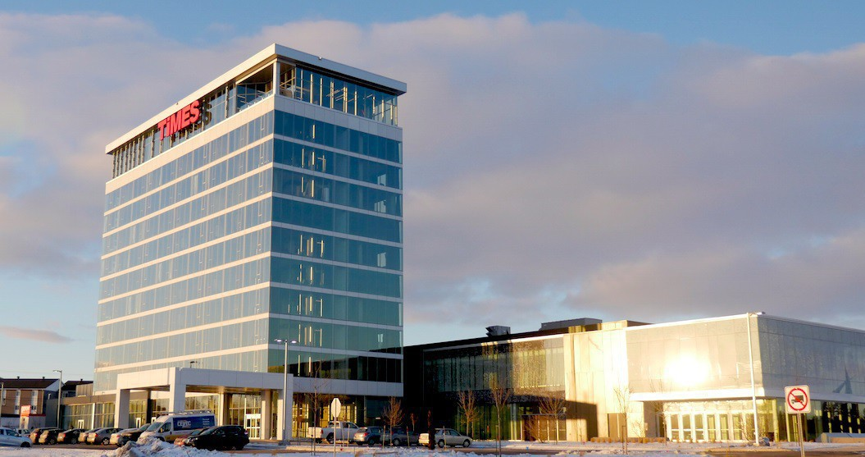](https://www.google.ca/url?sa=i&rct=j&q=&esrc=s&source=images&cd=&cad=rja&uact=8&ved=2ahUKEwiW1LiB84beAhWhSt8KHcTgDZUQjRx6BAgBEAU&url=http://www.grandtimeshotel.com/grand-times-drummondville/fr/&psig=AOvVaw0PdIbUJgvzgCXb9wvB79xJ&ust=1539639707032816)

*Costs*

*Single and double occupation*

* Grand Comfort rooms $159
* Grand Confort Plus rooms: $159
* Vertige King suite: $159

$15.00 per additional person, no charge for children 12 years old or under.

Taxes (subject to change without notice according to government laws)

Lodging : 3.5%  
GST : 5%  
QST : 9.975%

*Reservation procedure*

Group code: **CHAU030220**

All reservations will be made on an individual basis unless otherwise indicated. These must be received by the reservation department at 1-833-474-5550 or by email at [reservationdrummond@timeshotel.ca](mailto:reservationdrummond@timeshotel.ca) A credit card number will be required as a guarantee.

You can make your reservation directly online at the following address : <https://www.luxuryres.com/BookingEngines/V16/index.asp?h=7846&a=01/28/2019&d=01/29/2019&p=CHAUCS>

Arrival time: 3:00 pm  
Departure time: 12 Noon

## **Other hôtels**

### Hôtel le Dauphin



600 Boulevard Saint-Joseph, Drummondville, QC J2C 2C1

855-500-8480 ou 819-478-4141

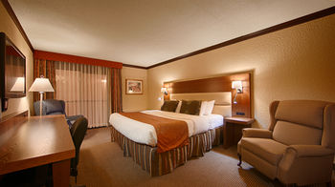

### Best Western Plus Hôtel Universel

915, Hains st., Drummondville, QC J2C 3A1 . . . 819- 478-4971

### Hotel Comfort Inn

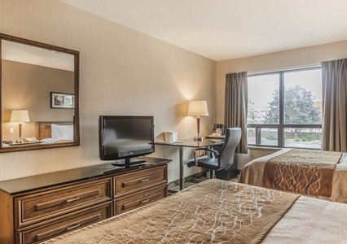

1055, Rue Hains, Drummondville, QC J2C 6G6

819-477-4000

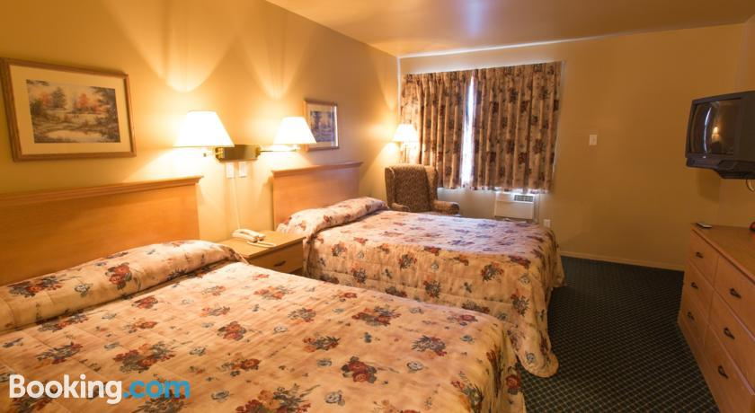

### Motel/Hotel Blanchet

225, Boulevard Saint-Joseph O, Drummondville, QC J2E 1A9

800-567-3823 ou 819-477-0222