Southern Nevada Law Enforcement Foundation
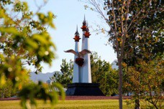
Public Art Project by Adolfo Gonzalez

The Memorial Wall in Police Memorial Park honors those who served our Southern Nevada Community.
Criteria for a Memorial Brick:
- Person must have served in federal, state or local law enforcement in Southern Nevada. (Esmeralda, Lincoln, Nye and Clark Co.)
- Fee: $150.00 ($100.00 of this fee may be considered as a contribution and tax deductible to the extent allowed by law).
- Please make your check payable to the Southern Nevada Law Enforcement Foundation or SNLEF.
- The quarrying and engraving process may take three to six weeks before installation can take place.
- The SNLEF Board reserves the right to abbreviate rank/position or department to accommodate the allotted space on the surface of the memorial brick.
Name: Rank: (optional) Personnel No./Badge No.
Department:
Donor’s Name: Address: Phone Number and email:
Please return the completed form and check to:
SNLEMF
840 S Rancho Dr. #4-425
Las Vegas, NV. 89106

For more information, call Lisa Waller @ 702-378-5333.
Southern Nevada Law Enforcement Foundation is a 501 (c) (3) charity organization.

